|  |  |
| --- | --- |
| NO_CAPTION null | **MINISTRY OF**  **EDUCATION AND TRAINING** |

|  |
| --- |
| **FPT UNIVERSITY** |
| Capstone Project Document |
| **Applying machine learning in building an online examination support and proctoring system** |

|  |  |
| --- | --- |
| **SEP490.3** | |
| **Group Members** |  |
| **Supervisor** | Luong Hoang Huong |
| **Ext Supervisor** | N/A |
| **Capstone Project code** | SEP490 |

- CanTho, November 2022-

**Table of Contents**

[Acknowledgement 11](#_Toc121509800)

[Definition and Acronyms 11](#_Toc121509801)

[I. Project Introduction 12](#_Toc121509802)

[1. Overview 12](#_Toc121509803)

[1.1 Project Information 12](#_Toc121509804)

[1.2 Project Team 12](#_Toc121509805)

[a. Supervisor 12](#_Toc121509806)

[b. Team Members 12](#_Toc121509807)

[2. Product Background 12](#_Toc121509808)

[2.1 Machine Learning 12](#_Toc121509809)

[2.2 Deep Learning 12](#_Toc121509810)

[2.3 Convolutional Neural Network (CNN) 13](#_Toc121509811)

[1. Convolution layer 13](#_Toc121509812)

[2. Pooling layer 14](#_Toc121509813)

[3. Fully connected layer 14](#_Toc121509814)

[2.4 ResNet 14](#_Toc121509815)

[2.5 Programming languages 15](#_Toc121509816)

[2.5.1 C# (Framework use: ASP.NET Core) 15](#_Toc121509817)

[2.5.2 JavaScript (Framework use: ReactJS) 16](#_Toc121509818)

[3. Existing Systems 16](#_Toc121509819)

[3.1 FPT University’s Exam Online System (EOS) 16](#_Toc121509820)

[3.2 FPT University Learning Management System (LMS) 16](#_Toc121509821)

[4. Business Opportunity 16](#_Toc121509822)

[5. Software Product Vision 17](#_Toc121509823)

[6. Project Scope & Limitations 17](#_Toc121509824)

[6.1 Major Features 17](#_Toc121509825)

[6.2 Limitations & Exclusions 18](#_Toc121509826)

[II. Project Management Plan 19](#_Toc121509827)

[1. Overview 19](#_Toc121509828)

[1.1 WBS & Estimation 19](#_Toc121509829)

[1.2 Project Risks 20](#_Toc121509830)

[2. Management Approach 21](#_Toc121509831)

[2.1 Project Process 22](#_Toc121509832)

[2.2 Quality Management 22](#_Toc121509833)

[2.3 Training Plan 23](#_Toc121509834)

[3. Master Schedule 24](#_Toc121509835)

[4. Project Organization 24](#_Toc121509836)

[4.1 Team & Structures 24](#_Toc121509837)

[4.2 Roles & Responsibilities 25](#_Toc121509838)

[5. Project Communication 25](#_Toc121509839)

[5.1 Communication Plan 25](#_Toc121509840)

[5.2 External Interface 26](#_Toc121509841)

[a. FU Contacts 26](#_Toc121509842)

[b. Customer Contacts 26](#_Toc121509843)

[6. Configuration Management 26](#_Toc121509844)

[6.1 Tools & Infrastructures 26](#_Toc121509845)

[6.2 Document Management 27](#_Toc121509846)

[6.3 Source Code Management 27](#_Toc121509847)

[III. Software Requirement Specification 28](#_Toc121509848)

[1. Overall Description 28](#_Toc121509849)

[1.1 Product Overview 28](#_Toc121509850)

[1.2 Business Rules 29](#_Toc121509851)

[2. User Requirements 30](#_Toc121509852)

[2.1 Overview 30](#_Toc121509853)

[a. Use Case Diagram 30](#_Toc121509854)

[b. System Actors 33](#_Toc121509855)

[c. Use Cases List 33](#_Toc121509856)

[2.2 Authentication 34](#_Toc121509857)

[a. UC-01 Login 34](#_Toc121509858)

[b. UC-02 Logout 35](#_Toc121509859)

[c. UC-03 Forgot password 35](#_Toc121509860)

[2.3 Manage 36](#_Toc121509861)

[a. 1. UC-04 Manage account 36](#_Toc121509862)

[a. 2. UC-24 Create account by excel 37](#_Toc121509863)

[b. UC-06 Manage Modules 38](#_Toc121509864)

[c. UC-07 Manage Classes 38](#_Toc121509865)

[d. UC-10 Manage Exams 39](#_Toc121509866)

[e. UC-08 Manage Exams 39](#_Toc121509867)

[2.4 View 40](#_Toc121509868)

[a. UC-05 View deactivated account list 40](#_Toc121509869)

[b.UC-19 View Exam Schedule 40](#_Toc121509870)

[c. UC-22 Mark report 41](#_Toc121509871)

[d. UC-23 View module list 42](#_Toc121509872)

[e. UC-09 View module list 42](#_Toc121509873)

[f. UC-12 View exam result, analysis 43](#_Toc121509874)

[g. UC-15 View request add question bank 43](#_Toc121509875)

[2.5 Exam taking 44](#_Toc121509876)

[a. UC-20 Take exam 44](#_Toc121509877)

[b. UC-21 Submit exam 45](#_Toc121509878)

[c. UC-11 Export excel module's exam result 46](#_Toc121509879)

[d. UC-13 Create exam paper 46](#_Toc121509880)

[e. UC-14 Grade written question 47](#_Toc121509881)

[f. UC-25 Export excel student's exam information 48](#_Toc121509882)

[g. UC-26 Invigilate 49](#_Toc121509883)

[2.6 Manage question bank 49](#_Toc121509884)

[a. UC-16 Approve/reject to add questions 49](#_Toc121509885)

[b. UC-17 Request add new question to question bank 50](#_Toc121509886)

[c. UC-18 Assign teacher to process add question request 51](#_Toc121509887)

[3. Functional Requirements 53](#_Toc121509888)

[3.1 System Functional Overview 53](#_Toc121509889)

[a. Screen Flow 53](#_Toc121509890)

[b. Screen Details 54](#_Toc121509891)

[c. Screen Authorization 55](#_Toc121509892)

[d. Non-Screen Functions 57](#_Toc121509893)

[e. Entity Relationship Diagram 57](#_Toc121509894)

[3.2 Authentication 58](#_Toc121509895)

[a. Login 58](#_Toc121509896)

[b. Logout 61](#_Toc121509897)

[c. Forgot password 62](#_Toc121509898)

[3.3 Role Administrator 64](#_Toc121509899)

[a. Manage account 64](#_Toc121509900)

[b. View deactivated account 66](#_Toc121509901)

[c. Create accounts by excel 67](#_Toc121509902)

[3.4 Role Academic department 68](#_Toc121509903)

[a. Manage modules 68](#_Toc121509904)

[b. Manage classes 71](#_Toc121509905)

[c. Manage exams 73](#_Toc121509906)

[3.5 Role Teacher 75](#_Toc121509907)

[a. Manage Exam 75](#_Toc121509908)

[b. Grade written question 77](#_Toc121509909)

[c. Approve/reject to add questions 81](#_Toc121509910)

[d. Request add new question to question bank 83](#_Toc121509911)

[e. Invigilate 87](#_Toc121509912)

[3.6 Role Student 89](#_Toc121509913)

[a. Take and submit Exam 89](#_Toc121509914)

[b. Mark report 92](#_Toc121509915)

[4. Non-Functional Requirements 93](#_Toc121509916)

[4.1 External Interfaces 93](#_Toc121509917)

[a. User Interfaces 93](#_Toc121509918)

[b. Software Interfaces 93](#_Toc121509919)

[c. Hardware Interfaces 93](#_Toc121509920)

[d. Communications Interfaces 93](#_Toc121509921)

[4.2 Quality Attributes 94](#_Toc121509922)

[a. Usability 94](#_Toc121509923)

[b. Reliability 94](#_Toc121509924)

[c. Performance 94](#_Toc121509925)

[d. Dependability 94](#_Toc121509926)

[**Security** 94](#_Toc121509927)

[e. Supportability 94](#_Toc121509928)

[f. Design Constraints 94](#_Toc121509929)

[g. Support Documents 94](#_Toc121509930)

[5. Other Requirements 94](#_Toc121509931)

[5.1 Appendix1 - Messages List 94](#_Toc121509932)

[IV. Software Design Description 95](#_Toc121509933)

[1. Overall Description 95](#_Toc121509934)

[1.1 Assumptions 95](#_Toc121509935)

[1.2 Design Constraints 95](#_Toc121509936)

[2. System Architecture Design 96](#_Toc121509937)

[2.1 Overall Architecture 96](#_Toc121509938)

[2.2 System Architecture 97](#_Toc121509939)

[2.3 Package Diagram 98](#_Toc121509940)

[3. System Detailed Design 99](#_Toc121509941)

[a. Class Diagram 99](#_Toc121509942)

[b. Sequence Diagrams 100](#_Toc121509943)

[1. Login 100](#_Toc121509944)

[2. Logout 101](#_Toc121509945)

[3. Forgot password 102](#_Toc121509946)

[4. Create Account 103](#_Toc121509947)

[5. View Account List 103](#_Toc121509948)

[6. Update Account 104](#_Toc121509949)

[7. Deactivate Account 105](#_Toc121509950)

[8. View deactivated account list 105](#_Toc121509951)

[9. Create Module 106](#_Toc121509952)

[10. View Module list 107](#_Toc121509953)

[11. Update Module 108](#_Toc121509954)

[12. Delete Module 109](#_Toc121509955)

[13. Create Class 110](#_Toc121509956)

[14. View Class List (Academic Department) 111](#_Toc121509957)

[15. Update Class (Academic department) 111](#_Toc121509958)

[16. Create Final Exam 112](#_Toc121509959)

[17. View Exam List 113](#_Toc121509960)

[18. Update Final Exam 114](#_Toc121509961)

[19. Delete Exam (Academic Role) 115](#_Toc121509962)

[20. View module list 116](#_Toc121509963)

[21. Create Exam 117](#_Toc121509964)

[22. View Exam List 118](#_Toc121509965)

[23. Update Exam 119](#_Toc121509966)

[24. Delete Exam (Teacher Role) 120](#_Toc121509967)

[25. Export excel module’s exam results (Teacher) 121](#_Toc121509968)

[26. View exam result, analysis 121](#_Toc121509969)

[27. Create exam paper 122](#_Toc121509970)

[28. Grade written questions (Teacher) 123](#_Toc121509971)

[29. View all requests add question bank 124](#_Toc121509972)

[30. Approve/Reject request to add question 125](#_Toc121509973)

[31. Request add new question to question bank 126](#_Toc121509974)

[32. Assign teacher to process add question request 127](#_Toc121509975)

[33. View exam schedule (Student) 128](#_Toc121509976)

[34. View exam questions 129](#_Toc121509977)

[35. Submit exam (Student) 130](#_Toc121509978)

[36. Mark report 131](#_Toc121509979)

[37. View module list by Student 131](#_Toc121509980)

[38. Invigilate 132](#_Toc121509981)

[4. Class Specification 132](#_Toc121509982)

[4.1 AcademicDepartmentController Class 132](#_Toc121509983)

[4.1.1 Class Methods 132](#_Toc121509984)

[4.1.2 Attributes of the Class 132](#_Toc121509985)

[4.2 AccountController Class 132](#_Toc121509986)

[4.2.1 Class Methods 132](#_Toc121509987)

[4.2.2 Attributes of the Class 136](#_Toc121509988)

[4.3 AnswerController Class 136](#_Toc121509989)

[4.3.1 Class Methods 136](#_Toc121509990)

[4.3.2 Attributes of the class 137](#_Toc121509991)

[4.4 AuthenticationController Class 138](#_Toc121509992)

[4.4.1 Class Methods 138](#_Toc121509993)

[4.4.2 Attributes of the Class 140](#_Toc121509994)

[4.5 CheatController Class 140](#_Toc121509995)

[4.5.1 Class Methods 140](#_Toc121509996)

[4.5.2 Attributes of the Class 141](#_Toc121509997)

[4.6 ClassController Class 141](#_Toc121509998)

[4.6.1 Class Methods 141](#_Toc121509999)

[4.6.2 Attributes of the Class 141](#_Toc121510000)

[4.7 ClassModuleController Class 142](#_Toc121510001)

[4.7.1 Class Methods 142](#_Toc121510002)

[4.7.2 Attributes of the class 144](#_Toc121510003)

[4.8 ExamController Class 144](#_Toc121510004)

[4.8.1 Class Methods 144](#_Toc121510005)

[4.8.2 Attributes of the class 149](#_Toc121510006)

[4.9 ExamQuestionsController Class 150](#_Toc121510007)

[4.9.1 Class Methods 150](#_Toc121510008)

[4.9.2 Attributes of the Class 151](#_Toc121510009)

[4.10 InvigilateController Class 151](#_Toc121510010)

[4.10.1 Class Methods 151](#_Toc121510011)

[4.10.2 Attributes of the Class 153](#_Toc121510012)

[4.11 MarkController Class 153](#_Toc121510013)

[4.11.1 Class Methods 153](#_Toc121510014)

[4.11.2 Attributes of the Class 153](#_Toc121510015)

[4.12 ModuleController Class 153](#_Toc121510016)

[4.12.1 Class Methods 153](#_Toc121510017)

[4.12.2 Attributes of the class 156](#_Toc121510018)

[4.13 NotifyController Class 156](#_Toc121510019)

[4.13.1 Class Methods 156](#_Toc121510020)

[4.13.2 Attributes of the class 157](#_Toc121510021)

[4.14 QuestionController Class 157](#_Toc121510022)

[4.14.1 Class Methods 157](#_Toc121510023)

[4.14.2 Attributes of the Class 158](#_Toc121510024)

[4.15 StudentController Class 159](#_Toc121510025)

[4.15.1 Class Methods 159](#_Toc121510026)

[4.15.2 Attributes of the class 161](#_Toc121510027)

[4.16 TeacherController Class 161](#_Toc121510028)

[4.16.1 Class Methods 161](#_Toc121510029)

[4.16.2 Attributes of the Class 161](#_Toc121510030)

[4.17 TokenController Class 162](#_Toc121510031)

[4.17.1 Class Methods 162](#_Toc121510032)

[4.17.2 Attributes of the Class 163](#_Toc121510033)

[5. Data & Database Design 164](#_Toc121510034)

[5.1 Database Design 164](#_Toc121510035)

[a. AcademicDeparment Table 165](#_Toc121510036)

[b. AddQuestionRequest Table 165](#_Toc121510037)

[c. Administartor Table 166](#_Toc121510038)

[d. Answer Table 166](#_Toc121510039)

[e. CheatingType Table 166](#_Toc121510040)

[f. ClassModuleStudent Table 166](#_Toc121510041)

[g. Class Table 167](#_Toc121510042)

[h. ClassModule Table 167](#_Toc121510043)

[i. ExamFEQuestion Table 167](#_Toc121510044)

[j. Exam Table 168](#_Toc121510045)

[k. ExamQuestion Table 169](#_Toc121510046)

[l. FEAnswer Table 169](#_Toc121510047)

[m. FEQuestion Table 169](#_Toc121510048)

[n. Level Table 170](#_Toc121510049)

[o. Module Table 170](#_Toc121510050)

[p. Question Table 170](#_Toc121510051)

[q. QuestionType Table 171](#_Toc121510052)

[r. Role Table 171](#_Toc121510053)

[s. Student Table 171](#_Toc121510054)

[t. StudentAnswer Table 171](#_Toc121510055)

[u. StudentCheating Table 172](#_Toc121510056)

[v. StudentExamInfos Table 172](#_Toc121510057)

[w. StudentFEAnswer Table 172](#_Toc121510058)

[x. Teachers Table 173](#_Toc121510059)

[V. Software Testing Documentation 173](#_Toc121510060)

[1. Overall Description 173](#_Toc121510061)

[1.1 Test Model 173](#_Toc121510062)

[1.2 Testing Levels 173](#_Toc121510063)

[1.3 Testing Types 174](#_Toc121510064)

[2. Test Plan 174](#_Toc121510065)

[2.1 Test Stages 174](#_Toc121510066)

[2.2 Resources 175](#_Toc121510067)

[a. Human Resources 175](#_Toc121510068)

[b. Environment 175](#_Toc121510069)

[2.3 Test Milestones 175](#_Toc121510070)

[2.4 Deliverables 175](#_Toc121510071)

[3. Test Cases 175](#_Toc121510072)

[4. Test Reports 176](#_Toc121510073)

[a. Unit Test Case 176](#_Toc121510074)

[b. Other Test Cases 177](#_Toc121510075)

[VI. Release Package & User Guides 177](#_Toc121510076)

[1. Deliverable Package 177](#_Toc121510077)

[1.1 Source codes & documents 177](#_Toc121510078)

[1.2 Known Issues, Limitations & Restrictions 177](#_Toc121510079)

[2. Installation Guides 178](#_Toc121510080)

[2.1 System Requirements 178](#_Toc121510081)

[2.2 Setup Files 178](#_Toc121510082)

[2.3 Installation Instruction 178](#_Toc121510083)

[3. User Manual 184](#_Toc121510084)

[3.1 Terms and definitions 184](#_Toc121510085)

[3.2 System requirements 185](#_Toc121510086)

[3.3 Application Usage 185](#_Toc121510087)

[a. Overview 185](#_Toc121510088)

[b. Authentication 186](#_Toc121510089)

[c. Role Administrator 192](#_Toc121510090)

[d. Role Academic department 197](#_Toc121510091)

[e. Role Teacher 204](#_Toc121510092)

[f. Role Student 216](#_Toc121510093)

[VII. Appendix 219](#_Toc121510094)

[1. References 219](#_Toc121510095)

# Acknowledgement

Our graduation thesis can not be completed without the help and advice from our friend in class SE1501, our teacher at FPT university, and our mentor Mr.Luong Hoang Huong. This project is motivated by the inspiration that every exam is fair and from that, improves education. Despite all the work we have done, this project may still have mistakes, we would like to receive feedback from teachers to improve the project.

Finally thanks for all the support from our family, our friends, and our enthusiastic mentor Mr.Luong Hoang Huong.

# Definition and Acronyms

|  |  |
| --- | --- |
| **Acronym** | **Definition** |
| SEB | Safe Exam Browser |
| AI | Artificial Intelligence |
| BR | Business Rule |
| ERD | Entity Relationship Diagram |
| ML | Machine Learning |
| SDD | Software Design Description |
| CNN | Convolutional Neural Networks |
| SRS | Software Requirement Specification |
| SDLC | Software Development Lifecycle |
| UC | Use Case |
| API | Application Programming Interface |

# I. Project Introduction

## 1. Overview

### 1.1 Project Information

* Project name: << Strawberry Leaf Disease DetectionSystem>>
* Project code: <<PTNT>>
* Group name: <<SEP490.55>>
* Software type: <<Software Type: Web>>

### 1.2 Project Team

#### a. Supervisor

|  |  |  |  |
| --- | --- | --- | --- |
| **Full Name** | **Email** | **Phone Number** | **Title** |
| Lương Hoàng Hướng | Huonglh3@fe.edu.vn | 0941666545 | Lecturer |

#### b. Team Members

|  |  |  |  |
| --- | --- | --- | --- |
| **Full Name** | **Email** | **Mobile** | **Role** |
| Tran Dac Tri |  |  | Leader |
| Nguyen Tuong Thanh | wall.nguyen1801@gmail.com | 0923797090 | Member |
| Ly Nguyen Hoang Phuc |  |  | Member |
| Pham Minh Nhi | [minhphamslchd@gmail.com](mailto:minhphamslchd@gmail.com) | 0941612011 | Member |

## 2. Product Background

 The idea for a disease detection system for strawberries came about due to the increasing need for efficient and accurate methods of detecting and managing diseases in strawberry crops. Strawberry farmers and growers were facing challenges with traditional methods of disease detection, which were time-consuming and often resulted in incorrect diagnoses. This led to significant losses in productivity and profits for the industry.  In response to these challenges, we in the fields of agriculture and disease detection came together to develop a state-of-the-art system for detecting and managing diseases in strawberry crops. The system utilizes advanced imaging technology and machine learning algorithms to accurately identify and classify diseases in strawberry plants.The target customers for this product are strawberry farmers and growers who are looking for a reliable and efficient method of detecting and managing diseases in their crops. The product has the potential to revolutionize the way strawberry farmers approach disease management, enabling them to protect their crops and improve their bottom line.

2.1 C# and ASP.NET Core 5

C# is a modern, general-purpose programming language that was first introduced by Microsoft in 2000. It is designed to be simple, powerful, and easy to learn, making it a popular choice for building a wide range of software applications. C# is particularly well-suited for developing Windows desktop applications, as well as web applications and mobile applications for iOS and Android.

One of the key features of C# is its object-oriented programming (OOP) model, which allows developers to create reusable code components that can be easily maintained and modified over time. This makes it possible to build large, complex software systems that are both robust and flexible.

C# is also known for its strong type checking and automatic memory management, which helps to prevent common programming errors and improve application performance. Additionally, C# includes a wide range of libraries and frameworks that make it easy to build a variety of software applications, including user interfaces, databases, and networking protocols.



*Figure 2. ASP.NET*

ASP.NET Core 5 builds on previous versions of the framework, and includes a number of new features and improvements. One of the major changes in this release is the integration of .NET 6, which allows developers to use a single framework for both web and desktop development. Additionally, it has support for C# 9 and improved support for gRPC and WebAssembly.

The framework is widely used to build web applications and APIs of various types and sizes. Also, the framework is widely adopted by many enterprises, startups, and small businesses due to its stability, security, performance, and feature richness. It's supported by Microsoft, so it's got strong community support and a number of resources and tools available to help developers get started and build powerful, efficient applications.

2.2 Docker



*Figure 2. Docker*

A software platform called Docker was developed to make it simpler to build, distribute, and operate programs in containers. Since its initial release in March 2013 by Docker, Inc., it has grown in popularity among professionals working in the software development field.

Software applications were traditionally delivered on dedicated servers or virtual machines prior to the invention of containerization. High overhead, lengthy deployment times, and difficulties scaling programs were a few drawbacks of this technique. In order to overcome these difficulties, Docker was created.

Applications and their dependencies are packaged into isolated, lightweight containers using Docker's containerization technology, making it simple to move these containers between environments. This method enables programmers to produce programs that are fast deployable, readily portable, and able to operate on any operating system.

Developers may save and distribute their container images in Docker's centralized repository, the Docker Hub. This makes it possible for developers to obtain pre-built images that may serve as the basis for their own apps with speed and ease.

Docker has gained popularity in the software development sector because it makes the process of developing applications simpler, speeds up deployment, and facilitates simple scaling. It is utilized in a wide range of applications, from small initiatives to huge, mission-critical systems, and has been extensively embraced by companies of all kinds.

2.3 Microsoft SQL Server



*Figure 3. Microsoft SQL Server*

Microsoft SQL Server is a relational database management system (RDBMS) developed and marketed by Microsoft. It is used to store and retrieve data as requested by other software applications, be it those on the same computer or those running on another computer across a network

Microsoft SQL Server is a relational database management system (RDBMS) developed and marketed by Microsoft. It is used to store and retrieve data as requested by other software applications, be it those on the same computer or those running on another computer across a network

SQL Server also provides options for cloud deployment, such as Microsoft Azure SQL Database and SQL Server on Azure Virtual Machines, which allows for the flexibility of deploying the SQL Server in hybrid or on cloud environments.

2.4 MVC architecture



*Figure 4. MVC Architecture*

A software design pattern called Model-View-Controller (MVC) architecture divides an application into three interrelated parts: the Model, the View, and the Controller. Trygve Reenskaug developed it in the late 1970s as a method for classifying and arranging software programs.

The application's data and business logic are represented by the model. It is in charge of handling user requests and data management for the application. The drawing of the user interface and the display of the data to the user are the responsibilities of the View. The Model and the View are connected through the Controller. It takes user input and modifies the Model appropriately, updating the View in turn.

Among its many advantages are improved modularity, maintainability, and scalability in the MVC design. Developers may work on each component independently when an application is divided into several components, lowering the possibility of conflicts and making it simpler to maintain the product over time. MVC's modular design also makes it simple to scale an application since new components may be added or changed without having an impact on the overall program.

MVC architecture is a common design pattern in the software industry and is used extensively in the creation of online applications. It is incorporated into several well-known web development frameworks, such as Laravel, ASP.NET, and Ruby on Rails. It is popular because it offers a distinct separation of concerns, which makes it simpler to create and manage complicated systems.

2.5 Machine Learning

Machine learning algorithms are a subset of artificial intelligence that use statistical models and algorithms to enable computers to learn from data and improve their performance over time. This technology has a wide range of applications, including image and speech recognition, natural language processing, fraud detection, recommendation systems, and autonomous vehicles.

The development of machine learning has been fueled by the availability of large datasets, powerful computing resources, and advances in algorithms and software frameworks. Some of the most popular machine learning frameworks include TensorFlow, PyTorch, Scikit-learn, and Keras.

In recent years, machine learning has become increasingly accessible to businesses and organizations of all sizes, thanks to the rise of cloud-based machine learning services such as Amazon SageMaker, Microsoft Azure ML, and Google Cloud AI Platform. These platforms provide a range of tools and services for data preparation, model training, deployment, and monitoring.

As the demand for machine learning continues to grow, the industry is expected to see rapid innovation and development. The ability to automate decision making and make predictions based on data will be increasingly valuable in a variety of industries, from healthcare and finance to transportation and retail.

2.5.1 Vision Transformer model

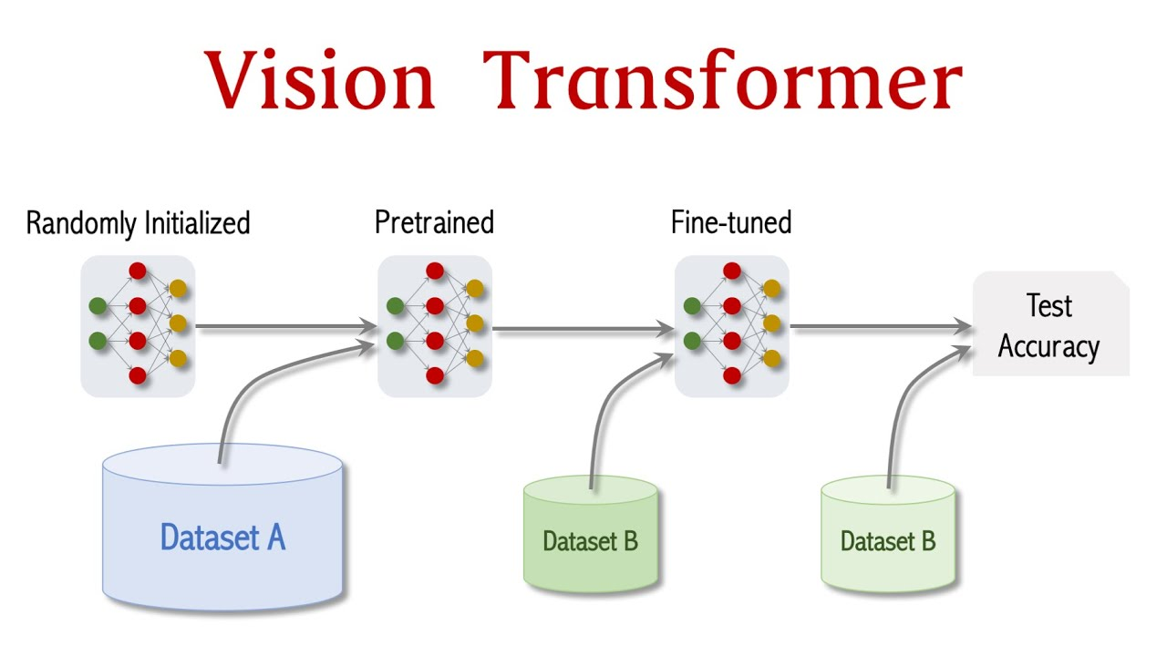

*Figure 5 . VT model*

Machine learning is a wider discipline that includes a variety of methods for creating predictive models from data. It entails creating algorithms that can absorb knowledge from data and forecast or decide based on that knowledge. Applications for machine learning techniques include fraud detection, picture identification, and natural language processing.

The Vision Transformer applies the Transformer architecture to image recognition by treating image data as a set of pixels with a fixed number of channels (e.g., red, green, and blue for a color image). Each pixel is represented as a feature vector, and the entire image is treated as a sequence of feature vectors. The Transformer's self-attention mechanism is used to weigh the importance of each pixel in the image, allowing the network to focus on the most informative parts of the image when making a prediction.One of the main benefits of the Vision Transformer is its ability to learn from extremely large image datasets, which allows it to achieve high accuracy on image recognition tasks.Additionally, it does not require any data preprocessing step such as cropping or resizing, thus making it more efficient for large-scale image recognition tasks.

It also has a good performance in object detection, image classification and others. The idea of using the transformer architecture on vision task has been quickly adopted and various variations of it have been proposed and used in various research work.

2.5.2 Data Augmentation

Data augmentation is a technique used in machine learning and computer vision to increase the size and diversity of a training dataset by artificially creating new examples from existing data. This technique is often used when there is limited data available or when the existing data is not representative enough of the real-world scenarios that the model will encounter.

Data augmentation techniques include image transformations such as rotation, scaling, cropping, flipping, and adding noise. These transformations can create variations of the original image, increasing the diversity of the dataset and improving the robustness of the model. For example, if training a model to recognize handwritten digits, data augmentation could be used to create new examples by rotating, scaling, and shifting the original images.

Data augmentation is also commonly used in natural language processing (NLP) to create variations of text data. This can involve techniques such as changing word order, synonym replacement, and adding or removing punctuation.

## 3. Existing Systems

#### 3.1 Related Works

Strawberry is a plant that needs a lot of conditions to grow healthy, the abnormal growth of strawberries can be due to many different reasons, immediate detection and treatment is essential. Most of the symptoms of a strawberry can be expressed in its leaves. CNNs are supervised multi-layer networks that can automatically learn features from datasets. Within the same architectural framework, it may carry out both feature extraction and classification [12] [13] [14] [16] [17] [18] [19] [20] [23] [24]. CNNs are a specific subset of neural networks that have found extensive use in a range of pattern recognition issues, including speech recognition, computer vision, and others. The CNN is based on the human visual system . To some extent achieve shift, scale, and distortion invariance, CNNs combine three architectural concepts: local receptive fields, shared weights, and spatial or temporal sub-sampling [25] For object recognition, a number of CNN designs, including MobileNet, ResNet, GoogLeNet, etc. Classification of leaf diseases by Syafiqah Ishakais (2015) [26] using Artificial Neural Network this model is to collect data then analyze data from leaf images 4 Strawberry leaf disease image classification based on Vision Transformer to identify symptoms through leaf expression. Part extract data from image, to adjust extract contrast, segmentation and features from an algorithm used from image processing method. In which the analysis and detection of the experiment is based on the Artificial Neural Network architecture. The architecture used to classify whether leaves are normal or have abnormal symptoms is due to multilayer feed-forward Neural Networks, which are multilayer perceptrons and radial basis functions RBF. The result of the last parameter comparison is RBF network is superior to MLP network, as demonstrated by this experiment. Deep Convolutional Neural network by Srdjan Sladojevic and colleagues (2016) is detecting plant diseases by classifying images of plant leaves, Applying modern methods of plant image classification and deep convolutional networks to developed a feature used to crop diseases recognition. With the application of the optimal training methods and techniques, it will a quick system put into operation. The constructed model, which can recognize crops from their surroundings, can distinguish thirteen different plant diseases from healthy leaves. The processes covers every step required to implement this disease recognition model, The collecting of photos to a database that is assessed by agricultural professionals. The deep CNN training was carried out using Caffe, a deep learning framework created by Berkley Vision and Learning Centre. For independent class tests, the experimental findings using the constructed model had an average precision of 96.3%, ranging from 91% to 98% [27]. Serawork Wallelign and colleagues (2018) constructed Neural Network Models models to conduct crop disease identification and diagnosis using simple leaf images of healthy and sick plants. CNN models are used to identify plant diseases. This article discusses the viability of using CNN to identify plant diseases in leaf photos captured in their natural habitat. To classify plant diseases, a model based on the LeNetarchitecture was created. demonstrate unequivocally that CNN is able to identify key characteristics and classify plant diseases from photographs obtained in the wild. 12,673 samples of green photos from four categories, including pictures of healthy leaves, were obtained from the PlantVillage collection. Unstructured conditions were used to take the pictures. The developed model achieves a classification accuracy of 99.32% [28]. The disease recognition model by Nishant Shelara (2022) and colleagues is assisted by the classification of leaf images. Using image processing with a convolution neural network to identify plant illnesses (CNN), are a type of artificial neural network used in image recognition that are designed primarily to process pixel input.A 95.6% accuracy rate when training the model across 50 epochs. the outcome of finding and identifying a strawberry plant [29]. A. K. Reyes and colleagues (2015) employed a deep learning technique where the entire system was learnt without the usage of manually-engineered parts. We employed 1.8 million photos to pre-train a convolutional neural network and a fine-tuning technique to apply learned recognition skills from general domains to the particular problem of Plant Identification task. The classification accuracy achieved by our approach was better than the top result from 2014 [30]. Strawberry leaf disease image classification based on Vision Transformer 5 Jia-Rong Xiao and colleagues (2020) using a convolutional neural network (CNN) model, an image recognition system for the detection of strawberry illnesses. The three strawberry diseases leaf blight, gray mold, and powdery mildew are detected, using two separate datasets that each comprise the original and feature photos. The symptoms of leaf blight vary depending on whether it affects the fruit, leaf, or crown. The CNN model obtains a classification accuracy rate of 100% for cases of leaf blight affecting the crown, leaf, and fruit; 98% for cases of gray mold; and 98% for cases of powdery mildew by utilizing the ResNet50 model with a training time of 20 epochs for 1306 feature photos. The accuracy rate of 99.6% obtained from the feature image dataset over the course of 20 epochs was higher than the accuracy rate of 1.53% obtained from the original dataset [12]. Besides, Vision Transformer, an up-to-the-minute and promising model, is used by Zheng (2022) for strawberry appearance quality identification. First research he and his colleagues build a model based on multi-layer perceptron (MLP) and Swin Transformer [21], which is a type of Vision Transformer model, and obtain a wonderful results with 98.45% on accuracy rate that is higher than the original Swin-T model and 16.79 seconds for required training time, outweighs other models’ outcomes. Afterward, in July, they continue to build a Transformer-related model to identify strawberry appearance quality [22], using ViT-B/32 with fine-tuning in order to extract the class token then import it into the support vector machine (SVM) for strawberry identification. In addition, they import the class token into the SVM with different kernel functions to make a comparison between their performance. After completing the experiment with the recommended model, outstanding outcomes has been showed, with 98.1% and 62.13 seconds as accuracy and required training time, respectively, compared with original ViT models’ such as 97.38% of ViT-L/16 and 93.7% of ViT-B/32

## 4. Business Opportunity

There is a significant market opportunity for a strawberry disease detection system as the global demand for strawberries continues to increase. Strawberries are a popular fruit with many health benefits, making them a popular choice for both individuals and food producers. However, strawberries are also susceptible to a variety of diseases that can significantly reduce crop yields and quality. Currently, the most common method for detecting strawberry diseases is through manual inspection by trained professionals. This method is time-consuming, labor-intensive, and prone to error. In addition, manual inspection is only effective at detecting visible symptoms of disease, meaning that diseases may not be detected until they have already caused significant damage.

A strawberry disease detection system that utilizes machine learning algorithms and advanced imaging technology could significantly improve the accuracy and efficiency of disease detection. This system would be able to detect diseases at an early stage, allowing for timely intervention and the prevention of significant crop loss.

In terms of competition, there are currently no comprehensive strawberry disease detection systems available on the market. While there are products that claim to detect certain diseases, they are limited in scope and effectiveness. The proposed strawberry disease detection system would be the first of its kind, offering a unique and highly sought-after solution for strawberry producers.

In terms of market trends, there is a growing demand for precision agriculture technologies that can improve crop yields and reduce the use of chemicals. The proposed strawberry disease detection system fits in with this trend as it can help farmers identify and address diseases in a more targeted and efficient manner, reducing the need for broad-spectrum chemical treatments.

Overall, the market opportunity for a strawberry disease detection system is significant, as it addresses a major pain point for strawberry producers and aligns with current market trends. This system has the potential to revolutionize the way that strawberry diseases are detected and managed, leading to increased crop yields, reduced costs, and improved food safety.

## 5. Software Product Vision

By utilizing the power of machine learning, our device seeks to fundamentally alter how strawberry leaf diseases are identified and treated. Our method will allow farmers and producers to quickly and easily recognize disease indications and take necessary action to avoid the spread of these illnesses by using a sophisticated algorithm that can reliably assess photos of strawberry leaves.

In order to find patterns and anomalies in photos of strawberry leaves, our system will employ cutting-edge computer vision algorithms. It will then give users a simple interface to examine and understand the findings. In order to increase the precision of the illness identification process, the system will also include a machine learning component. This component will learn and adapt over

Our device will offer a straightforward, user-friendly, and effective tool for identifying and diagnosing strawberry leaf diseases since it was created with farmers and growers in mind. Also, it will deliver a crucial service to the agricultural sector by assisting in the prevention of crop loss and guaranteeing producers' ability to produce nutritious and superior harvests.

Our ultimate objective is to provide farmers and producers with the information and resources they need to prevent strawberry leaf diseases and to support the agriculture sector's ongoing development and prosperity.

## 6. Project Scope & Limitations

### 6.1 Major Features

FE-01: Our system will analyze images of strawberry leaves to detect patterns and anomalies that may indicate the presence of a disease.

FE-02: The system will utilize machine learning algorithms to accurately detect the presence of various strawberry leaf diseases.

FE-03: The system will store and manage a large database of strawberry leaf images and associated disease information, allowing it to learn and improve over time.

FE-04: Upload images of taken strawberry leaf onto the system database to be analyze

FE-05: Return the prediction results of the image

FE-06: Disease Management

FE-07: Account Management

FE-08: Pesticide Management

FE-09: Preventative Measure Management

FE-10: Symptom Management

FE-11: Cause Management

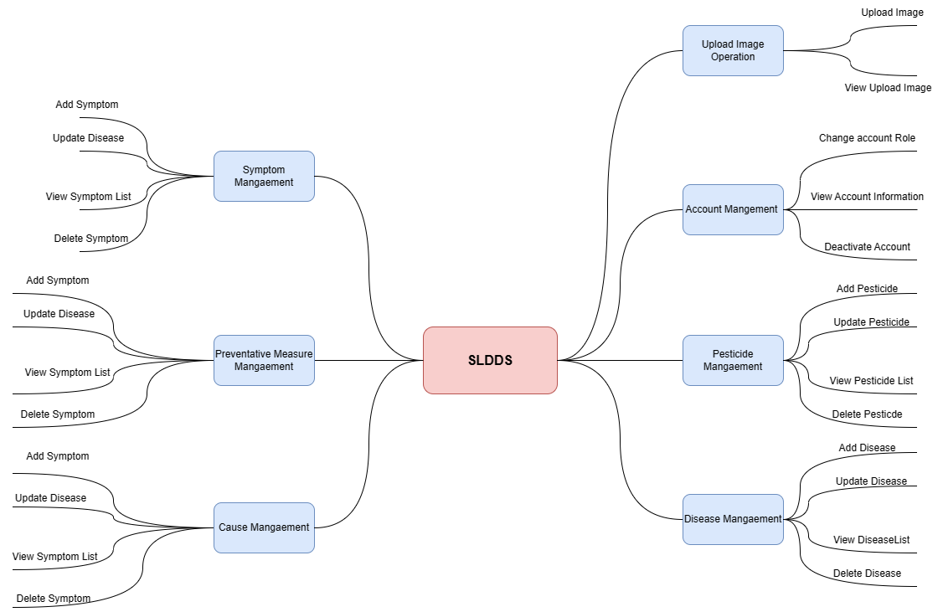

*Figure 6. Features diagram of SLDDS system*

### 6.2 Limitations & Exclusions

LI-1: The SLDS shall be used only for detecting disease through images of the strawberry leaf and not the fruit.

LI-2 :    The system will not include a scheduling or task management component for treatment recommendations.

LI-3: The system's accuracy will be limited by the size and quality of the dataset of strawberry leaf images that are used to train the machine learning algorithms. If the dataset is not representative of all possible variations and conditions, the system's performance may be compromised.

LI-4:  The system's accuracy will be affected by external factors such as weather, lighting conditions, and variations in soil and water quality. These factors can impact the appearance of strawberry leaves, potentially leading to misdiagnosis.

LI-5: The system's performance will be limited by the hardware that is used to run the machine learning algorithms. Depending on the size and complexity of the dataset, the algorithms may require significant computational resources and may be slow to execute on less powerful hardware.

# II. Project Management Plan

## 1. Overview

### 1.1 WBS & Estimation

|  |  |  |  |
| --- | --- | --- | --- |
| **#** | **WBS Item** | **Complexity** | **Est. Effort**  **(man-days)** |
| ***1*** | ***Project Management*** |  | ***2*** |
| 1.1 | Kick-off Meeting | Simple | 1 |
| 1.2 | Progress Monitoring | Simple | 1 |
| ***2*** | ***Dataset*** |  | ***13*** |
| 2.1 | Image Acquisition | Simple | 10 |
| 2.2 | Image Selection | Simple | 1 |
| 2.3 | Image Segmentation | Simple | 2 |
| ***3*** | ***Model Development*** |  | ***31*** |
| 3.1 | Model Selection | Medium | 1 |
| 3.2 | Model Training | Complex | 20 |
| 3.3 | Model Validation | Complex | 6 |
| 3.4 | Make necessary comparison | Medium | 4 |
| ***4*** | ***Design Database*** | ***Medium*** | ***2*** |
| ***5*** | ***Code web-based application*** |  | **73** |
| 5.1 | Manages cause | Medium | 4 |
| 5.2 | Manages Account | Medium | 4 |
| 5.3 | Manage disease | Medium | 8 |
| 5.4 | Manage pesticide | Medium | 4 |
| 5.5 | Manage preventative measures | Medium | 4 |
| 5.6 | Manages symptom | Medium | 3 |
| 5.7 | Upload Image for AI to Prediction | Complex | 30 |
| 5.8 | Upload History | Simple | 2 |
| 5.9 | Authentication | Medium | 10 |
| 6 | ***Develop website front-end*** |  | **62** |
| 6.1 | Admin Main Page | Medium | 4 |
| 6.2 | Admin Mange Disease | Medium | 5 |
| 6.3 | Admin Mange Pesticide | Medium | 1 |
| 6.4 | Admin Mange Preventative Measure | Medium | 2 |
| 6.5 | Admin Mange Symptom | Medium | 2 |
| 6.6 | Admin Mange Cause | Medium | 2 |
| 6.7 | Admin Mange Account | Medium | 4 |
| 6.8 | Farmer Disease Page | Medium | 7 |
| 6.9 | Farmer Pesticide Page | Medium | 4 |
| 6.10 | Farmer Preventative Measure  Page | Medium | 3 |
| 6.11 | Farmer Symptom Page | Medium | 2 |
| 6.12 | Farmer Cause Page | Medium | 2 |
| 6.13 | Upload Image Page | Medium | 2 |
| 6.14 | Disease Article Page | Medium | 2 |
| 6.15 | Upload History Page | Simple | 3 |
| 6.16 | User Profile | Simple | 5 |
| 6.17 | Web Homepage | Simple | 3 |
| 6.18 | Admin Homepage | Medium | 9 |
| ***8*** | ***Testing*** |  | **18** |
| 8.1 | Unit test | Medium | 12 |
| 8.2 | Integrated test | Simple | 3 |
| 8.3 | System test | Simple | 3 |
| ***Total Estimated Effort (man-days)*** | |  |

### 1.2 Project Risks

|  |  |  |  |  |
| --- | --- | --- | --- | --- |
| **#** | **Risk Description** | **Impact** | **Possibility** | **Response Plans** |
| 1 | Time Constraints | Time constraints can lead to a rush in the testing phase, potentially resulting in bugs and defects that can impact the performance of the system. | 10-20% | Develop a detailed project plan with clear timelines and milestones  Regularly review and adjust the plan as needed  Prioritize high-impact tasks |
| 2 | Technical risks | Issues with hardware, software, or other technical components that can delay or derail the project. | 15% | Identify the source of the technical issue by conducting a root cause analysis.  Work with the technical support team to resolve the issue as quickly as possible.  Document the issue and resolution for future reference. |
| 3 | Change management | When changes to project requirements or stakeholders are not effectively managed, leading to confusion, delays, or rework. | 10% | Communicate with the stakeholders to gain consensus on the proposed changes before implementing any changes. |
| 4 | Schedule delays | When the project takes longer than planned, causing missed deadlines, stakeholder frustration, and decreased morale. | 20% | The first step is to identify why the project is behind schedule. This could be due to a variety of factors, such as unrealistic timeframes, inadequate resources, or unforeseen obstacles.  Reassess the schedule: Once the root cause of the delay is identified, reassess the schedule and determine how much time is needed to get the project back on track. This may require revising the project timeline and resource allocation.  Prioritize tasks: Prioritize tasks based on their importance to the project's overall success. This will help ensure that the most critical tasks are completed first.  Implement contingency plans:  Monitor progress: Regularly monitor the progress of the project to ensure that it stays on track. This will allow for any potential delays to be identified and addressed before they become major issues. |
| 5 | Key team member leaves the project unexpectedly |  | 2% | Conduct an immediate review of the team’s skill set to identify if any skills gaps have been created by the team member leaving.  Reassign project tasks and responsibilities to the remaining team members to ensure all critical work is covered. |

## 2. Management Approach

The Agile model is selected to develop our project. Agile project management is an iterative and incremental approach to managing and delivering projects. It emphasizes flexibility, collaboration, and continuous improvement. When someone is using the Agile model to develop their project, they will typically follow a management approach that involves establishing a project vision and objectives, forming an Agile team, defining user stories, planning sprints, conducting daily stand-up meetings, monitoring progress, reviewing and adapting, testing and delivering, and continuously improving the project based on feedback.

The Agile model is designed to help teams respond to changes quickly and deliver a high-quality product incrementally, ensuring that the product meets the user's expectations and requirements. This approach emphasizes the importance of collaboration, communication, and teamwork, as well as a focus on delivering a working product increment at the end of each sprint. By following an Agile management approach, a team can effectively manage and deliver their project, ensuring that it meets the goals and objectives of the project, as well as the needs of the users.

### 2.1 Project Process

**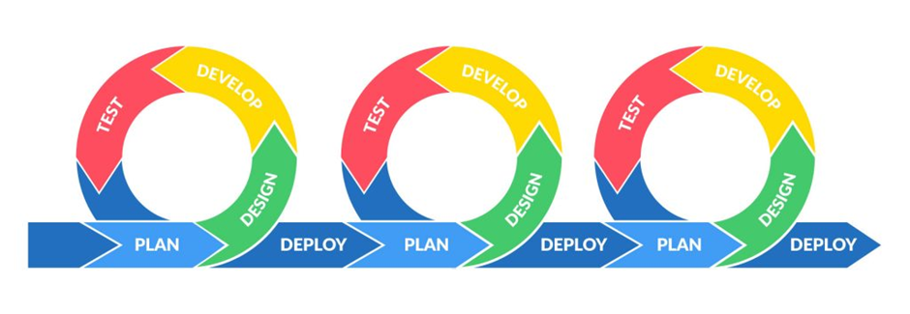**

**Figure 2. *Illustration of Agile model***

To manage and implement the Project using the Agile Model

**Project Initiation**: Define the project scope, objectives, and key stakeholders. Create a project charter and gain approval from stakeholders to proceed with the project.

**Sprint 0**: Plan the initial sprint, including the creation of a product backlog with user stories, which will serve as a prioritized list of requirements for the project.

**Sprint Planning**: Hold sprint planning meetings with the team to review the product backlog, determine the sprint goal, and plan the sprint. The sprint goal should be a clear, concise statement of the intended outcome of the sprint.

**Daily Scrum**: Hold daily scrum meetings with the team to review progress, identify obstacles, and plan for the next day.

**Sprint Execution**: Work on completing user stories during the sprint, using an iterative and incremental approach to build and test the system.

**Sprint Review**: Hold a sprint review meeting with stakeholders to demonstrate the progress made during the sprint and gather feedback.

**Sprint Retrospective**: Hold a sprint retrospective meeting with the team to reflect on the sprint, identify areas for improvement, and plan for the next sprint.

**Repeat Sprints**: Repeat the sprint planning, execution, review, and retrospective process until all user stories in the product backlog are completed or the project is otherwise deemed complete.

The Agile Model is characterized by regular, iterative sprints, close collaboration between the development team and stakeholders, and a focus on delivering working software quickly. This approach is designed to be flexible and responsive to changing requirements and allows for rapid and frequent feedback, which can help ensure the project is on track and meeting the needs of the stakeholders.

### 2.2 Quality Management

### To improve the project quality and reach the project quality objectives, the following approach can be applied:

### Defect Prevention: This approach involves identifying and addressing potential issues before they occur. This can be done through practices such as requirements gathering, design and code reviews, and formal inspections.

### Reviewing: This approach involves reviewing the work produced by the team to ensure that it meets the quality standards and requirements. This can be done through practices such as code reviews, walkthroughs, and inspections.

### Unit Testing: This approach involves testing individual units or components of the system to ensure that they meet the quality standards and requirements. This is usually done by the development team and involves testing the code at the unit level.

### Integration Testing: This approach involves testing the integration of multiple units or components to ensure that they work together as expected. This is usually done by the development team and involves testing the code at the integration level.

### System Testing: This approach involves testing the entire system to ensure that it meets the quality standards and requirements. This is usually done by the testing team and involves testing the code at the system level.

### These approaches can help ensure that the project is delivering quality results and meeting the project quality objectives. By applying these approaches throughout the project lifecycle, potential issues can be identified and addressed early, reducing the risk of defects and improving the overall quality of the project.

### 2.3 Training Plan

|  |  |  |  |
| --- | --- | --- | --- |
| **Training Area** | **Participants** | **When, Duration** | **Waiver Criteria** |
| Tensorflow and CNN | All members | 1/10/2022, | Mandatory |
| Git, GitLab | All members |  | Mandatory |
| Testing, Unit Testing, System Testing | NhiPM |  | Mandatory |
| Docker | TriTD |  | Mandatory |
| Python | ThanhNT |  | Mandatory |
| C# & .NET | All members |  | Mandatory |

## 3. Master Schedule

|  |  |  |  |
| --- | --- | --- | --- |
| **#** | **Deliverable** | **Due Date** | **Deliverable Scope** |
| 1 | Project  Introduction | 2/1/2023 | Report 01 (Product Background, Existing Systems,  Business Opportunity, Software Product Vision,  Project scope & Limitations) |
| 2 | Project  Management  Plan | 1/1/1111 | Report 02 (Management Approach, Master  Schedule, Project Organization, Project  Communication, Configuration Management) |
| 3 | Software  Requirement  Specification |  | Architecture Design, Detailed Design, Database |
| 4 | Software Design  Documentation |  | Code & Unit test, System test cases |
| 5 | Test Documentation |  | Code & Unit test, System test cases |
| 6 | Code Package |  | Code & Unit test, System test cases |
| 7 | Software User  Guides |  | Codes, System test reports |
| 8 | Final Package |  | Final Codes & documents, User manual |

## 4. Project Organization

### 4.1 Team & Structures

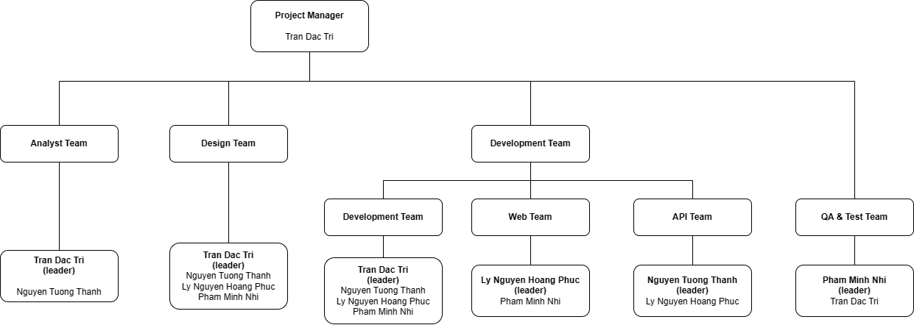

*Figure 6. Team & Structures*

### 4.2 Roles & Responsibilities

|  |  |
| --- | --- |
| **Role** | **Responsibility** |
| Project Manager | - Plan the schedule for the team  - Monitor progress of all members  - Make the decision  - Note the contributions and evaluations performance of the    members  - Create inspiration for the team |
| Analysis Leader | - Analyze requirement documentation  - Analyze the dataset  - Analyze the operation of system  - Analyze the process of system |
| Analysis Member | - Perform the analysis tasks that assigned by leader  - Report the task status for analysis leader |
| Design Leader | - Design architecture system  - Manage tasks of members  - Report the process detail to project manager |
| Design Member | - Perform the architecture tasks that assigned by leader  - Report the task status to design leader |
| Development Leader | - Manage the development process  - Make decision when having conflicts  - Report the process detail to project manager |
| Machine Learning Leader | - Manage about the machine learning model  - Manage tasks of members  - Analyze model  - Report the process detail to development leader |
| Machine Learning  Member | - Perform the machine learning tasks that assigned by leader  - Report the task status to machine learning leader |
| Web Leader | - Manage the web-based application  - Manage tasks of members  - Make decision when having conflicts  - Report the process detail to development leader |
| Web Member | - Perform the web modules / tasks that assigned by leader  - Report the task status to web leader |
| API Leader | - Manage the API  - Manage tasks of members  - Make decision when having conflicts  - Report the process detail to development leader |
| API Member | - Perform the API modules / tasks that assigned by leader  - Report the task status to API leader |
| QA & Test Leader | - Manage test cases and ensure the system’s quality  - Manage tasks of members  - Report the process detail to project manager |
| QA & Test Member | - Perform the QA-test tasks that assigned by leader  - Report the task status to QA & test leader |

## 5. Project Communication

### 5.1 Communication Plan

|  |  |  |  |  |
| --- | --- | --- | --- | --- |
| **Communication Item** | **Who/ Target** | **Purpose** | **When, Frequency** | **Assign Roles and**  **Tasks**  **Type, Tool, Method(s)** |
| Weekly project update meetings | Team  members | Report status  Supervisor support  Exchange  information  Identify issues | Every  Wednesday | Google-Meet  Discord |
| Decide Capstone Project Topic | Team  members | Confirm the thesis’s  topic and overall  information | 02/9/2022 | Messenger  Discord  Face to face |
| Assigns roles and tasks | Team  members | Specify roles and  tasks do in the capstone project | 13/9/2022 | Messenger  Discord  Face to face |

### 5.2 External Interface

#### a. FU Contacts

|  |  |  |  |
| --- | --- | --- | --- |
| **Function** | **Contact Person**  **(name, position)** | **Contact address**  **(email, telephone)** | **Responsibility** |
| Supervisor/Supporter | Luong HoangHuong | huonglh3@fe.edu.vn  0941666545 | - Review product stages  - Give feedback about the system  - Answer related questions about  the project  - Provide document template  - Receive report project |

#### b. Customer Contacts

|  |  |  |  |
| --- | --- | --- | --- |
| **Function** | **Contact Person**  **(name, position)** | **Contact address**  **(email, telephone)** | **Responsibility** |
| Supervisor | Luong Hoang Huong | kiennt@gmail.com  0912656836 | - Provide document template - Give instruction to project team - Review deliverables - Supervise project status |

## 6. Configuration Management

### 6.1 Tools & Infrastructures

|  |  |
| --- | --- |
| **Programming languages** | C# |
| **Framework** | ASP.Net core 5 |
| **API** | ASP.NET Web API |
| **DBMS** | SQL Server Management Studio |
| **IDEs/Editors** | Visual Studio |
| **UML tools** | Draw.io |
| **Version Control** | Git lab |
| **Deployment server** | AWS |
| **Project management tool** | Notion |

### 6.2 Document Management

*[Describe how you would manage project documents & their changes/versions]*

**

Managing project documents in Google Docs requires clear communication and organization. By setting up a clear folder structure, using naming conventions, setting permissions, using version control, assigning ownership, using comments, establishing a review process, and archiving old documents, you can effectively manage your project documents and their changes/versions.

Create a folder structure: Create a folder structure in Google Drive to organize your project documents. You can create folders for different project phases or for different types of documents.

### Use naming conventions: Use naming conventions for your documents to make it easy to identify and search for them. Consistency is key.

### Set permissions: Set permissions for your folders and documents to control who can access and edit them. You can set permissions at the folder level or for individual documents.

### Use version control: Use Google Docs' version history feature to track changes to your documents. This will allow you to see who made the changes and when they were made. You can also revert to a previous version if needed.

### Assign ownership: Assign ownership of documents to specific team members. This will make it clear who is responsible for a document and who should be consulted for updates.

### Use comments: Use Google Docs' commenting feature to provide feedback and ask questions. This will keep conversations organized and within the context of the document.

### Establish a review process: Establish a review process for your documents. This can include having a peer review, a manager review, or a client review. Use Google Docs' commenting feature to collect feedback and make revisions.

### Archive old documents: Archive old documents that are no longer relevant to the project. This will keep your folder structure clean and make it easier to find current documents

### 6.3 Source Code Management



Managing project source codes and their changes/versions is an important aspect of software development, and GitLab is a popular platform for version control and project management. Here are some steps to manage project source codes on GitLab:

Create a new project: Start by creating a new project in GitLab and setting up repository. Choose to create a new project from scratch or import an existing repository from another platform.

Set up development environment: Make sure local development environment is set up and configured to work with GitLab. Installing Git and other development tools, configuring SSH keys, and setting up your local repositories.

Create branches: When working on a new feature or bug fix, we create a new branch in GitLab to make changes in isolation from the main codebase. This helps keep the codebase clean and makes it easier to manage changes.

Commit changes: Make changes to the code in your local repository and commit them to your branch. Write clear and informative commit messages to help others understand what changes you made.

Push changes to GitLab: Once we've  made changes and committed them to ourlocal repository, push changes to GitLab so they are visible to others.

Merge changes: When ready to merge changes back into the main codebase, submit a merge request in GitLab. This allows other team members to review your changes and provide feedback before the changes are merged.

Use GitLab's version control features: GitLab offers a range of version control features, such as tags, releases, and rollback capabilities, that can help to manage our codebase and releases.

Collaborate with team: GitLab's collaboration features, such as issue tracking, comments, and code review, to work with team members and manage changes to the codebase.

Backup code: Regularly backup code to prevent data loss or corruption. GitLab offers automatic backups, but it's also a good idea to backup our code manually to a secure location.

# III. Software Requirement Specification

## 1. Overall Description

### 1.1 Product Overview

The Strawberry Leaf Detection System(SLDS) detects diseases  through images of the strawberry leaf is an innovative product that is being developed to aid farmers in identifying and addressing crop diseases in their strawberry plants. The system will use advanced image processing and machine learning techniques to detect the presence of disease in the leaves of strawberry plants, enabling farmers to take action early and prevent the spread of diseases. The system will be designed to be user-friendly and easily accessible for farmers of all levels of technological experience. It is designed to stand alone and address a specific need in the agricultural industry. The system will interface with various external entities, such as cameras, mobile devices, and the internet, to enable farmers to upload images of their strawberry leaves to the system for analysis.

Farmers/Users will be the primary users of the system. They will use the system to capture and upload images of their strawberry leaves for analysis. Based on the analysis results, they will be able to take appropriate action to prevent or control the spread of diseases in their crop

Expert will have a high level of knowledge and expertise in crop diseases and their identification. They  would be responsible for ensuring the accuracy of the system's disease predictions.

Admin will be responsible for managing the system, including ensuring the system's uptime, monitoring user activity, and performing system maintenance. The admin will also be responsible for managing the system's database, which will contain all the data related to users and their submissions.

The ecosystem map for this product will show the various systems related to the system of interest that interact with each other and the nature of those interactions. These related systems may include the camera or mobile device used to capture images of the strawberry leaves, the internet connection used to upload the images to the system, and any third-party systems used to store or analyze data from the system.

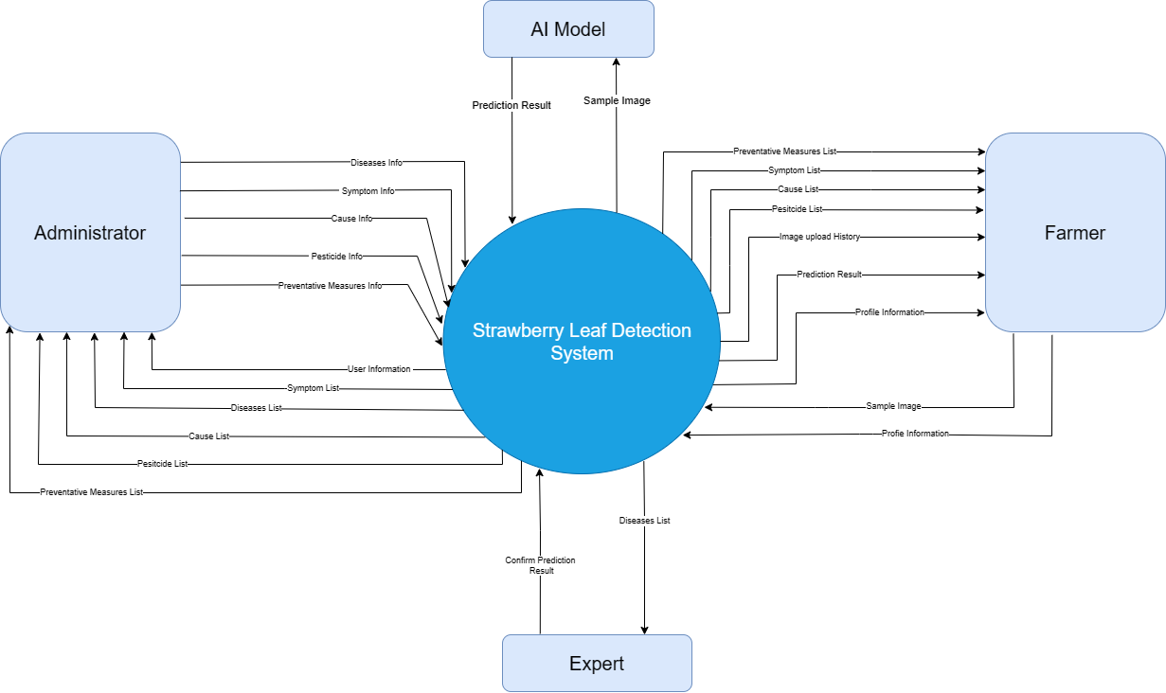

*Figure 9. An ecosystem map of SLDDS.*

### 1.2 Business Rules

|  |  |
| --- | --- |
| **ID** | **Rule Definition** |
| BR-01 | All user data and images uploaded to the system must be kept confidential and not shared with any third party without the user's consent. |
| BR-02 | The system must be available to users 24/7 to allow for continuous and timely disease detection |
| BR-03 | The system must be secure to prevent unauthorized access, modification, or destruction of user data. |
| BR-04 | The system must have a high level of accuracy in detecting and classifying different types of diseases in strawberry leaves. |
| BR-05 | The system must be able to handle a large number of user requests and image uploads without experiencing significant delays or downtime |
| BR-06 | Users should be required to authenticate themselves using a secure login and password to prevent unauthorized access to the system. |
| BR-07 | Only Administrators can create, modify, or delete plant databases. |
| BR-08 | At least one machine learning model must be chosen to apply in the system when  there are many models. |
| BR-09 | Only expert are responsible to confirm the final diagnosing status of the plant |
| BR-10 | Each user is only allowed to use some of the functions in the system based on the  given permissions set by the administrator. |
| BR-11 | All the passwords stored in the database required bcrypt encryption. |
| BR-12 | Only Farmer can update their profile |

## 2. User Requirements

### 2.1 Overview

#### a. Use Case Diagram

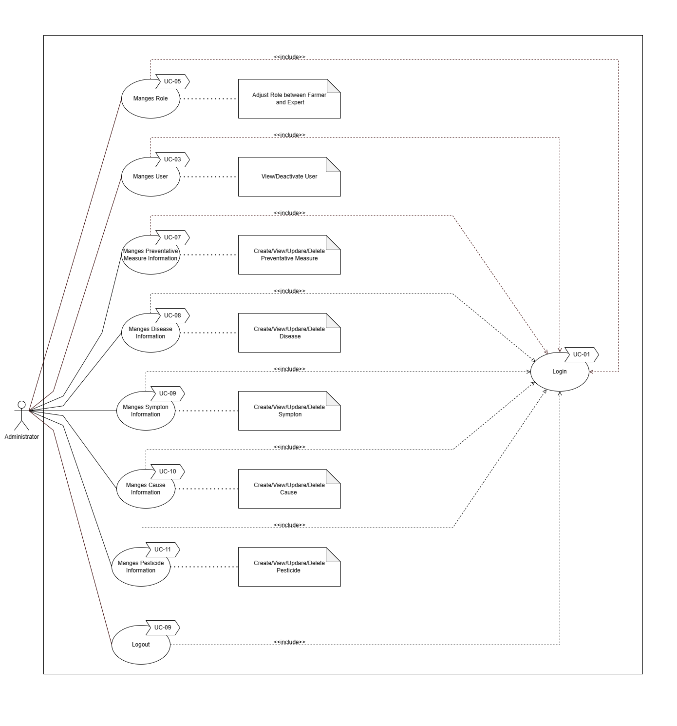

*Figure 10. Use case Administrator*

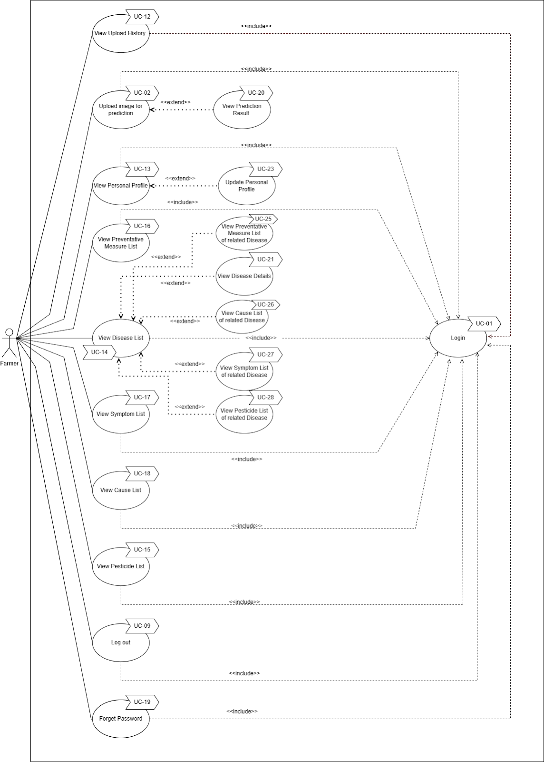

*Figure 11. Use case Teacher and Head of Farmer[[1]](#footnote-1)*

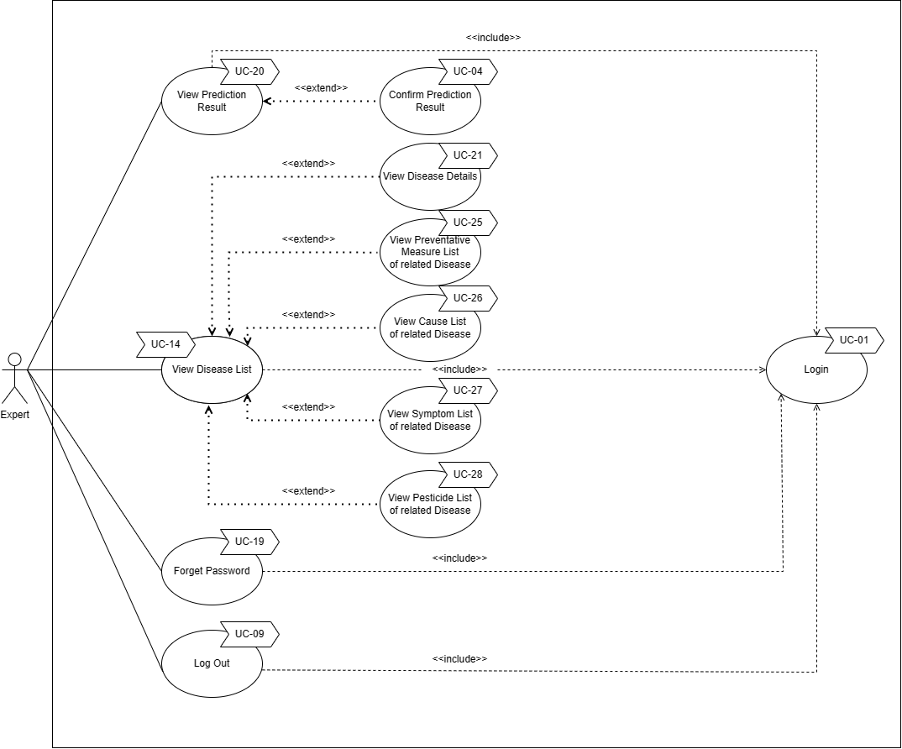

*Figure 12. Use case of Expert*

#### b. System Actors

|  |  |  |
| --- | --- | --- |
| **#** | **Actor** | **Description** |
| 1 | Administrator | Admin is responsible for managing all system functions and issues. |
| 2 | Expert | An expert is responsible for ensuring the accuracy of the system's disease predictions. |
| 3 | Farmer | Farmer loads images into the system for prediction. |

#### c. Use Cases List

|  |  |  |  |
| --- | --- | --- | --- |
| **ID** | **Use Case** | **Primary Actors** | **Secondary Actors** |
| 01 | Login | Administrator  Farmer  Expert |  |
| 02 | Upload image to predict | Farmer |  |
| 03 | Manages User | Administrator |  |
| 04 | Confirm prediction result | Expert |  |
| 05 | Manages role | Administrator |  |
| 06 | Logout | Administrator  Farmer  Expert |  |
| 07 | Manages Preventative Measure Information | Administrator |  |
| 08 | Manages Disease Information | Administrator |  |
| 09 | Manages Symptom Information | Administrator |  |
| 10 | Manages Cause Information | Administrator |  |
| 11 | Manages Pesticide Information | Administrator |  |
| 12 | View Upload History | Farmer |  |
| 13 | View Personal Profile | Farmer |  |
| 14 | View Disease List | Farmer  Administrator  Expert |  |
| 15 | View Pesticide List | Farmer  Administrator |  |
| 16 | View Preventative Measure List | Farmer  Administrator |  |
| 17 | View Symptom List | Farmer  Administrator |  |
| 18 | View Cause List | Farmer  Administrator |  |
| 19 | Forget Password | Farmer  Administrator |  |
| 20 | View Prediction Result | Expert | Farmer |
| 21 | View Disease Details | Administrator  Farmer  Expert |  |
| 22 | View User List | Administrator |  |
| 23 | Update Personal Profile | Farmer |  |
| 24 | Verify  Account | Farmer |  |
| 25 | View Preventative Measure List of related Disease | Administrator  Farmer  Expert |  |
| 26 | View Cause List of related Disease | Administrator  Farmer  Expert |  |
| 27 | View Symptom List of related Disease | Administrator  Farmer  Expert |  |
| 28 | View Pesticide List of related Disease | Administrator  Farmer  Expert |  |

### 2.2 Authentication

#### a. UC-01 Login

|  |  |  |  |
| --- | --- | --- | --- |
| UC ID and Name: | **UC-1 Login** | | |
| Created By: | Pham Minh Nhi | Date Created: | 12/5/2023 |
| Primary Actor: | Administrator, Farmer, Expert | Secondary Actors: |  |
| Trigger: | Users access to web pages. | | |
| Description: | A function for users to login and get access to the system. | | |
| Preconditions: | The system must be connected to the database successfully. | | |
| Post-conditions: | Redirect user to main page after successful login. | | |
| Normal Flow: | 1. The user navigates to the login page of the system. 2. The system presents a login form, which includes fields for the user to input their username and password. 3. The user enters their valid username and password in the respective fields. 4. The user clicks the [Login] button. 5. The system verifies the user's credentials against the database. 6. If the user's credentials are valid, the system grants access to the user and redirects them to the home page. 7. The user can now access the system's features and functionalities. | | |
| Alternative Flows: | None | | |
| Exceptions: | 1.0.E1: If the user leaves either the username or password field empty, the system displays a notification informing the user that they cannot leave any fields empty.  1.0.E2: If the user inputs invalid credentials, the system displays a notification informing the user that they have entered invalid credentials. | | |
| Priority: | High (Medium, Low) | | |
| Frequency of Use: | Always. | | |
| Business Rules: |  | | |
| Other Information: | N/A. | | |
| Assumptions: | N/A | | |

#### b. UC-06 Log out

|  |  |  |  |
| --- | --- | --- | --- |
| ID and Name: | **UC-06  Log Out** | | |
| Created By: | Pham Minh Nhi | Date Created: | 12/5/2023 |
| Primary Actor: | Administrator,Farmer, Expert | Secondary Actors: |  |
| Description: | Logout user | | |
| Trigger: | Users click logout. | | |
| Preconditions: | PRE-1. The User must be logged into the system.  PRE-2. The User must have completed all necessary tasks and wish to log out of the system. | | |
| Postconditions: | POST-1. The User is logged out of the system and cannot access any system functions without logging back in. | | |
| Normal Flow: | **8.0 Log out of the system**   1. The User selects the "Log Out" option from the system menu. 2. The system logs the User out of the system. 3. The system displays a confirmation message that the User has been logged out. | | |
| Alternative Flows: | None | | |
| Exceptions: | None | | |
| Priority: | High | | |
| Frequency of Use: | Always | | |
| Business Rules: | BR-10 | | |
| Other Information: | N/A | | |
| Assumptions: | N/A | | |

#### c. UC-19 Forget password

|  |  |  |  |
| --- | --- | --- | --- |
| ID and Name: | **UC-21 Forget password** | | |
| Created By: | Pham Minh Nhi | Date Created: | 12/5/2023 |
| Primary Actor: | Farmer, Expert | Secondary Actors: |  |
| Description: | This use case describes the process of changing the user's password. | | |
| Trigger: | The user selects the "Change Password" option. | | |
| Preconditions: | PRE-1. The user must be logged into the system.  PRE-2. The user must have a current password. | | |
| Postconditions: | POST-1. The user's password is updated in the system. | | |
| Normal Flow: | **21. Change Password**   1. The User selects the "Change Password" option from the system menu. 2. The system prompts the User to enter their current password and a new password. 3. The User enters their current password and new password. 4. The system verifies the User's current password and validates the new password against the system's password requirements. 5. The system updates the User's password and displays a message indicating that the password has been changed. | | |
| Alternative Flows: | **The user enters the incorrect current password.**  Ex1. The system displays a message indicating that the current password is incorrect and prompts the user to try again.  **The user enters a new password that does not meet the system's password requirements.**  Ex2. The system displays a message indicating that the new password does not meet the system's requirements and prompts the user to enter a new password. | | |
| Exceptions: | None | | |
| Priority: | High | | |
| Frequency of Use: | As needed by the User. | | |
| Business Rules: | BR-10 | | |
| Other Information: | N/A | | |
| Assumptions: | N/A | | |

#### d. UC-24 Verify Account

|  |  |  |  |
| --- | --- | --- | --- |
| ID and Name: | **UC-24 Veify Account** | | |
| Created By: | Pham Minh Nhi | Date Created: | 12/5/2023 |
| Primary Actor: | Farmer, Expert | Secondary Actors: |  |
| Description: | This use case describes the process of verifying the user's account. | | |
| Trigger: | The user finish registering account on the system | | |
| Preconditions: | PRE-1. The user must successfully registering account | | |
| Post conditions: | POST-1. An link and token sent to user via email | | |
| Normal Flow: | **24. Verify Account**   1. The user sign up for an account on the system 2. Enter valid user information 3. User check their email for verify link and token 4. Click submit to verity their account | | |
| Alternative Flows: | **The user link is expired or already used**  Ex1. The system displays a message indicating that the token is incorrect | | |
| Exceptions: | None | | |
| Priority: | High | | |
| Frequency of Use: | As needed by the User. | | |
| Business Rules: | BR-10 | | |
| Other Information: | N/A | | |
| Assumptions: | N/A | | |

### 2.3 Manage

#### a. UC-03 Manage User

|  |  |  |  |
| --- | --- | --- | --- |
| ID and Name: | UC-03 Manage User | | |
| Created By: | Pham Minh Nhi | Date Created: | 12/5/2023 |
| Primary Actor: | Administrator | Secondary Actors: |  |
| Description: | Allow the Administrator to perform Deactivate action on user account. | | |
| Trigger: | User login as Administrator | | |
| Preconditions: | PRE-1. Success login as an administrator.  PRE-2. The system must be connected to the database successfull | | |
| Post conditions: | The list of all permissions are shown successfully. Icon to of deactivate account shows. | | |
| Normal Flow: | 1. Open the web application. 2. Log in as an Administrator. 3. Action to take on the account list. Deactivate action case: Click on [Deactivate] button in the account user wants to deactivate 4. Confirm information shown on the popup. 5. Click on [confirm] button to Deactivate. | | |
| Alternative Flows: | None | | |
| Exceptions: | None | | |
| Priority: | High | | |
| Frequency of Use: | Daily | | |
| Business Rules: | BR-10 | | |
| Other Information: | N/A | | |
| Assumptions: | N/A | | |

#### b.UC-05 Manage Role

|  |  |  |  |
| --- | --- | --- | --- |
| ID and Name: | UC-05 Manage Role | | |
| Created By: | Pham Minh Nhi | Date Created: | 12/5/2023 |
| Primary Actor: | Administrator | Secondary Actors: |  |
| Description: | Administrator view on the Permissions Management. | | |
| Trigger: | Administrator clicks on the Permissions Management. | | |
| Preconditions: | PRE-1. Success login as an administrator.  PRE-2. The system must be connected to the database successfull | | |
| Post conditions: | The list of all permissions are shown successfully. | | |
| Normal Flow: | 05 Manage Role  1. Click on the User tab on the left side bar 2. Change the Role of user | | |
| Alternative Flows: | None | | |
| Exceptions: | None | | |
| Priority: | High | | |
| Frequency of Use: | Daily | | |
| Business Rules: | BR-10 | | |
| Other Information: | N/A | | |
| Assumptions: | N/A | | |

#### c. UC-07 Mange Preventative Measure Information

|  |  |  |  |
| --- | --- | --- | --- |
| ID and Name: | UC-07 Mange Preventative Measure Information | | |
| Created By: | Pham Minh Nhi | Date Created: | 12/5/2023 |
| Primary Actor: | Administrator | Secondary Actors: |  |
| Description: | Allow the Administrator to perform CRUD (Create, Update,Delete) action on Preventative Measure List. | | |
| Trigger: | User login as Administrator | | |
| Preconditions: | PRE-1. Success login as an administrator.  PRE-2. The system must be connected to the database successfull | | |
| Post conditions: | The list of all  Preventative Measureare shown successfully. Icon of CRUD (Create, Update,Delete) action shown successfully. | | |
| Normal Flow: | 1. Open the web application. 2. Log in as an Administrator. 3. Action to take on the  Preventative Measure List.   Create action case: Click on the [Create] button in the list wants to edit .   Add Information shown on the popup.  Click on the [save change] button to save change.  Update action case: Click on the [Update] button in the list wants to edit .   Update Information shown on the popup.  Click on the [save change] button to save change.  Delete action case: Click on the [Delete ] button in the list wants to edit  Click on [confirm] button to Delete | | |
| Alternative Flows: | None | | |
| Exceptions: | None | | |
| Priority: | High | | |
| Frequency of Use: | Daily | | |
| Business Rules: | BR-10 | | |
| Other Information: | N/A | | |
| Assumptions: | N/A | | |

#### d. UC-08 Mange Disease Information

|  |  |  |  |
| --- | --- | --- | --- |
| ID and Name: | UC-08 Mange Disease Information | | |
| Created By: | Pham Minh Nhi | Date Created: | 12/5/2023 |
| Primary Actor: | Administrator | Secondary Actors: |  |
| Description: | Allow the Administrator to perform CRUD (Create, Update,Delete) action on Disease List. | | |
| Trigger: | User login as Administrator | | |
| Preconditions: | PRE-1. Success login as an administrator.  PRE-2. The system must be connected to the database successfull | | |
| Postconditions: | The list of all  Disease  shown successfully. Icon of CRUD (Create, Update,Delete) action shown successfully. | | |
| Normal Flow: | 1. Open the web application. 2. Log in as an Administrator. 3. Action to take on the Disease  List.   Create action case: Click on the [Create] button in the list wants to edit .   Add Information shown on the popup.  Click on the [save change] button to save change.  Update action case: Click on the [Update] button in the list wants to edit .   Update Information shown on the popup.  Click on the [save change] button to save change.  Delete action case: Click on the [Delete ] button in the list wants to edit  Click on [confirm] button to Delete | | |
| Alternative Flows: | None | | |
| Exceptions: | None | | |
| Priority: | High | | |
| Frequency of Use: | Daily | | |
| Business Rules: | BR-10 | | |
| Other Information: | N/A | | |
| Assumptions: | N/A | | |

#### e. UC-09 Mange Symptom Information

|  |  |  |  |
| --- | --- | --- | --- |
| ID and Name: | UC-09 Mange Symptom Information | | |
| Created By: | Pham Minh Nhi | Date Created: | 12/5/2023 |
| Primary Actor: | Administrator | Secondary Actors: |  |
| Description: | Allow the Administrator to perform CRUD (Create, Update,Delete) action on Symptom List. | | |
| Trigger: | User login as Administrator | | |
| Preconditions: | PRE-1. Success login as an administrator.  PRE-2. The system must be connected to the database successfull | | |
| Postconditions: | The list of all Symptom shown successfully. Icon of CRUD (Create, Update,Delete) action shown successfully. | | |
| Normal Flow: | 1. Open the web application. 2. Log in as an Administrator. 3. Action to take on the Symptom  List.   Create action case: Click on the [Create] button in the list wants to edit .   Add Information shown on the popup.  Click on the [save change] button to save change.  Update action case: Click on the [Update] button in the list wants to edit .   Update Information shown on the popup.  Click on the [save change] button to save change.  Delete action case: Click on the [Delete ] button in the list wants to edit  Click on [confirm] button to Delete | | |
| Alternative Flows: | None | | |
| Exceptions: | None | | |
| Priority: | High | | |
| Frequency of Use: | Daily | | |
| Business Rules: | BR-10 | | |
| Other Information: | N/A | | |
| Assumptions: | N/A | | |

#### f. UC-10 Mange Cause Information

|  |  |  |  |
| --- | --- | --- | --- |
| ID and Name: | UC-10 Mange Cause Information | | |
| Created By: | Pham Minh Nhi | Date Created: | 12/5/2023 |
| Primary Actor: | Administrator | Secondary Actors: |  |
| Description: | Allow the Administrator to perform CRUD (Create, Update,Delete) action on Cause List. | | |
| Trigger: | User login as Administrator | | |
| Preconditions: | PRE-1. Success login as an administrator.  PRE-2. The system must be connected to the database successfull | | |
| Postconditions: | The list of all Cause shown successfully. Icon of CRUD (Create, Update,Delete) action shown successfully. | | |
| Normal Flow: | 1. Open the web application. 2. Log in as an Administrator. 3. Action to take on the  Preventative Measure List.   Create action case: Click on the [Create] button in the list wants to edit .   Add Information shown on the popup.  Click on the [save change] button to save change.  Update action case: Click on the [Update] button in the list wants to edit .   Update Information shown on the popup.  Click on the [save change] button to save change.  Delete action case: Click on the [Delete ] button in the list wants to edit  Click on [confirm] button to Delete | | |
| Alternative Flows: | None | | |
| Exceptions: | None | | |
| Priority: | High | | |
| Frequency of Use: | Daily | | |
| Business Rules: | BR-10 | | |
| Other Information: | N/A | | |
| Assumptions: | N/A | | |

#### g. UC-11 Mange Pesticide Information

|  |  |  |  |
| --- | --- | --- | --- |
| ID and Name: | UC-11 Mange Pesticide Information | | |
| Created By: | Pham Minh Nhi | Date Created: | 12/5/2023 |
| Primary Actor: | Administrator | Secondary Actors: |  |
| Description: | Allow the Administrator to perform CRUD (Create, Update,Delete) action on Pesticide List. | | |
| Trigger: | User login as Administrator | | |
| Preconditions: | PRE-1. Success login as an administrator.  PRE-2. The system must be connected to the database successfull | | |
| Postconditions: | The list of all Pesticide shown successfully. Icon of CRUD (Create, Update,Delete) action shown successfully. | | |
| Normal Flow: | 1. Open the web application. 2. Log in as an Administrator. 3. Action to take on the Pesticide List.   Create action case: Click on the [Create] button in the list wants to edit .   Add Information shown on the popup.  Click on the [save change] button to save change.  Update action case: Click on the [Update] button in the list wants to edit .   Update Information shown on the popup.  Click on the [save change] button to save change.  Delete action case: Click on the [Delete ] button in the list wants to edit  Click on [confirm] button to Delete | | |
| Alternative Flows: | None | | |
| Exceptions: | None | | |
| Priority: | High | | |
| Frequency of Use: | Daily | | |
| Business Rules: | BR-10 | | |
| Other Information: | N/A | | |
| Assumptions: | N/A | | |

### 2.4 View

#### a. UC-22 View User List

|  |  |  |  |
| --- | --- | --- | --- |
| ID and Name: | UC-22 View User List | | |
| Created By: | Pham Minh Nhi | Date Created: | 12/5/2023 |
| Primary Actor: | Administrator | Secondary Actors: |  |
| Description: | This use case describes the process of viewing the list of User | | |
| Trigger: | User selects "User” option on the sidebar | | |
| Preconditions: | PRE-1. The User must be logged into the system as Administrator.  PRE-2. The system must be connected to the database successfull | | |
| Post conditions: | POST-1. List of User shown successfully | | |
| Normal Flow: | 1. The User selects the "User" option from the system menu. 2. The system retrieves and displays a list of information about all types of Users 3. The User can select a specific User from the list to view additional details. | | |
| Alternative Flows: | None | | |
| Exceptions: | None | | |
| Priority: | High | | |
| Frequency of Use: | Medium | | |
| Business Rules: | BR-10 | | |
| Other Information: | N/A | | |
| Assumptions: | N/A | | |

#### b. UC-12 View Upload History

|  |  |  |  |
| --- | --- | --- | --- |
| ID and Name: | UC-12 View Upload History | | |
| Created By: | Pham Minh Nhi | Date Created: | 12/5/2023 |
| Primary Actor: | Farmer | Secondary Actors: |  |
| Description: | This use case describes the process of viewing the history of images uploaded by the User. | | |
| Trigger: | User selects "View Upload Image History" option. | | |
| Preconditions: | PRE-1. The User must be logged into the system.  PRE-2. The system must be connected to the database successfull | | |
| Postconditions: | POST-1. The User is able to view the history of images they have uploaded to the system. | | |
| Normal Flow: | **9.0 View Upload Image History**   1. The User selects the "View Upload Image History" option from the system menu. 2. The system retrieves and displays a list of all images previously uploaded by the User. 3. The User can select a specific image from the list to view additional details. | | |
| Alternative Flows: | None | | |
| Exceptions: | **The User has not previously uploaded any images.**  Ex1. The system displays a message indicating that no images have been uploaded by the User. | | |
| Priority: | High | | |
| Frequency of Use: | As needed by the User. | | |
| Business Rules: | BR-10 | | |
| Other Information: | N/A | | |
| Assumptions: | N/A | | |

#### c. UC-13 View Personal Profile

|  |  |  |  |
| --- | --- | --- | --- |
| ID and Name: | **UC-10 View personal information** | | |
| Created By: | Pham Minh Nhi | Date Created: | 12/5/2023 |
| Primary Actor: | Farmer, Expert | Secondary Actors: |  |
| Description: | This use case describes the process of viewing the User's personal information. | | |
| Trigger: | Users click on their profile. | | |
| Preconditions: | PRE-1. The User must be logged into the system.  PRE-2. The User must have personal information already saved in the system. | | |
| Postconditions: | None. | | |
| Normal Flow: | **10.View Personal Information**   1. The User selects their profile on the system menu 2. The system retrieves and displays the User's personal information. 3. The User reviews their personal information. | | |
| Alternative Flows: | None | | |
| Exceptions: | None | | |
| Priority: | High | | |
| Frequency of Use: | As needed by the User. | | |
| Business Rules: | BR-10 | | |
| Other Information: | N/A | | |
| Assumptions: | N/A | | |

#### d. UC-14 View Diease List

|  |  |  |  |
| --- | --- | --- | --- |
| ID and Name: | UC-14 View Diease List | | |
| Created By: | Pham Minh Nhi | Date Created: | 12/5/2023 |
| Primary Actor: | Farmer | Secondary Actors: |  |
| Description: | This use case describes the process of viewing the list of Diseases | | |
| Trigger: | User selects "Disease” option on the sidebar | | |
| Preconditions: | PRE-1. The User must be logged into the system.  PRE-2. The system must be connected to the database successfull | | |
| Postconditions: | POST-1. List of Disease shown successfully | | |
| Normal Flow: | 1. The User selects the "Disease" option from the system menu. 2. The system retrieves and displays a list of information about all types of Diseases 3. The User can select a specific disease from the list to view additional details. | | |
| Alternative Flows: | None | | |
| Exceptions: | None | | |
| Priority: | High | | |
| Frequency of Use: | Medium | | |
| Business Rules: | BR-10 | | |
| Other Information: | N/A | | |
| Assumptions: | N/A | | |

#### e. UC-15 View Pesticide List

|  |  |  |  |
| --- | --- | --- | --- |
| ID and Name: | UC-15 View Pesticide List | | |
| Created By: | Pham Minh Nhi |  |  |
| Primary Actor: | Farmer, Administrator |  |  |
| Description: | This use case describes the process of viewing the list of Diseases | | |
| Trigger: | User selects "Pesticide” option on the sidebar | | |
| Preconditions: | PRE-1. The User must be logged into the system.  PRE-2. The system must be connected to the database successfull | | |
| Postconditions: | POST-1. List of Pesticide shown successfully | | |
| Normal Flow: | 1. The User selects the "Pesticide" option from the system menu. 2. The system retrieves and displays a list of information about all types of Pesticides | | |
| Alternative Flows: | None | | |
| Exceptions: | None | | |
| Priority: | High | | |
| Frequency of Use: | Medium | | |
| Business Rules: | BR-10 | | |
| Other Information: | N/A | | |
| Assumptions: | N/A | | |

#### f. UC-16 View Preventative Measure  List

|  |  |  |  |
| --- | --- | --- | --- |
| ID and Name: | UC-16 View Preventative Measure List | | |
| Created By: | Pham Minh Nhi |  |  |
| Primary Actor: | Farmer |  |  |
| Description: | This use case describes the process of viewing the list of Diseases | | |
| Trigger: | User selects "Preventative Measure” option on the sidebar | | |
| Preconditions: | PRE-1. The User must be logged into the system.  PRE-2. The system must be connected to the database successfull | | |
| Postconditions: | POST-1. List of Preventative Measures Shown successfully | | |
| Normal Flow: | 1. The User selects the "Preventative Measure" option from the system menu. 2. The system retrieves and displays a list of information about all types of Preventative Measures | | |
| Alternative Flows: | None | | |
| Exceptions: | None | | |
| Priority: | High | | |
| Frequency of Use: | Medium | | |
| Business Rules: | BR-10 | | |
| Other Information: | N/A | | |
| Assumptions: | N/A | | |

#### g. UC-17 View Symptom List

|  |  |  |  |
| --- | --- | --- | --- |
| ID and Name: | UC-17 View Symptom List | | |
| Created By: | Pham Minh Nhi |  |  |
| Primary Actor: | Farmer |  |  |
| Description: | This use case describes the process of viewing the list of Symptoms | | |
| Trigger: | User selects "Symptom” option on the sidebar | | |
| Preconditions: | PRE-1. The User must be logged into the system.  PRE-2. The system must be connected to the database successfull | | |
| Postconditions: | POST-1. List of Symptom shown successfully | | |
| Normal Flow: | 1. The User selects the "Symptom" option from the system menu. 2. The system retrieves and displays a list of information about all types of Symptoms | | |
| Alternative Flows: | None | | |
| Exceptions: | None | | |
| Priority: | High | | |
| Frequency of Use: | Medium | | |
| Business Rules: | BR-10 | | |
| Other Information: | N/A | | |
| Assumptions: | N/A | | |

#### h. UC-18 View Cause List

|  |  |  |  |
| --- | --- | --- | --- |
| ID and Name: | UC-18 View Cause List | | |
| Created By: | Pham Minh Nhi |  |  |
| Primary Actor: | Farmer |  |  |
| Description: | This use case describes the process of viewing the list of Causes | | |
| Trigger: | User selects "Cause” option on the sidebar | | |
| Preconditions: | PRE-1. The User must be logged into the system.  PRE-2. The system must be connected to the database successfull | | |
| Postconditions: | POST-1. List of Causes shown successfully | | |
| Normal Flow: | 1. The User selects the "Cause" option from the system menu. 2. The system retrieves and displays a list of information about all types of Causes | | |
| Alternative Flows: | None | | |
| Exceptions: | None | | |
| Priority: | High | | |
| Frequency of Use: | Medium | | |
| Business Rules: | BR-10 | | |
| Other Information: | N/A | | |
| Assumptions: | N/A | | |

#### i. UC-20 View Prediction Result

|  |  |  |  |
| --- | --- | --- | --- |
| ID and Name: | UC-20 View Prediction Result | | |
| Created By: | Pham Minh Nhi |  |  |
| Primary Actor: | Farmer, Expert |  |  |
| Description: | This use case describes the process of viewing the list of Diseases | | |
| Trigger: | User selects "Disease” option on the sidebar | | |
| Preconditions: | PRE-1. The User must be logged into the system.  PRE-2. The system must be connected to the database successfull  PRE-3. There already been an image upload and submit the system | | |
| Postconditions: | POST-1. The User is able to view the history of images they have uploaded to the system.  POST-2. The User is is able to view the prediction result of upload images | | |
| Normal Flow: | 1. The User selects the "History" option from the system menu. 2. The system retrieves and displays a list of upload images and prediction result 3. The User can select a specific image from the list to view more about the prediction result | | |
| Alternative Flows: | None | | |
| Exceptions: | None | | |
| Priority: | High | | |
| Frequency of Use: | High | | |
| Business Rules: | BR-10 | | |
| Other Information: | N/A | | |
| Assumptions: | N/A | | |

#### j. UC-21 View Disease Details

|  |  |  |  |
| --- | --- | --- | --- |
| ID and Name: | UC-21 View Disease Details | | |
| Created By: | Pham Minh Nhi |  |  |
| Primary Actor: | Farmer |  |  |
| Description: | This use case describes the process of viewing the Details of a specific disease | | |
| Trigger: | User selects "Disease” option on the sidebar, click on one the disease | | |
| Preconditions: | PRE-1. The User must be logged into the system.  PRE-2. The system must be connected to the database successfull | | |
| Postconditions: | POST-1. The list of Disease shows successfully  POST- 2. The Details of chosen dieases is shown as page | | |
| Normal Flow: | 1. The User selects the "Disease" option from the system menu. 2. The system retrieves and displays a list of information about all types of Diseases 3. The User can select a specific disease from the list to view additional details. | | |
| Alternative Flows: | None | | |
| Exceptions: | None | | |
| Priority: | High | | |
| Frequency of Use: | Medium | | |
| Business Rules: | BR-10 | | |
| Other Information: | N/A | | |
| Assumptions: | N/A | | |

#### k. UC-25 View Preventative Measure of related Disease

|  |  |  |  |
| --- | --- | --- | --- |
| ID and Name: | UC-25 View Preventative Measure of related Disease | | |
| Created By: | Pham Minh Nhi | Date Created: | 12/5/2023 |
| Primary Actor: | Farmer | Secondary Actors: |  |
| Description: | This use case describes the process of viewing the history of images uploaded by the User. | | |
| Trigger: | User selects "Disease” on the side bar and click on Preventative Measure | | |
| Preconditions: | PRE-1. The User must be logged into the system.  PRE-2. The system must be connected to the API successfully.  PRE-3. The system must have information on preventative measures for the related disease | | |
| Postconditions: | POST-1. List of Preventative Measures is shown for that Disease | | |
| Normal Flow: | **25  View Preventative Measure of related Disease**   1. User selects the "Disease" option from the system menu. 2. User selects the "Preventative Measure" option on one of the disease 3. The system displays the preventative measures for the selected disease. | | |
| Alternative Flows: | **No Preventative Measures:**  - If the system does not have information on preventative measures for the selected disease, the system will display a message informing the user that no preventative measures are available. | | |
| Exceptions: | **System Error:**  - If the system encounters an error while retrieving the preventative measures, it will display an error message and ask the user to try again later. | | |
| Priority: | High | | |
| Frequency of Use: | As needed by the User. | | |

#### l. UC-26 View Cause  of related Disease

|  |  |  |  |
| --- | --- | --- | --- |
| ID and Name: | UC-26 View Cause of related Disease | | |
| Created By: | Pham Minh Nhi | Date Created: | 12/5/2023 |
| Primary Actor: | Farmer | Secondary Actors: |  |
| Description: | This use case describes the process of viewing the cause of a related disease by the user. | | |
| Trigger: | User selects "Disease” on the side bar and clicks on "Cause" | | |
| Preconditions: | PRE-1. The User must be logged into the system.  PRE-2. The system must be connected to the API successfully.  PRE-3. The system must have information on causes for the related disease. | | |
| Postconditions: | POST-1. List of causes is shown for that disease. | | |
| Normal Flow: | **26  View Cause of related Disease**   1. User selects the "Disease" option from the system menu. 2. User selects the "Cause" option on one of the diseases. 3. The system displays the causes for the selected disease. | | |
| Alternative Flows: | **No Cause :**  - If the system does not have information on causes for the selected disease, the system will display a message informing the user that no causes are available.. | | |
| Exceptions: | **System Error:**  - If the system encounters an error while retrieving the causes, it will display an error message and ask the user to try again later. | | |
| Priority: | High | | |
| Frequency of Use: | As needed by the User. | | |

#### m. UC-27 View Symptom of related Disease

|  |  |  |  |
| --- | --- | --- | --- |
| ID and Name: | UC-27 View Symptom of related Disease | | |
| Created By: | Pham Minh Nhi | Date Created: | 12/5/2023 |
| Primary Actor: | Farmer | Secondary Actors: |  |
| Description: | This use case describes the process of viewing the list of symptoms related to a specific disease. | | |
| Trigger: | User selects "Disease” on the side bar and click on "Symptom" | | |
| Preconditions: | PRE-1. The User must be logged into the system.  PRE-2. The system must be connected to the API successfully.  PRE-3. The system must have information on symptoms for the related disease. | | |
| Postconditions: | POST-1. List of symptoms is shown for that disease. | | |
| Normal Flow: | **27  View Symptomof related Disease**   1. User selects the "Disease" option from the system menu. 2. User selects the "Symptom" option on one of the diseases. 3. The system displays the symptoms for the selected disease. | | |
| Alternative Flows: | **No Symptom:**  -If the system does not have information on symptoms for the selected disease, the system will display a message informing the user that no symptoms are available. | | |
| Exceptions: | **System Error:**  If the system encounters an error while retrieving the symptoms, it will display an error message and ask the user to try again later. | | |
| Priority: | High | | |
| Frequency of Use: | As needed by the User. | | |

#### n. UC-28 View Pesticide of related Disease

|  |  |  |  |
| --- | --- | --- | --- |
| ID and Name: | UC-28 View Pesticide of related Disease | | |
| Created By: | Pham Minh Nhi | Date Created: | 12/5/2023 |
| Primary Actor: | Farmer | Secondary Actors: |  |
| Description: | This use case describes the process of viewing the list of pesticides related to a specific disease. | | |
| Trigger: | User selects "Disease” on the side bar and click on "Pesticide" | | |
| Preconditions: | PRE-1. The User must be logged into the system.  PRE-2. The system must be connected to the API successfully.  PRE-3. The system must have information on pesticides for the related disease. | | |
| Postconditions: | POST-1. List of pesticides is shown for that disease. | | |
| Normal Flow: | **28  View Pesticide of related Disease**   1. User selects the "Disease" option from the system menu. 2. User selects the "Pesticide" option on one of the diseases. 3. The system displays the pesticides for the selected disease. | | |
| Alternative Flows: | **No Pesticide :**  --If the system does not have information on pesticides for the selected disease, the system will display a message informing the user that no pesticides are available. | | |
| Exceptions: | **System Error:**  -If the system encounters an error while retrieving the pesticides, it will display an error message and ask the user to try again later. | | |
| Priority: | High | | |
| Frequency of Use: | As needed by the User. | | |

### 2.5 Upload

#### a. UC-02 Upload Image to Predict

|  |  |  |  |
| --- | --- | --- | --- |
| ID and Name: | **UC-02 Upload image to predict** | | |
| Created By: | Pham Minh Nhi | Date Created: | 10/4/13 |
| Primary Actor: | Farmer | Secondary Actors: |  |
| Description: | This use case describes the process of submitting an image for disease prediction by the system. | | |
| Trigger: | Farmer selects an image to submit for disease prediction. | | |
| Preconditions: | PRE-1. The Farmer must be logged into the system as the farner role  and have an image to submit for prediction.  PRE-2. - The system must be connected to the API successfully | | |
| Post-conditions: | POST-1. The system receives and stores the submitted image and initiates the prediction process.  POST-2. Successfully submit image to run prediction process then notify to farmer when prediction process done. | | |
| Normal Flow: | **2.0 Submit image to predict**   1. The Farmer selects the "Upload Image" option from the system menu. 2. The system displays a form for the farmer to upload the image. 3. The Farmer uploads the image 4. The system validates the image format and metadata, and saves the image and information to the database. | | |
| Alternative Flows: | **The system detects an issue with the image format or metadata.**  1. The system notifies the Sonographer of the issue and requests that they correct the image and/or metadata and resubmit.  2. The Farmer corrects the issue and resubmits the image.  3. The system validates the corrected image and metadata, and proceeds as normal. | | |
| Exceptions: | **The Farmer does not have an image to submit.**  **Ex1**. The system notifies the Farmer that an image is required for submission and prompts them to upload an image.  **Ex2**. The Farmer selects an invalid image format for submission.  **Ex3**. The system notifies the Farmer that the selected image format is invalid and prompts them to select a valid format.  **Ex4**. The Farmer does not provide all the necessary information on the submission form.  **Ex5**. The system notifies the Sonographer that all fields are required and prompts them to fill out the necessary information. | | |
| Priority: | High | | |
| Frequency of Use: | Daily | | |
| Business Rules: | BR-4 | | |
| Other Information: | N/A | | |
| Assumptions: | The Farmer is properly trained on how to capture and upload images for submission. | | |

### 2.6 Confirm Result

#### UC-04 Confirm Prediction Result

|  |  |  |  |
| --- | --- | --- | --- |
| ID and Name: | **UC-04 Confirm prediction result** | | |
| Created By: | Pham Minh Nhi | Date Created: | 12/5/2023 |
| Primary Actor: | Expert | Secondary Actors: |  |
| Description: | This use case describes the process of submitting an image for disease prediction by the system and confirming the prediction with an expert. | | |
| Trigger: | Farmer selects an image to submit for disease prediction. | | |
| Preconditions: | PRE-1. The Farmer must be logged into the system as the expert role  PRE-2. The system must be connected to the API successfully. | | |
| Post conditions: | POST-1. The system receives and stores the submitted image and initiates the prediction process. | | |
| Normal Flow: | **04 Confirm prediction result**   1. The Expert selects the "History" option from the system menu. 2. The system displays a list of Images upload by Farmer and Prediction Reult from the AI model. 3. The Expert reviews the image and Confirm the disease diagnosis. 4. The system saves the prediction result to the database. | | |
| Alternative Flows: | None | | |
| Exceptions: | N/A | | |
| Priority: | High | | |
| Frequency of Use: | Daily | | |
| Business Rules: | BR-09 Only expert are responsible to confirm the final diagnosing status of the plant | | |
| Other Information: | N/A | | |
| Assumptions: | Expert Confirmation Template:  The Expert reviews the image and predicts the disease diagnosis.  The system returns the predicted disease diagnosis to the Expert.  The Expert confirms the diagnosis.  The system saves the prediction result to the databa | | |

### 2.7 Update

#### UC-23 Update Personal Profile

|  |  |  |  |
| --- | --- | --- | --- |
| ID and Name: | **UC-23 Update Personal Profile** | | |
| Created By: | Pham Minh Nhi | Date Created: | 12/5/2023 |
| Primary Actor: | Farmer | Secondary Actors: |  |
| Description: | This use case describes the process of updating farmer profile information by the farmer | | |
| Trigger: | Farmer click on Update on the profile | | |
| Preconditions: | PRE-1. The User must be logged into the system as the Farmer role  PRE-2. The user must have permission to update their profile.  PRE-3. The system must be connected to the API successfully. | | |
| Post conditions: | POST-1. The farmer's profile information is updated in the system. | | |
| Normal Flow: | **23 Update Personal Profile**   1. User selects the "Profile" option from the system menu. 2. The system displays the user's current profile information. 3. User selects the "Update" option to update their profile. 4. The system displays a form for the user to update their information. 5. User updates their information and selects the "Save" option. 6. The system validates the updated information. 7. The system saves the updated information to the user's profile. 8. The system displays a message to confirm the profile has been updated successfully. | | |
| Alternative Flows: | None | | |
| Exceptions: | N/A | | |
| Priority: | Medium | | |
| Frequency of Use: | Daily | | |
| Business Rules: | BR-12 | | |
| Other Information: | N/A | | |
| Assumptions: | User has a valid account and login credentials. | | |

## 3. Functional Requirements

### 3.1 System Functional Overview

#### a. Screen Flow

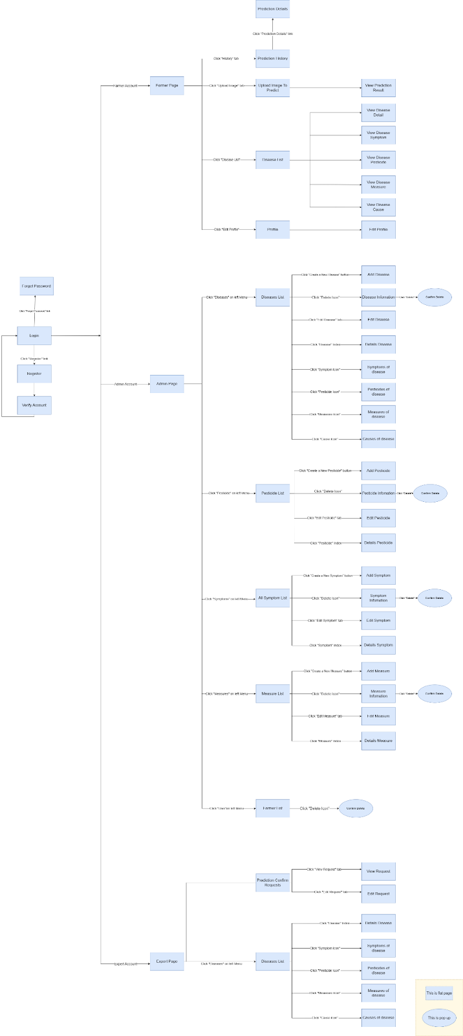

*Figure 14. Screen Flow[[2]](#footnote-2)*

#### b. Screen Details

|  |  |  |  |
| --- | --- | --- | --- |
| **#** | **Feature** | **Screen** | **Description** |
| 1 | Registration | Register | Provides interface for signing up farmer account |
| 2 | Authentication | Login | Provides interface for user to sign in |
| 4 | View Profile | User Profile | Displays detailed information about current user |
| 5 | Edit User Profile | Edit Profile | Provide interface for update user profile |
| 6 | Reset Password | Forget Password | Provides interface to reset user password |
| 7 | View Prediction History | Prediction History | Displays list of prediction histories of current user |
| 8 | View Prediction Details | Prediction Details | Show prediction details |
| 9 | Upload Image | Upload Image To Predict | User upload selected image(s) for predicting |
| 10 | View Prediction Result | View Prediction Result | Displays result information after predict by AI about disease |
| 11 | View Disease List | Disease List | Show disease list |
| 12 | Add Disease | Add Disease | Provide interface to post a request to add new disease |
| 13 | Edit Disease | Edit Disease | Provide interface to update a disease exists |
| 14 | View Disease Details | View Disease Details | Provide interface to view information of disease |
| 15 | Delete Disease | Disease delete Information | Provide interface to view information of disease |
| 16 | View Symptoms of Disease | View Disease Symptom | Provide interface to view what symptom of the disease have |
| 17 | View Pesticides of Disease | View Pesticide Symptom | Provide interface to view what pesticides of the disease have |
| 18 | View Measures of Disease | View Measure Symptom | Provide interface to view what prevent measures of the disease have |
| 19 | View Causes of Disease | View Cause Symptom | Provide interface to view what causes of the disease have |
| 20 | View Pesticide List | Pesticide List | Show Pesticide list |
| 21 | Add Pesticide | Add Pesticide | Provide interface for creating pesticide |
| 22 | Edit Pesticide | Edit Pesticide | Provide interface to update a pesticide |
| 23 | Delete Pesticide | Delete Pesticide | Provide interface to delete  a pesticide |
| 24 | View Symptom List | Symptom List | Show symptom list |
| 25 | Add Symptom | Add Symptom | Provide interface for creating symptom |
| 26 | Edit Symptom | Edit Symptom | Provide interface to update a symptom |
| 27 | Delete Symptom | Delete Symptom | Provide interface to delete  a symptom |
| 28 | View Preventative Measure List | Preventative Measure List | Show preventative measure list |
| 29 | Add Preventative Measure | Add Preventative Measure | Provide interface for creating measure |
| 30 | Edit Preventative Measure | Edit Preventative Measure | Provide interface to update a measure |
| 31 | Delete Preventative Measure | Delete Preventative  Measure | Provide interface to delete  a measure |
| 32 | View Cause List | Cause List | Show Cause list |
| 33 | Add Cause | Add Cause | Provide interface for creating cause |
| 34 | Edit Cause | Edit Cause | Provide interface to update a cause |
| 35 | Delete Cause | Delete Cause | Provide interface to delete  a cause |
| 36 | User List | User List | Show User List |
| 37 | Forgot Password | Forgot password | Provide user a token to reset their password |
| 38 | Verify Account | Verify Account | Verify account of user after register |
| 39 | View User Page | User Page | Displays a series of images as an overview for guiding user to use the system |
| 40 | View Admin Page | Admin Page | Displays a series of images as an overview for guiding Admin to use the system |
| 41 | View Expert Page | Expert Page | Displays a series of images as an overview for guiding Expert to use the system |

#### c. Screen Authorization

*system user role names]*

|  |  |  |  |
| --- | --- | --- | --- |
| **Screen** | **Farmer** | **Expert** | **Admin** |
| Registration | X |  |  |
| Authentication | X | X | X |
| View Profile | X |  |  |
| Edit User Profile | X |  |  |
| Reset Password | X |  |  |
| View Prediction History |  | X |  |
| View Prediction Details |  | X |  |
| Upload Image | X |  |  |
| View Prediction Result |  | X |  |
| View Disease List | X | X | X |
| Add Disease |  |  | X |
| Edit Disease |  |  | X |
| View Disease Details | X | X | X |
| Delete Disease |  |  | X |
| View Symptoms of Disease | X | X | X |
| View Pesticides of Disease | X | X | X |
| View Measures of Disease | X | X | X |
| View Causes of Disease | X | X | X |
| View Pesticide List |  |  | X |
| Add Pesticide |  |  | X |
| Edit Pesticide |  |  | X |
| Delete Pesticide |  |  | X |
| View Symptom List |  |  | X |
| Add Symptom |  |  | X |
| Edit Symptom |  |  | X |
| Delete Symptom |  |  | X |
| View Preventative Measure List |  |  | X |
| Add Preventative Measure |  |  | X |
| Edit Preventative Measure |  |  | X |
| Delete Preventative Measure |  |  | X |
| View Cause List |  |  | X |
| Add Cause |  |  | X |
| Edit Cause |  |  | X |
| Delete Cause |  |  | X |
| User List |  |  | X |
| View Prediction Result | X | X |  |
| Forgot Password | X |  |  |
| Verify Account | X |  |  |
| View User Page | X |  |  |
| View Admin Page |  |  | X |
| View Expert Page |  | X |  |

In which:

* Farmer: uses the system for predicting strawberry disease purposes by uploading images.
* Expert: uses their knowledge to mainly re-diagnose predicting results when receiving Farmer’s request.
* Admin: uses the system to focus on managing the resources such as users, diseases, etc.

#### d. Non-Screen Functions

|  |  |  |  |
| --- | --- | --- | --- |
| **#** | **Feature** | **System Function** | **Description** |
| 1 | Pie Chart | Disease data analysis | Display data prediction by chart |

#### e. Entity Relationship Diagram

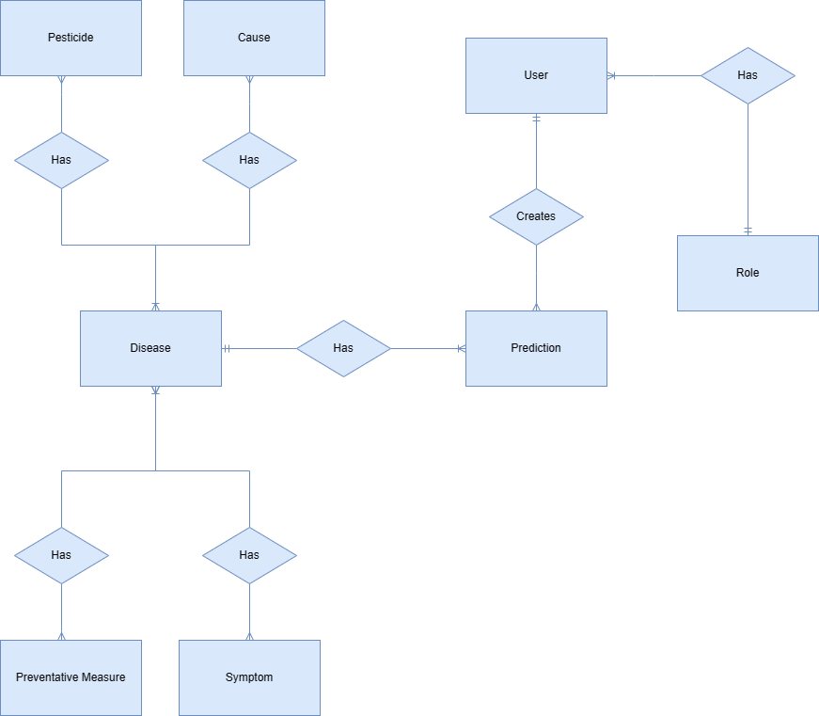

*Figure 15. ERD diagram[[3]](#footnote-3)*

**Entities List**

|  |  |  |
| --- | --- | --- |
| **#** | **Entity** | **Description** |
| 1 | User | Stores information about the user account |
| 2 | Role | Stores information about the role |
| 3 | Permission | Stores information about the permission |
| 4 | Prediction | Stores information about the prediction |
| 5 | Disease | Stores information about the disease |
| 6 | Cause | Stores information about the cause of the disease |
| 7 | Pesticide | Stores information about the pesticide for strawberry |
| 8 | Symptom | Stores information about the symptom of the disease |
| 9 | Preventative Measure | Stores information about the preventative measure for strawberry |

### 3.2 Authentication

#### a. Login

* Triggering the function: Go to the link “SDDS.com” to access the login page.
* Function description: Allow the user to log in to the web application to be able to use all functions of the account’s role.

* Screen layout:

*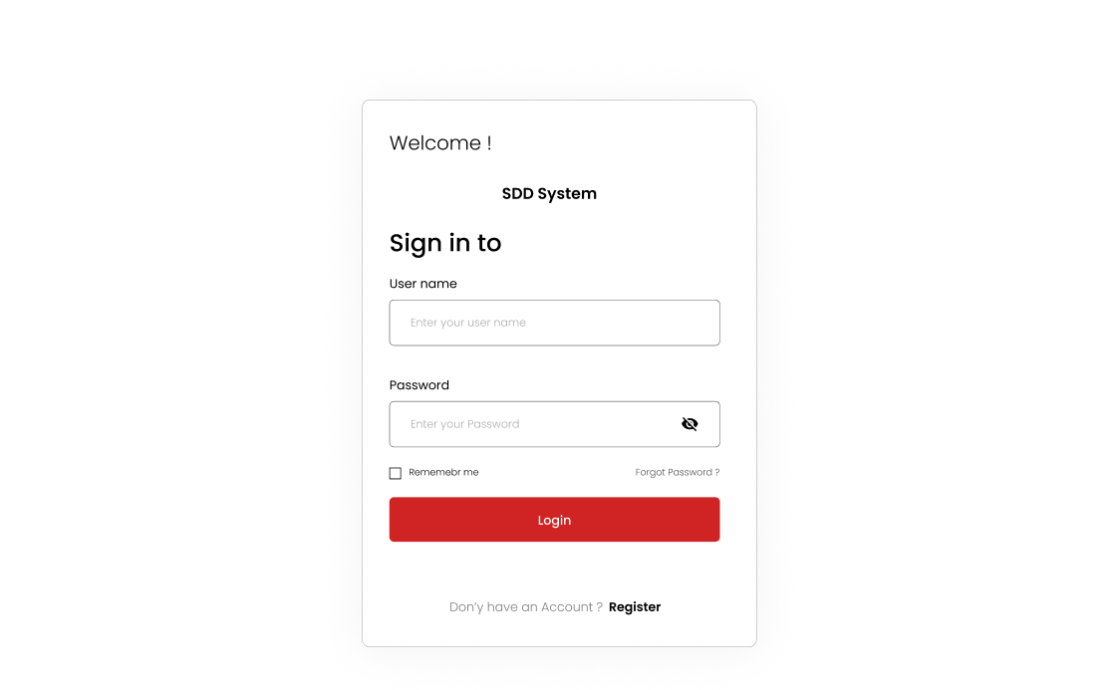*

*Figure 1. The login page*

*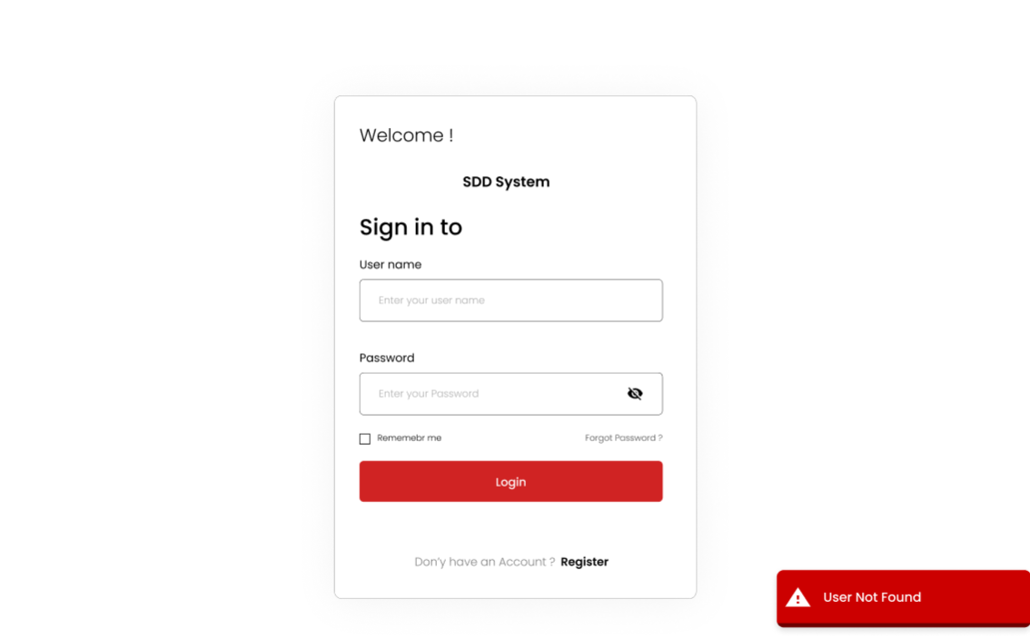*

*Figure 2. The notification when user does not exist*

*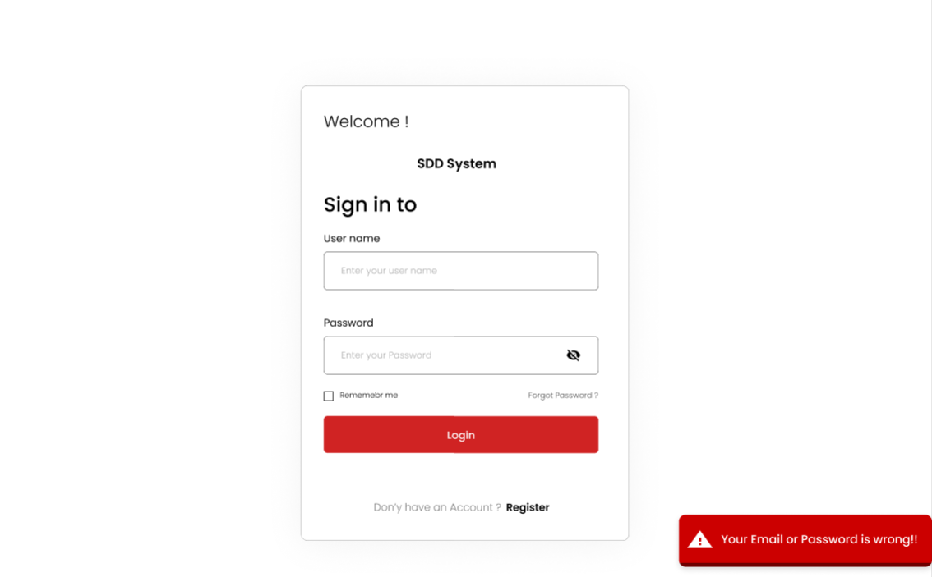*

*Figure 3. The notification when the input incorrect*

*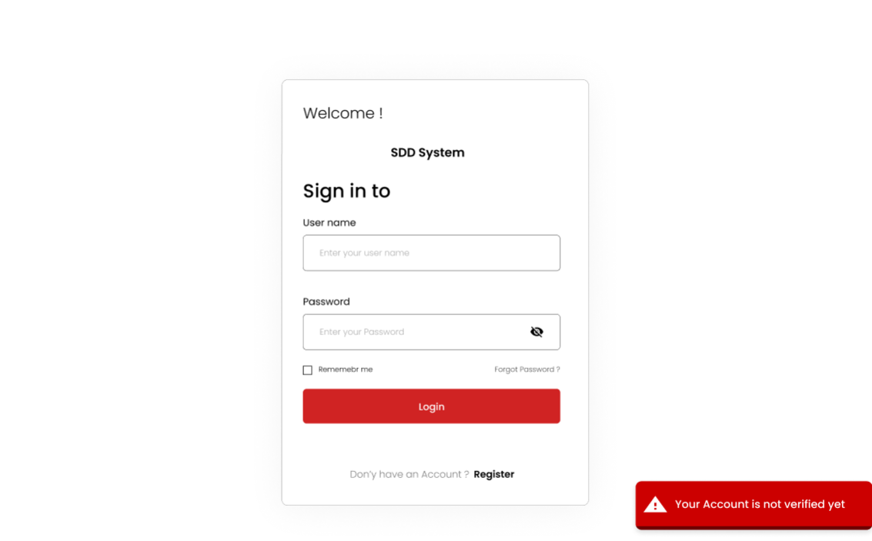*

*Figure 4. The notification when the account is not verified*

* Details of the function:

o   Normal execution case:Login successfully and direct user to the main page

o   Abnormal execution case: If the user leaves the email or password input field empty and clicks the “Login” button, an error will be displayed (Figure 1). If the user inputs invalid email format, an error will be displayed (Figure 1). If the user does not exist, an error will be displayed(Figure 2).  If the user inputs the wrong email or password, an error will be displayed (Figure 3). If the user logs in by a deactivated account, an error will be displayed (Figure 4).

#### b. Logout

#### Triggering the function: Login successfully and click on the logout icon on the top right corner of the web application (Figure 5).

#### Function description: Allow the user to log out from the system and go back to the login page.

* Screen layout:
* 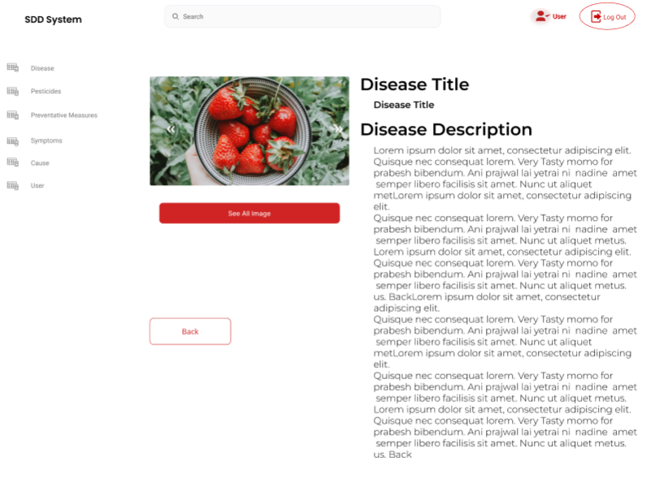

*Figure 5. The logout*

* Details of the function:
  + Normal execution case:Logout successfully and direct user to the login page.
  + Abnormal execution case: Loss of connection.

#### c. Forgot password

* Triggering the function: Click on the “Forgot Password?” link on the login page (Figure 6).
* Function description: Allow users to generate a new password when they forget the current password.
* Screen layout:

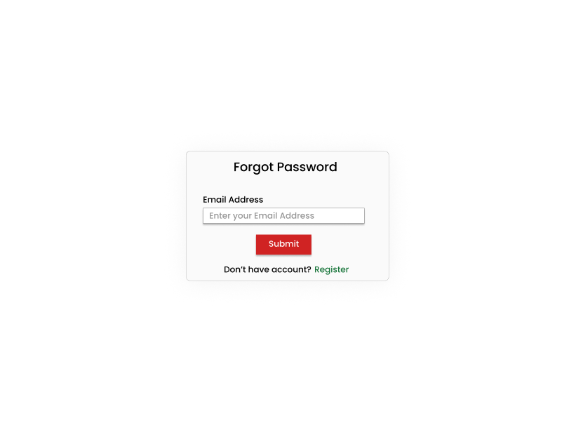

*Figure 6. The forgot password page*

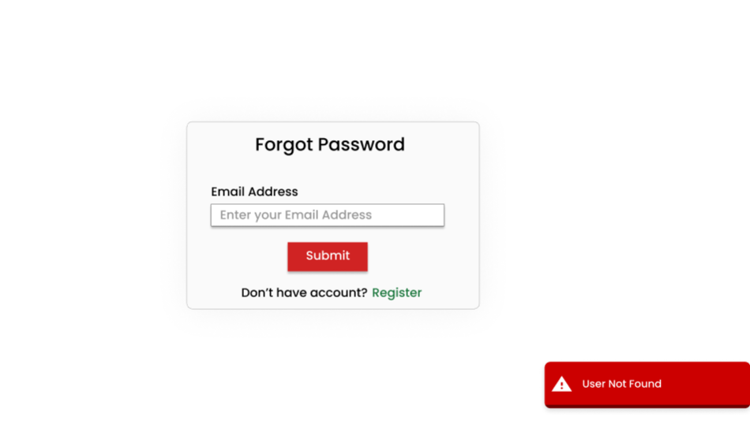

*Figure 7. The notification when the email is not exist*

* Details of the function:
  + Normal execution case:System sends an email with a newly generated token to the user’s email address. User entered the token to reset the account password.
  + Abnormal execution case: If the user inputs email does not exist in the system, an error will be displayed (Figure 7).

#### d. Register account

* Triggering the function: Click on the “Register” link on the login page (Figure 8).
* Function description: Allow farmers to create a new account
* Screen layout: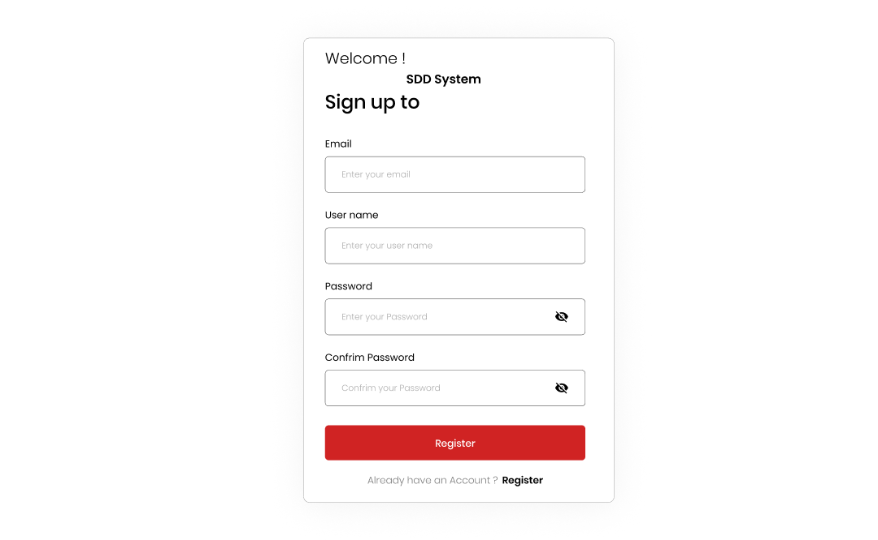

*Figure 8. The sign up page*

*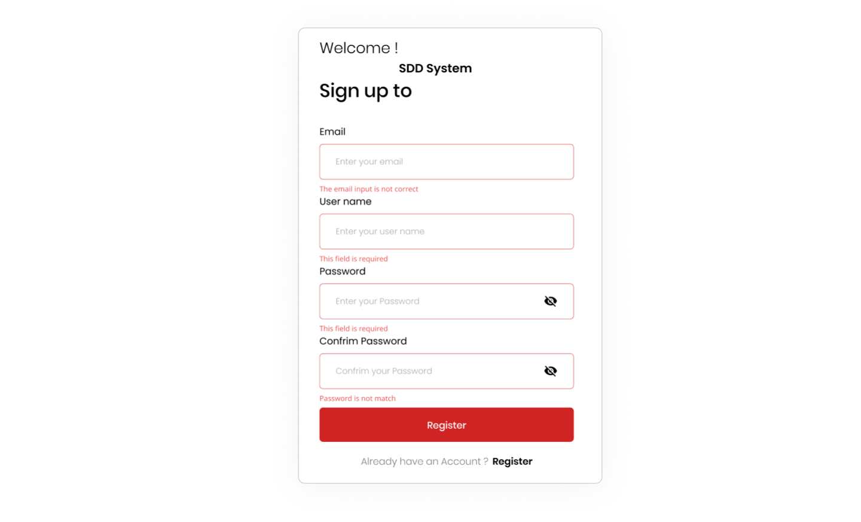*

*Figure 9. The error when input is not correct*

* Details of the function:
  + Normal execution case:The function displays a success message indicating that the registration was successful and the password has been sent.
  + Abnormal Execution Cases: If the email input field is empty, display an error message indicating that the email field cannot be empty. If the email input field does not have a valid email format, display an error message indicating that the email address is invalid.(Figure 9)

#### e. Verify account

* Triggering the function: After user successfully enters all the field to register new account
* Function description: Enter the given token to verify user registered account
* Screen layout:

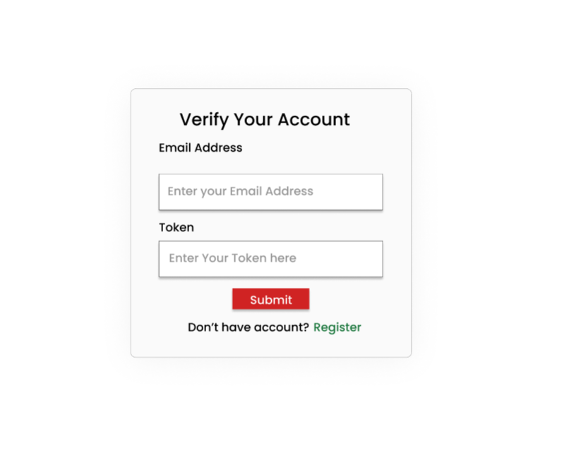

*Figure 10. The verify account page*

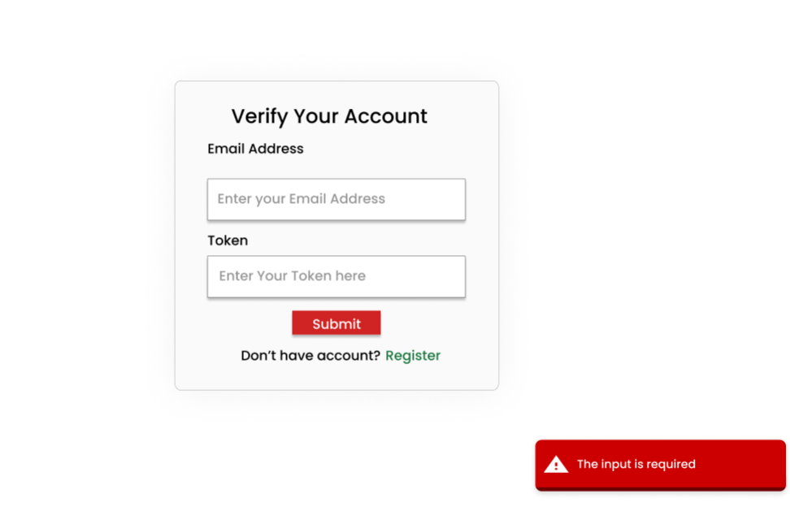

*Figure 11. The error when  the input is blank*

* Details of the function:
  + Normal execution case:The function displays a success message indicating that the account was successfully verified
  + Abnormal Execution Cases: If the token field is invalid ,display an error message indicating that the token field  is invalid. (Figure 11)

### 3.3 Role Administrator

**a. Manage account**

* Triggering the function: Login as an Administrator role successfully.
* Function description: A user with Administrator role is allowed to create an account, edit basic information (full name, …), deactivate account, and view account list.
* Screen layout: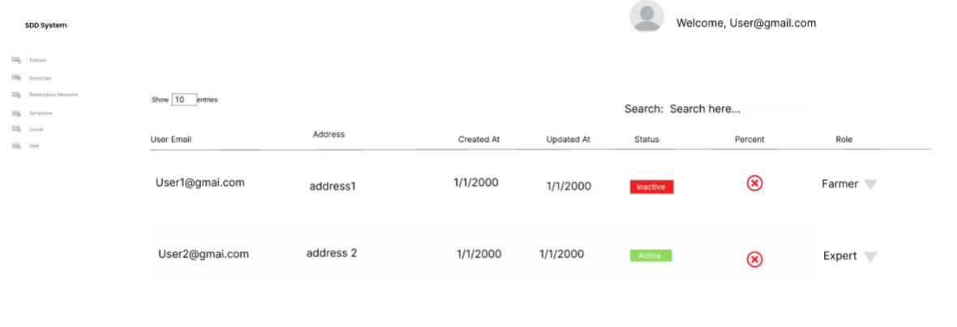

*Figure 12. The list user page*

* Details of the function:
  + Normal execution case: Successfully, an user with Administrator role has access to the account list page (Figure 20) and on each account, has access to update account information(full name, email), deactivate account. Administrator also has access to the create account page (Figure 23), has access to the create account function.

**b. Deactivated account**

* Triggering the function: Login as an Administrator role successfully.
* Function description: A user with Administrator role is allowed deactivate account, and view account list.
* Screen layout:

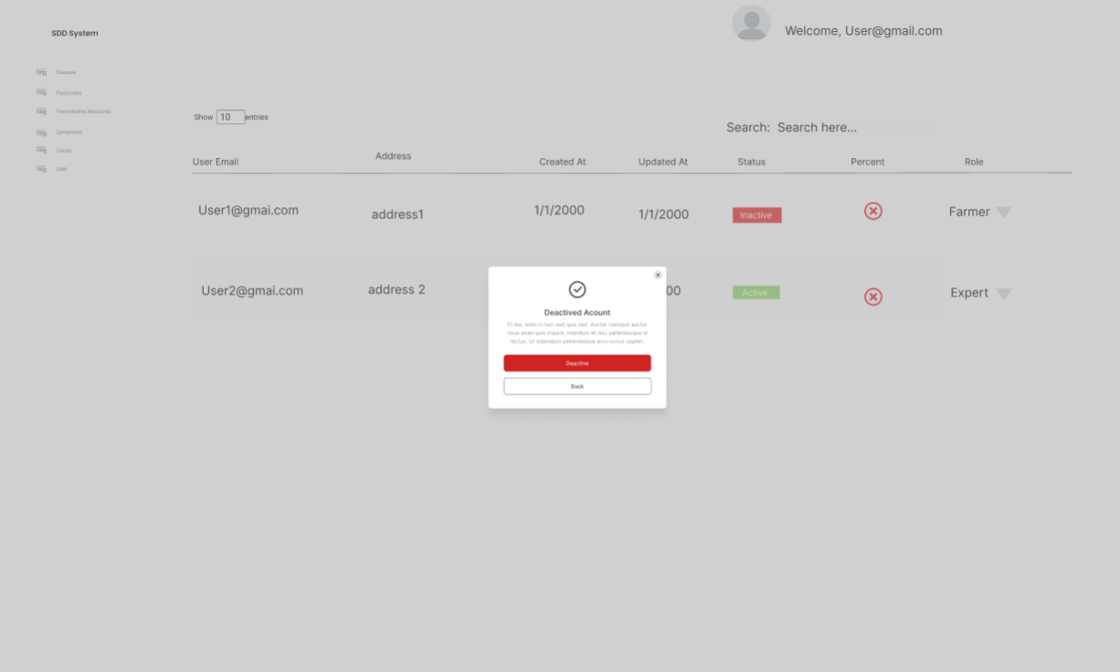

*Figure 13. The deactivated account*

* Details of the function:
  + Normal execution case: Successfully, an user with Administrator role has access to the account list page (Figure 12) and on each account, has access deactivate account(Figure 13)

**c. Manages Roles**

* Triggering the function: Login as an Administrator role successfully.
* Function description: A user with Administrator role is allowed to change role of an account
* Screen layout: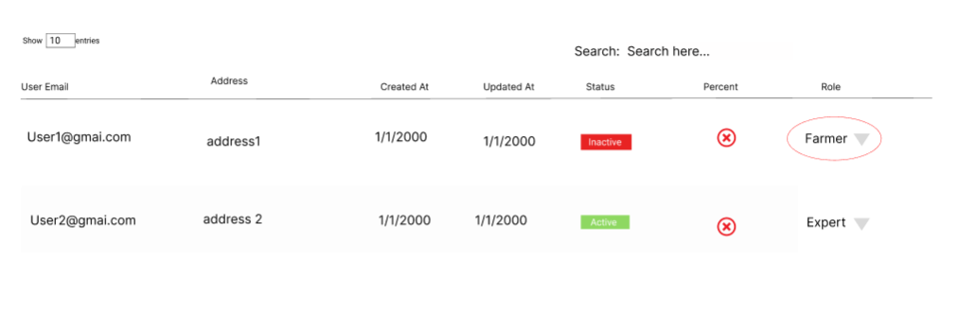

*Figure 14. The deactivated account*

* Details of the function:
  + Normal execution case: Successfully, an user with Administrator role has access to the account list page (Figure 20) and on each account,has access to the change role function.(Figure 14)

**d. Manage disease**

* Triggering the function: Login as an Administrator role successfully.
* Function description: An Administrator user is allowed to add disease, edit basic information and view disease list.
* Screen Layout:

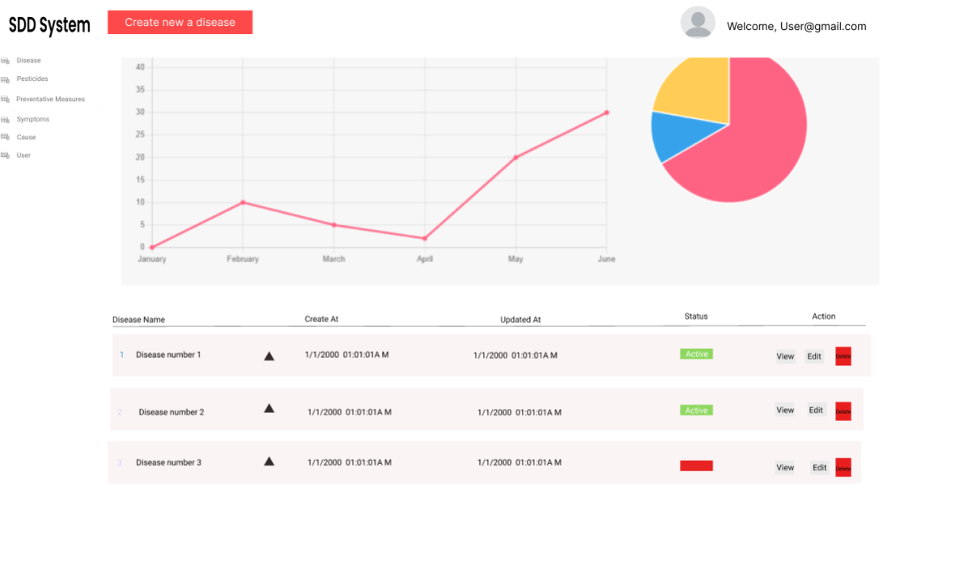

*Figure 15. The disease list*

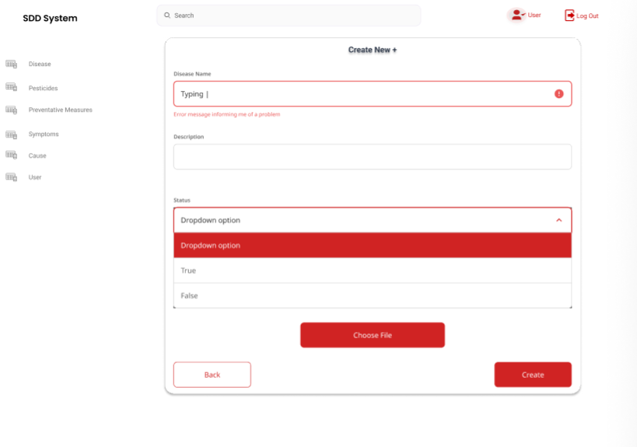

*Figure 16. The create disease page*

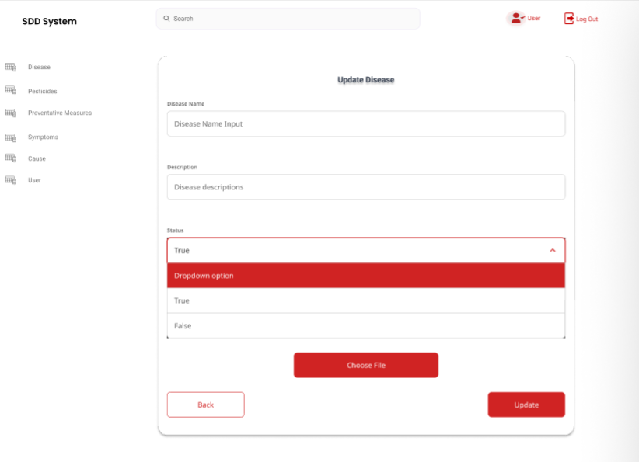

*Figure 17. The update disease page*

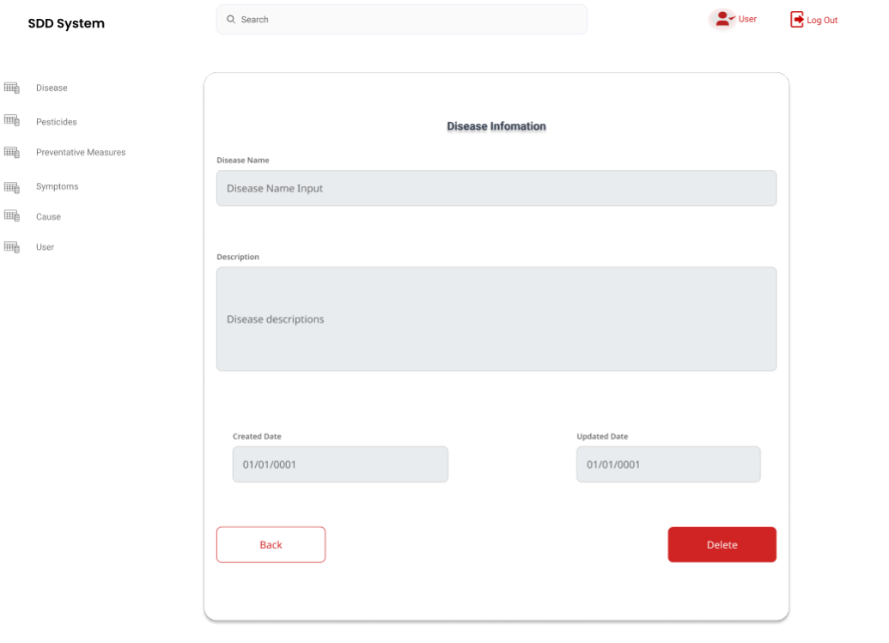

*Figure 18. The delete disease page*

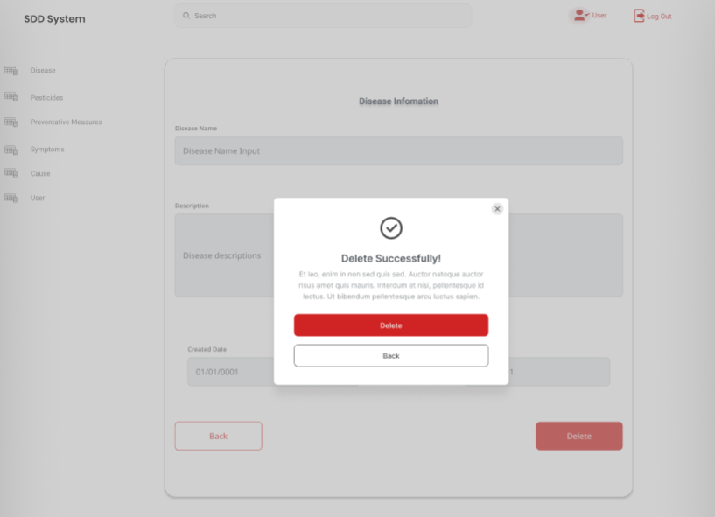

*Figure 19. The delete disease popup confirmation*

*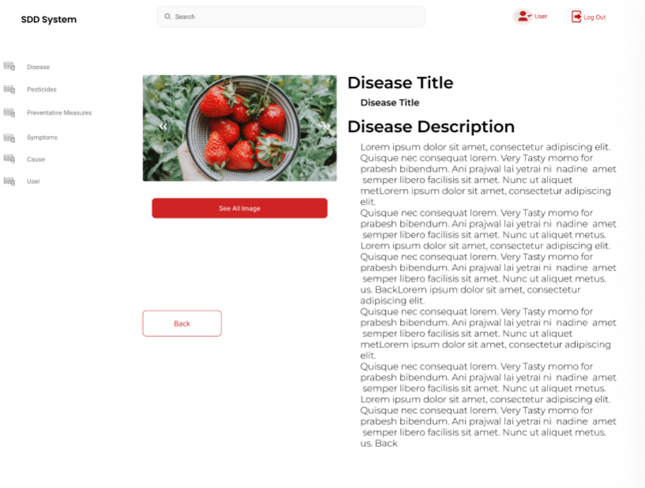*

*Figure 20. The details information disease*

*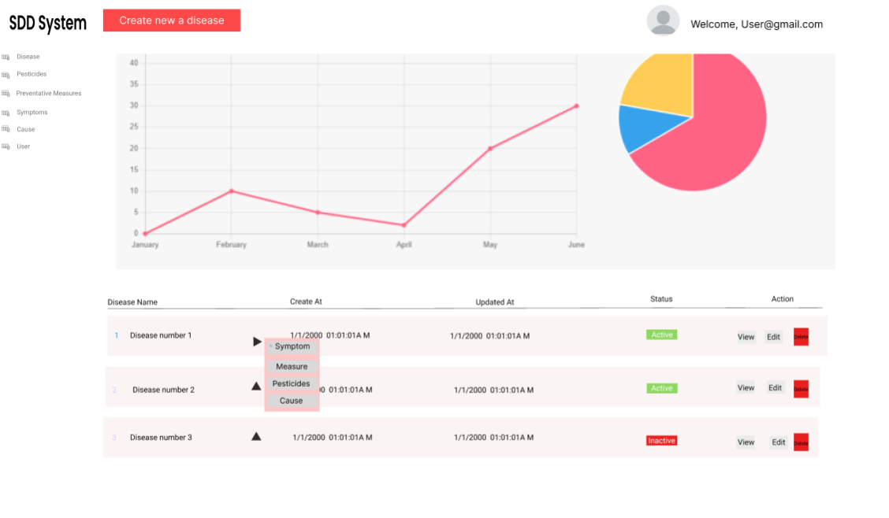*

Figure 21. The details information disease

*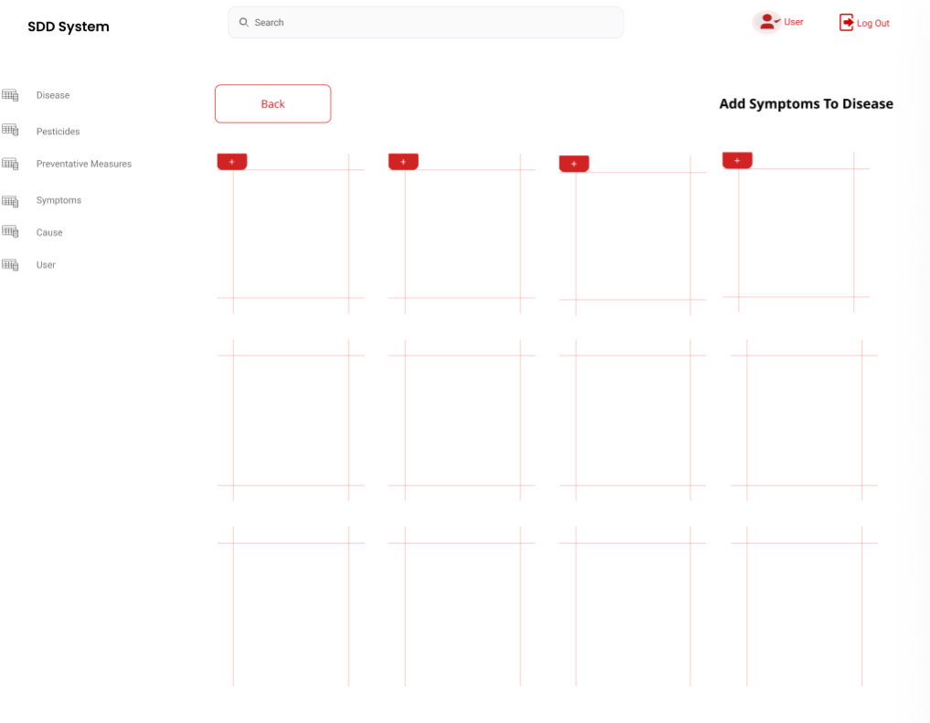*

*Figure 22. The Add the new symptoms, cause, preventative measures ,pesticide  to disease*

*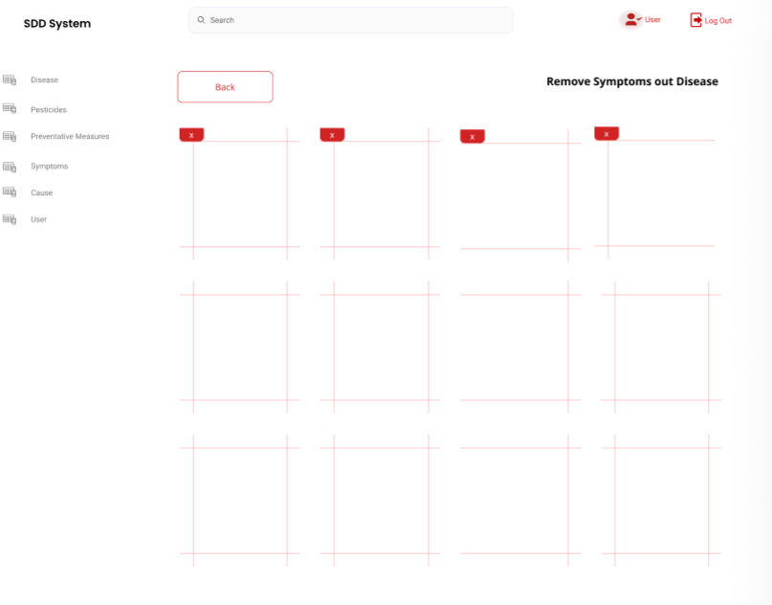*

*Figure 23. Remove symptoms, cause, preventative measures ,pesticide from disease*



*Figure 24. The create pesticide page*

*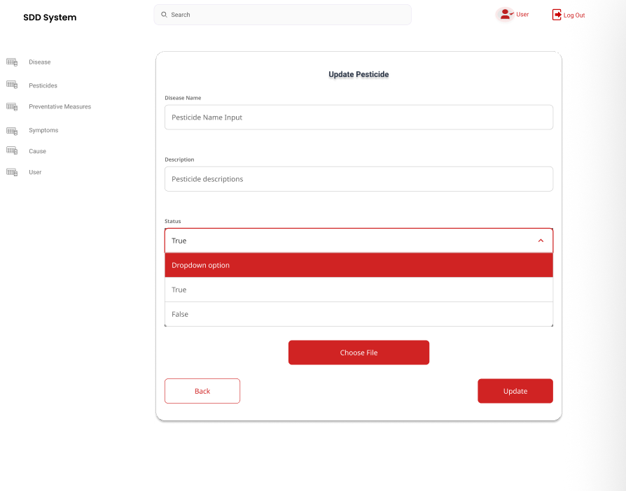*

*Figure 25. The update pesticide page*

*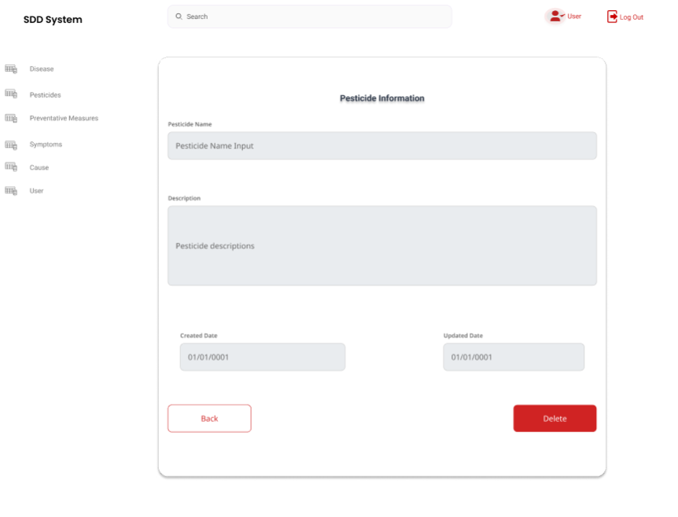*

*Figure 26. The delete pesticide page*

*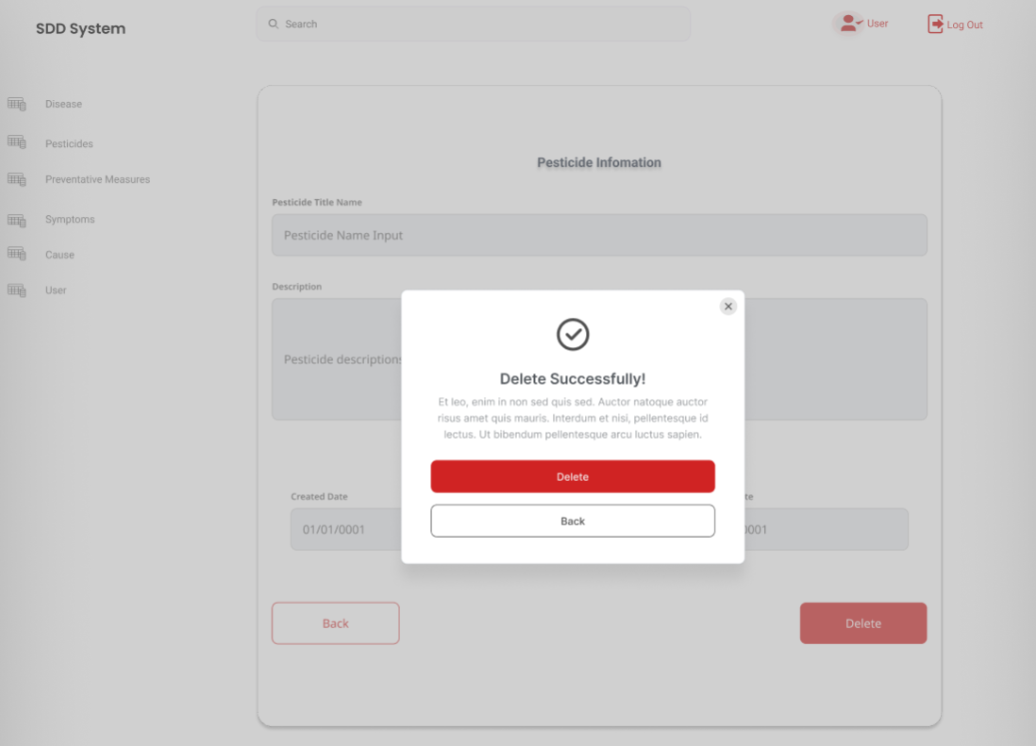*

*Figure 27. The delete pesticide popup confirmation*

*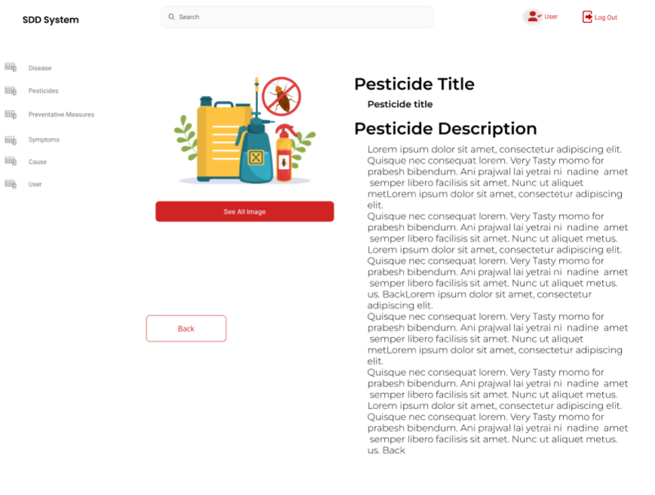*

*Figure 28. The pesticide details information*



*Figure 29. The create symptom page*

*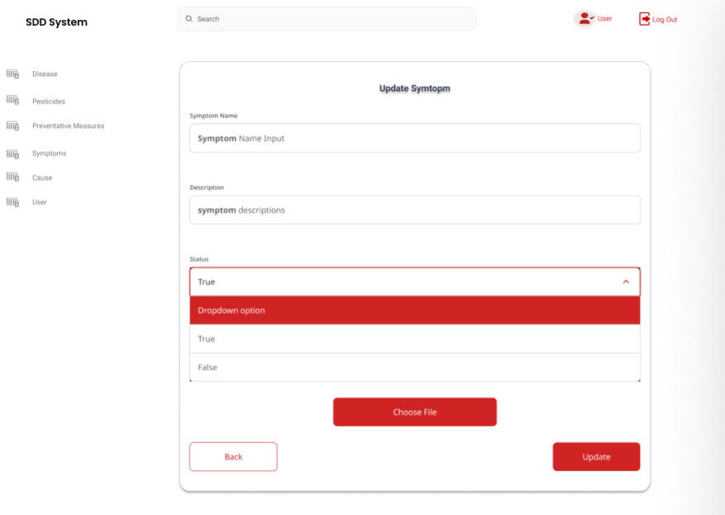*

*Figure 30. The update symptom page*

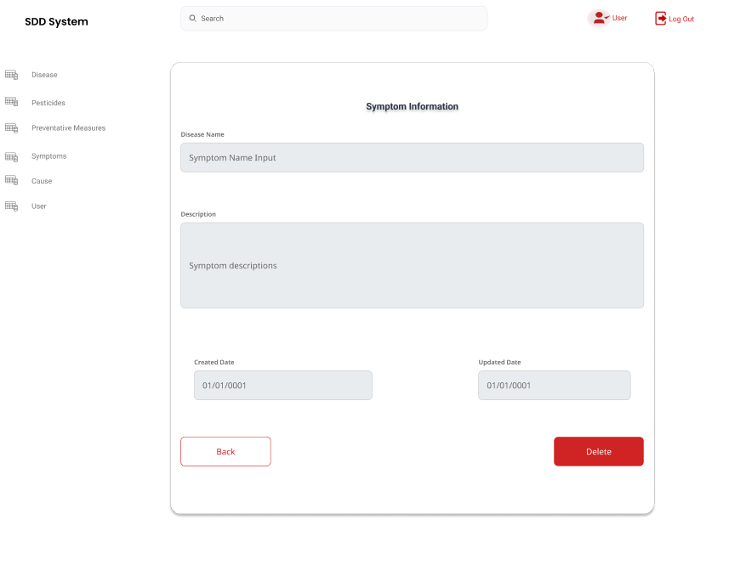

*Figure 31. The delete symptom page*

*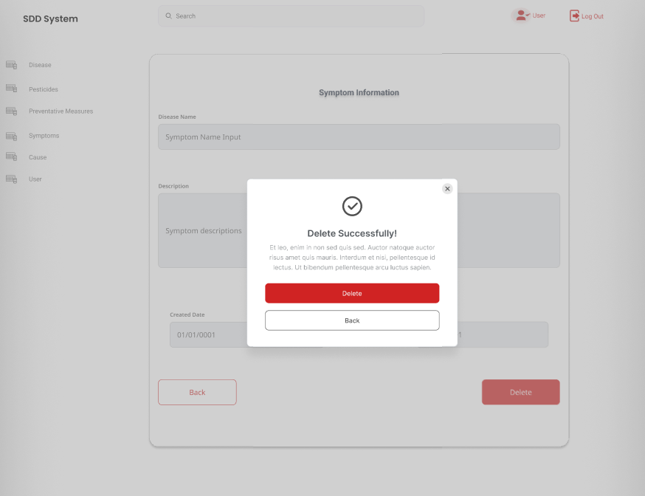*

*Figure 32. The delete confirmation popup*

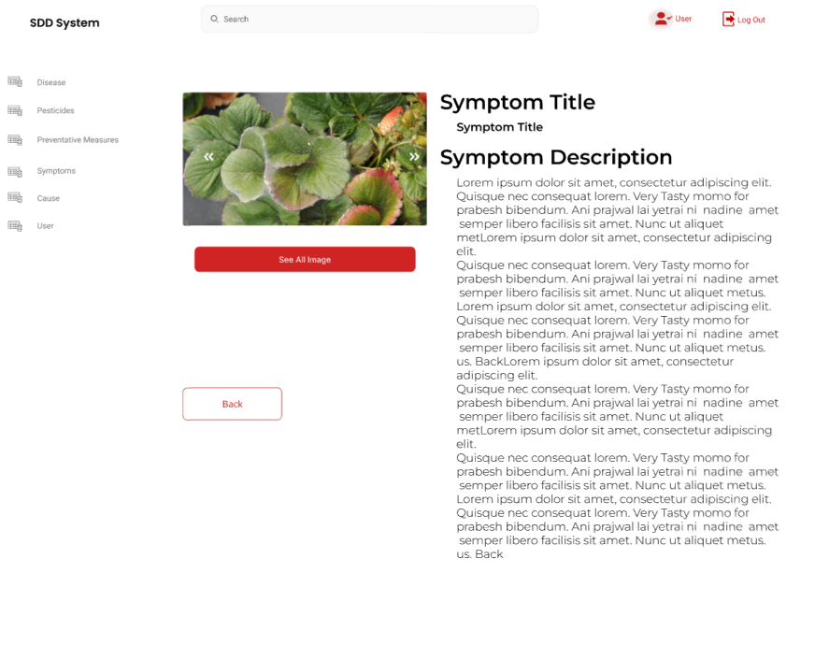

*Figure 33. The detail symptom page*

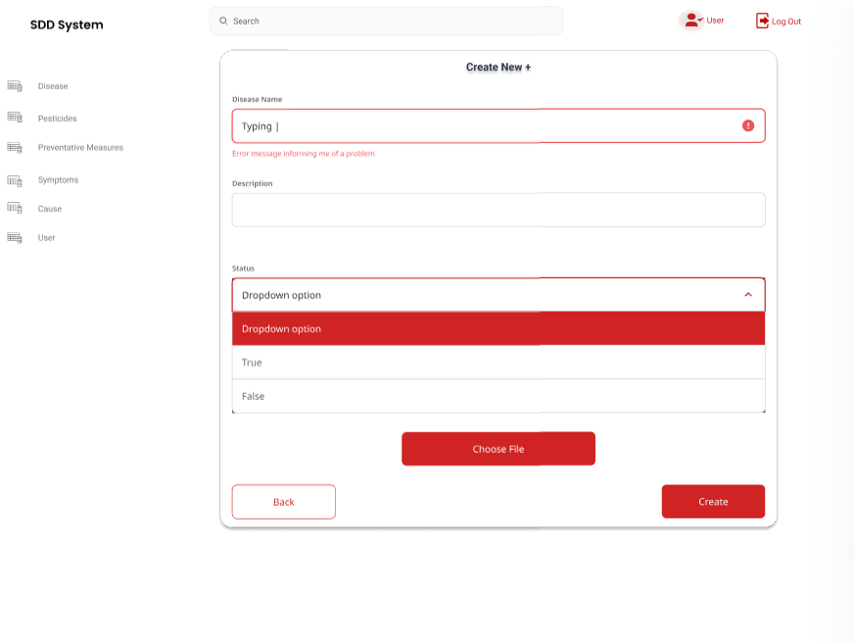

*Figure 34. The create cause page*

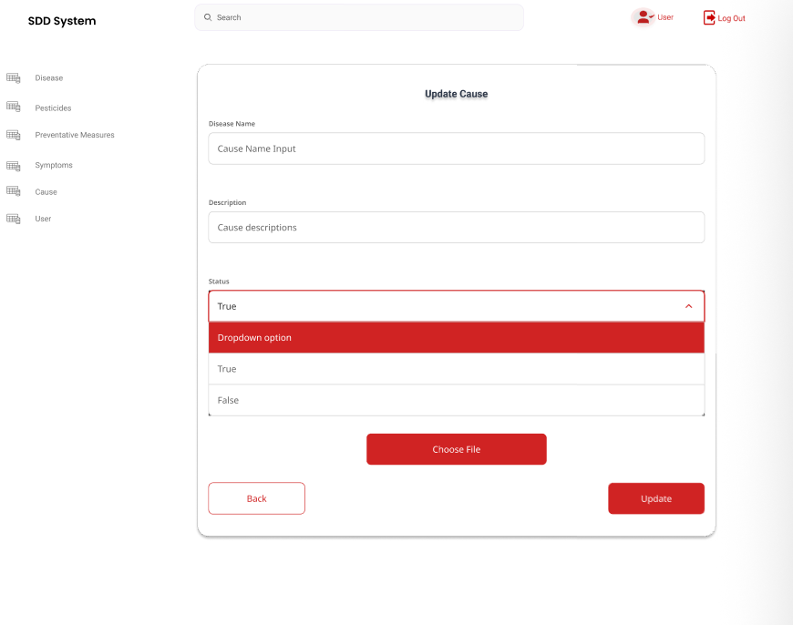

*Figure 35. The update cause page*

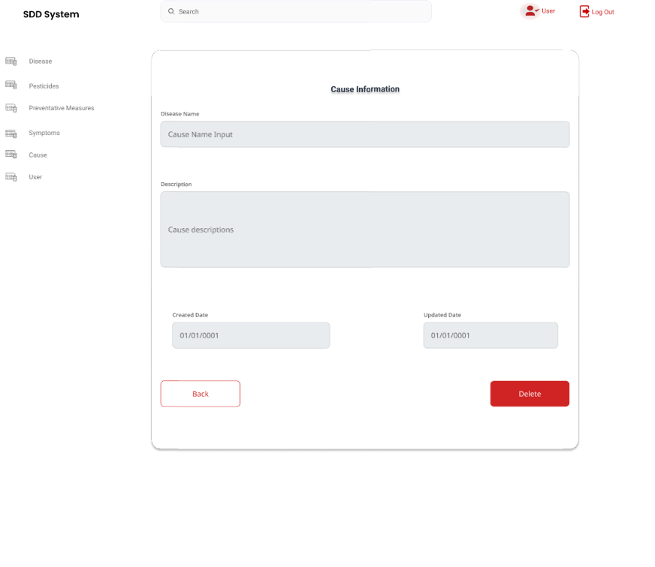

*Figure 36. The delete cause page*

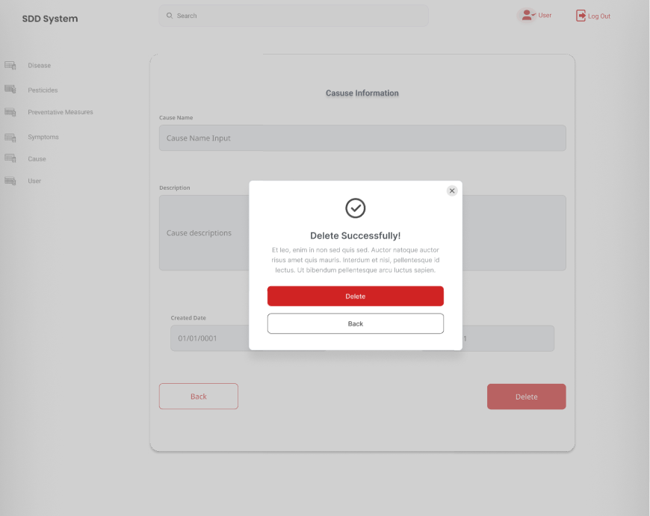

*Figure 37. The delete confirmation popup*

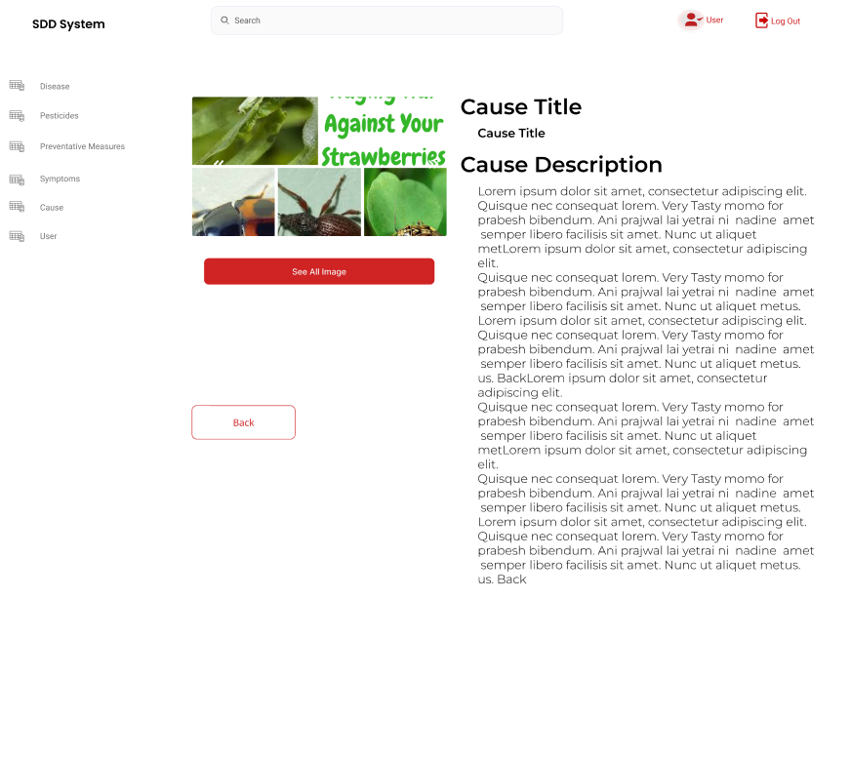

*Figure 38. The delete cause page*

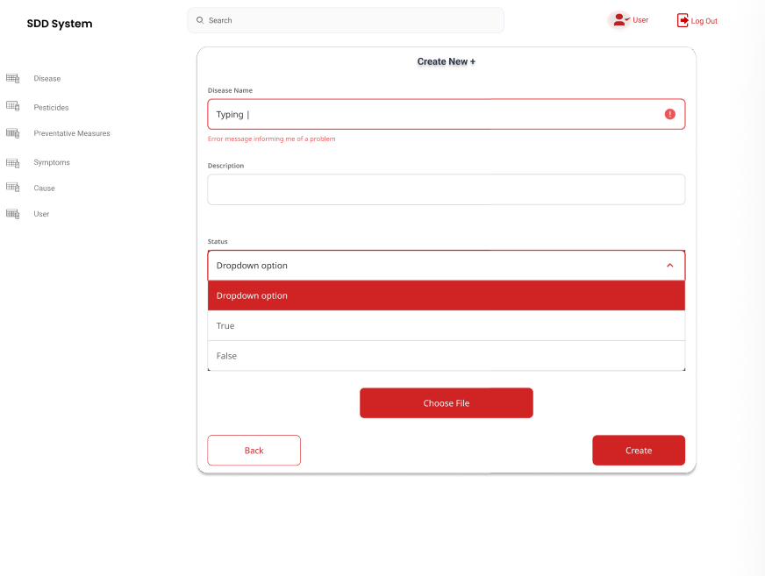

*Figure 39. The create preventative measure page*

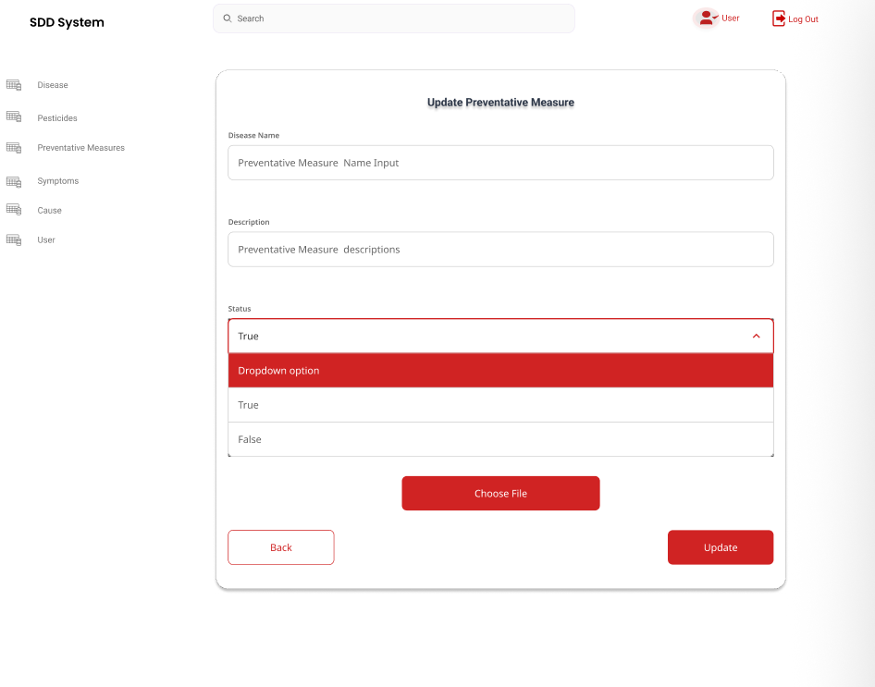

*Figure 40. The update preventative measure page*

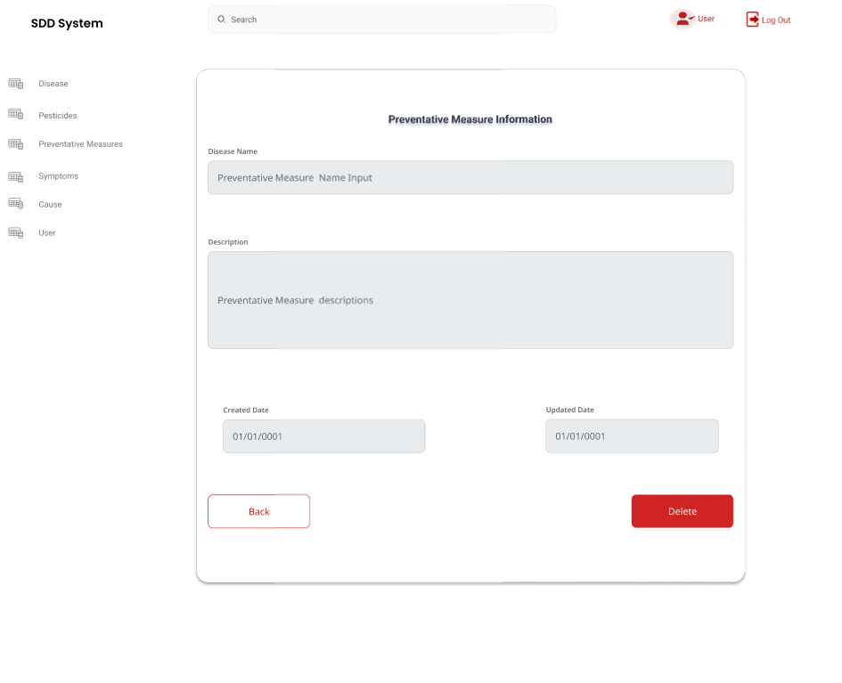

*Figure 41. The delete preventative measure page*

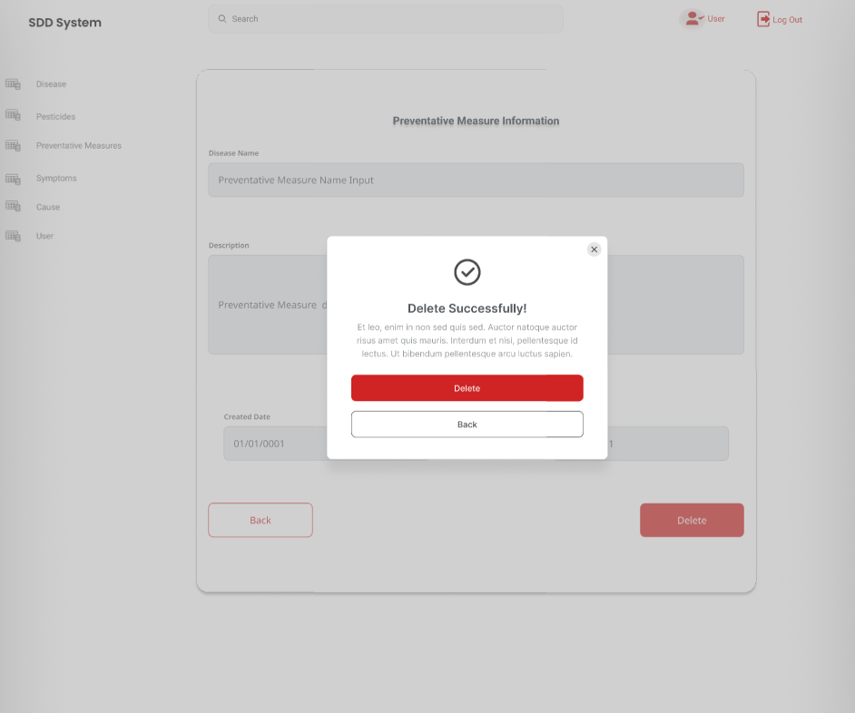

*Figure 42. The delete preventative measure popup*

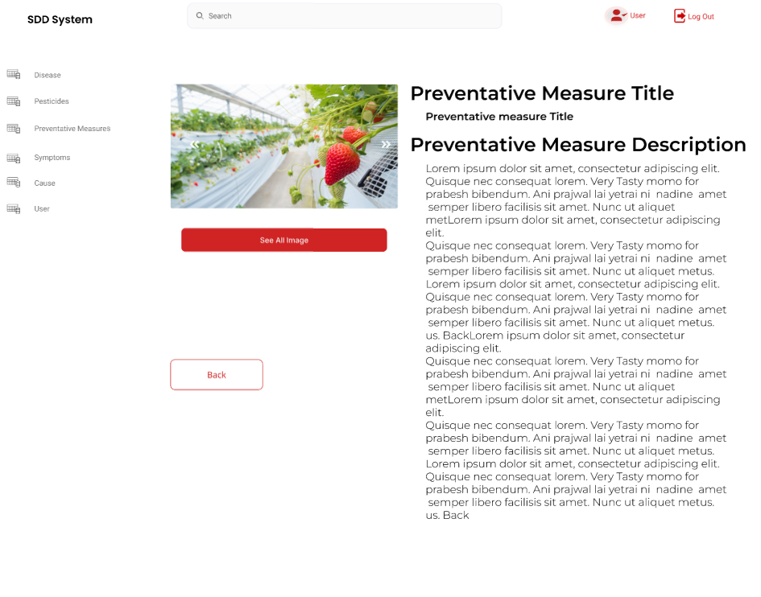

*Figure 43.  The detail preventative measure page*

* Details of the function:
  + Normal execution case: Successfully, an user with Administrator role has access to the disease list page (Figure 15). Administrator also has access to the disease account page (Figure 23), has access to the add disease function, delete disease function, update disease function. Add symptoms, cause, pesticides, preventative measures, and causes to existing disease(Figure 20,21,22,23), delete symptoms, cause, pesticides, preventative measures, and causes to existing disease.

### 3.4 Role Farmer

1. **Upload Image for prediction**

* Triggering the function: Login successfully as farmer and click on the upload image icon on the sidebar of the web application
* Description of the function: an Farmer user is allowed to upload images for disease prediction

Screen layout: 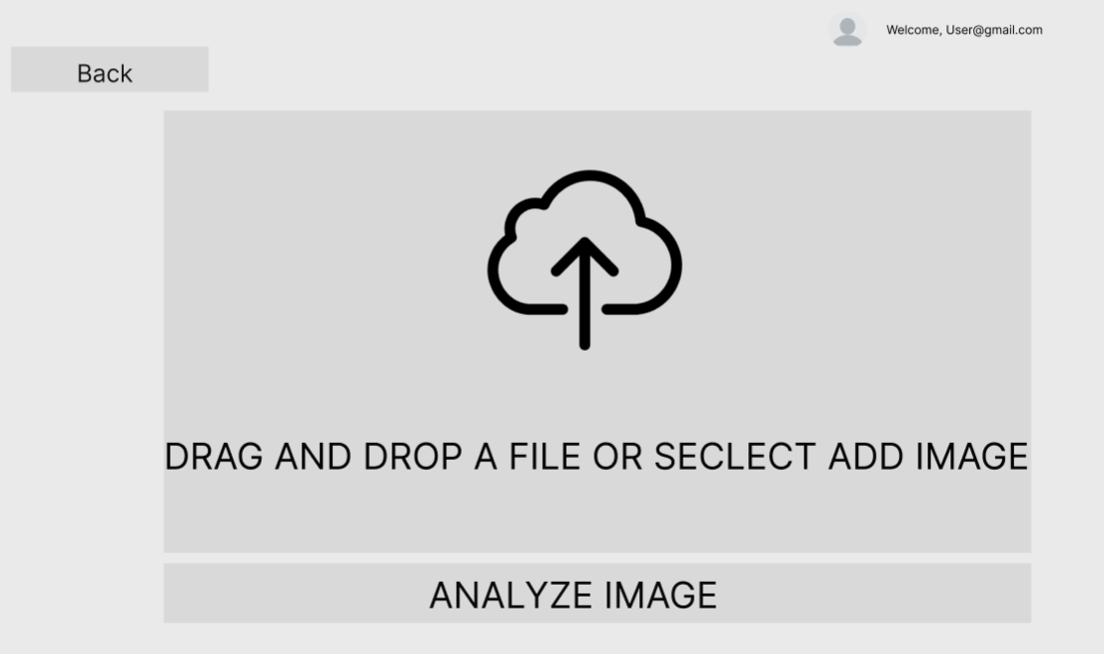

*Figure 44.  The upload image page to analyse*

* Details of the function:
  + Normal execution case: The farmer is able to upload selected image to the system for prediction
  + Abnormal execution case: Loss of connection.

1. **Prediction Result**

* Triggering the function: After Farmer successfully upload image.
* Description of the function:The system return the result after finishing analyzing the image.

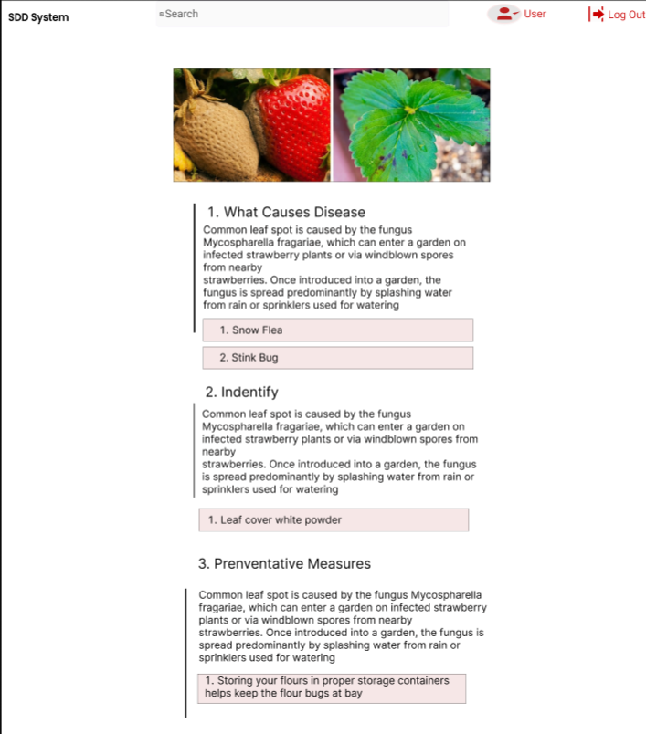

*Figure 45.  The prediction result*

* Details of the function:
  + Normal execution case: The farmer is able to upload selected image to the system for prediction and the system return the result. Transfer to the details information of the disease
  + Abnormal execution case: Loss of connection.

1. **Prediction History**

* Triggering the function: Login successfully with the Farmer account. Click on the “History” icon on the vertical navigation bar
* Description of the function: Allow farmer to view their upload/prediciton history**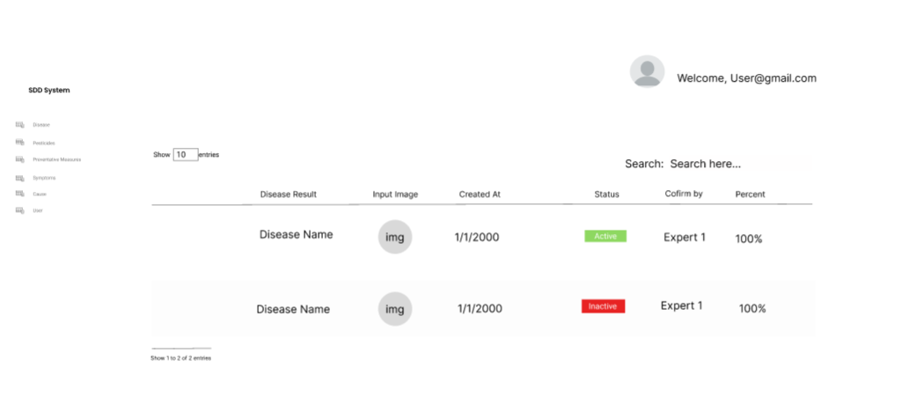**

*Figure 46.  The prediction history page*

* Details of the function:

o   Normal execution case: The Farmer is able to access the history page and is able to view the prediction result of all the images

o   Abnormal execution case: Loss of connection.

### 3.5 Role Expert

1. **Prediction History**

* Triggering the function: Login successfully with the Expert account. Click on the “History” icon on the vertical navigation bar
* Description of the function: Allow expert to view the upload/prediction history

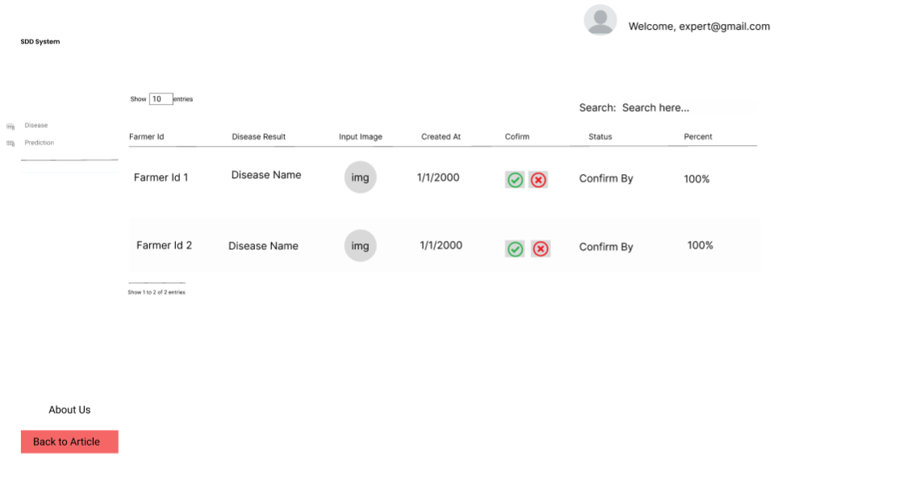

*Figure 47.  The prediction history page*

* Details of the function:

o   Normal execution case: The Expertis able to access the history page and is able to view the prediction result of all the images

o   Abnormal execution case: Loss of connection.

1. **View Disease List**

●       Triggering a function: Login as a Expert successfully, click on the section “Disease” on the left vertical navigation bar.

●       Description of the function: Expert is allowed to view the disease  list and their details information

●       Details of the function:

○       Normal execution case: Successfully, a expert user has access to the disease list page (Figure 48) and on each one has access to click on it for more details

●    Layout of the screen:

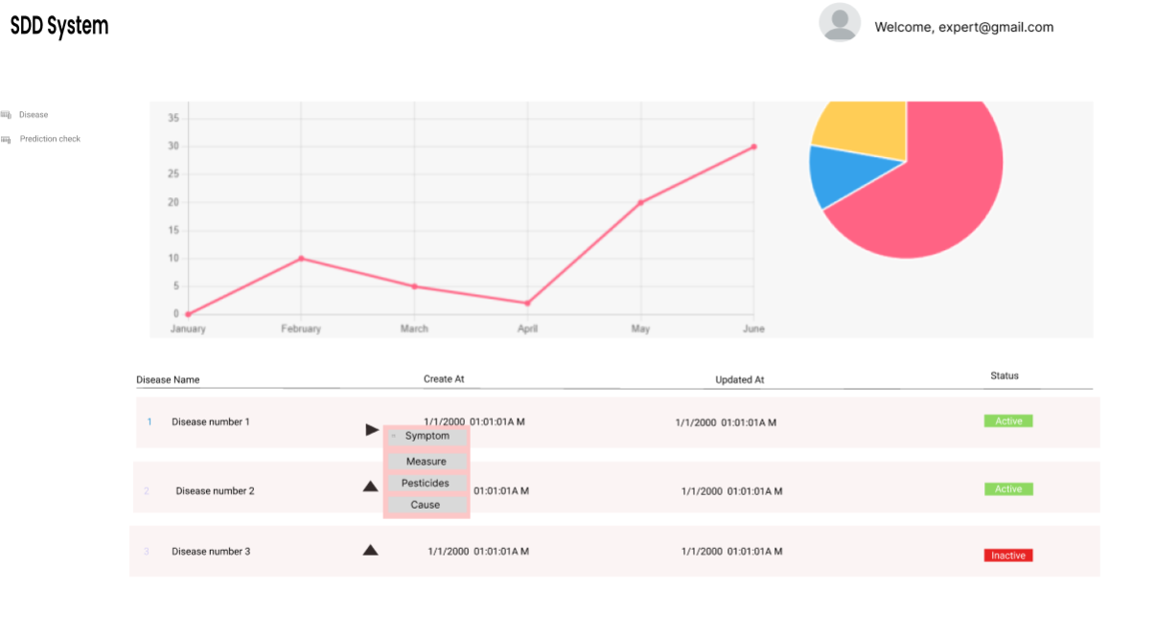

*Figure 48.  The disease list*

1. **Disease Details**

●       Triggering a function: Login as a Expert successfully, click on the section “Disease” on the left vertical navigation bar. Chose one disease on the list.

●       Description of the function: Expert is allowed to view the disease  list and their details information of specific disease

●       Details of the function:

○       Normal execution case: Successfully, a Expert has access to  the disease list page (Figure 48) and on each one, has access to view the disease list. Has access to more addtional information page (Figure 49)

●    Layout of the screen:

*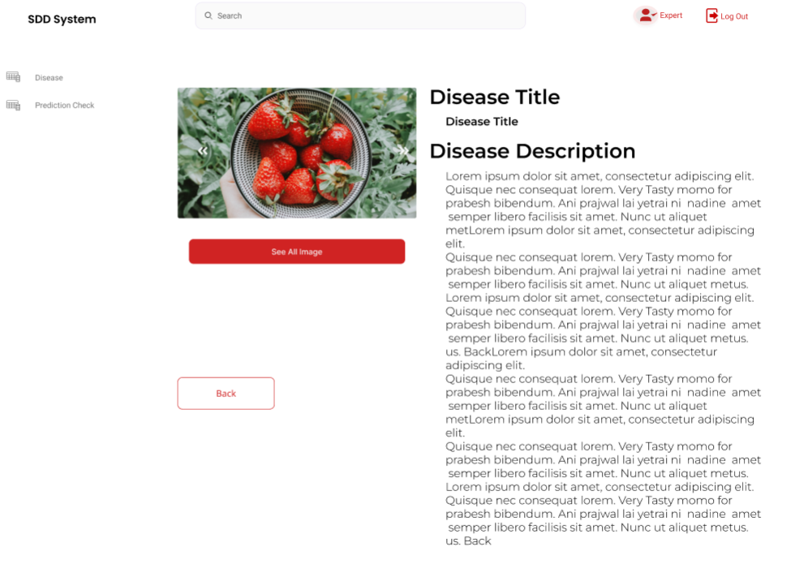*

*Figure 49.  The disease detail expert page*

1. **Prediction Confirm**

●      Triggering a function: Login as a Expert successfully, click on the section “History” on the left vertical navigation bar. Chose one prediction to confirm

●       Description of the function: Expert is allowed to view the History list and confirm the result of the prediction

●       Details of the function:

○       Normal execution case: Successfully, a expert r has access to the upload history  list page (Figure 47) and on each one, has access to view the prediction result and confirm the accuracy of the result (Figure 50)

●    Layout of the screen:

*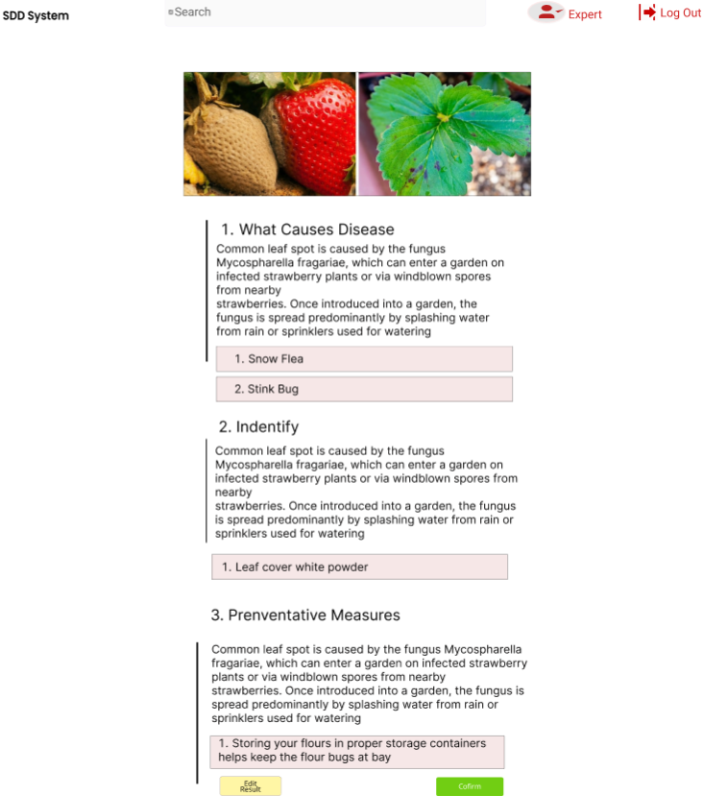*

*Figure 50.  The predict confirm page*

## 4. Non-Functional Requirements

### 4.1 External Interfaces

#### a. User Interfaces

UI-1: Responsiveness refers to the user interface's ability to respond promptly to user actions. This non-functional requirement is critical in ensuring that the user interface feels smooth and snappy, even under heavy loads or network latency.

UI-2: The system shall provide a FAQ  to explain how to use that page,on the website's logo on the left navigation bar to return to the homepage.

UI-3: The user interface's ability to be accessible to a wide range of users, including those with disabilities. This non-functional requirement aims to make the user interface usable and navigable for all users.

#### b. Software Interfaces

SI-1: Ensuring that the software product can integrate with other systems or software components seamlessly. Interoperability involves complying with established standards and protocols, such as REST or SOAP.

SI-2: Can handle a growing user base or workload without experiencing slowdowns or downtime.

SI-3: The system web pages must run smoothly on common web browsers (Chrome, Edge).

#### c. Hardware Interfaces

The system has no hardware interface.

#### d. Communications Interfaces

CI-1: The systems can transmit data without experiencing congestion or network delays.

CI-2: The systems can exchange data with minimal errors.

Cl-3 :  The system's front-end and system's back-end is connected through HTTP Response and HTTP Request.

CI-4: The system's back-end is connected through HTTP Response and HTTP Request with Fast API

### 4.2 Quality Attributes

#### a. Usability

USE-1 : New users can quickly learn how to use the software product and that existing users can easily adapt to changes. Learnability involves providing clear and concise instructions and feedback

USE-2: Using familiar UI patterns and terminology, and minimizing the need for training or documentation

USE-3 : Training sessions for customer on how to use system

#### b. Reliability

RE-1: The software product can recover from system failures, hardware malfunctions, or network outages without significant data loss or system downtime hours.

RE-2: The software product can evolve and adapt to changing requirements or technology trends without compromising reliability or performance.

RE-3: Can scale up or down as needed to meet changing requirements or usage patterns.

RE-4: The Mean Time To Repair (MTTP) of the SLDDS should be less than 3 hours.RE-5: The accuracy of the SLDDS  should be around 97% accurate

#### c. Performance

PER-1: The SLDS  should support at least 1.000 users.

PER-2: The SLDS  should support a maximum of 300 concurrent users.

PER-3: The SLDS  should support at least 100.000 operations.

PER-4: The maximum response time when getting data should be 3 seconds.

PER-5: The SLDS should return the predicting results within at most 3.0 seconds.

#### d. Dependability

##### Security

DE-1: All of the passwords stored in the database must be encrypted.

DE-2: Only administrators can view, create, update and delete values in database.

DE-3: Only  experts can confirm, predict for predicted disease by AI.

DE-4: JWT (JSON Web Tokens) for Authentication, Authorization and Session management

DE-5: To prevent XSRF attacks by limiting access to sensitive endpoints

#### e. Supportability

SUP-1: The system will be improved and updated if there are problems reported through surveys.

#### f. Design Constraints

DC-1: The SDDS supports the English language.

DC-2: The SDDS is developed by .Net, MVC, TensorFlow (Python).

#### g. Support Documents

SD-1: SLDDS must have a user manual to guide users, including experts and administrators.

## 5. Other Requirements

### 5.1 Appendix1 - Messages List

|  |  |  |  |  |
| --- | --- | --- | --- | --- |
| **#** | **Message code** | **Message Type** | **Context** | **Content** |
| 1 | MSG01 | In red, under the text box | The input field is in the wrong format | *The \* field is in the wrong format* |
| 2 | MSG02 | In red, under the text box | Input-required fields are empty | *The \* field is required.* |
| 3 | MSG03 | Toast message | Username or password is incorrect when login | Login failed!  Wrong credentials |
| 4 | MSG04 | Toast message | Add information successfully | *Add* information *successfully.* |
| 6 | MSG06 | Toast message | Resetting asset information successfully | *Return asset(s) successfully.* |
| 7 | MSG07 | Toast message | Deleting asset information successfully | *Delete asset(s) successfully.* |

# IV. Software Design Description

## 1. Overall Description

### 1.1 Assumptions

This system is designed basing on these following assumptions:

* Windows 10 or higher
* Microsoft Edge, Chrome, Mozilla Firefox
* Microsoft SQL Server
* C#
* .NET Core 5.0 Framework
* Python
* Development tools: Visual Studio Code, Google Collab
* Version control: Git, GitLab.

In our system, users are divided into 3 roles:

1. Administrator: are allowed to manage plant’s information.
2. Farmer : are a allowed to view and upload their image to system for prediction
3. Expert: are responsible for confirming the prediction result accuracy

### 1.2 Design Constraints

This system should be complied with following items:

* The system can be scaled up if needed.
* Obey network information security laws.
* The SDDS supports the English language as the software language.
* The given result of the machine learning model must be checked and confirmed by experts
* All of the data will be stored locally from the local machine.
* User’s password must be encrypted when stored in the database.
* All of the coding process must be tested applying unit testing, integration testing, system testing, and user acceptance testing

## 2. System Architecture Design

### 2.1 Overall Architecture

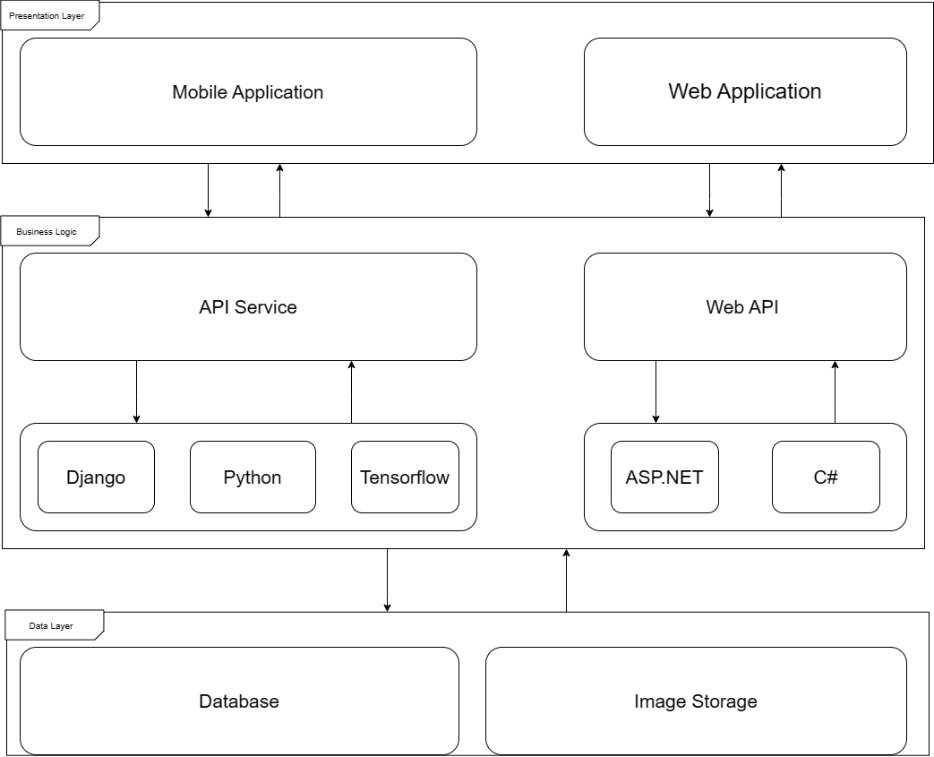

*Figure 86. Overall Architecture*

The presentation layer is responsible for displaying the user interface, receiving input from the user, and performing local validation. It sends appropriate HTTP requests to the business logic layer based on the user's actions, and displays data or error messages sent by the business logic layer in response.

The business logic layer processes incoming requests from the presentation layer and handles data sent by the data layer. It is responsible for executing the core logic of the system. The data layer is responsible for storing all system data and only communicates with the business logic layer. It performs the actions required by the business logic layer and has no direct interaction with the presentation layer.

### 2.2 System Architecture

*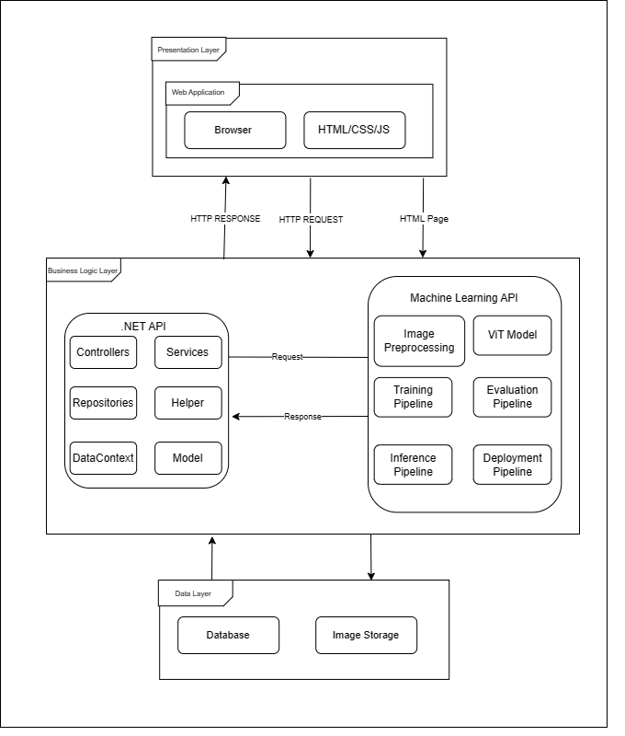*

*Figure 87. System architecture*

### 2.3 Package Diagram

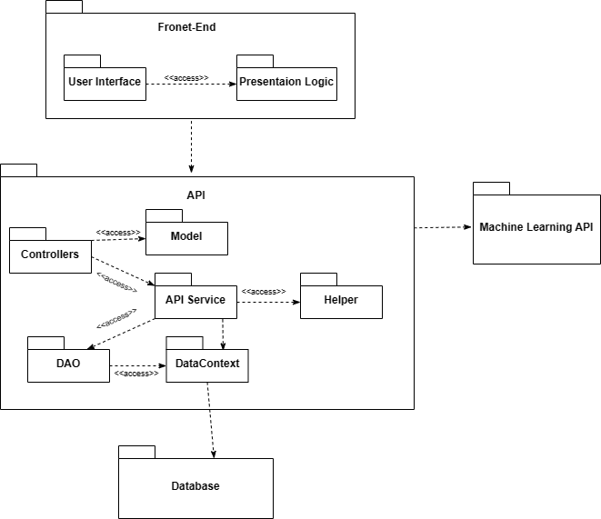

*Figure 88. Package Diagram*

***Code Packages***

|  |  |  |
| --- | --- | --- |
| **No** | **Package** | **Description** |
| 1 | Front-end | Containing the user interface and the programming logic that makes user interface functions |
| 2 | User Interface | Containing all the user interfaces of system |
| 3 | Presentation Logic | Containing all the programming logic that makes user interface functions |
| 4 | API | Containing all packages and classes that handle request and response from front-end |
| 5 | Controllers | Containing all classes that handle the input and output of the API |
| 7 | Data Context | Handling getting data into and out of the database |
| 8 | Helper | Containing all packages and classes that handle all the other logic |
| 9 | Database | Containing all datas of the system |
| 10 | API Deep Learning | Containing all deep learning functions that handle the images analyzing |

## 3. System Detailed Design

### a. Class Diagram

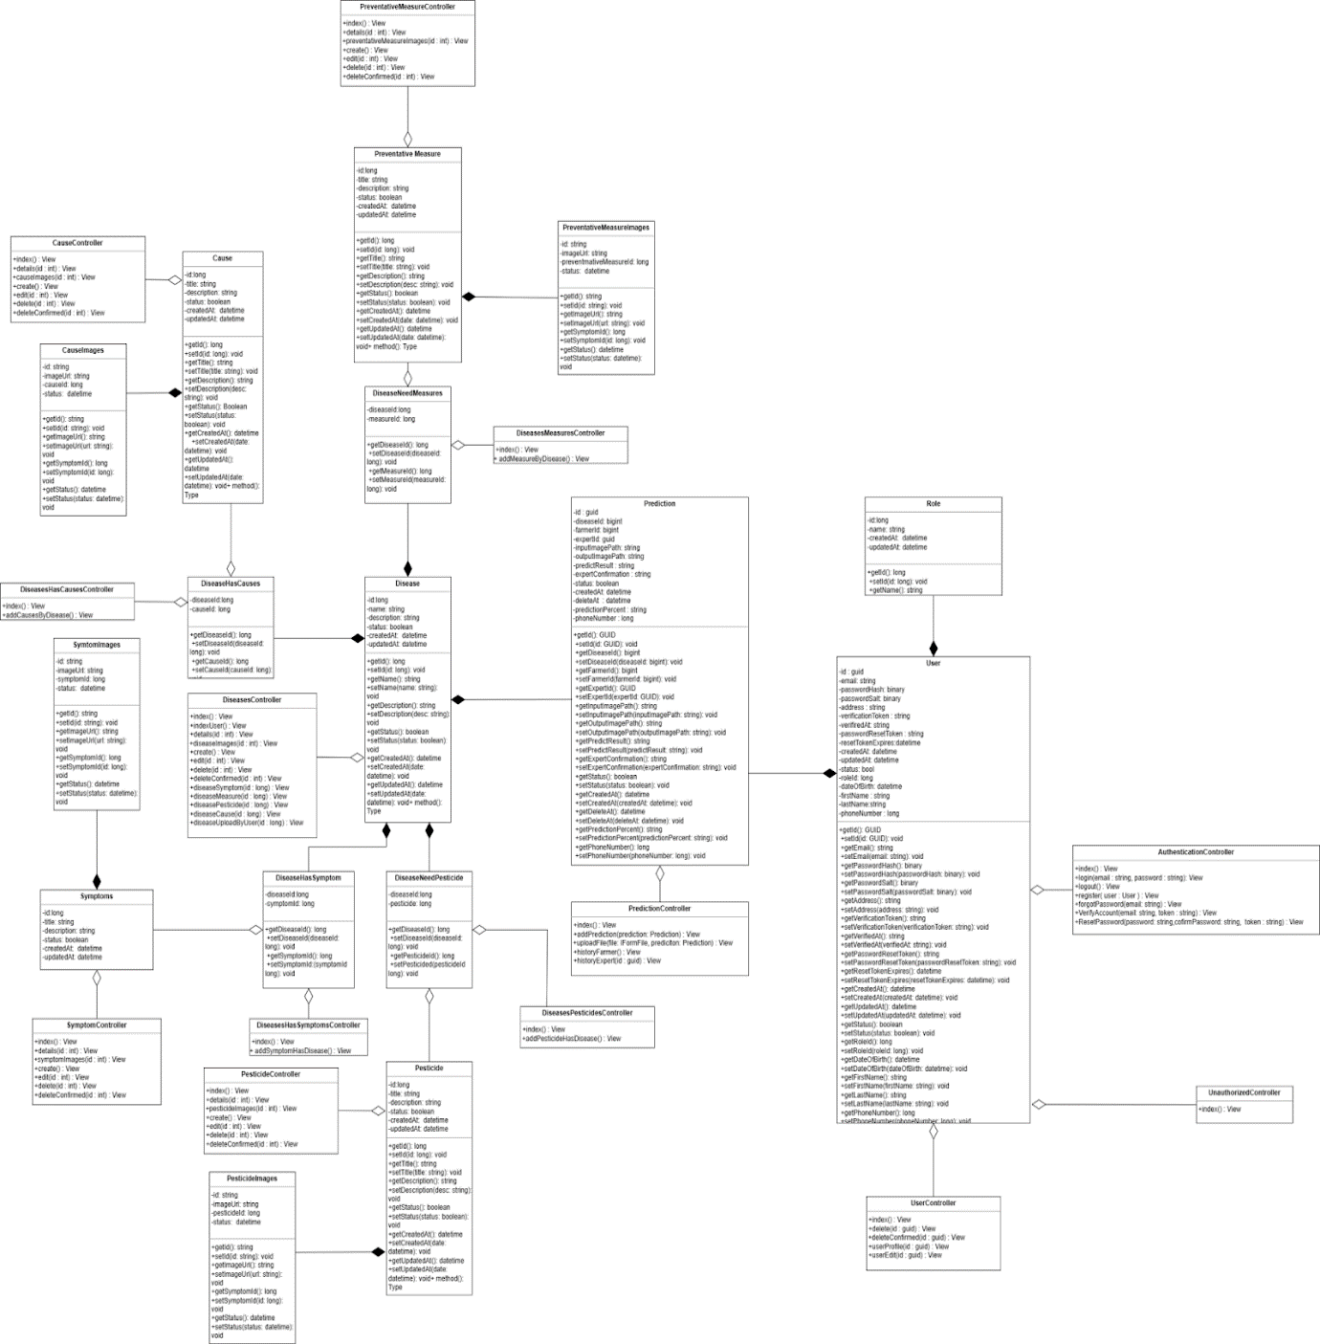

*Figure 89. Class diagram[[4]](#footnote-4)*

### Sequence Diagrams

#### Login

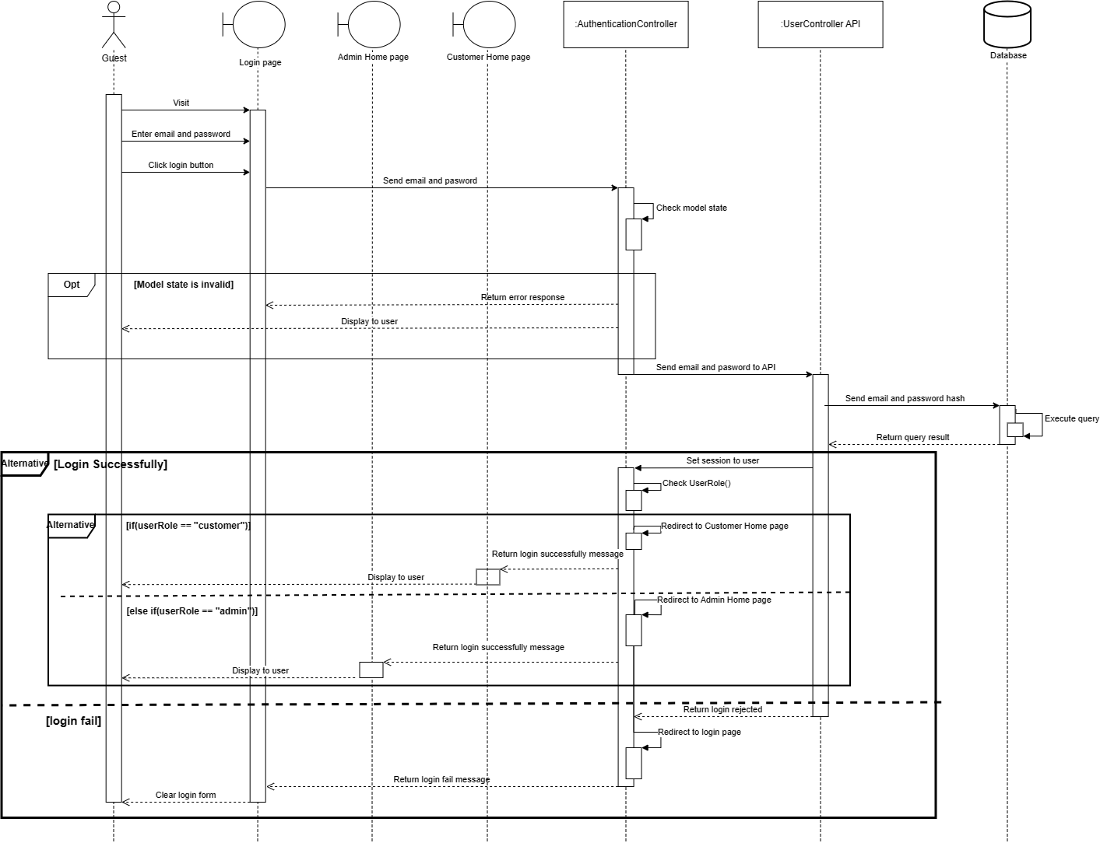

*Figure 5 Login*

#### Logout

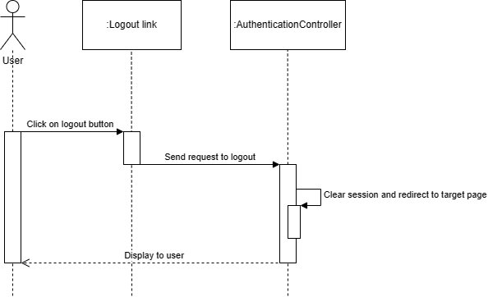

*Figure 6 Logout*

#### Register Account

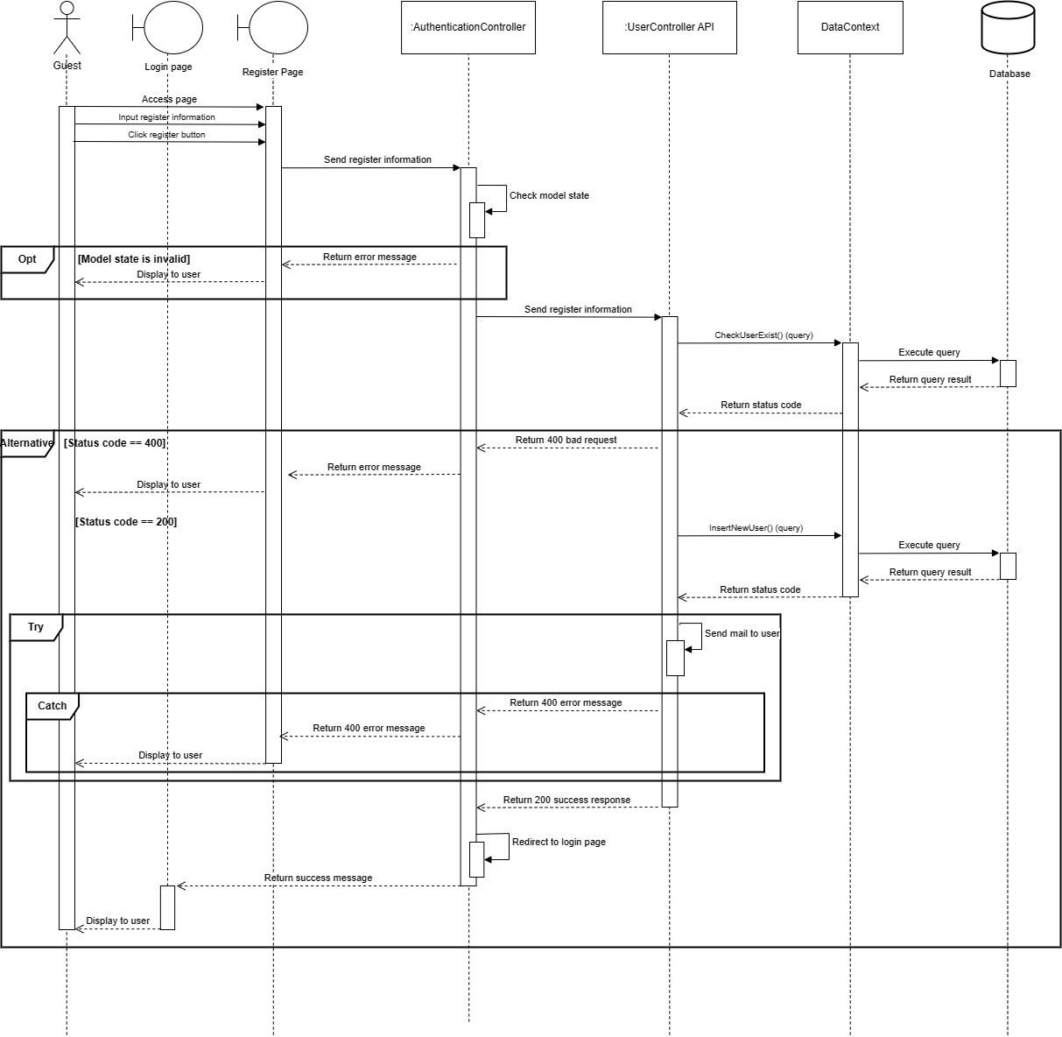

#### Forgot password

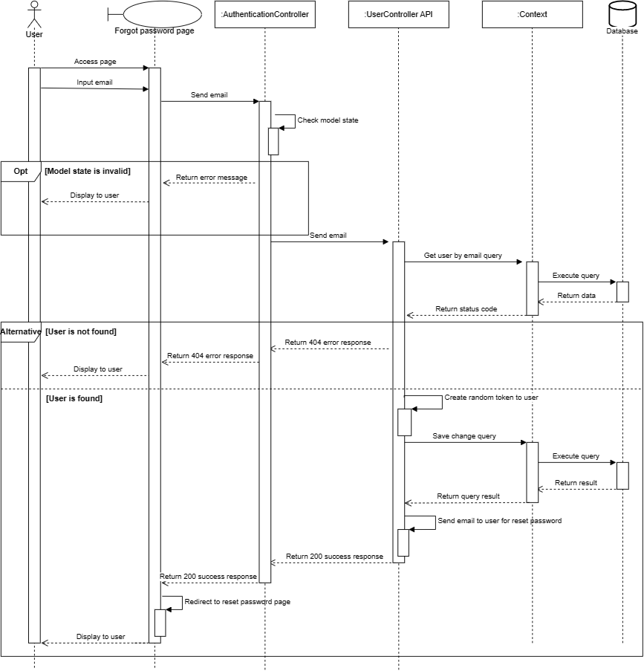

*Figure 7 Forgot password*

#### Verify Accounthttps://lh6.googleusercontent.com/380omfnlvM-Ae38A-1ysf3P6FJS7R6QlFr0vUdCe85Ua_qLau8mbbf3FMUOvpO_BUb5Tv4RC9jkMgF7V7gzXxuWCt9ZJ-epCeiIWzU0xze62oDl8cenBQF53WN7Suy7Z_cg7kj1u9Ulq

*Figure 8 Verify Account*

#### Reset Passwordhttps://lh6.googleusercontent.com/r1_vjfZSbOza_b3-QQlH30fTYsGaQZxx2U6LY9stUWnCskrvReJ9SR7GMUpaeLdH_JMXIAEUxZnqhfnFA13jyksa01NPq8aM1j957rEqaYVgy1L9RzQPtKjy1_2CT5BiGCTMbm7vwFyt

*Figure 9 Reset Password*

#### Create Disease

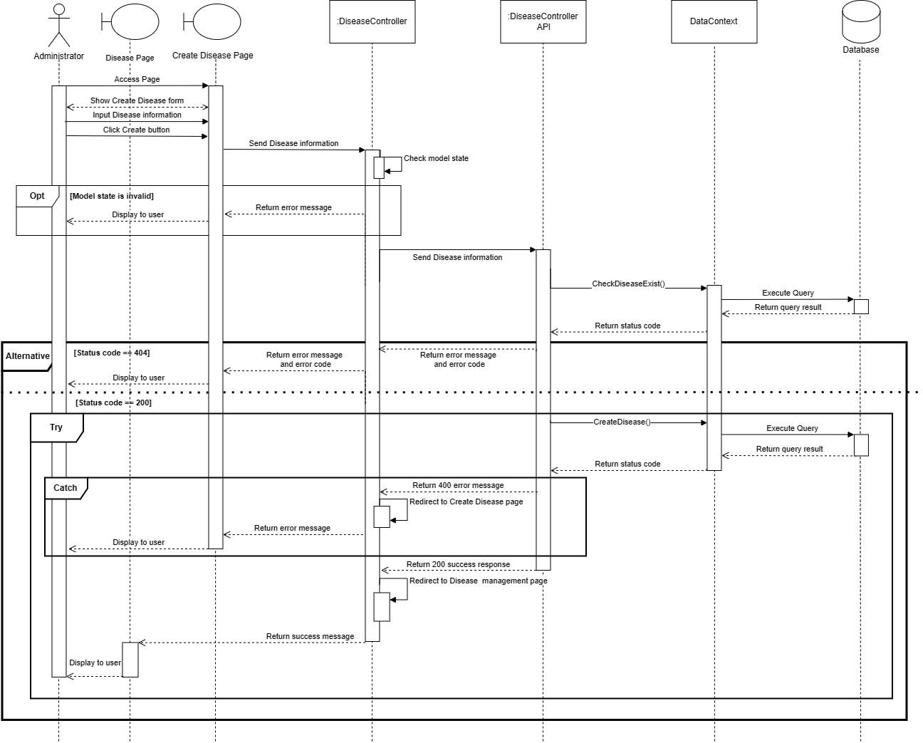

*Figure 10 Create Disease*

#### View Disease List

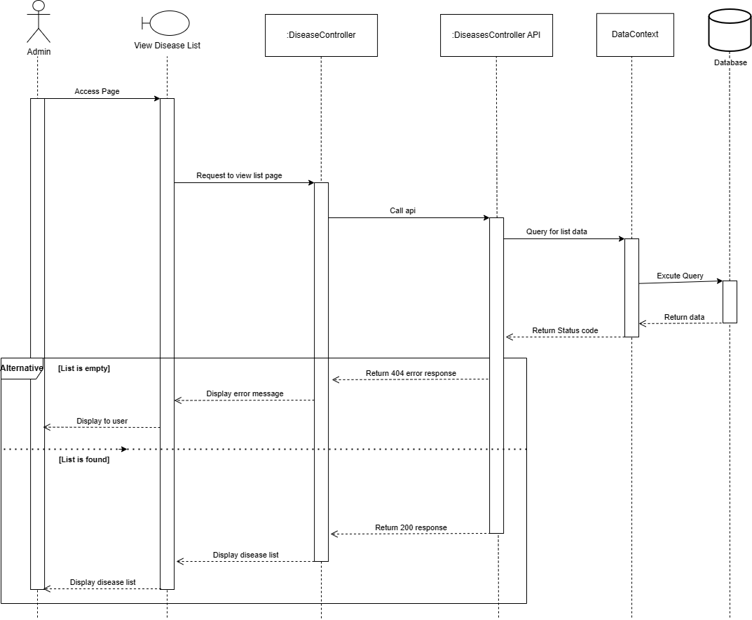

*Figure 11 View DiseaseList*

#### Update Disease

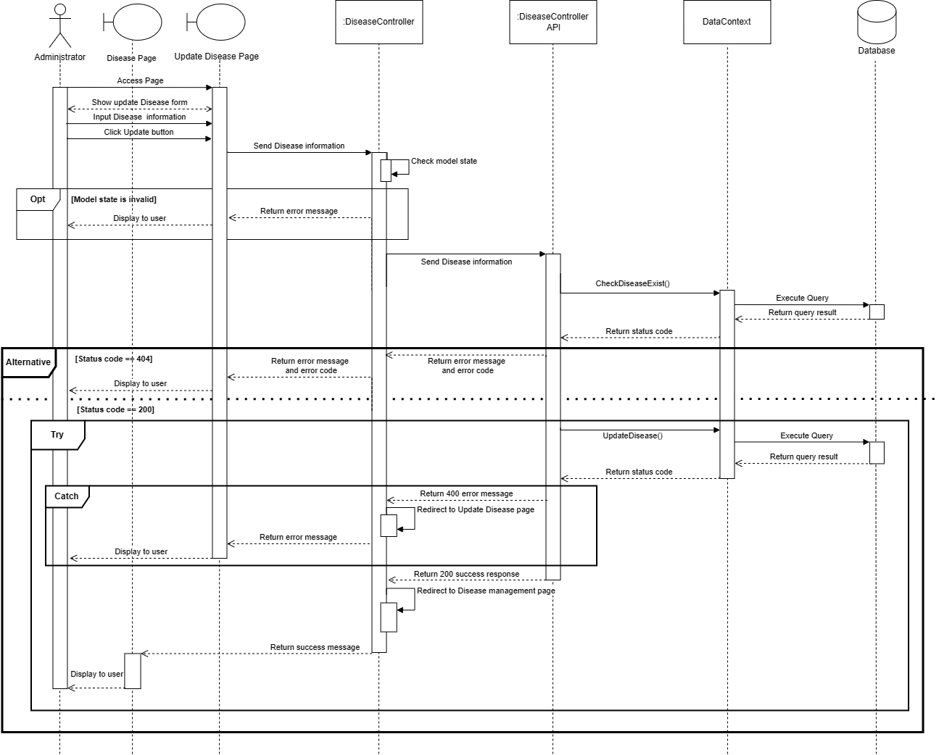

*Figure 12 Update Account*

#### Delete Disease

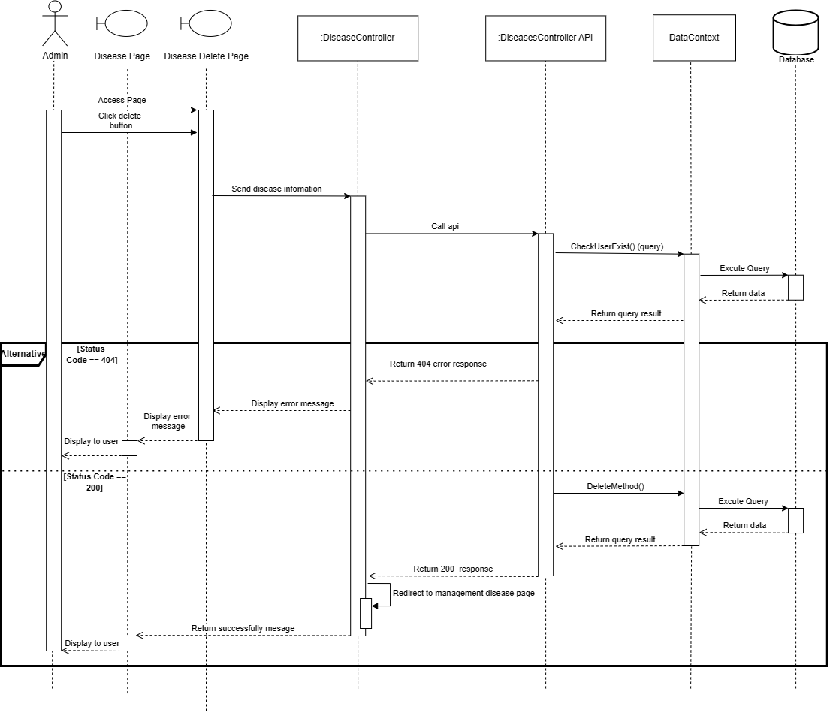

*Figure 13 Delete Disease*

#### Create Pesticide

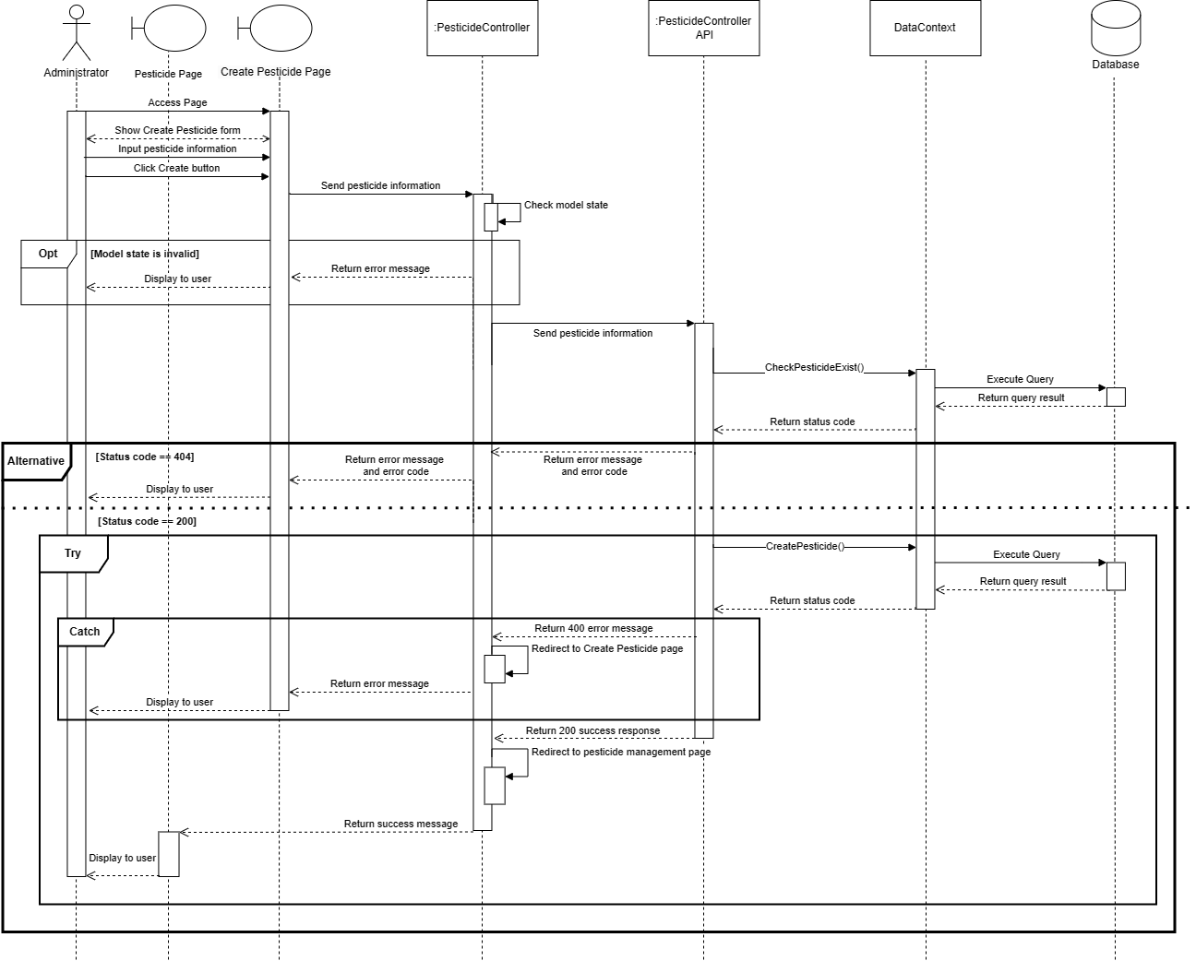

*Figure 14 Create Pesticide*

#### View Pesticide list

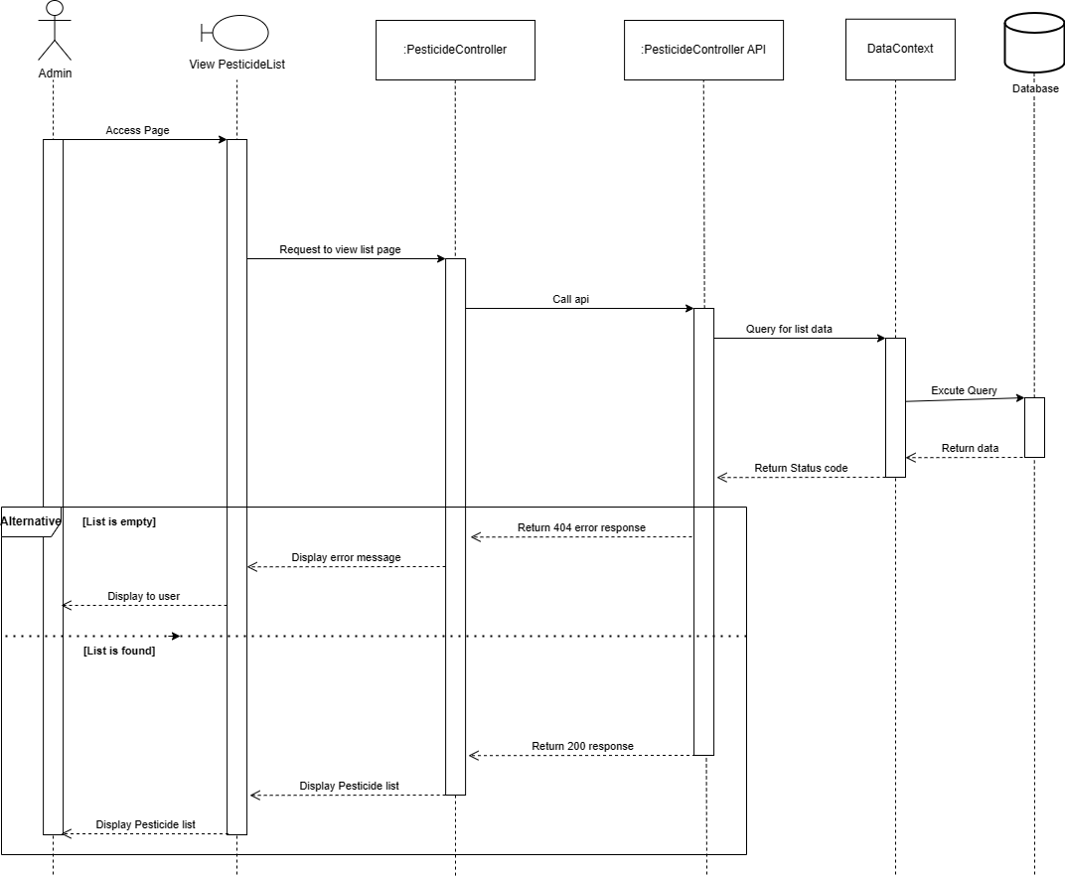

*Figure 15  View Pesticide list*

#### Update Pesticide

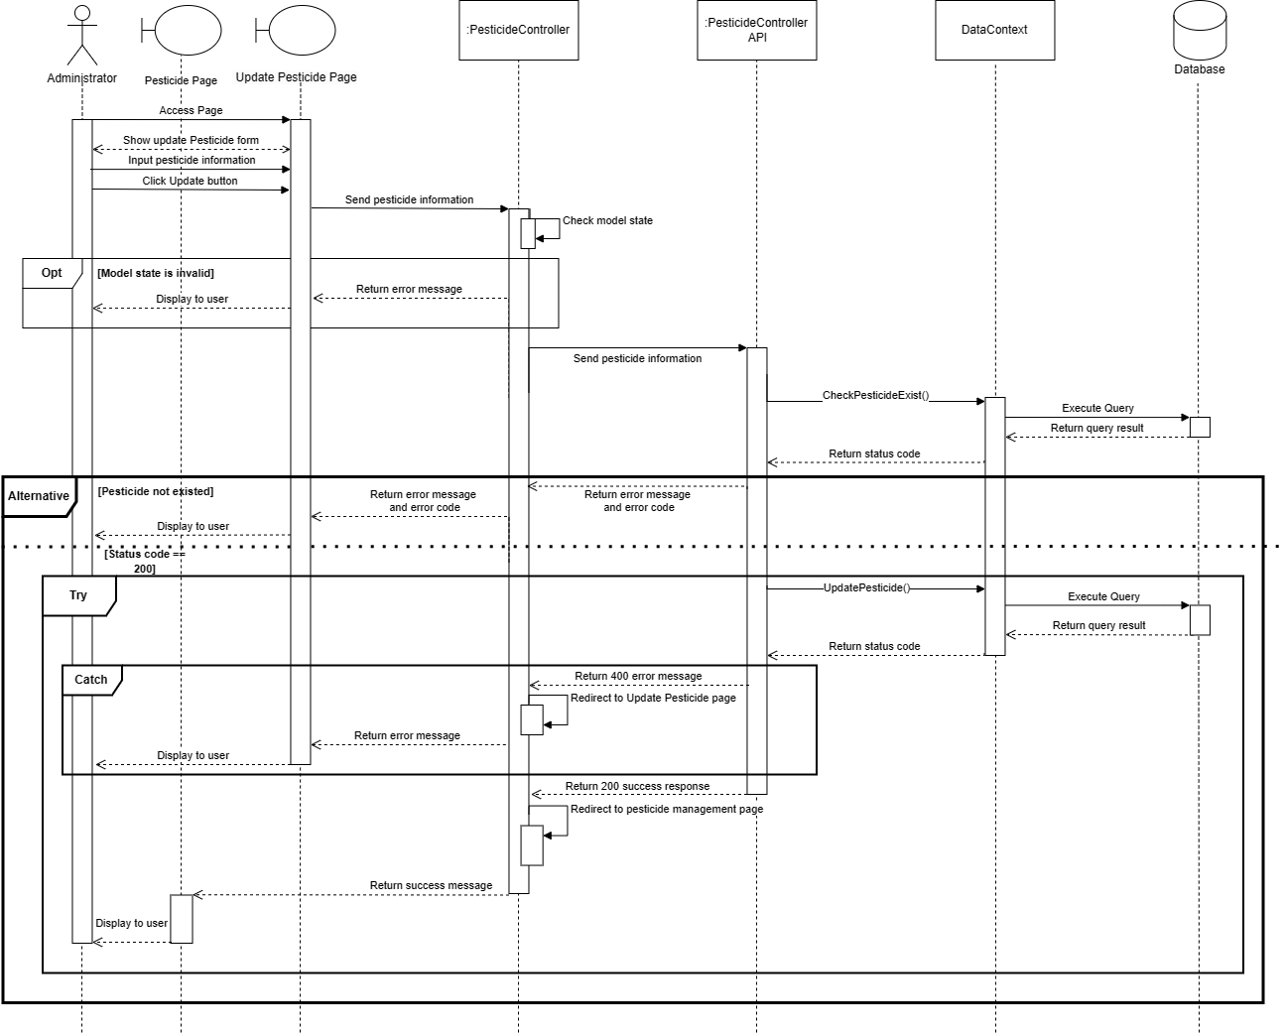

*Figure 15 Update Pesticide*

#### Delete Pesticide

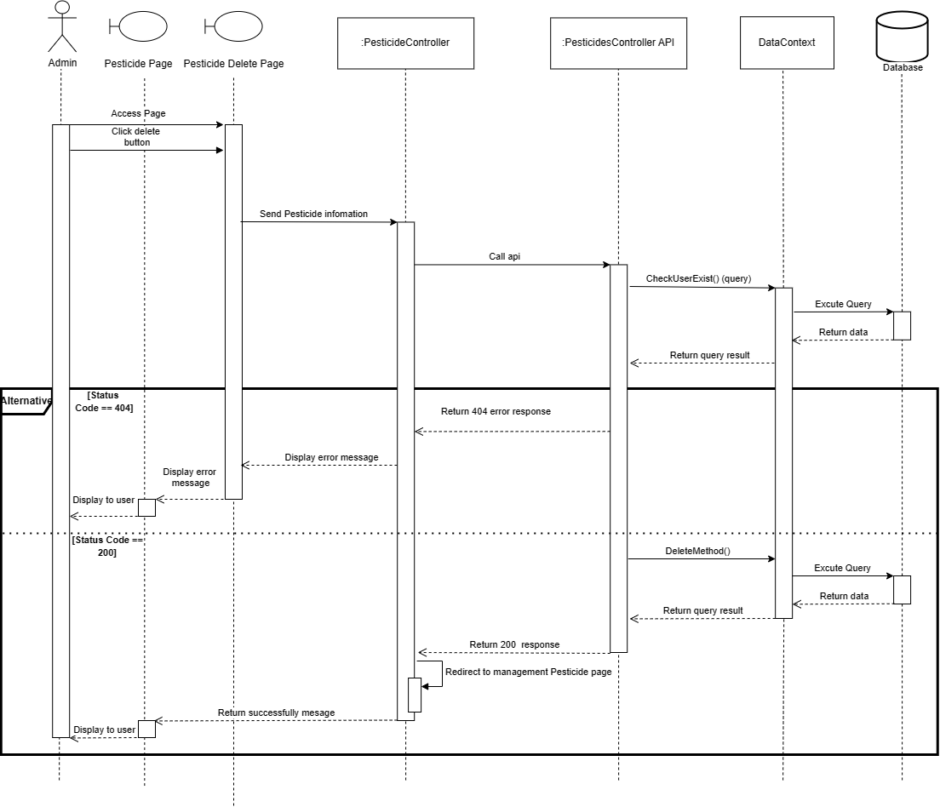

*Figure 16 Delete Pesticide*

#### Create Symptom

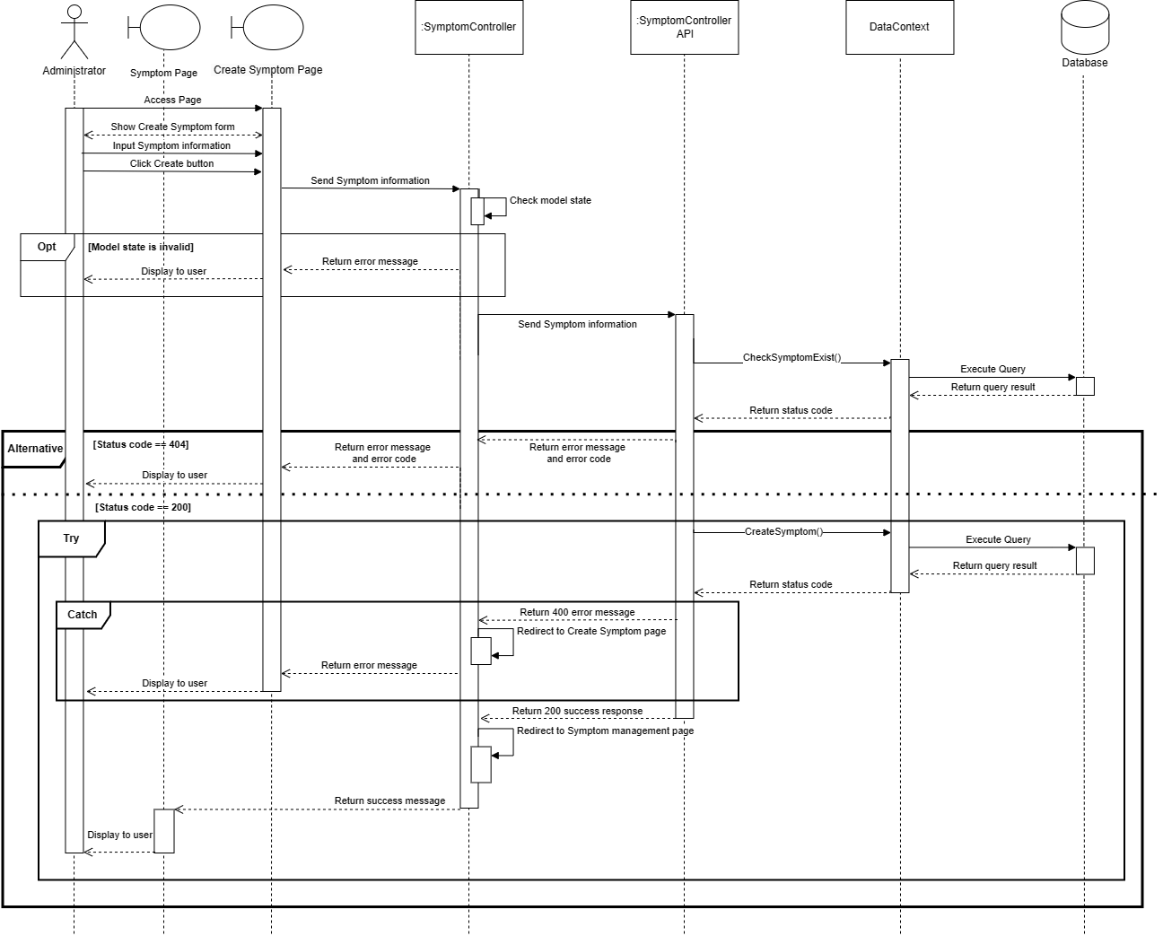

*Figure 17 Create Symptom*

#### View Symptom List

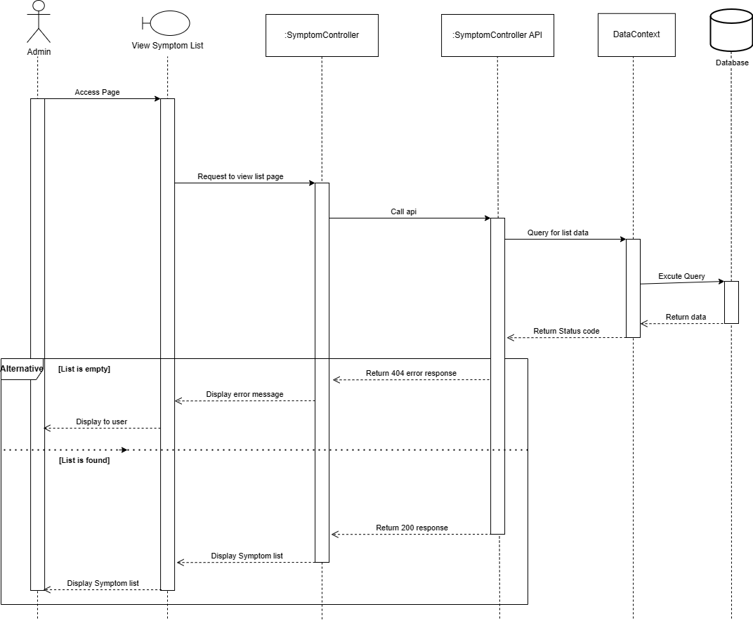

*Figure 18 View Symptom List*

#### Update Symptom

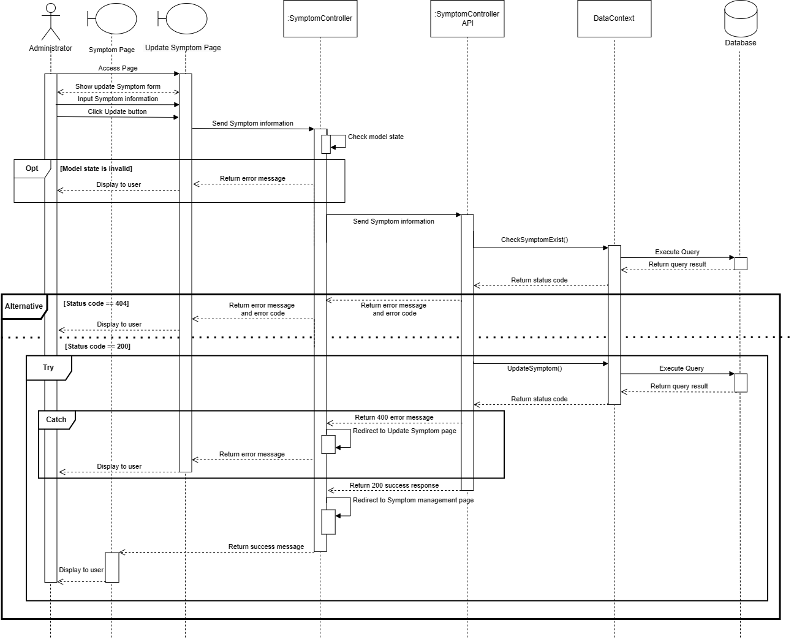

*Figure 20 Update Symptom*

#### Delete Symptom

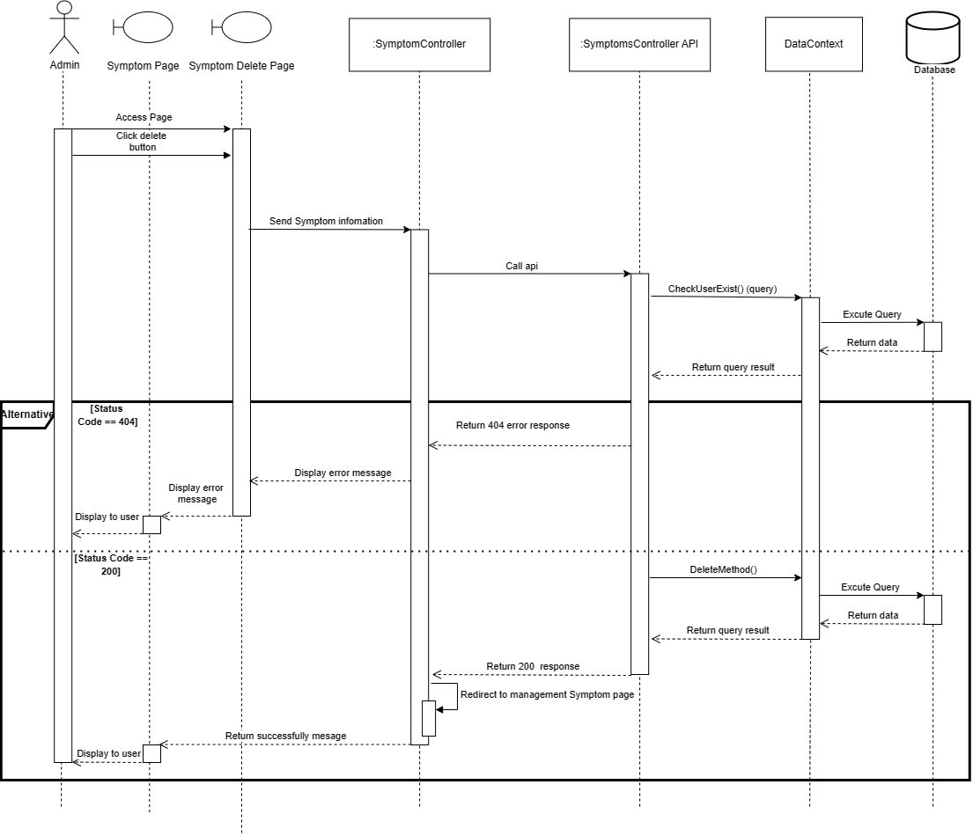

*Figure 21 Delete Symptom*

#### Create Cause

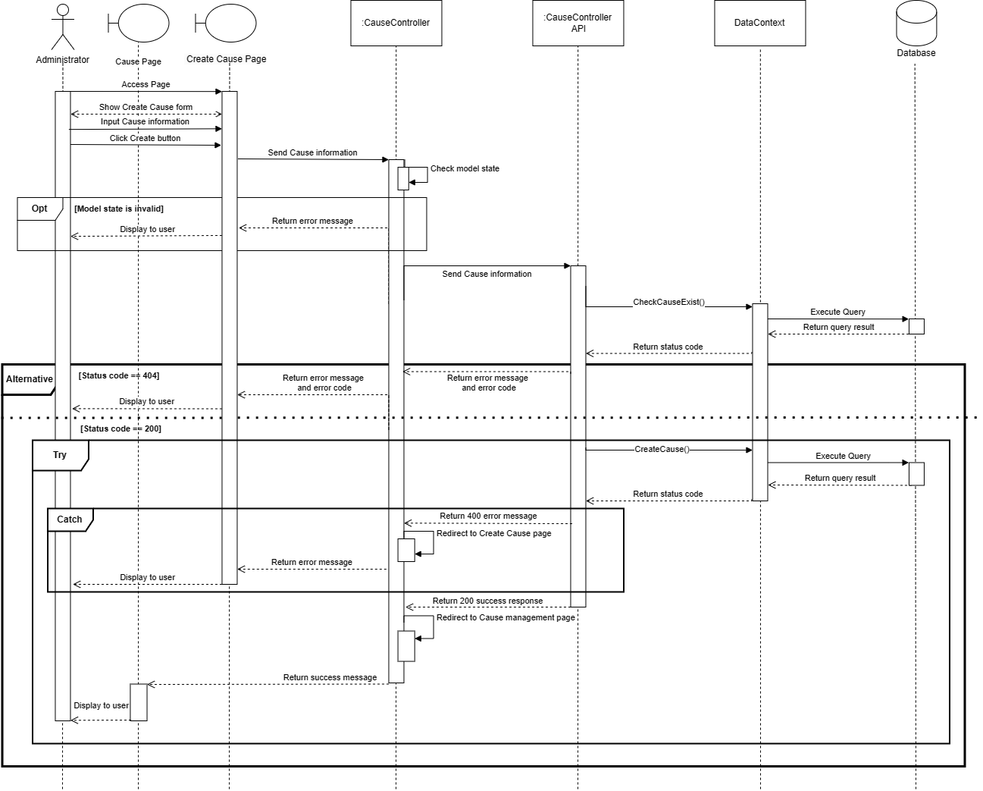

*Figure 22 Create Cause*

#### View Cause List

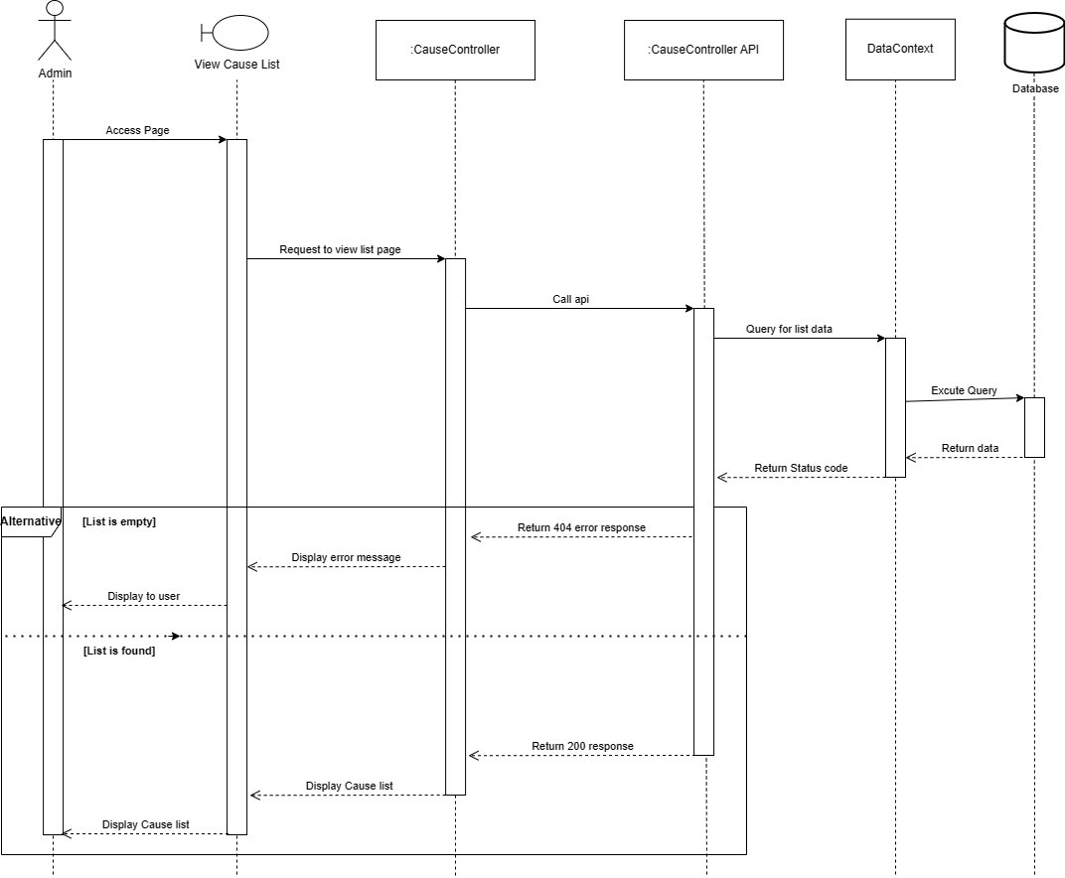

*Figure 23  View Cause List*

#### Update Cause

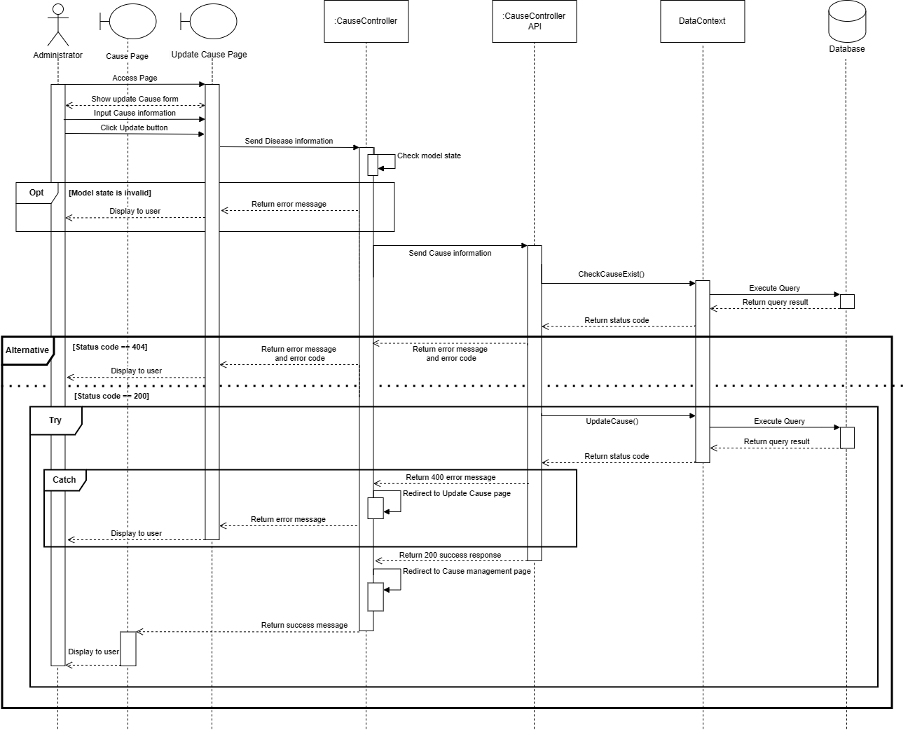

*Figure 24  Update Final Exam*

#### Delete Cause

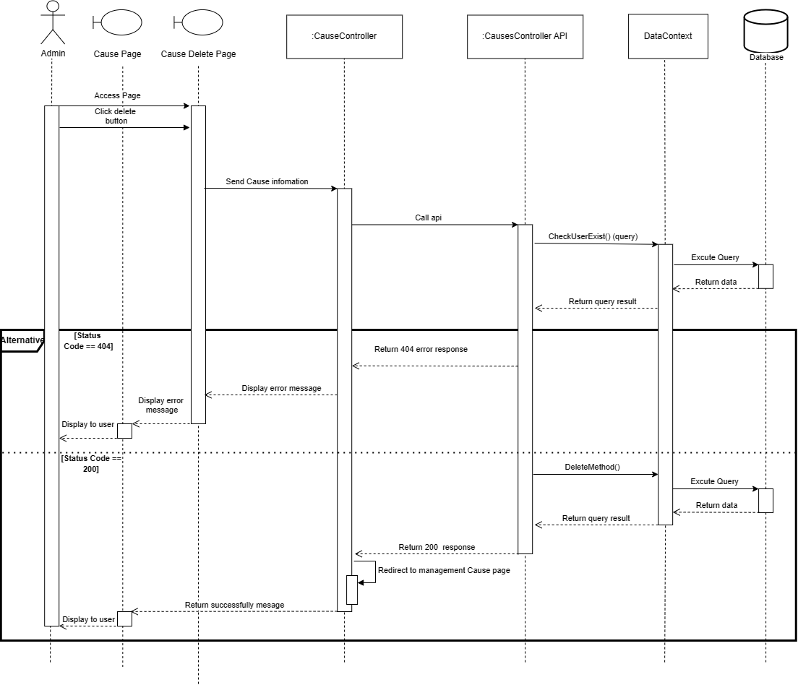

*Figure 25  Delete Cause*

#### Create PreventativeMeasure

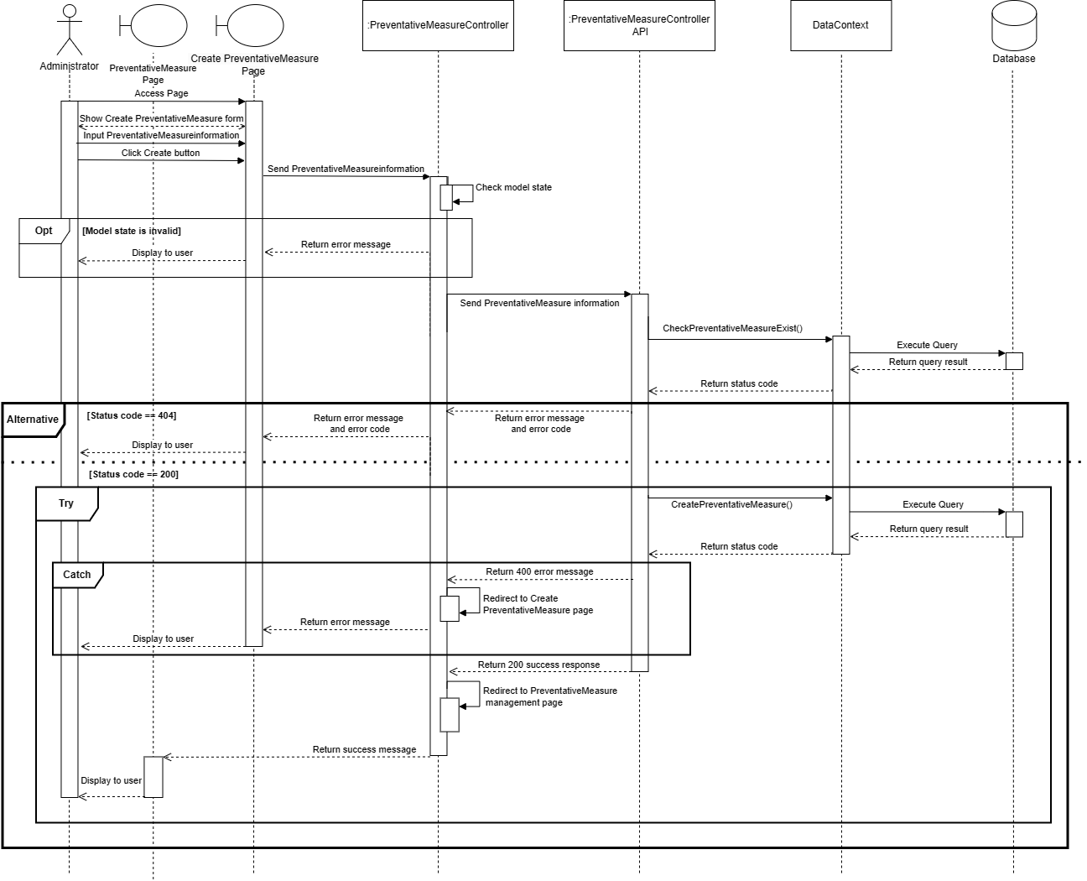

*Figure 27  Create PreventativeMeasure*

#### View PreventativeMeasure List

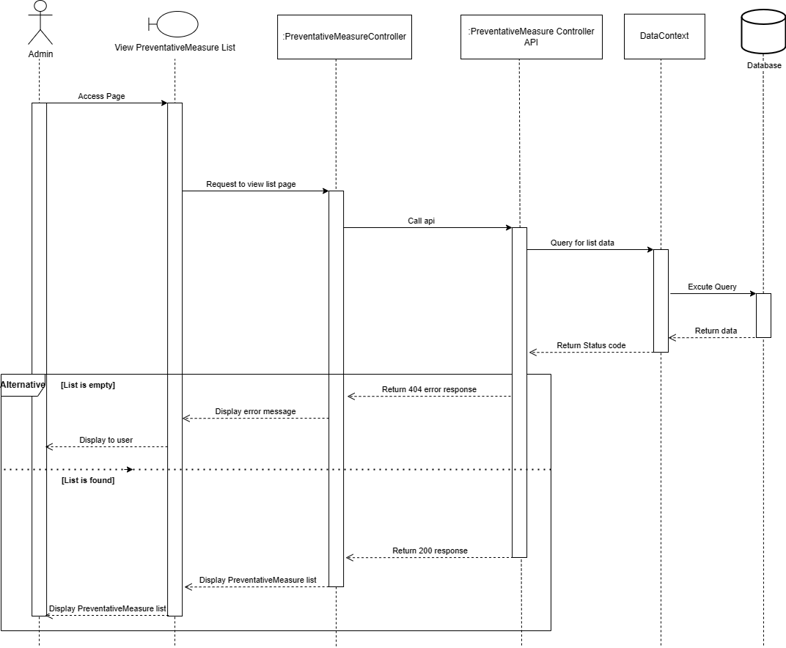

*Figure 28  View PreventativeMeasure List*

#### Update PreventativeMeasure

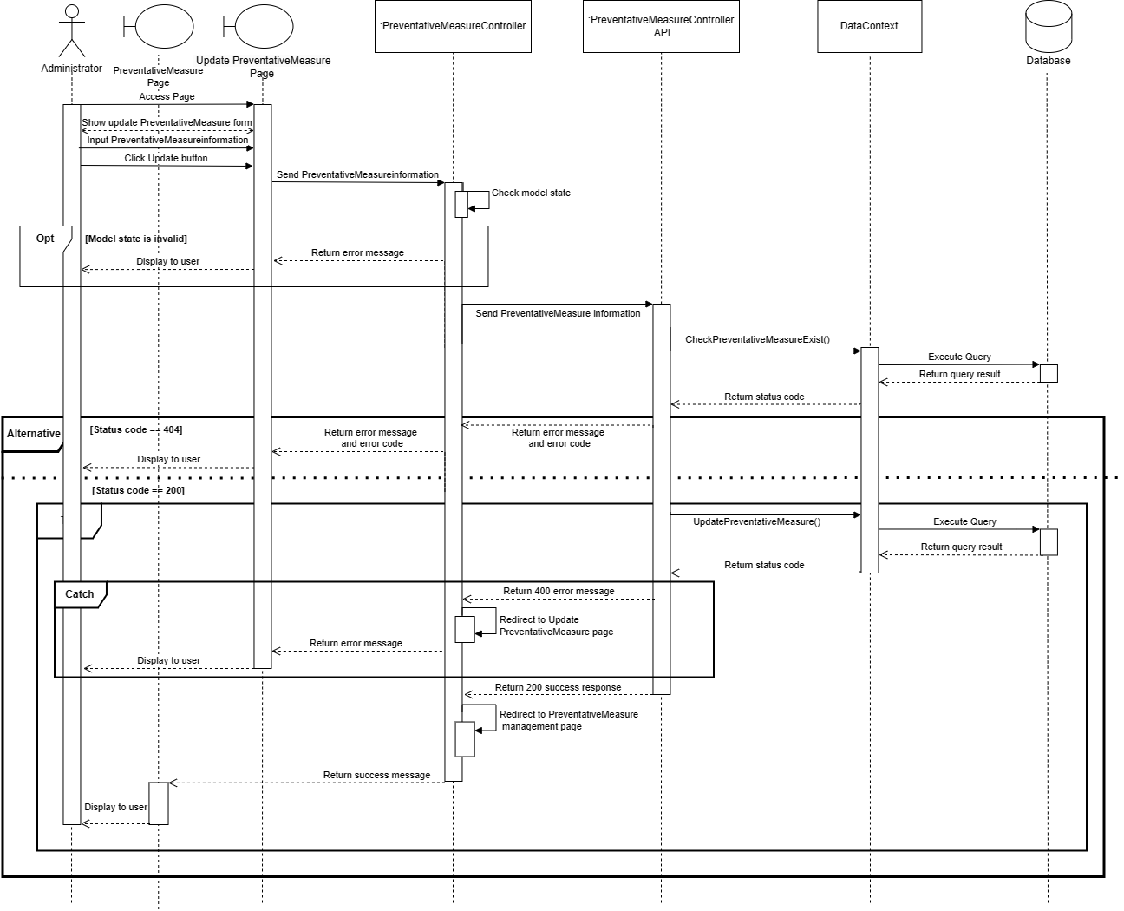

*Figure 29 Update PreventativeMeasure*

#### Delete PreventativeMeasure

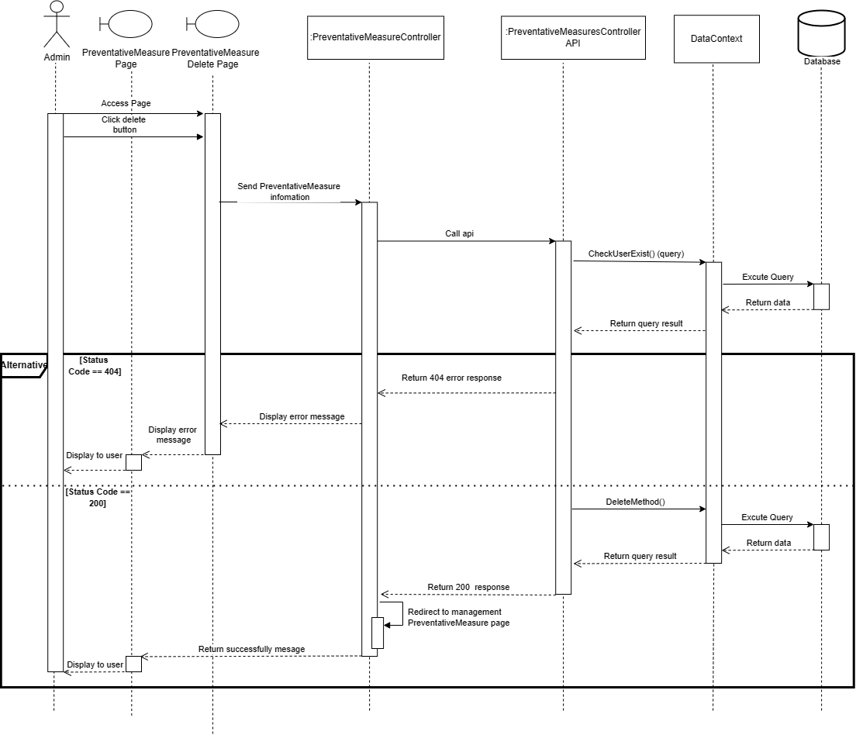

*Figure 30 Delete PreventativeMeasure*

#### View Upload History

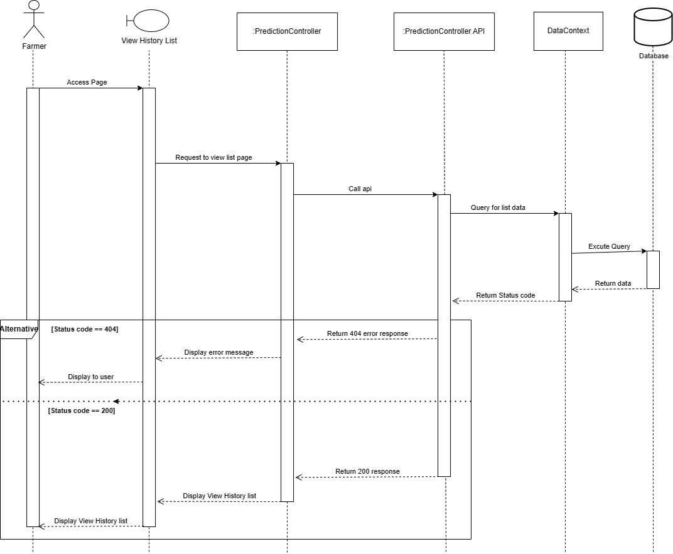

*Figure 31 View Upload History*

#### View Personal Profile

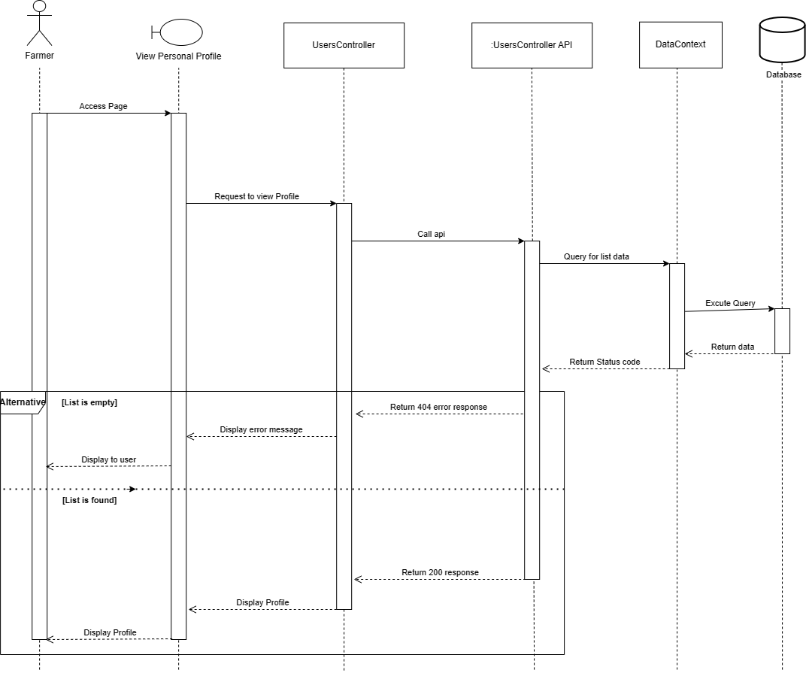

*Figure 32 View Personal Profile*

1. **Update Personal Profile**

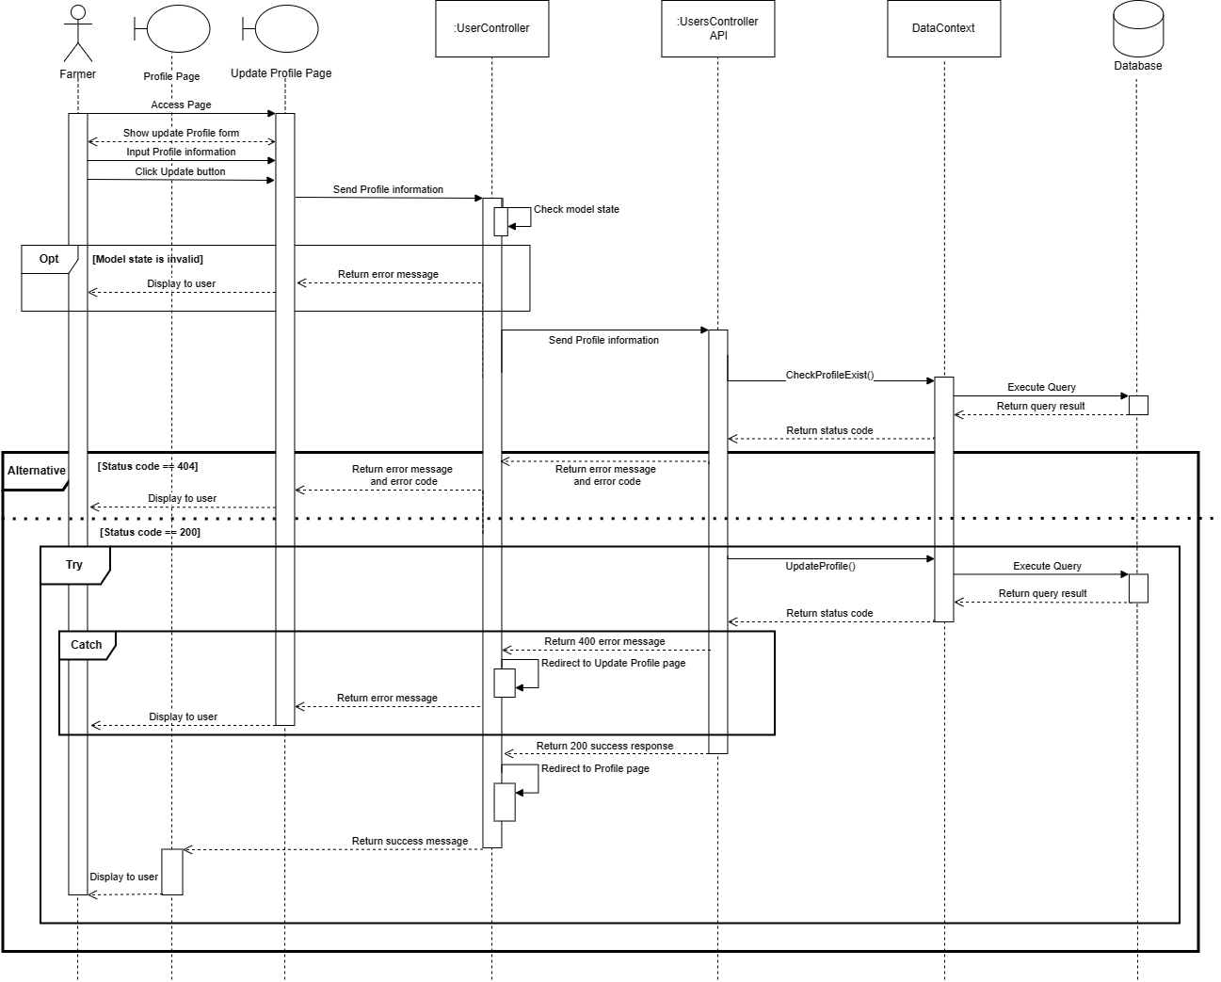

*Figure 33 Update Personal Profile*

#### View Prediction Result

*Figure 32 Create exam paper*

#### View Diease Detail

*Figure 33 Grade written questions*

#### View User List

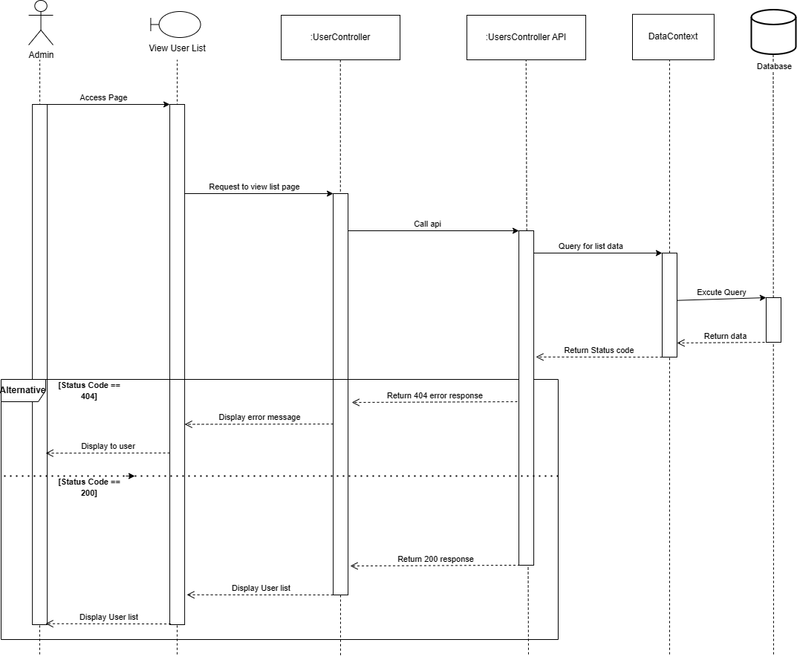

*Figure 34 View all requests add question bank*

#### Upload Image to predict

*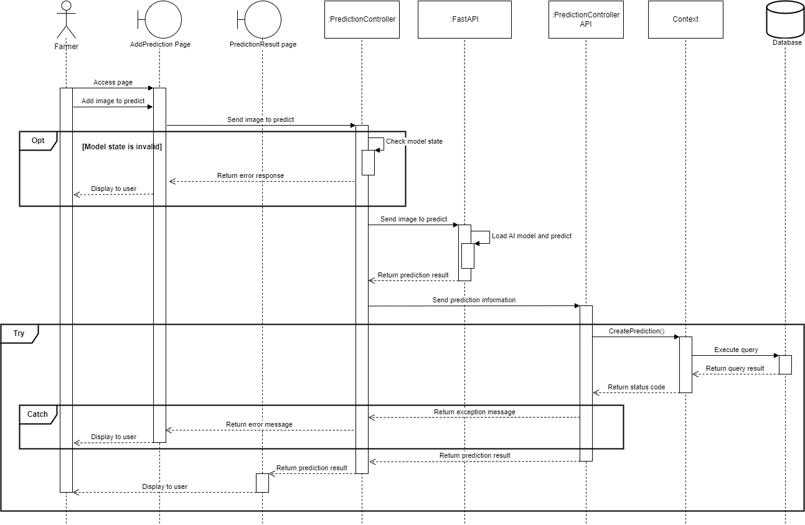*

## 4. Class Specifications

### 4.1 DiseaseController Class

#### 4.1.1 Class Methods

|  |  |  |
| --- | --- | --- |
| **No** | **Method** | **Description** |
| 1 | GetDiseases | Get a list of Disease |
| 2 | GetDisease | Get a single Disease |
| 3 | GetImages | Get list of Disease Images |
| 4 | GetCausesByDisease | Get list of Causes of Disease |
| 5 | GetRestCauses | Get list of Cause not tag by Disease |
| 6 | GetSymptomsByDisease | Get list of Symptoms of Disease |
| 7 | GetRestSymptoms | Get list of Symptoms not tag by Disease |
| 8 | GetPesticidesByDisease | Get list of Pesticides of Disease |
| 9 | GetRestPesticides | Get list of Pesticides not tag by Disease |
| 10 | GetMeasuresByDisease | Get list of Measures of Disease |
| 11 | GetRestMeasures | Get list of Measures not tag by Disease |
| 12 | PutDisease | Edit Disease |
| 13 | PostDisease | Update Disease |
| 14 | PostDiseaseImages | Add Images to Disease |
| 15 | DeleteDisease | Remove Disease |
| 16 | DeleteImages | Remove Disease Images |
| 17 | DiseaseExists | Check if Disease Exists |
| 18 | ImagesExists | Check if DiseaseImages Exists |
| 19 | SearchDisease | Find Disease by name |

#### 4.1.2 Attributes of the Class

|  |  |  |
| --- | --- | --- |
| **No** | **Attribute** | **Type** |
| 1 | \_mapper | IMapper |
| 2 | \_context | DataContext |

### 4.2 PesticideController Class

#### 4.2.1 Class Methods

|  |  |  |
| --- | --- | --- |
| **No** | **Method** | **Description** |
| 1 | PesticidesController | Class constructor, used to instantiate the controller and bind necessary attributes through dependency injection. |
| 2 | GetPesticides | A method get a list of all Pesticides with pagination support.  function GetPesticides{  retrieve a list of all pesticide if there is no total record then return “List Empty” error message  return a success message with a list of all pesticide  } |
| 3 | GetPesticide | A method to get a single pesticide.  function GetPesticide{  retrieve a single pesticide  if there is no total record then return “List Empty” error message  return a success message with a single pesticide  } |
| 4 | GetImages | A method to get a list of images of the Pesticides  function GetImages(){  retrieve a list of all pesticide images  if the id is not existed in the database then return “Id not found!” error message  if unexpected error occur then “Edit failed” error message  return “Update Successfully!” success message  } |
| 5 | PutPesticide | A method to edit Pesticide information.  function PutPesticide(){  edit information of the pesticide  if the id is not existed in the database then return “Id not found!” error message  if unexpected error occur then “Something is wrong while updating!” error message  return “Update Successfully!” success message  } |
| 6 | PostPesticide | A method to cretae new diease  function PostPesticide(){  create new Pesticide in database  if unexpected error occur then “Create failed” error message  return “Create success” success message  } |
| 7 | PostPesticideImages | A method to upload Image to Pesticide  function PutPesticide(){  upload image of the pesticide  if the id is not existed in the database then return “Id not found!” error message  if unexpected error occur then “Upload failed” error message  return “Update image Successfully!” success message  } |
| 8 | DeletePesticide | A method to remove Pesticide  function DeletePesicide(){  remove pesticide from the database  if the id is not existed in the database then return “Id not found!” error message  if unexpected error occur then “Delete failed” error message  return “Delete Successfully!” success message  } |
| 9 | DeleteImages | A method to remove Pesticide Image  function DeleteImages(){  remove pesticide image from the database  if the id is not existed in the database then return “Image  not found!” error message  if unexpected error occur then “Delete failed” error message  return “Delete Successfully!” success message  } |
| 10 | PesticideExists | A method to check if Pesticide exists  function PesticideExists(){  check if pesticide exist in the database  if the id is not existed in the database then return “Pesticide  not found!” error message  return Pesticde  } |
| 11 | ImagesExists | A method to check if Pesticide image exists  function ImagesExists(){  check if pesticide image exist in the database  if the id is not existed in the database then return “image  not found!” error message  return Pesticide image  } |

#### 4.2.2 Attributes of the Class

|  |  |  |
| --- | --- | --- |
| **No** | **Attribute** | **Type** |
| 1 | \_context | DataContext |
| 2 | \_mapper | IMapper |

### 4.3 PreventativeMeasuresControllerClass

#### 4.3.1 Class Methods

|  |  |  |
| --- | --- | --- |
| **No** | **Method** | **Description** |
| 1 | PreventativeMeasuresController | Class constructor, used to instantiate the controller and bind necessary attributes through dependency injection. |
| 2 | GetPreventativeMeasures | A method get a list of all PreventativeMeasures  function GetPreventativeMeasures{  retrieve a list of all pesticide if there is no total record then return “List Empty” error message  return a success message with a list of all PreventativeMeasures  } |
| 3 | GetPreventativeMeasure | A method to get a single PreventativeMeasures.  function GetPreventativeMeasure  {  retrieve a single PreventativeMeasures  if there is no total record then return “List Empty” error message  return a success message with a single PreventativeMeasures  } |
| 4 | GetImages | A method to get a list of images of the PreventativeMeasures  function GetImages(){  retrieve a list of all PreventativeMeasures images  if the id is not existed in the database then return “Id not found!” error message  if unexpected error occur then “Edit failed” error message  return “Update Successfully!” success message  } |
| 5 | PutPreventativeMeasure | A method to edit Pesticide information.  function PutPesticide(){  edit information of the pesticide  if the id is not existed in the database then return “Id not found!” error message  if unexpected error occur then “Something is wrong while updating!” error message  return “Update Successfully!” success message  } |
| 6 | PostPreventativeMeasure | A method to create new PreventativeMeasure  function PostPreventativeMeasure(){  create new PreventativeMeasure in database  if unexpected error occur then “Create failed” error message  return “Create success” success message  } |
| 7 | PostPreventativeMeasureImages | A method to upload Image to PostPreventativeMeasureImages  function PostPreventativeMeasureImages(){  upload image of the PreventativeMeasureImages  if the id is not existed in the database then return “Id not found!” error message  if unexpected error occur then “Upload failed” error message  return “Update image Successfully!” success message  } |
| 8 | DeletePreventativeMeasure | A method to remove PreventativeMeasure  function DeletePreventativeMeasure(){  remove pesticide from the database  if the id is not existed in the database then return “Id not found!” error message  if unexpected error occur then “Delete failed” error message  return “Delete Successfully!” success message  } |
| 9 | DeleteImages | A method to remove PreventativeMeasureImage  function DeleteImages(){  remove PreventativeMeasure image from the database  if the id is not existed in the database then return “Image not found!” error message  if unexpected error occur then “Delete failed” error message  return “Delete Successfully!” success message  } |
| 10 | PreventativeMeasureExists | A method to check if PreventativeMeasure exists  function PreventativeMeasureExists(){  check if PreventativeMeasure exist in the database  if the id is not existed in the database then return “PreventativeMeasure  not found!” error message  return PreventativeMeasure  } |
| 11 | ImagesExists | A method to check if PreventativeMeasure image exists  function ImagesExists(){  check if pesticide image exist in the database  if the id is not existed in the database then return “image  not found!” error message  return PreventativeMeasure image  } |

#### 4.3.2 Attributes of the class

|  |  |  |
| --- | --- | --- |
| **No** | **Attribute** | **Type** |
| 1 | \_context | DataContext |
| 2 | \_mapper | IMapper |

### 4.4 Symptom Class

#### 4.4.1 Class Methods

|  |  |  |
| --- | --- | --- |
| **No** | **Method** | **Description** |
| 1 | SymptomsController | Class constructor, used to instantiate the controller and bind necessary attributes through dependency injection. |
| 2 | GetSymptoms | A method get a list of all Symptom  function GetSymptoms(){  retrieve a list of all Symptoms if there is no total record then return “List Empty” error message  return a success message with a list of all Symptoms  } |
| 3 | GetSymptom | A method to get a single Symptom.  function GetSymptom  {       retrieve a single Symptom.  if there is no total record then return “List Empty” error message  return a success message with a single Symptom.  } |
| 4 | GetImages | A method to get a list of images of the Symptom.  function GetImages(){  retrieve a list of all Symptom.  images  if the id is not existed in the database then return “Id not found!” error message  if unexpected error occur then “Edit failed” error message  return “Update Successfully!” success message  } |
| 5 | PutSymptom | A method to edit Symptominformation.  function PutSymptom(){  edit information of the Symptom  if the id is not existed in the database then return “Id not found!” error message  if unexpected error occur then “Something is wrong while updating!” error message  return “Update Successfully!” success message  } |
| 6 | PostSymptom | A method to create new Symptom  function PostSymptom(){  create new Symptom in database  if unexpected error occur then “Create failed” error message  return “Create success” success message  } |
| 7 | PostSymptomImages | A method to upload Image to PostPreventativeMeasureImages  function PostPreventativeMeasureImages(){  upload image of the PreventativeMeasureImages  if the id is not existed in the database then return “Id not found!” error message  if unexpected error occur then “Upload failed” error message  return “Update image Successfully!” success message  } |
| 8 | DeleteSymptom | A method to remove PreventativeMeasure  function DeletePreventativeMeasure(){  remove pesticide from the database  if the id is not existed in the database then return “Id not found!” error message  if unexpected error occur then “Delete failed” error message  return “Delete Successfully!” success message  } |
| 9 | DeleteImages | A method to remove PreventativeMeasureImage  function DeleteImages(){  remove PreventativeMeasure image from the database  if the id is not existed in the database then return “Image not found!” error message  if unexpected error occur then “Delete failed” error message  return “Delete Successfully!” success message  } |
| 10 | SymptomExists | A method to check if Symptom exists  function SymptomExists(){  check if Symptom exist in the database  if the id is not existed in the database then return “Symptom not found!” error message  return Symptom  } |
| 11 | ImagesExists | A method to check if Symptom image exists  function ImagesExists(){  check if Symptom image exist in the database  if the id is not existed in the database then return “image  not found!” error message  return Symptom image  } |

#### 4.4.2 Attributes of the Class

|  |  |  |
| --- | --- | --- |
| **No** | **Attribute** | **Type** |
| 1 | \_context | Datacontext |
| 2 | \_mapper | IMapper |

### 4.5 CausesController Class

#### 4.5.1 Class Methods

|  |  |  |
| --- | --- | --- |
| **No** | **Method** | **Description** |
| 1 | CausesController | Class constructor, used to instantiate the controller and bind necessary attributes through dependency injection. |
| 2 | GetCauses | A method get a list of all Cause  function GetCauses(){  retrieve a list of all Causes if there is no total record then return “List Empty” error message  return a success message with a list of all Causes  } |
| 3 | GetCause | A method to get a single Cause.  function GetCause  {       retrieve a single Cause.  if there is no total record then return “List Empty” error message  return a success message with a single Cause.  } |
| 4 | GetImages | A method to get a list of images of the Cause.  function GetImages(){  retrieve a list of all Cause images  if the id is not existed in the database then return “Id not found!” error message  if unexpected error occur then “Edit failed” error message  return “Update Successfully!” success message  } |
| 5 | PutCause | A method to edit Cause Information.  function PutCause(){  edit information of the Cause  if the id is not existed in the database then return “Id not found!” error message  if unexpected error occur then “Something is wrong while updating!” error message  return “Update Successfully!” success message  } |
| 6 | PostCause | A method to create new Cause  function PostCause(){  create new Cause ptom in database  if unexpected error occur then “Create failed” error message  return “Create success” success message  } |
| 7 | PostCauseImages | A method to upload Image to Cause  function PostCauseImages(){  upload image of the Cause in database  if the id is not existed in the database then return “Id not found!” error message  if unexpected error occur then “Upload failed” error message  return “Update image Successfully!” success message  } |
| 8 | DeleteCause | A method to remove Cause  function DeleteCause(){  remove pesticide from the database  if the id is not existed in the database then return “Id not found!” error message  if unexpected error occur then “Delete failed” error message  return “Delete Successfully!” success message  } |
| 9 | DeleteImages | A method to remove Cause image  function DeleteImages(){  remove Cause image from the database  if the id is not existed in the database then return “Image not found!” error message  if unexpected error occur then “Delete failed” error message  return “Delete Successfully!” success message  } |
| 10 | CauseExists | A method to check if Cause exists  function CauseExists(){  check if Symptom exist in the database  if the id is not existed in the database then return “Symptom not found!” error message  return Cause  } |
| 11 | ImagesExists | A method to check if Cause image exists  function ImagesExists(){  check if Cause image exist in the database  if the id is not existed in the database then return “image  not found!” error message  return Symptom image  } |

#### 4.5.2 Attributes of the Class

|  |  |  |
| --- | --- | --- |
| **No** | **Attribute** | **Type** |
| 1 | \_context | Datacontext |
| 2 | \_mapper | IMapper |

### 4.6 DiseasesHasSymptomsController Class

#### 4.6.1 Class Methods

|  |  |  |
| --- | --- | --- |
| **No** | **Method** | **Description** |
| 1 | DiseasesHasSymptomsController | Class constructor, used to instantiate the controller and bind necessary attributes through dependency injection. |
| 2 | GetDiseasesHasSymptoms | This is a method used to return a list all the Diseases that has Symptoms |
| 3 | GetDiseasesHasSymptoms | This is a method used to return an Disease has Symptom entity |
| 4 | PostDiseasesHasSymptoms | This is a method used to add Symptom to a Disease |
| 5 | DeleteDiseasesHasSymptoms | This is a method used to remove a Symptom from a Disease |
| 6 | DiseasesHasSymptomsExists | This is a method used to check if a Sysmptom is exist to Disease |

#### 4.6.2 Attributes of the Class

|  |  |  |
| --- | --- | --- |
| **No** | **Attribute** | **Type** |
| 1 | \_context | DataContext |

### 4.7 DiseasesHasCausesControllerClass

#### 4.7.1 Class Methods

|  |  |  |
| --- | --- | --- |
| **No** | **Method** | **Description** |
| 1 | DiseasesHasCausesController | Class constructor, used to instantiate the controller and bind necessary attributes through dependency injection. |
| 2 | GetDiseasesHasCauses | This is a method used to return all the Disease has Causes |
| 3 | GetDiseasesHasCauses | This is a method used to return an Disease has Cause entity |
| 4 | PostDiseasesHasCauses | This is a method used to add Cause to a Disease |
| 5 | DeleteDiseasesHasCauses | This is a method used to remove a Cause from a Disease |
| 6 | DiseasesHasCausesExists | This is a method used to check if a Cause is exist to Disease |

#### 4.7.2 Attributes of the class

|  |  |  |
| --- | --- | --- |
| **No** | **Attribute** | **Type** |
| 1 | \_context | DataContext |

### 4.8 DiseasesNeedsMeasuresControllerClass

#### 4.8.1 Class Methods

|  |  |  |
| --- | --- | --- |
| **No** | **Method** | **Description** |
| 1 | DiseasesNeedsMeasuresController | Class constructor, used to instantiate the controller and bind necessary attributes through dependency injection. |
| 2 | GetDiseasesNeedsMeasures | This is a method used to return all the Disease has MeasuresMeasures |
| 3 | GetDiseasesNeedsMeasures | This is a method used to return an Disease has Measures entity |
| 4 | PostDiseasesNeedsMeasures | This is a method used to add Measure to a Disease |
| 5 | DeleteDiseasesNeedsMeasures | This is a method used to remove a Measure from a Disease |
| 6 | DiseasesNeedsMeasuresExists | This is a method used to check if a Measures exist to Disease |

#### 4.8.2 Attributes of the class

|  |  |  |
| --- | --- | --- |
| **No** | **Attribute** | **Type** |
| 1 | \_context | DataContext |

### 4.9 DiseasesNeedsPesticidesController Class

#### 4.9.1 Class Methods

|  |  |  |
| --- | --- | --- |
| **No** | **Method** | **Description** |
| 1 | DiseasesNeedsPesticidesController | Class constructor, used to instantiate the controller and bind necessary attributes through dependency injection |
| 2 | GetDiseasesNeedsPesticides | This is a method used to return all the Disease has Pesticides |
| 3 | GetDiseasesNeedsPesticides | This is a method used to return an Disease has Pesticides entity |
| 4 | PostDiseasesNeedsPesticides | This is a method used to add Pesticides to a Disease |
| 5 | DeleteDiseasesNeedsPesticides | This is a method used to remove a Pesticides from a Disease |
| 6 | DiseasesNeedsPesticidesExists | This is a method used to check if a Pesticides exist to Disease |

#### 4.9.2 Attributes of the Class

|  |  |  |
| --- | --- | --- |
| **No** | **Attribute** | **Type** |
| 1 | \_context | DataContext |

### 4.10 UsersController Class

#### 4.10.1 Class Methods

|  |  |  |
| --- | --- | --- |
| **No** | **Method** | **Description** |
| 1 | UsersController | Manages user-related operations, such as registration and login, acting as a mediator between the user interface and the business logic and data layers of a software system. |
| 2 | Login | Manages the authentication of user credentials, acting as a mediator between the user interface and the authentication and authorization mechanisms of a software system. |
| 3 | Register | Manages user registration, acting as a mediator between the user interface and the business logic and data layers of a software system. |
| 4 | ForgotPassword | Manages the process for users who have forgotten their password, providing a way for them to reset it. |
| 5 | ResetPassword | Allows users to reset their password, typically after they have requested a password reset. |
| 7 | Verify | Verifies the validity of user input or data, such as verifying the format of an email address or the completeness of a form. |
| 8 | GetUsers | Retrieves and returns user data from the system, typically for use in user management or administration tasks. |
| 9 | VerifyPasswordHash | Verifies the correctness of a password hash, which is a one-way encrypted version of a password used for secure storage and comparison. |

#### 4.10.2 Attributes of the Class

| **No** | **Attribute** | **Type** |
| --- | --- | --- |
| 1 | \_context | DataContext |
| 2 | \_services | IUserServices |
| 3 | \_emailService | IEmailService |
| 4 | \_webHostEnvironment | IWebHostEnvironment |
| 5 | \_server | IServer |

### 4.11 UserManagementController Class

#### 4.11.1 Class Methods

|  |  |  |
| --- | --- | --- |
| **No** | **Method** | **Description** |
| 1 | UserManagementController | Manages user-related operations and interactions, providing a centralized component for user management. |
| 2 | GetAllUserAsync | Retrieves all user data from the system asynchronously and returns it as list. |
| 3 | GetUserAsync | Retrieves user data for a specific user asynchronously and returns it. |
| 4 | CreateUserAsync | Creates a new user in the system asynchronously, typically after receiving user input and performing validation. |
| 5 | EditUserAsync | Updates an existing user's data in the system asynchronously, typically after receiving user input and performing validation. |
| 6 | DeleteUserAsync | Deletes an existing user from the system asynchronously, typically after receiving confirmation from the user. |

#### 4.11.2 Attributes of the Class

| **No** | **Attribute** | **Type** |
| --- | --- | --- |
| 1 | \_context | DataContext |
| 2 | \_services | IUserServices |
| 3 | \_mapper | IMapper |

### 4.12 PredictionsController Class

#### 4.12.1 Class Methods

|  |  |  |
| --- | --- | --- |
| **No** | **Method** | **Description** |
| 1 | PredictionsController | Manages predictions-related operations and interactions, providing a centralized component for predictions management. |
| 2 | GetPredictions | Retrieves all predictions data from the system and returns it as a collection or list. |
| 3 | GetPrediction | Retrieves a specific prediction's data from the system and returns it. |
| 4 | PutPrediction | Updates an existing prediction's data in the system, typically after receiving user input and performing validation. |
| 5 | PostPrediction | Creates a new prediction in the system, typically after receiving user input and performing validation. |
| 6 | DeletePrediction | Deletes an existing prediction from the system, typically after receiving confirmation from the user. |
| 7 | GetHistoryByFarmer | Retrieves the prediction history for a specific farmer from the system and returns it. |
| 8 | GetHistoryByExpert | Retrieves the prediction history for a specific expert from the system and returns it. |

#### 4.12.2 Attributes of the class

|  |  |  |
| --- | --- | --- |
| **No** | **Attribute** | **Type** |
| 1 | \_context | DataContext |

## 5. Data & Database Design

### 5.1 Database Design

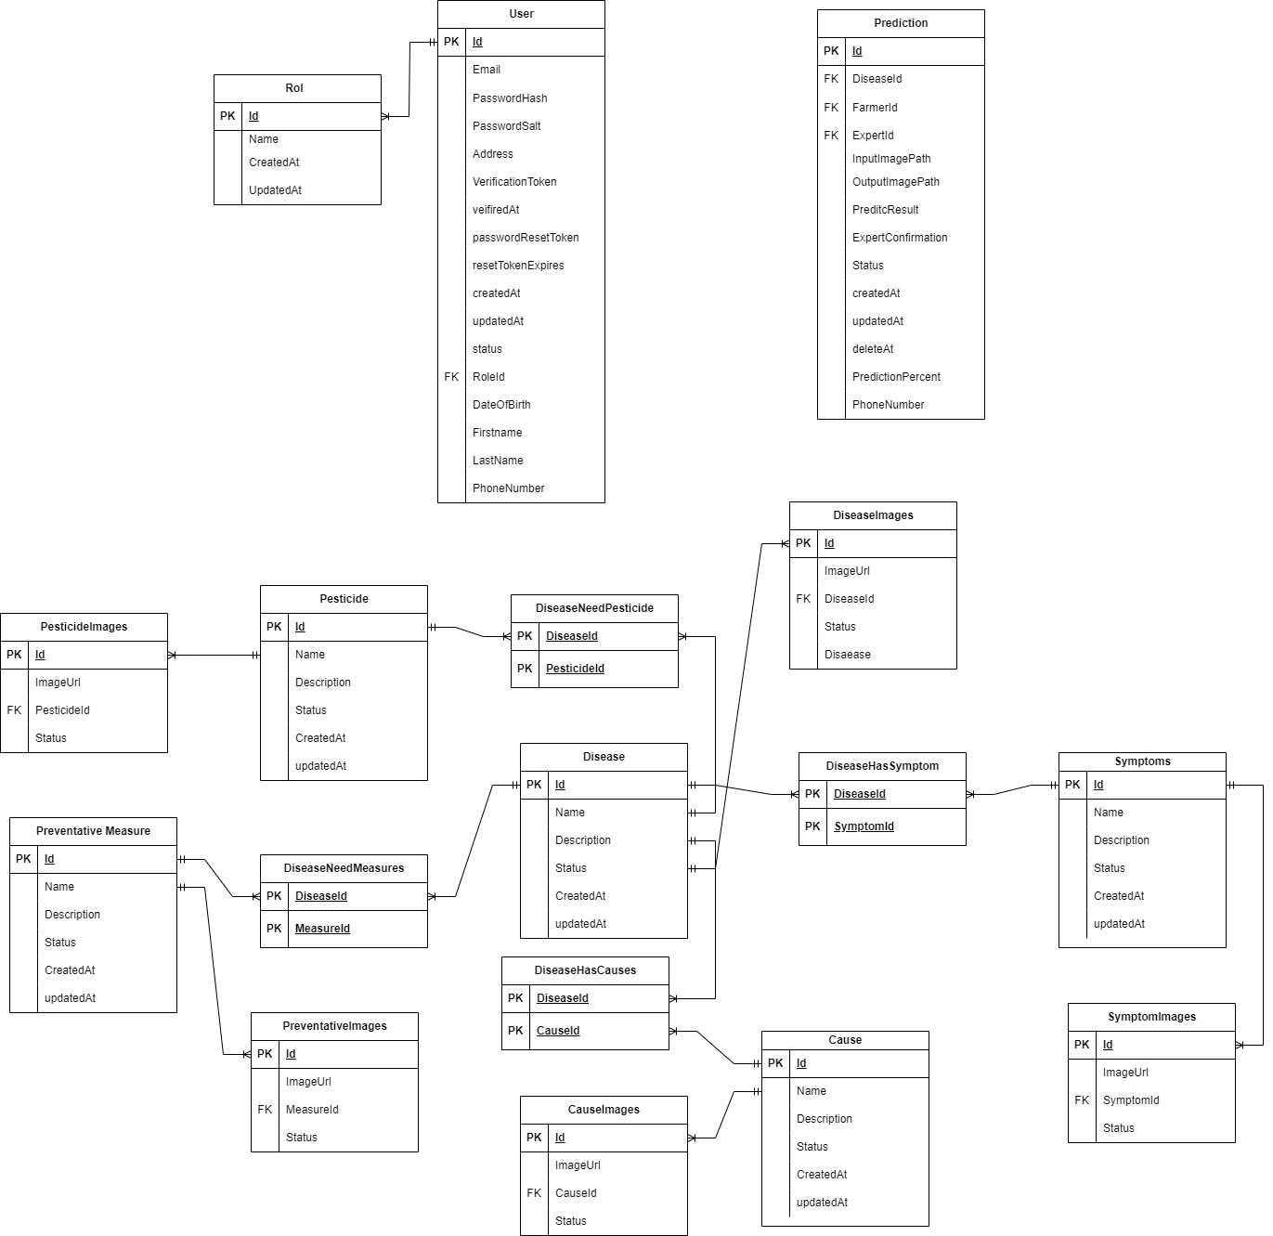

*Figure 128. Database Design Diagram[[5]](#footnote-5)*

#### a. Diseases Table

| **#** | **Field name** | **Type** | **Size** | **Unique** | **Not Null** | **PK/FK** | **Notes** |
| --- | --- | --- | --- | --- | --- | --- | --- |
| 1 | Id | BIGINT |  | ✓ | ✓ | PK |  |
| 2 | Name | TEXT | 191 |  | ✓ |  |  |
| 3 | Description | TEXT |  |  |  |  |  |
| 4 | Status | TEXT |  |  | ✓ |  |  |
| 5 | CreatedAt | TIMESTAMP |  |  | ✓ |  |  |
| 6 | UpdatedAt | TIMESTAMP |  |  | ✓ |  |  |

#### b. DiseasesHasSymptoms Table

| **#** | **Field name** | **Type** | **Size** | **Unique** | **Not Null** | **PK/FK** | **Notes** |
| --- | --- | --- | --- | --- | --- | --- | --- |
| 1 | DiseaseId | BIGINT |  | ✓ | ✓ | PK |  |
| 2 | SymptomId | BIGINT |  | ✓ | ✓ | PK |  |

#### c. Symptoms Table

| **#** | **Field name** | **Type** | **Size** | **Unique** | **Not Null** | **PK/FK** | **Notes** |
| --- | --- | --- | --- | --- | --- | --- | --- |
| 1 | Id | BIGINT |  |  | ✓ | PK |  |
| 2 | Title | TEXT | 50 |  | ✓ |  |  |
| 3 | Description | TEXT |  |  |  |  |  |
| 4 | Status | BIT |  |  | ✓ |  |  |
| 5 | CreatedAt | TIMESTAMP |  |  | ✓ |  |  |
| 6 | UpdatedAt | TIMESTAMP |  |  | ✓ |  |  |

#### d. Symptom Images Table

| **#** | **Field name** | **Type** | **Size** | **Unique** | **Not Null** | **PK/FK** | **Notes** |
| --- | --- | --- | --- | --- | --- | --- | --- |
| 1 | Id | BIGINT |  |  | ✓ | PK |  |
| 2 | ImageUrl | TEXT |  |  |  |  |  |
| 3 | SymptomId |  |  |  | ✓ | FK |  |
| 4 | Status | BIT |  |  | ✓ |  |  |

#### e. Preventative Meausre Table

| **#** | **Field name** | **Type** | **Size** | **Unique** | **Not Null** | **PK/FK** | **Notes** |
| --- | --- | --- | --- | --- | --- | --- | --- |
| 1 | Id | BIGINT |  |  | ✓ | PK |  |
| 2 | Title | TEXT | 50 |  | ✓ |  |  |
| 3 | Description | TEXT |  |  |  |  |  |
| 4 | Status | BIT |  |  | ✓ |  |  |
| 5 | CreatedAt | TIMESTAMP |  |  | ✓ |  |  |
| 6 | UpdatedAt | TIMESTAMP |  |  | ✓ |  |  |

#### f.  Diseases Needs Meausre Table

| **#** | **Field name** | **Type** | **Size** | **Unique** | **Not Null** | **PK/FK** | **Notes** |
| --- | --- | --- | --- | --- | --- | --- | --- |
| 1 | DiseaseId | BIGINT |  | ✓ | ✓ | PK |  |
| 2 | PreventativeMeasureId | BIGINT |  | ✓ | ✓ | PK |  |

#### g. PreventativeMeasuresImages Table

| **#** | **Field name** | **Type** | **Size** | **Unique** | **Not Null** | **PK/FK** | **Notes** |
| --- | --- | --- | --- | --- | --- | --- | --- |
| 1 | Id | BIGINT |  |  | ✓ | PK |  |
| 2 | ImageUrl | TEXT |  |  |  |  |  |
| 3 | PreventativeMeasureId | BIGINT |  |  | ✓ | FK |  |
| 4 | Status | BIT |  |  | ✓ |  |  |

#### h. PreventativeMeasure Table

| **#** | **Field name** | **Type** | **Size** | **Unique** | **Not Null** | **PK/FK** | **Notes** |
| --- | --- | --- | --- | --- | --- | --- | --- |
| 1 | Id | BIGINT |  |  | ✓ | PK |  |
| 2 | Title | TEXT | 50 |  | ✓ |  |  |
| 3 | Description | TEXT |  |  |  |  |  |
| 4 | Status | BIT |  |  | ✓ |  |  |
| 5 | CreatedAt | TIMESTAMP |  |  | ✓ |  |  |
| 6 | UpdatedAt | TIMESTAMP |  |  | ✓ |  |  |

#### i. DiseaseNeedPesticdesTable

| **#** | **Field name** | **Type** | **Size** | **Unique** | **Not Null** | **PK/FK** | **Notes** |
| --- | --- | --- | --- | --- | --- | --- | --- |
| 1 | DiseaseId | BIGINT |  | ✓ | ✓ | PK |  |
| 2 | PesticideId | BIGINT |  | ✓ | ✓ | PK |  |

#### j. PesticideImage Table

| **#** | **Field name** | **Type** | **Size** | **Unique** | **Not Null** | **PK/FK** | **Notes** |
| --- | --- | --- | --- | --- | --- | --- | --- |
| 1 | Id | BIGINT |  |  | ✓ | PK |  |
| 2 | ImageUrl | TEXT |  |  |  |  |  |
| 3 | PesticideId | BIGINT |  |  | ✓ | FK |  |
| 4 | Status | BIT |  |  | ✓ |  |  |

#### k. Causes Table

| **#** | **Field name** | **Type** | **Size** | **Unique** | **Not Null** | **PK/FK** | **Notes** |
| --- | --- | --- | --- | --- | --- | --- | --- |
| 1 | Id | BIGINT |  |  | ✓ | PK |  |
| 2 | Title | TEXT | 50 |  | ✓ |  |  |
| 3 | Description | TEXT |  |  |  |  |  |
| 4 | Status | BIT |  |  | ✓ |  |  |
| 5 | CreatedAt | TIMESTAMP |  |  | ✓ |  |  |
| 6 | UpdatedAt | TIMESTAMP |  |  | ✓ |  |  |

#### m. DiseaseHasCause Table

| **#** | **Field name** | **Type** | **Size** | **Unique** | **Not Null** | **PK/FK** | **Notes** |
| --- | --- | --- | --- | --- | --- | --- | --- |
| 1 | DiseaseId | BIGINT |  | ✓ | ✓ | PK |  |
| 2 | CauseId | BIGINT |  | ✓ | ✓ | PK |  |

#### m. CauseImage Table

| **#** | **Field name** | **Type** | **Size** | **Unique** | **Not Null** | **PK/FK** | **Notes** |
| --- | --- | --- | --- | --- | --- | --- | --- |
| 1 | Id | BIGINT |  |  | ✓ | PK |  |
| 2 | ImageUrl | TEXT |  |  |  |  |  |
| 3 | CauseId | BIGINT |  |  | ✓ | FK |  |
| 4 | Status | BIT |  |  | ✓ |  |  |

#### n. DiseaseImages Table

| **#** | **Field name** | **Type** | **Size** | **Unique** | **Not Null** | **PK/FK** | **Notes** |
| --- | --- | --- | --- | --- | --- | --- | --- |
| 1 | Id | BIGINT |  |  | ✓ | PK |  |
| 2 | ImageUrl | TEXT |  |  |  |  |  |
| 3 | DiseaseId | BIGINT |  |  | ✓ | FK |  |
| 4 | Status | BIT |  |  | ✓ |  |  |

#### o. User Table

| **#** | **Field name** | **Type** | **Size** | **Unique** | **Not Null** | **PK/FK** | **Notes** |
| --- | --- | --- | --- | --- | --- | --- | --- |
| 1 | Id | GUID |  | ✓ | ✓ | PK |  |
| 2 | Email | TEXT |  |  | ✓ |  |  |
| 3 | passwordHash | BINARY |  |  |  |  |  |
| 4 | passwordSalt | BINARY |  |  |  |  |  |
| 5 | Address | TEXT |  |  |  |  |  |
| 6 | verificationToken | TEXT |  |  |  |  |  |
| 7 | verifiedAt | TIMESTAMP |  |  |  |  |  |
| 8 | passwordResetToken | TEXT |  |  |  |  |  |
| 9 | resetTokenExpires | TIMESTAMP |  |  |  |  |  |
| 10 | CreatedAt | TIMESTAMP |  |  | ✓ |  |  |
| 11 | UpdatedAt | TIMESTAMP |  |  | ✓ |  |  |
| 12 | Status | BIT |  |  | ✓ |  |  |
| 13 | RoleId | BIGINT |  |  | ✓ | FK |  |
| 14 | DateOfBirth | DATETIME |  |  |  |  |  |
| 15 | FirstName | TEXT |  |  |  |  |  |
| 16 | LastName | TEXT |  |  |  |  |  |
| 17 | PhoneNumber | BIGINT |  |  | ✓ |  |  |

#### p. Role Table

| **#** | **Field name** | **Type** | **Size** | **Unique** | **Not Null** | **PK/FK** | **Notes** |
| --- | --- | --- | --- | --- | --- | --- | --- |
| 1 | Id | BIGINT |  |  | ✓ | PK |  |
| 2 | Name | TEXT |  |  | ✓ |  |  |
| 3 | CreatedAt | TIMESTAMP |  |  | ✓ |  |  |
| 4 | UpdatedAt | TIMESTAMP |  |  | ✓ |  |  |

#### q. Prediction Table

| **#** | **Field name** | **Type** | **Size** | **Unique** | **Not Null** | **PK/FK** | **Notes** |
| --- | --- | --- | --- | --- | --- | --- | --- |
| 1 | Id | BIGINT |  |  | ✓ | PK |  |
| 2 | DiseaseId | BIGINT |  |  | ✓ |  |  |
| 3 | FarmerId | GUID |  |  | ✓ |  |  |
| 4 | ExpertId | GUID |  |  | ✓ |  |  |
| 5 | InputImagePath | TEXT |  |  | ✓ |  |  |
| 6 | OutputImage | TEXT |  |  | ✓ |  |  |
| 7 | PredictResult | TEXT |  |  |  |  |  |
| 8 | ExpertConfirmation | TEXT |  |  |  |  |  |
| 9 | Status | BIT |  |  | ✓ |  |  |
| 10 | CreatedAt | TIMESTAMP |  |  | ✓ |  |  |
| 11 | UpdatedAt | TIMESTAMP |  |  | ✓ |  |  |
| 12 | DeletedAt | TIMESTAMP |  |  | ✓ |  |  |
| 13 | PredictionPercent | TEXT |  |  | ✓ |  |  |
| 14 | PhoneNumber | BIGINT |  |  | ✓ |  |  |

### 5.2 Data File Design

|  |  |  |  |
| --- | --- | --- | --- |
| **#** | **File Name** | **Type** | **Notes** |
| 1 | PRN231DiseaseService.mdf | SQL Server Database Primary Data File |  |
| 2 | PRN231DiseaseService.log.mdf | SQL Sever Database Transaction Log File |  |
| 3 | PRN231PredictionService.mdf | SQL Server Database Primary Data File |  |
| 4 | PRN231PredictionService.log.mdf | SQL Server Database Transaction Log File |  |
| 5 | PRN231UserService.mdf | SQL Server Database Primary Data File |  |
| 6 | PRN231UserService.log.mdf | SQL Sever Database Transaction Log File |  |

# V. Software Testing Documentation

## 1. Overall Description

### 1.1 Test Model

A testing model that would fit this process is the Agile testing model. The Agile testing model involves continuous testing throughout the development cycle, with testing and development occurring simultaneously. Testers work closely with developers and other team members to identify and fix defects as they arise.

The Agile testing model includes the following stages:

Test planning: Testers work with the development team to define the scope of testing, identify test objectives, and determine the testing strategy.

Test design: Testers create test cases based on the requirements and design specifications. They also create automated test scripts to facilitate faster and more efficient testing.

Test execution: Testers execute the test cases and report any defects they find. They also work with the development team to resolve any defects and ensure that the product meets the requirements.

Test reporting: Testers create test reports that document the testing process and provide insights into the quality of the product. They also provide recommendations for improving the product.

The Agile testing model is well-suited to an iterative software development process because it emphasizes continuous testing and collaboration between testers and developers. This approach helps ensure that defects are identified and resolved early in the development cycle, saving time and reducing costs.

### 1.2 Testing Levels

*[List out and describe all testing levels that would be performed in the project: unit testing, integration testing, system testing, acceptance testing (alpha, beta),..]*

Unit Testing: This is the first level of testing and involves testing individual software modules or components in isolation. The purpose of unit testing is to verify that each unit of code works as expected and meets the specified requirements.

Integration Testing: This level of testing involves testing the interaction between different modules or components of the software. The goal of integration testing is to ensure that the modules can work together seamlessly and that the integrated system functions as intended.

System Testing: This level of testing involves testing the entire system as a whole, including all modules and components. The goal of system testing is to ensure that the system meets all the specified requirements and performs as expected in real-world scenarios.

Acceptance Testing: This is the final level of testing, and it involves testing the software in the production-like environment to ensure that it meets the user's requirements and expectations.

### 1.3 Testing Types

Functional Testing: This level of testing is focused on verifying the functional requirements of the software. It involves testing the software's behavior against the specified functional requirements, such as user interface, database interactions, and other functionality.

Integration Testing: This level of testing is focused on verifying that the different components or modules of the software are working together as expected. It involves testing the integration

User Interface test focuses on verifying the user interface of a software application. The purpose of UI testing is to ensure that the application's interface is user-friendly, easy to navigate, and meets the user's requirements.

Performance Testing: This testing is executed during the testing phase of the software development process. It is performed to test the software's performance under various workloads and scenarios to ensure that it performs optimally.

## 2. Test Plan

### 2.1 Test Stages

*common test are executed]*

|  |  |  |  |  |
| --- | --- | --- | --- | --- |
| **Type of Test** | **Stage of Test** | | | |
| ***Unit*** | ***Integration*** | ***System*** | ***Acceptance*** |
| Function Test | X | X | X | X |
| User Interface test | X |  | X |  |
| Performance Tests | X | X |  |  |
| Integration Testing |  |  | X | X |
| <Security test> | X |  | X |  |
| <Data integrity test> |  | X | X |  |

### 2.2 Resources

#### a. Human Resources

*[List and provide the details on roles and responsibilities of the project members who would involve in testing works, in the table format as below]*

|  |  |  |
| --- | --- | --- |
| **Worker/Doer** | **Role** | **Specific Responsibilities/Comments** |
| NhiPM | Tester | Responsible for testing system Server API and Web UI |

#### b. Environment

*[List and provide the details about the tools (software, hardware, infrastructure) which the project would use for testing. The information can be provided in the table format as below]*

|  |  |  |  |
| --- | --- | --- | --- |
| **Purpose** | **Tool** | **Provider** | **Version** |
| Unit Testing | Manual | Team |  |
| Acceptance Testing | Manual | Team |  |
| Integration Testing | Manual | Team |  |
| System Testing | Manual | Team |  |

### 2.3 Test Milestones

|  |  |  |  |
| --- | --- | --- | --- |
| **Milestone Task** | **Effort (md)** | **Start Date** | **End Date** |
| Complete the Unit Test | 7 | 9/3/2023 | 19/3/2023 |
| Complete the Acceptance Testing | 3 | 16/3/2023 | 18/3/2023 |
| Integration Testing | 3 | 19/3/2023 | 24/3/2023 |
| Complete the System Testing | 7 | 27/2023 | 30/3/2023 |

### 2.4 Deliverables

|  |  |  |
| --- | --- | --- |
| No | Deliverables | Due Date |
| 1 | Test Plan | 30/3/2023 |
| 2 | Unit Test Cases: Report5\_Unit Test Case.xls | 30/3/2023 |
| 3 | Other Test Cases: Report5\_ Test Case.xls] | 30/3/2023 |

## 3. Test Cases

* Unit Test Cases: Report5\_Unit Test Case.xls
* Other Test Cases: Report5\_ Test Case.xls

## 4. Test Reports

### Unit Test Case



*Figure 129. Unit test report*

### Other Test Cases

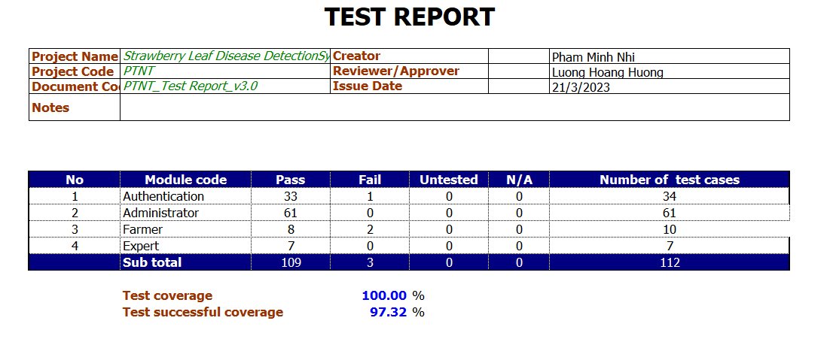

*Figure 130. Other test case report*

# VI. Release Package & User Guides

## 1. Deliverable Package

### 1.1 Source codes & documents

| **No.** | **Items** | **Sub-Items** | **Type** | **Version** |
| --- | --- | --- | --- | --- |
| ***Code Package*** | | | | |
| 1 | ExamEdu system | ExamEdu Web | New | 1.0 |
| ExamEdu API | New | 1.0 |
| 2 | ExamEdu Cheating Prediction | ExamEdu Prediction Model | New | 1.0 |
| ExamEdu Training Code | New | 1.0 |
| ***Database*** | | | | |
| 1 | Tables | ExamEdu.tar | New | 1.0 |
|
|
|
| ***Documents*** | | | | |
| 1 | Report 1 |  | New | 1.0 |
| 2 | Report 2 |  | New | 1.0 |
| 3 | Report 3 |  | New | 1.0 |
| 4 | Report 4 |  | New | 1.0 |
| 5 | Report 5 |  | New | 1.0 |
| 6 | Report 6 |  | New | 1.0 |
| 7 | Report 7 |  | New | 1.0 |

### 1.2 Known Issues, Limitations & Restrictions

* The ExamEdu web application needs to use the Safe Exam Browser to take the exam.
* The system needs to be connected to the internet during use.

## 2. Installation Guides

### 2.1 System Requirements

For server:

* Operating system: Windows 10
* Interpreter/compiler: Python 3.8, .NET 5
* Storage: 40GB HDD available
* RAM: 4GB or higher
* CPU: Intel Core i5-825U or higher
* Database: SQL Server Management Studio or newer

For web client:

* Operating system: Windows 10, macOS 10.13
* Browser: Google Chrome 90, Safari 14.0.3 (macOS), Safari 14 (iOS), Microsoft Edge 89.0 or newer.

### 2.2 Setup Files

* examedu.zip
* examedu-client.zip
* examedu.tar
* deepLearningAPI.zip
* .vsconfig

### 2.3 Installation Instruction

1. Install SQL Management Studio

Download latest SQL Management Studio version at [Download Page](https://www.enterprisedb.com/downloads/postgres-postgresql-downloads), run the installer to complete the setup. 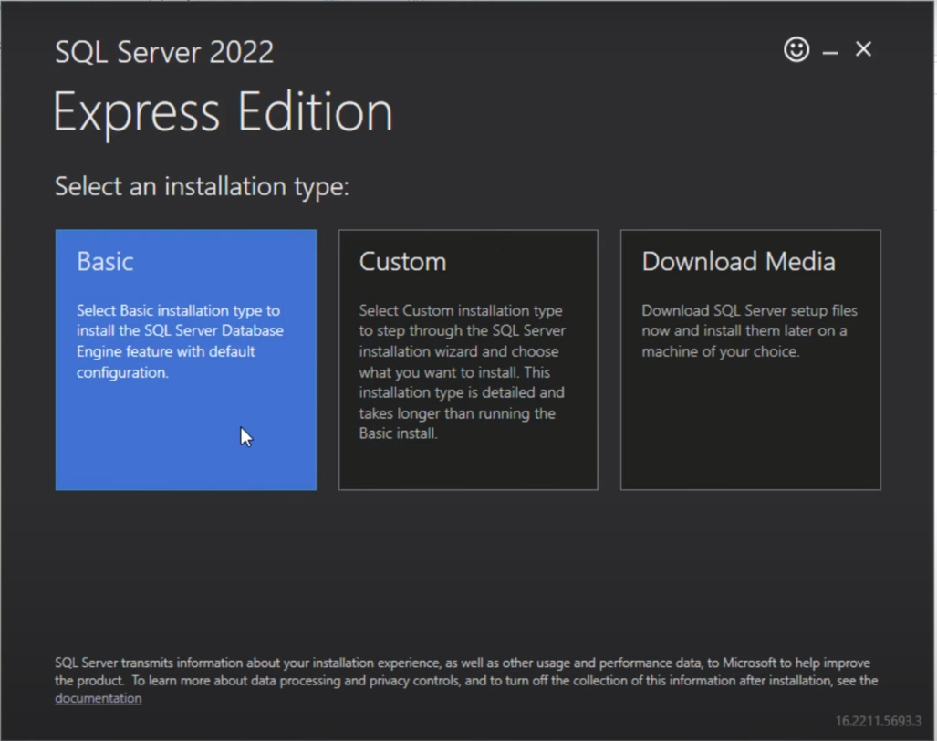

Figure SQL Management Studio setup

Then continue to install the basic Version.

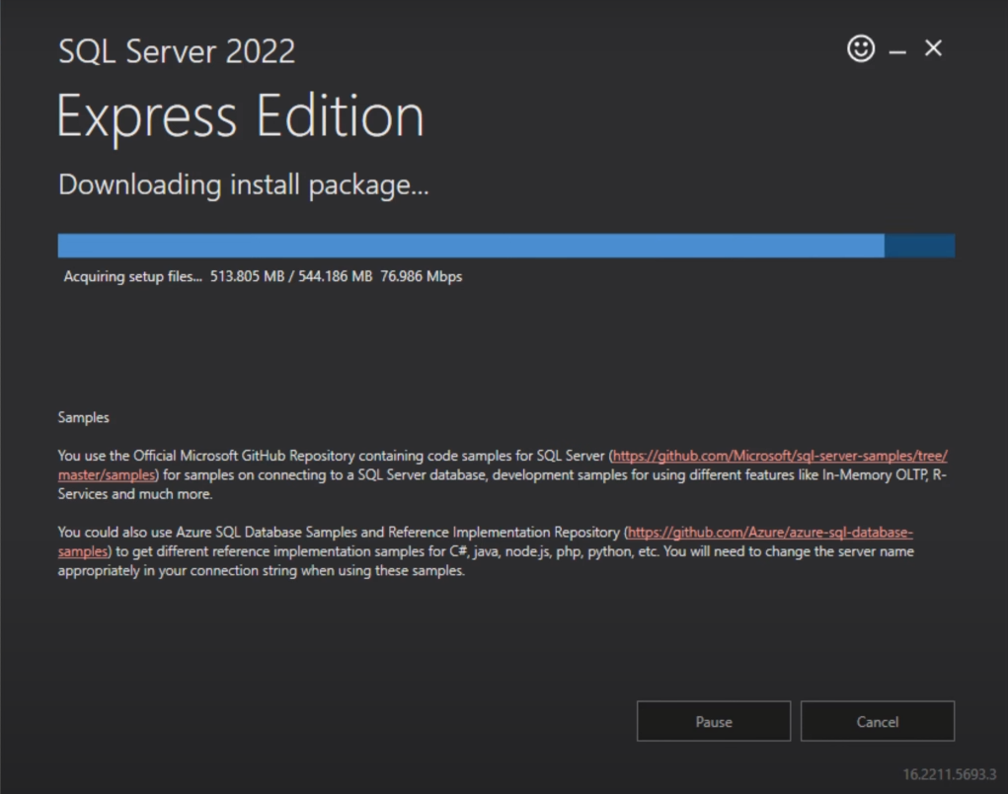

Figure SQL Management Studio installation process

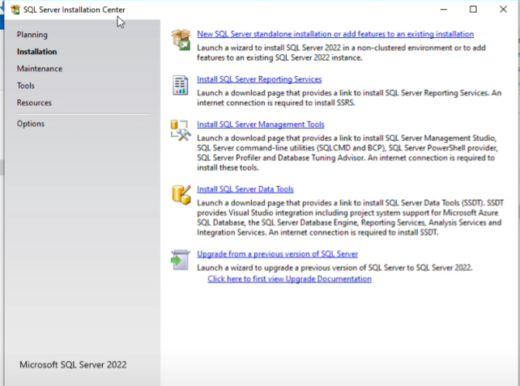

Figure 3 SQL Management Studio Installation Center

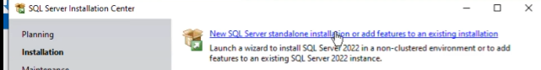

Figure 4 SQL Management Studio Installation Center

Next Click on the first option “New SQL Server standalone installation or add features to an existing installation”

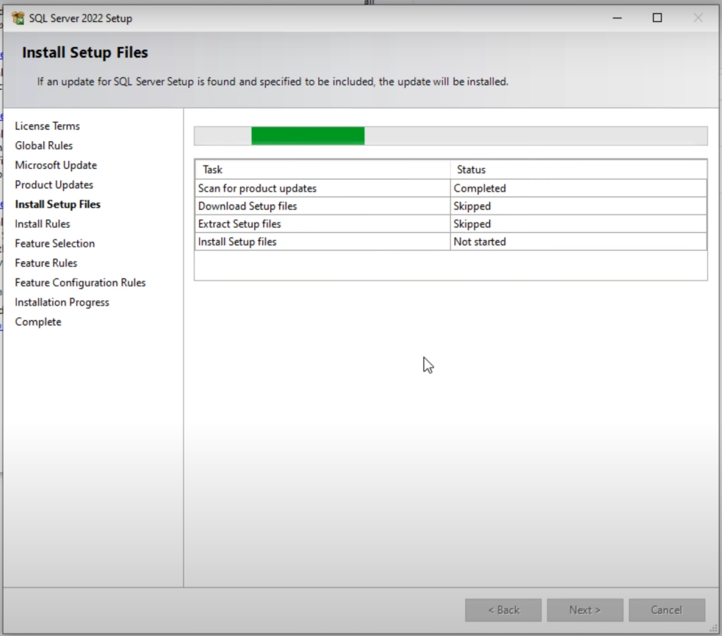

Figure 5 SQL Management Studio Set Up Files

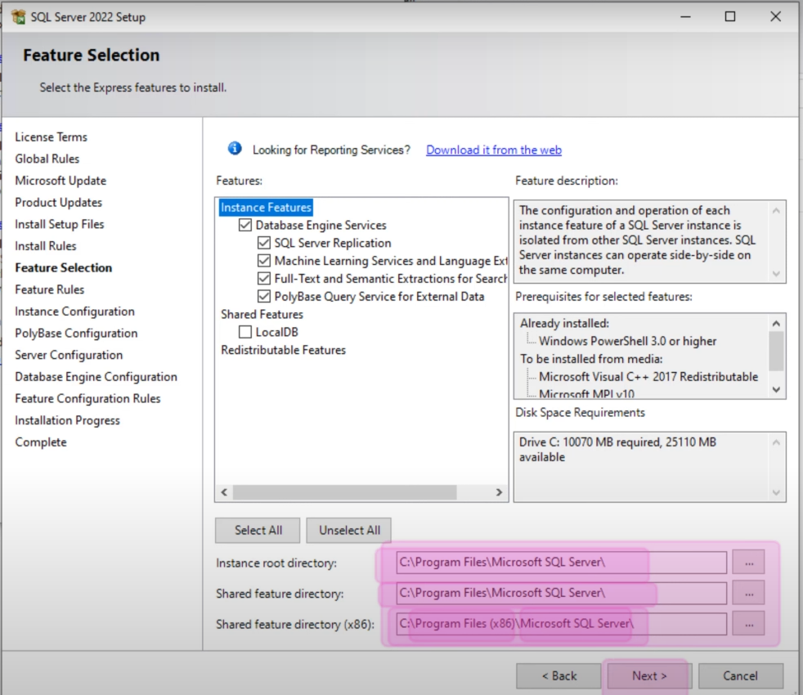

Figure 6 SQL Management Studio Set Up Files-Feature Selection

Continue Setting up files and check for the system files directory

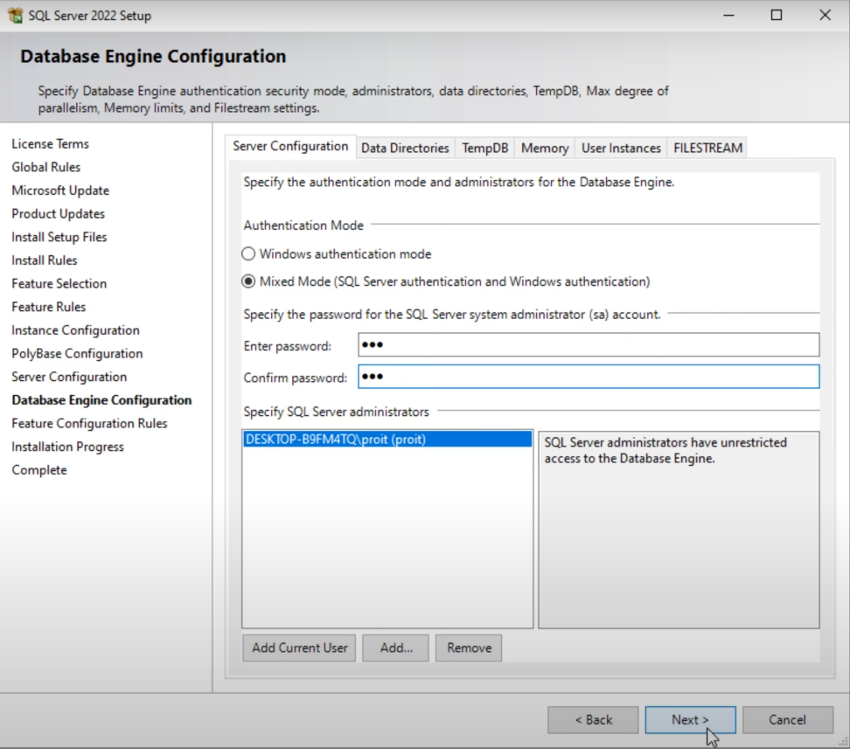

Figure 7 SQL Management Studio Set Up Files-Database Engine Configuration

Enter password for the SQL Server system Administrator (sa) Account

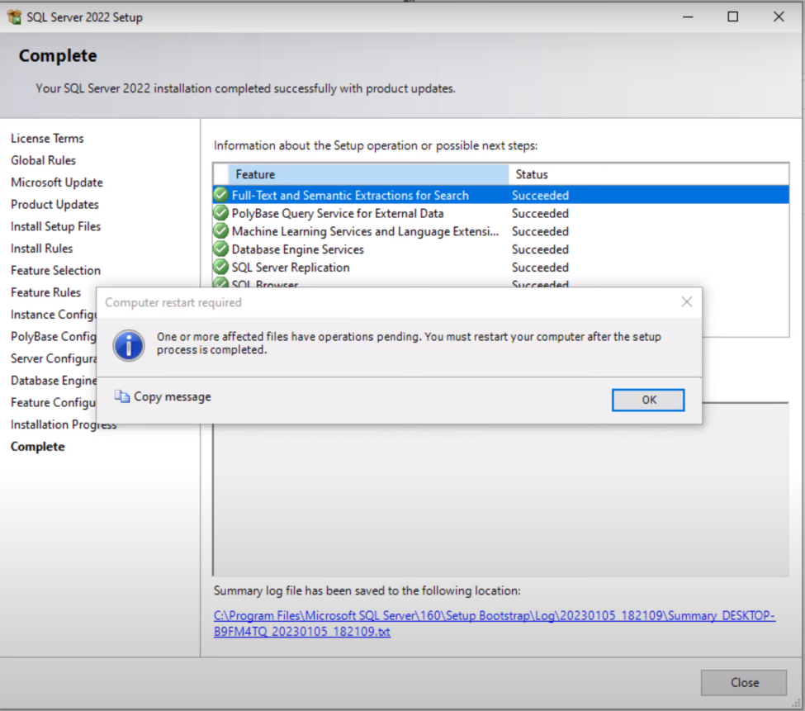

Figure 8 SQL Management Studio Set Up Files-Complete

Complete setting file then Restart Computer to finish up the installation process.

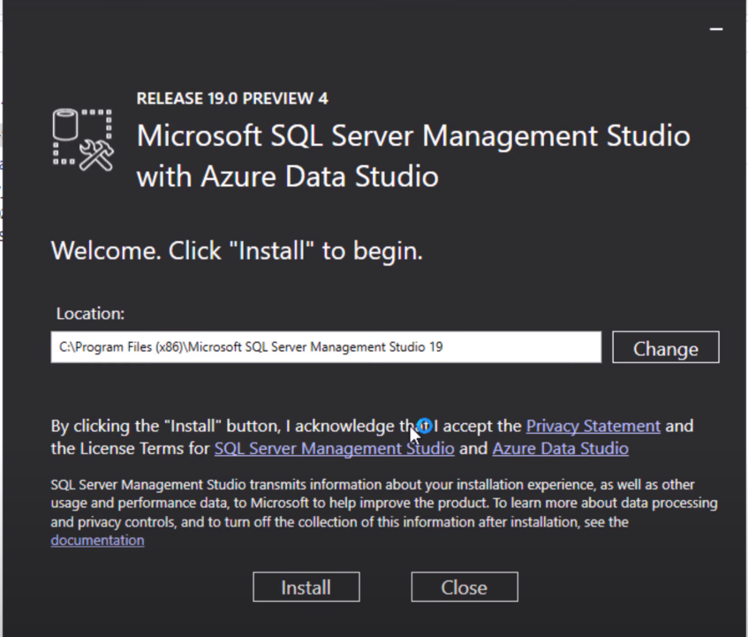

Figure 9 SQL Management Studio with Azure Data Studio

Install Microsoft SQL Server Management Studio with Azure Data Studio

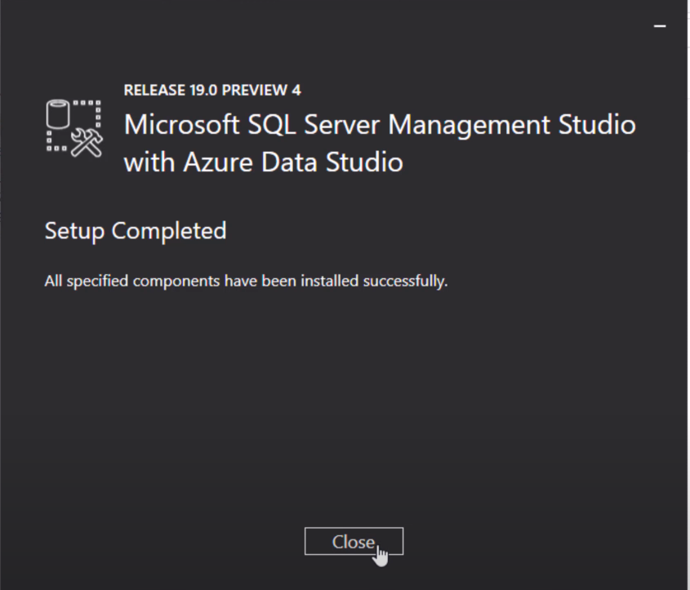

Figure 10 SQL Management Studio with Azure Data Studio

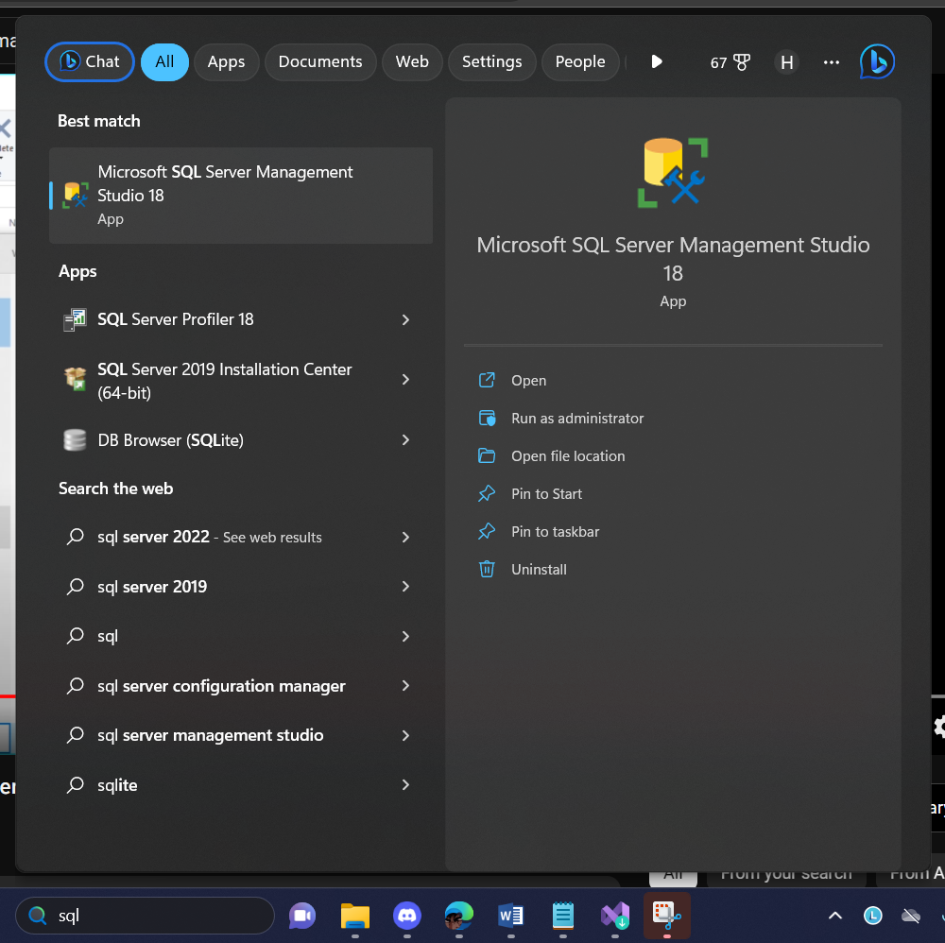

Figure 11 Open SQL Server Management Studio

Open up SQL Server Management Studio

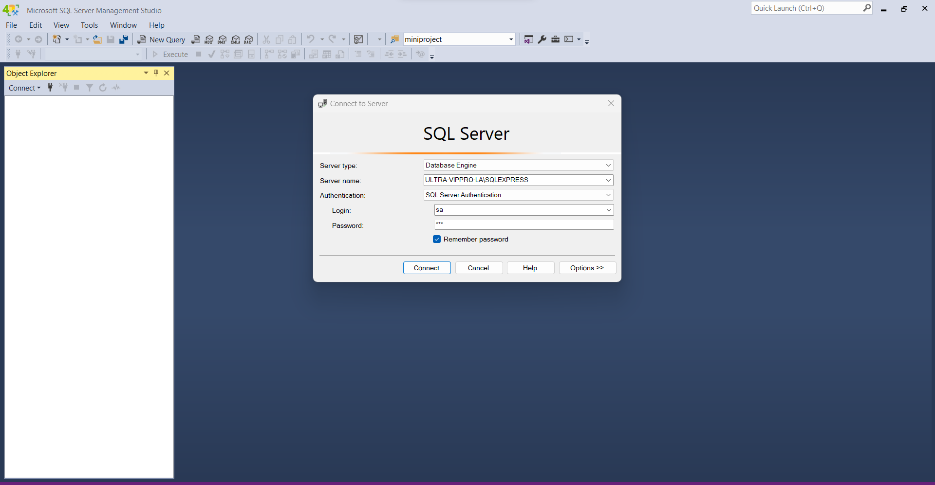

Figure 11 SQL Server Management Studio Authentication

Select preferred Server Name and enter password for the SQL Server system Administrator (sa) Account (Fig 7)

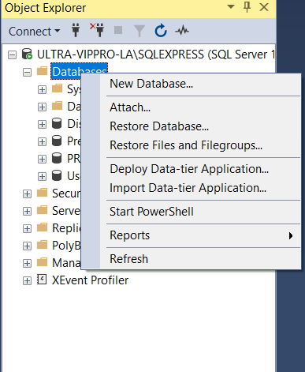

Figure 12 Attach database

After successfully logged in, Right click on Database and select Attach…

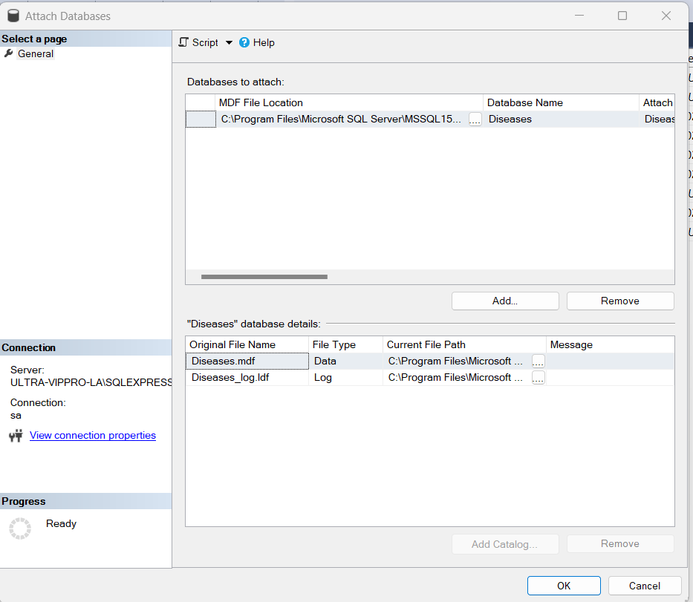

Figure 13 Attach database

Click Add.. then select the Data files with Database Name(PRN231DiseaseService, Disease, User, Prediction) then click OK

1. Install Python environment

Download the latest Python version from Microsoft Store if you’re on Window os

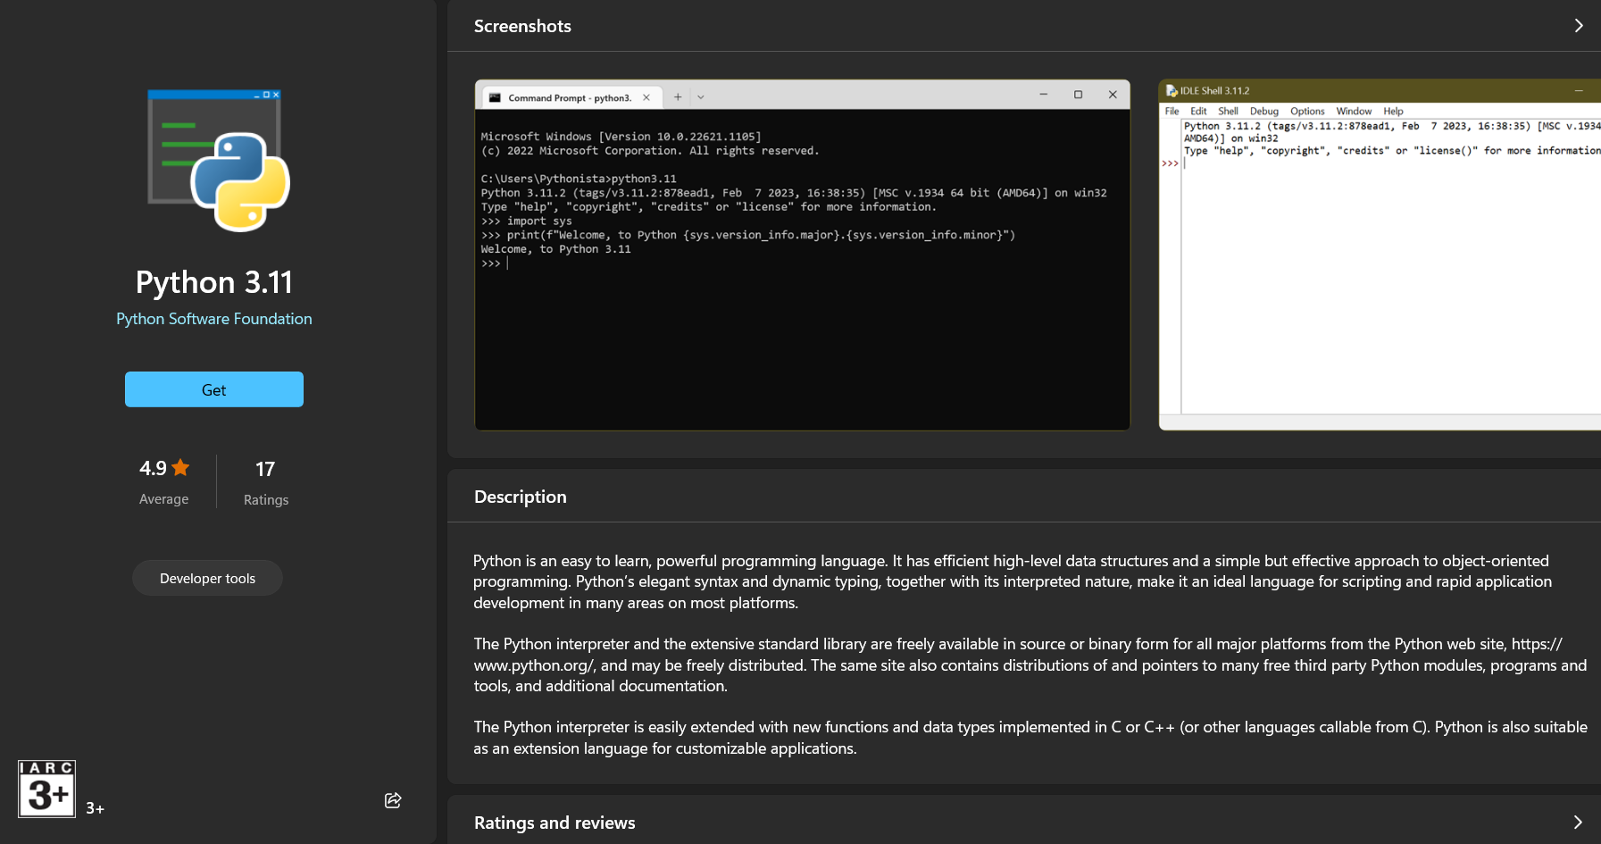

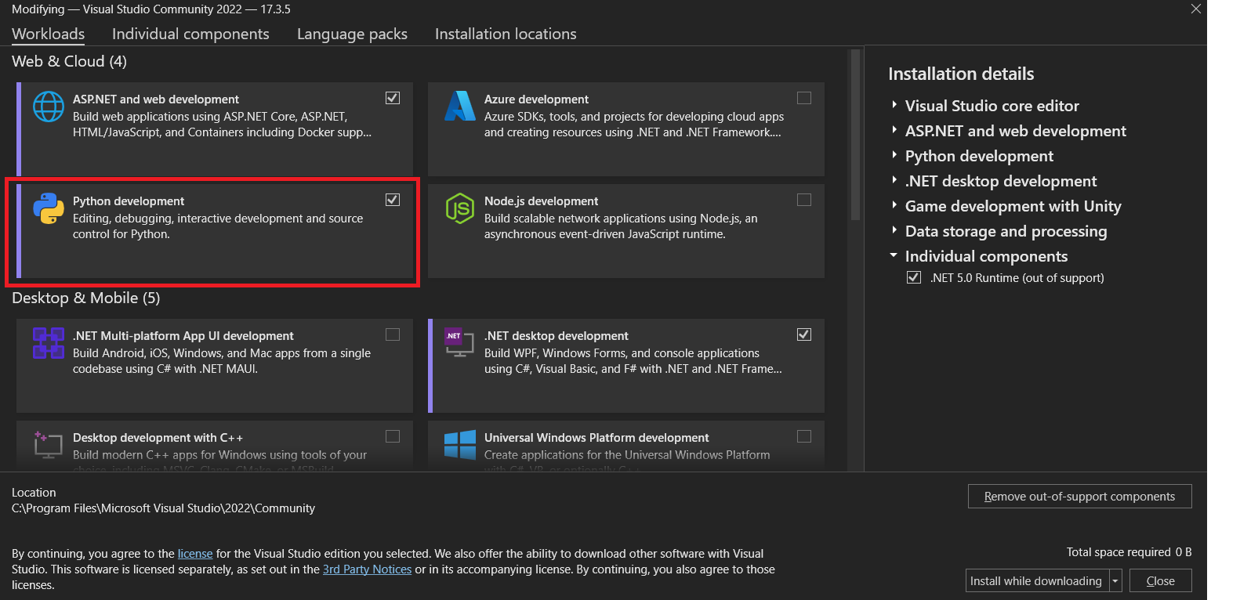

Install Python development in Visual Studio Installer

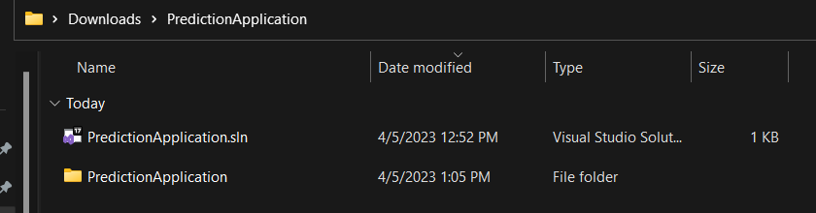

Open “PredictionApplication” with Visual Studio

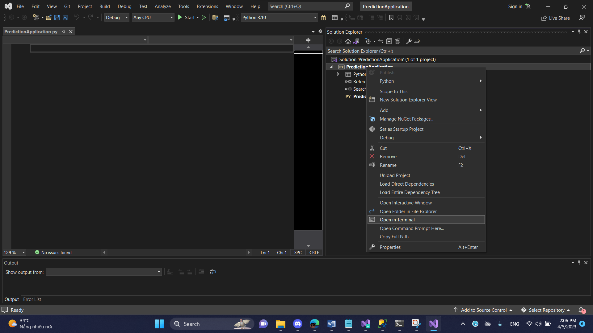

Right-click on Start up file “PredictionApplication” and open in Terminal

And enter the following commands:

pip install uvicorn

pip install fastapi

pip install tensorflow

pip install Pillow

pip install python-multipart

Enter python -m uvicorn main:app –reload to run

Copy URL “ <http://127.0.0.1:8000> ” and paste it onto your browser, you will see the message "{"message":"Hello World"}" . Like this model is loaded.

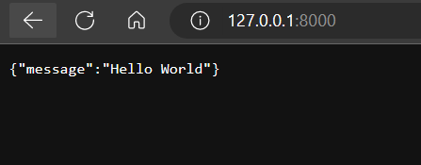

If you encounter error like this

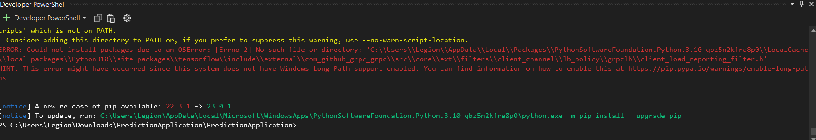

Please follow the instructions below:

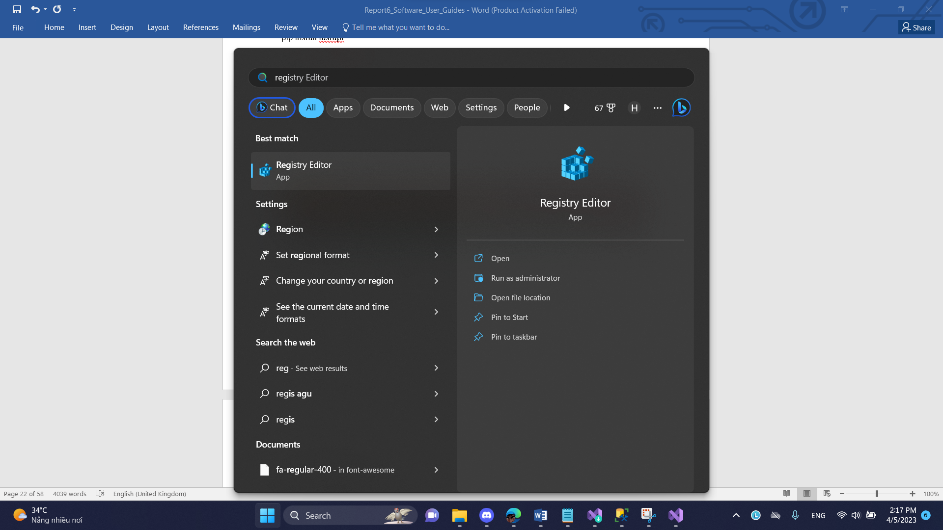

Open Registry Editor

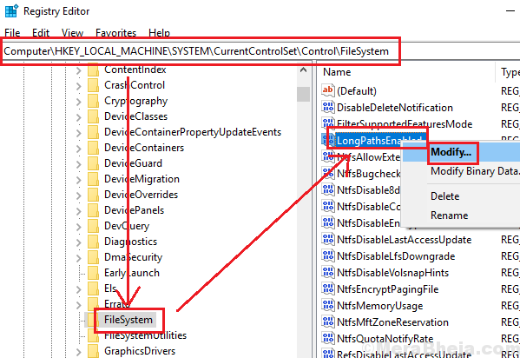

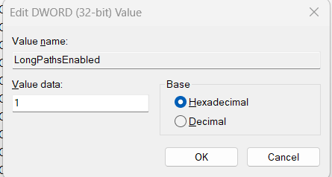

c) Install .Net 5 SDK and .Net 5 Run Time

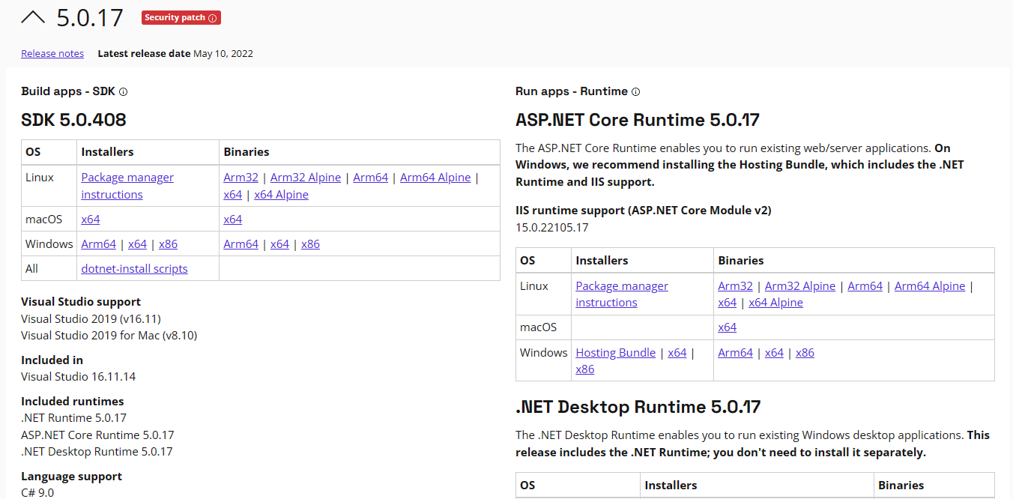

## 3. User Manual

### 3.1 Terms and definitions

|  |  |  |
| --- | --- | --- |
| No | Term and definition | Description |
| 1 | User | All users in the system, including administrator, farmer and expert |
| 2 | Administrator | An user who has the role of administrator and is allowed to manage user accounts of the system. |
| 3 | Farmer | An user who has the role Farmer and is responsible for managing classes, modules, exams,... |
| 4 | Expert | An user who has the role of student and is allowed to take exams, and view their mark report. |

### 3.2 System requirements

For server:

* Operating system: Windows 10,Window 11
* Interpreter/compiler: Python 3.10, .NET 5.
* Storage: 200gb SSD available.
* RAM: 4GB or higher.
* CPU: Intel Core i5-825U or higher.
* Database: SQL Server Management Studio 18.

For web client:

* Operating system: Windows 10, macOS
* Browser: Google Chrome 90, Safari 14.0.3 (macOS), Safari 14 (iOS), Microsoft Edge 89.0 or newer.

### 3.3 Application Usage

#### a. Overview

Our system has 3 roles (Administrator, Farmer and Expert). All the users have all of the following features:

1. Log in
2. Logout
3. Forgot Password
4. View Disease and others

An Administrator is the actor who can perform all of the following features:

1. Manage Disease
2. Manage Pesticide
3. Manage Preventative Measure
4. Manage Symptom
5. Manage Cause
6. Deactivate Account
7. Switch Account roles
8. View account list

An Farmer is the actor who can perform all of the following features:

1. Upload Image to predict
2. View Disease, Disease Symptom, Pesticide, Preventative Measure and Cause
3. View Upload/Prediction History

A Expert is the actor who can perform all of the following features:

1. View Disease, Disease Symptom, Pesticide, Preventative Measure and Cause
2. View Upload/Prediction History
3. Confirm the prediction result

#### b. Authentication

1. **Login**

Before using any system feature, user must log in first. When user accesses the system, a homepage page will be showed up as a default page (Figure 11). User can click on the Sign In option on the top right corner of the page to be redirect to Log In page (Figure)

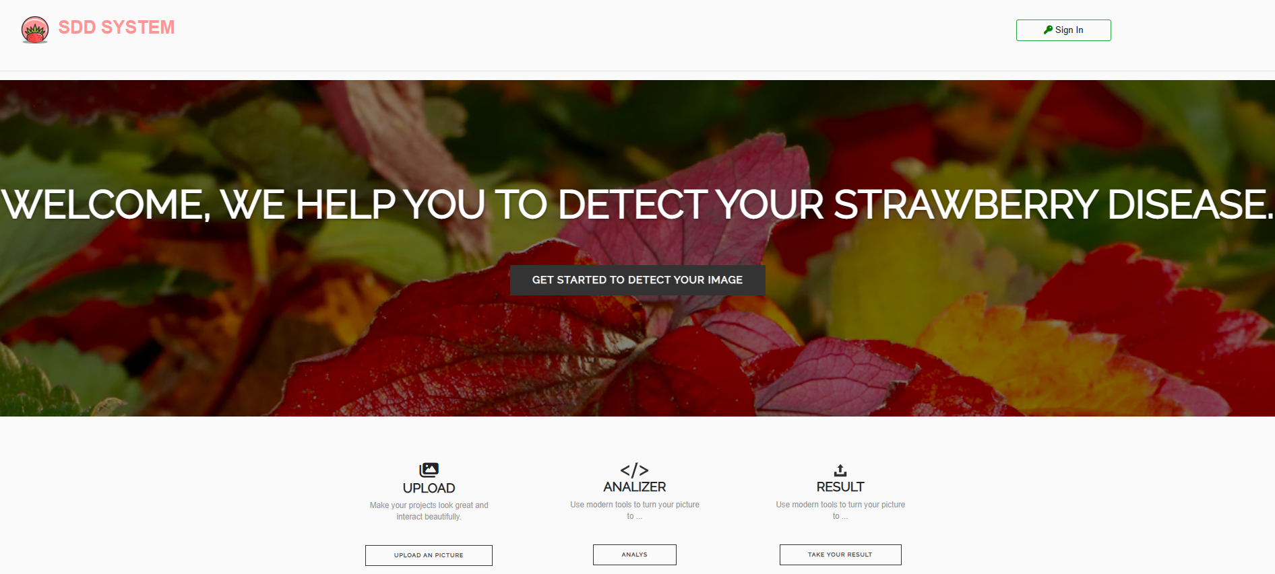

Figure The Home page

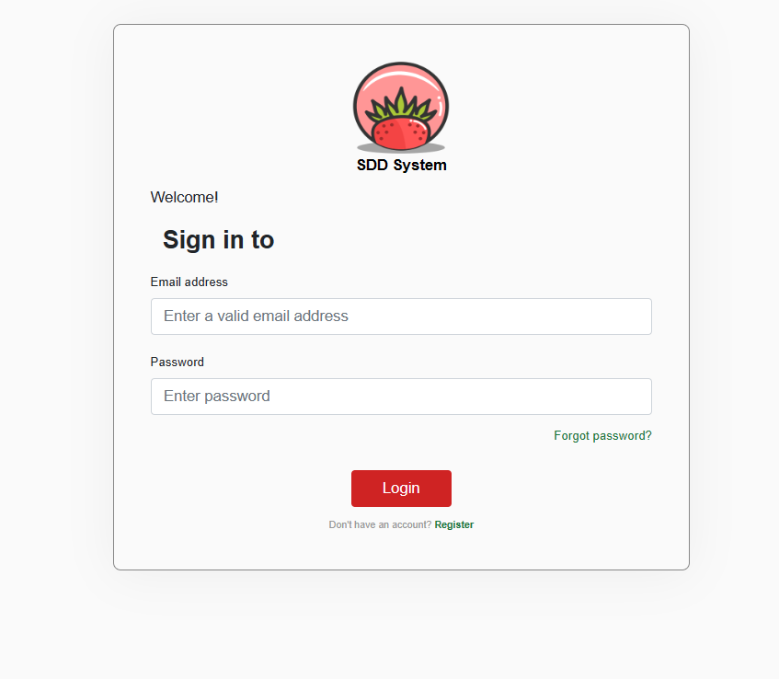

Figure The login page

If user leaves the input field blank or tries to log in with an invalid account, the system will show a corresponding error notification (Figure 12, 13).

*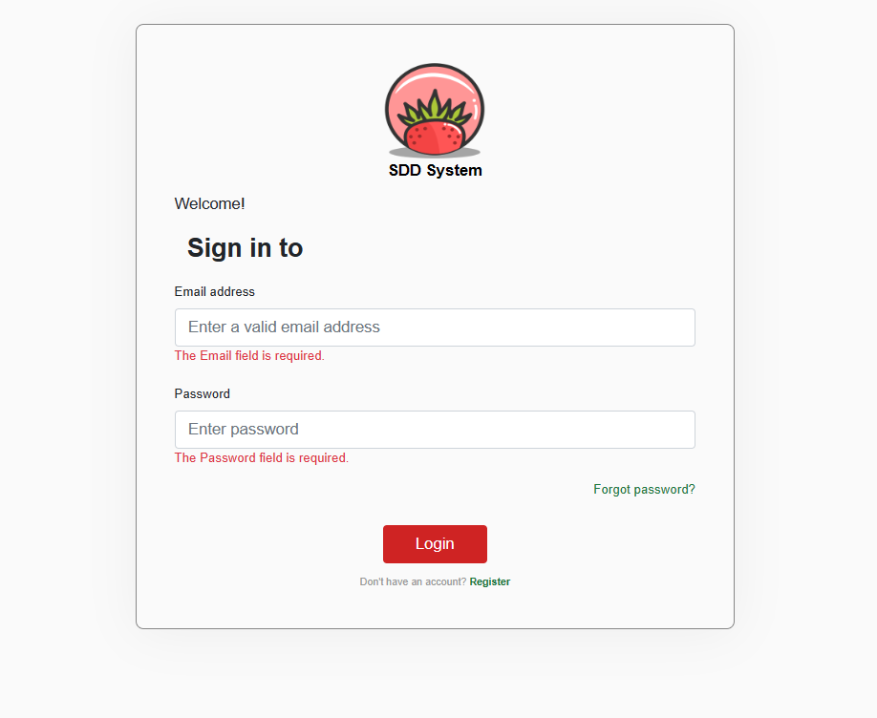*

Figure Error displayed when user does not inputs

*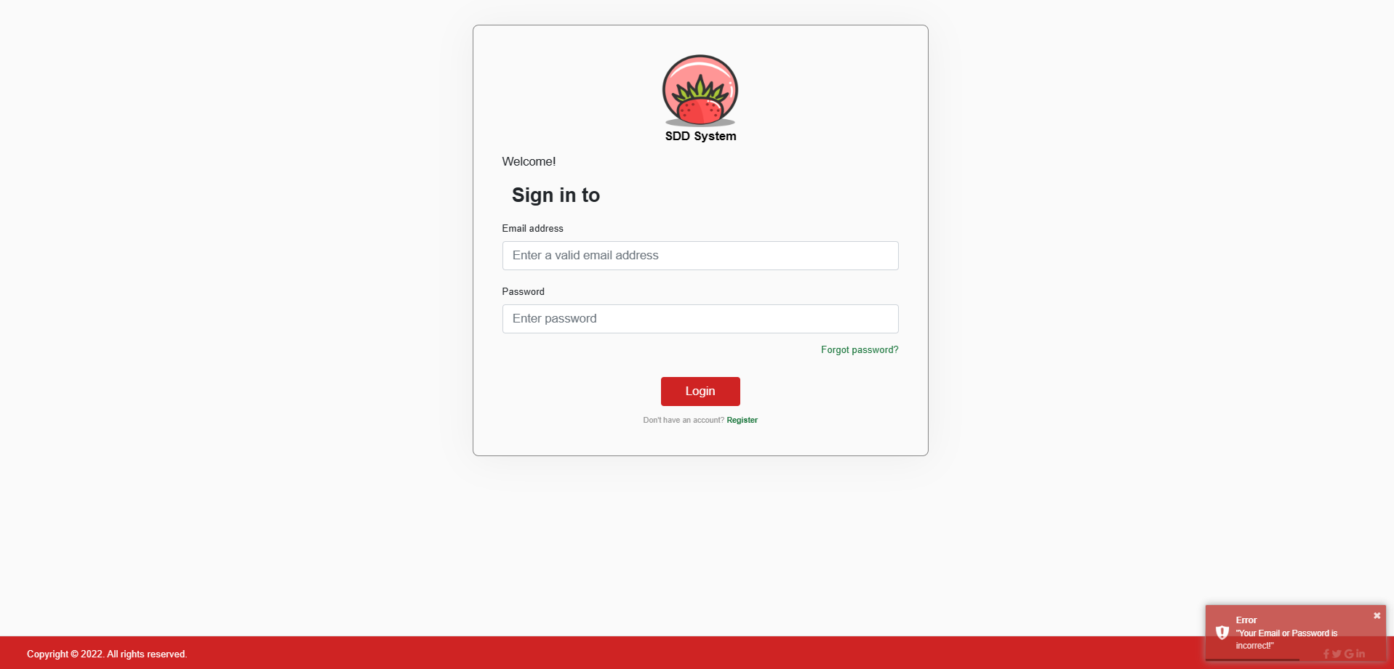*

Figure Error displayed when user inputs invalid email format or wrong password

After user enters a valid account and clicks on the “Login” button, the system will direct user to main page based on their account role. There will a notification on the bottom right show the message ”Login Success”

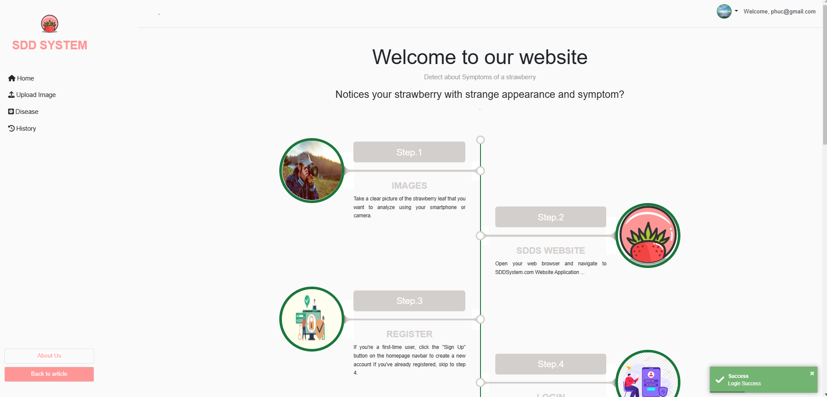

Figure The home page

1. **Logout**

When user wants to log out from the system and go back to the login page, they can click on the logout icon in the top right corner regardless of the account they’re on (Figure 16).

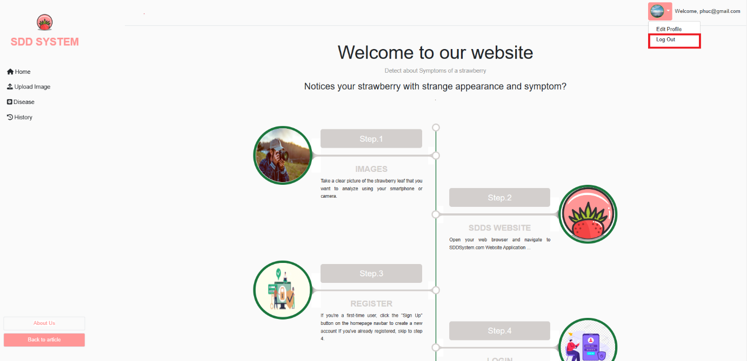

Figure The logout icon

1. **Forgot password**

User can click on the “Forgot Password?” link on the login page to be redirected to the forgot password page in order to reset their password and receive a newly generated password in their email (Figure 17, 18).

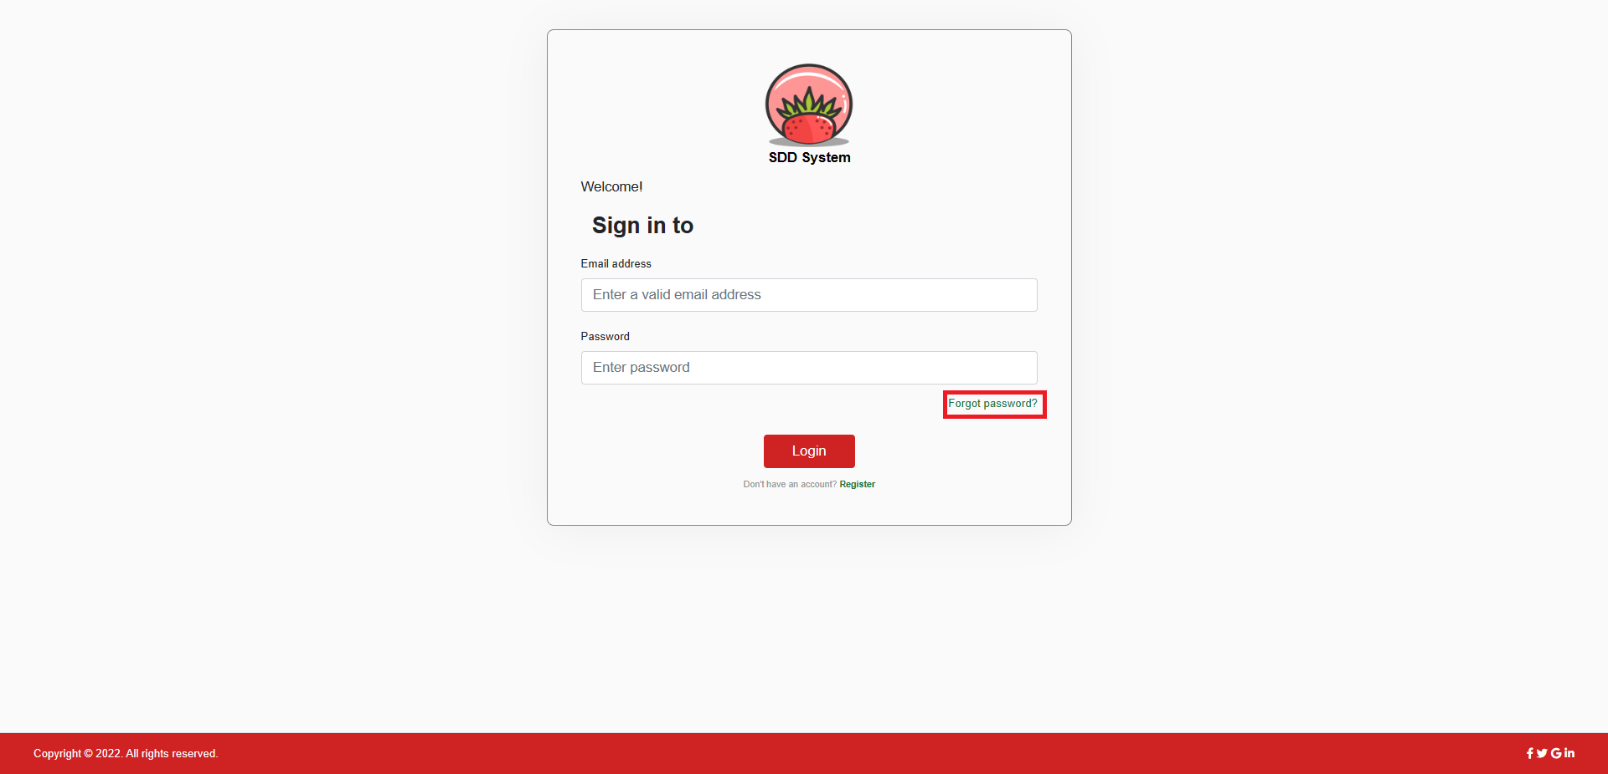

Figure The “Forgot Password?” link

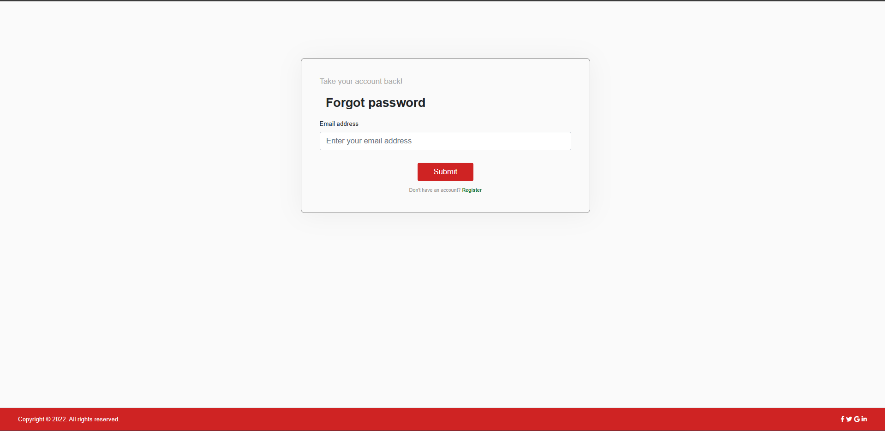

Figure The forgot password page

If user leaves the input field blank or tries to log in with an invalid email address, the system will show a corresponding error message (Figure 19, 20, 21).

*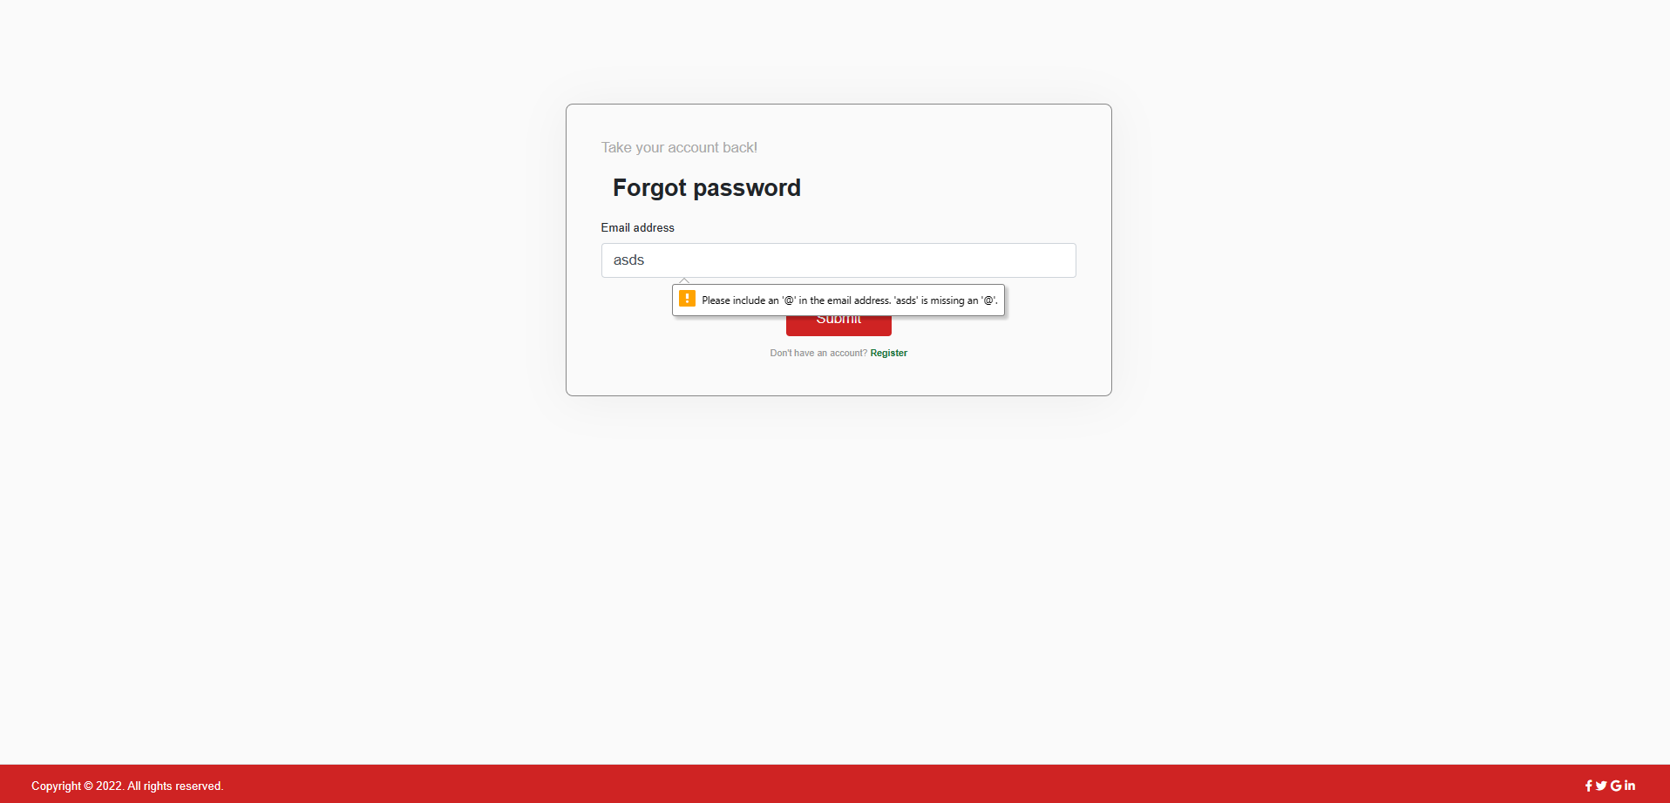*

Figure Error displayed when user inputs invalid email format

*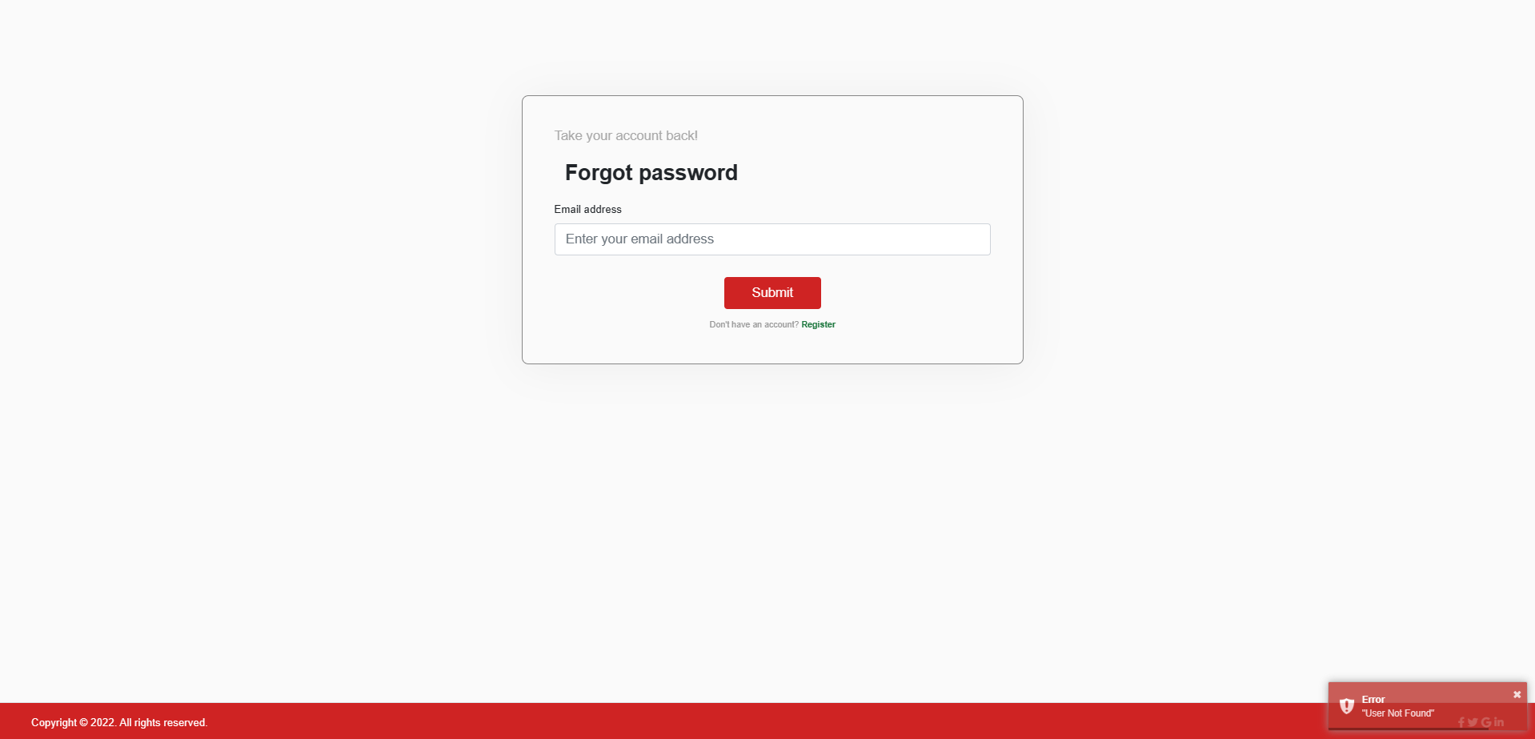*

Figure Error displayed when user inputs email not exist

If user inputs a valid email address and click “Get New Password” button, system will send an email containing a newly generated password to the user’s email address and show a success message (Figure 22).

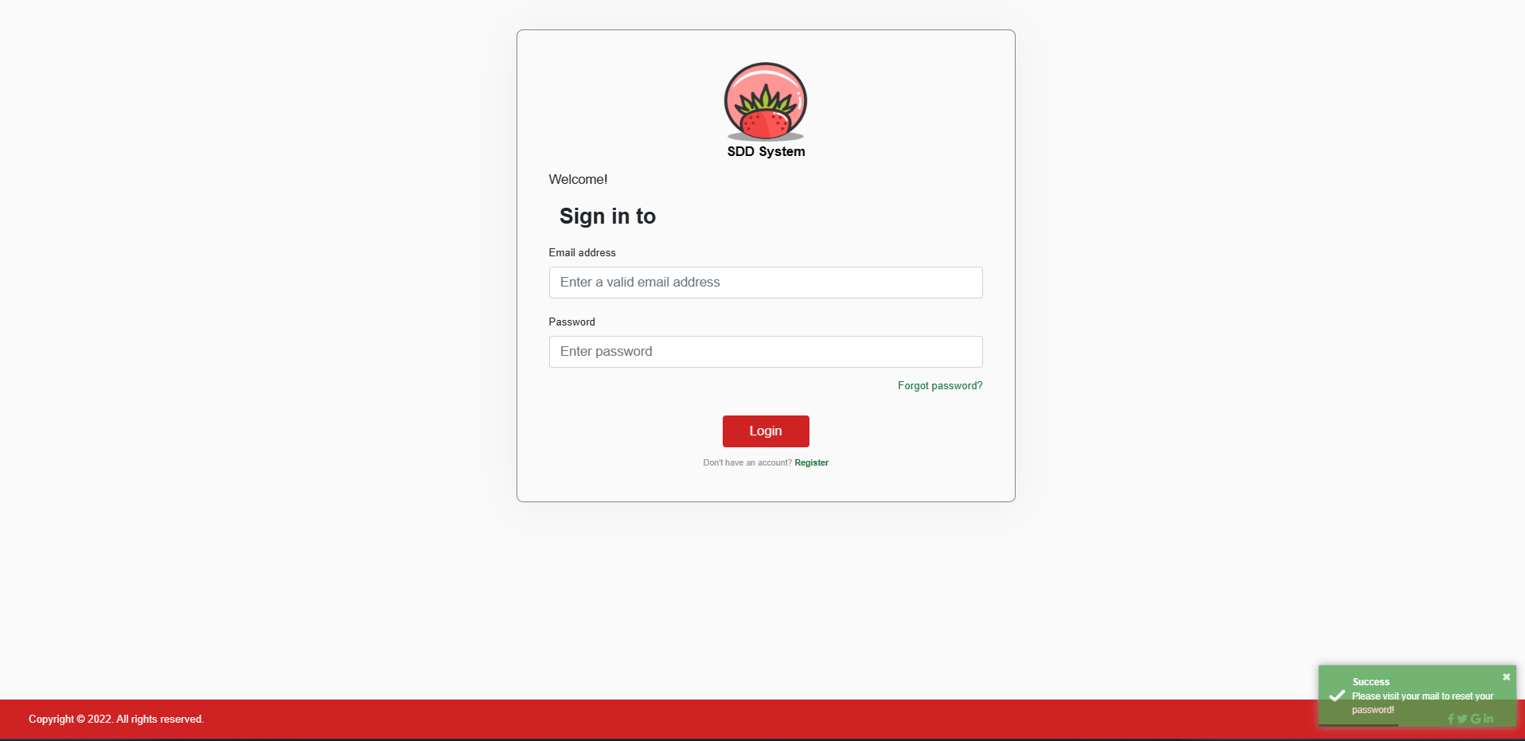

Figure Notification show reset password link has been sent to user mail

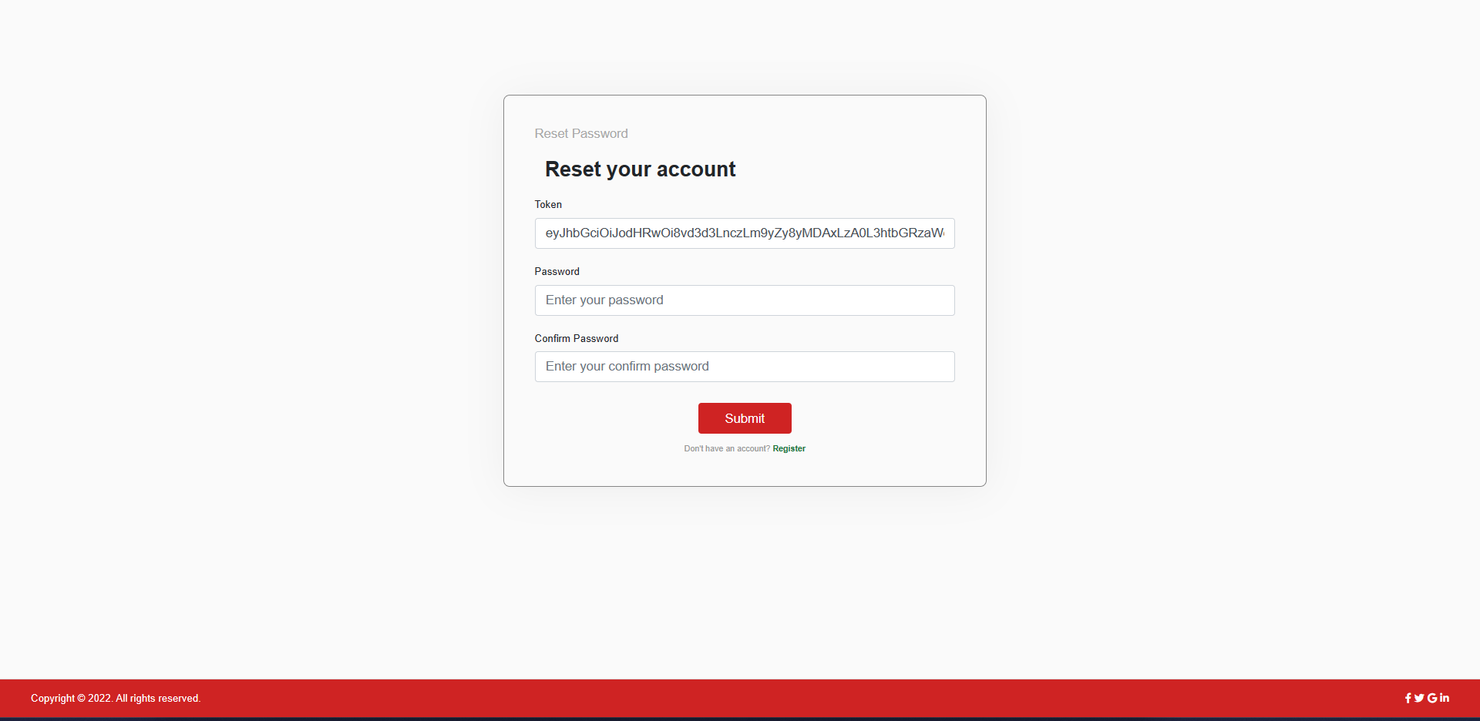

Figure The reset password page

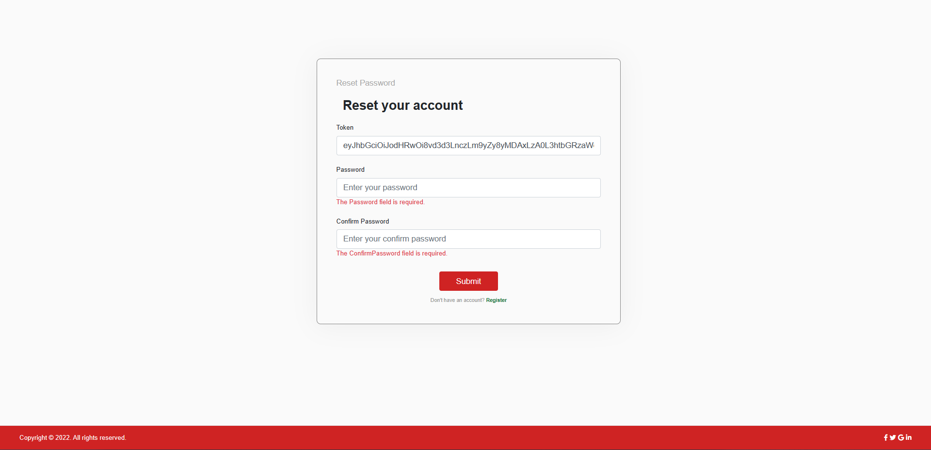

Figure Error displayed when user inputs leaves empty password

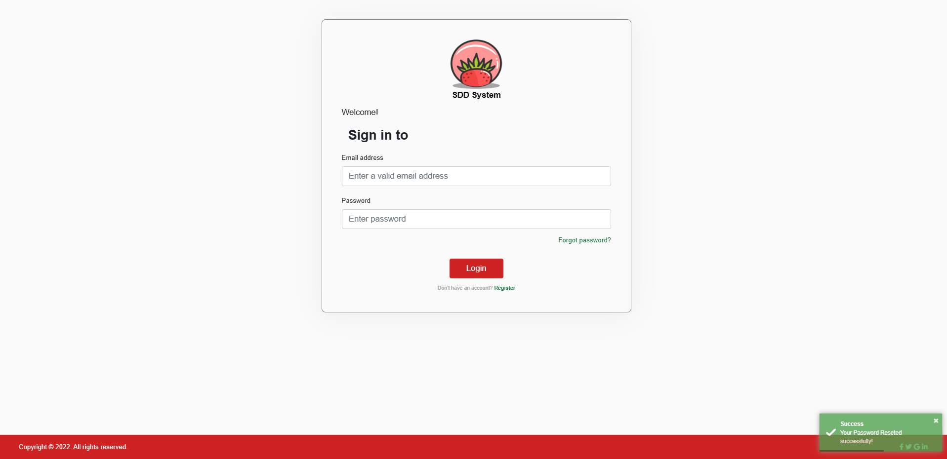

Figure The reset password success message

#### c. Role Administrator

1. **Manage Account**

**1.1 View Disease**

* After login as Administrator, the Admin homepage will be displayed

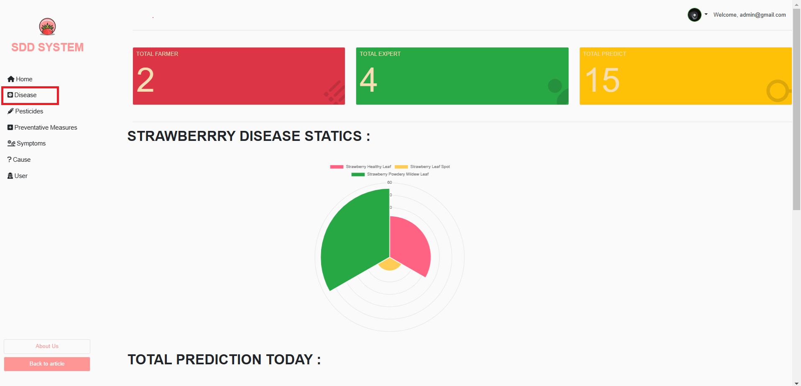

Figure The reset password success message

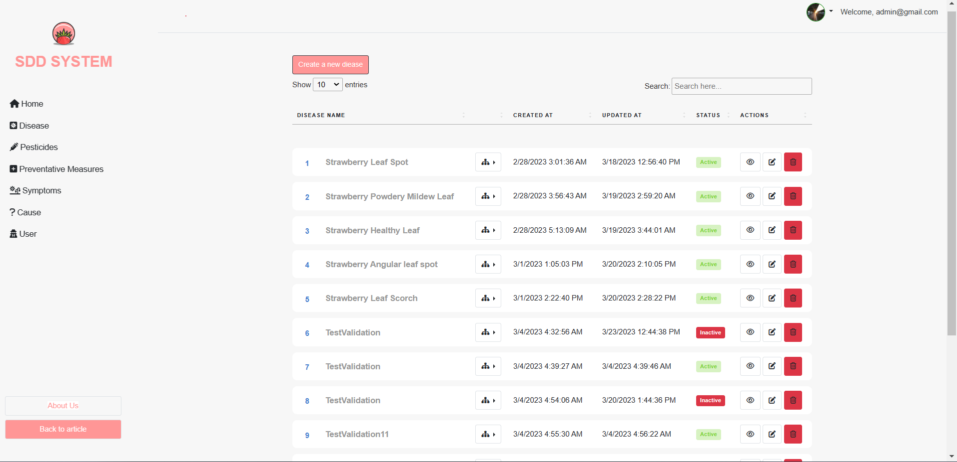

Figure Disease list page

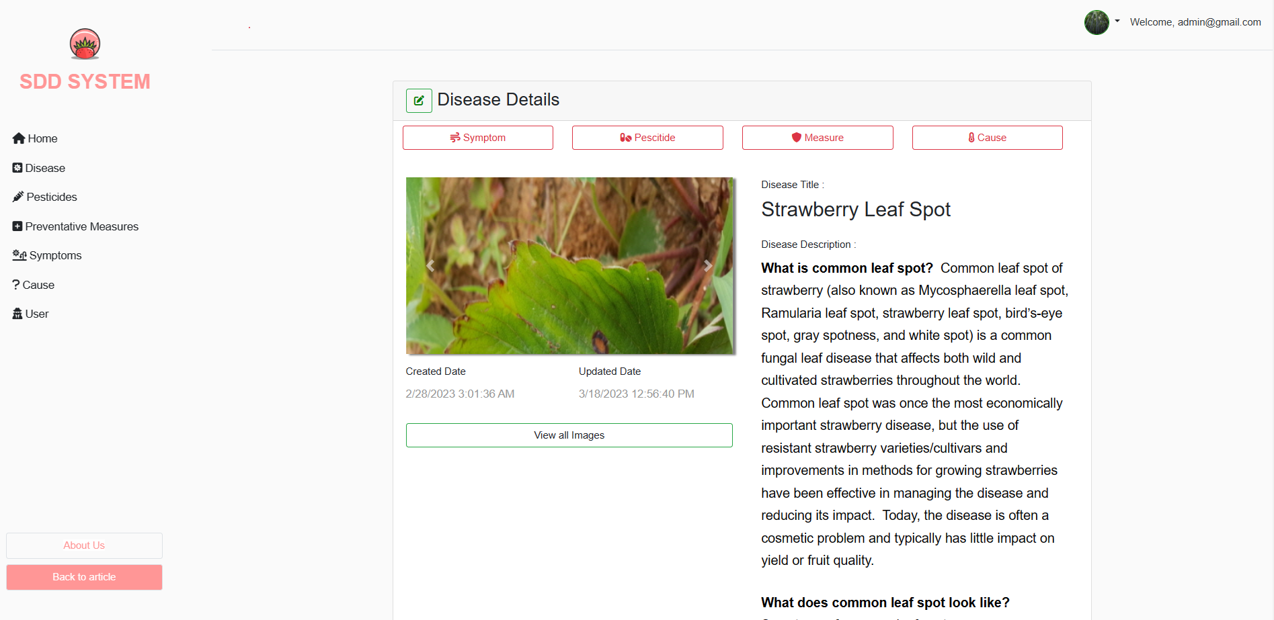

**1.2 Add Disease**

-On the main page (Disease List Page) click on the [Create a new disease] icon.

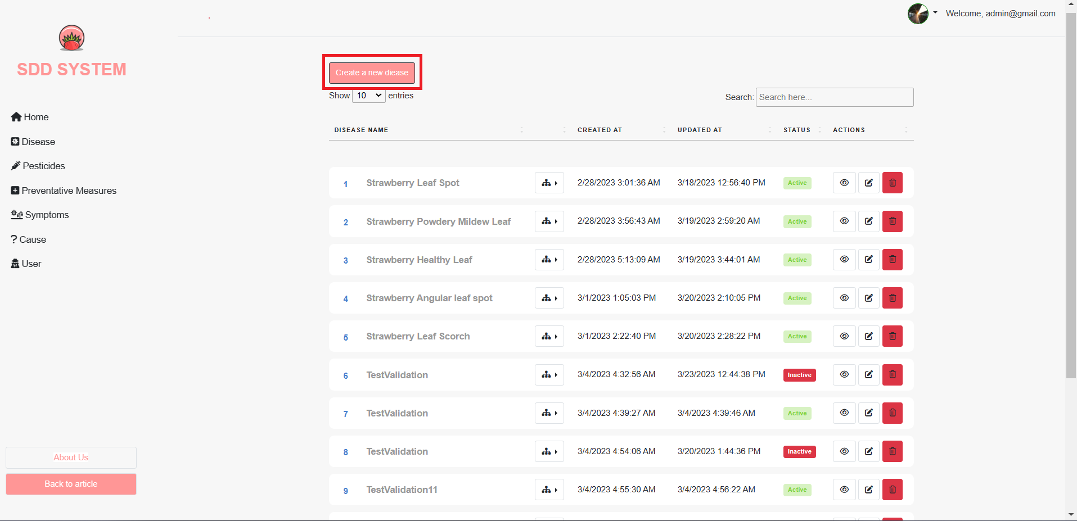

Figure Edit button on Disease list page

-A form will be shown, from which you can add information in the disease name description of the disease, and click the [Create] button to ad disease information.

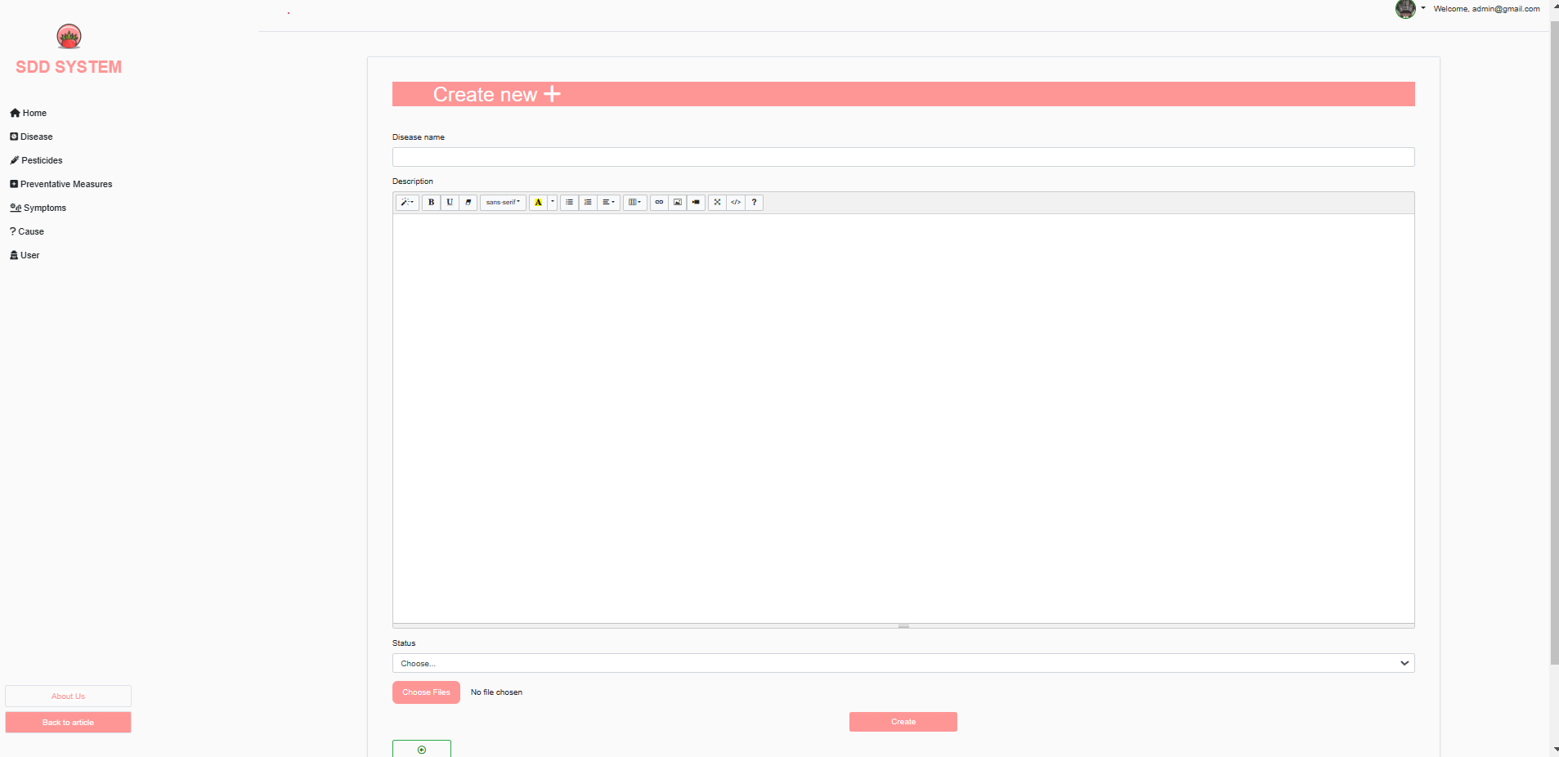

Figure Add disease page

**1.3 Delete Disease**

-On the main page (Disease List Page) click on the [Diseas account] icon.

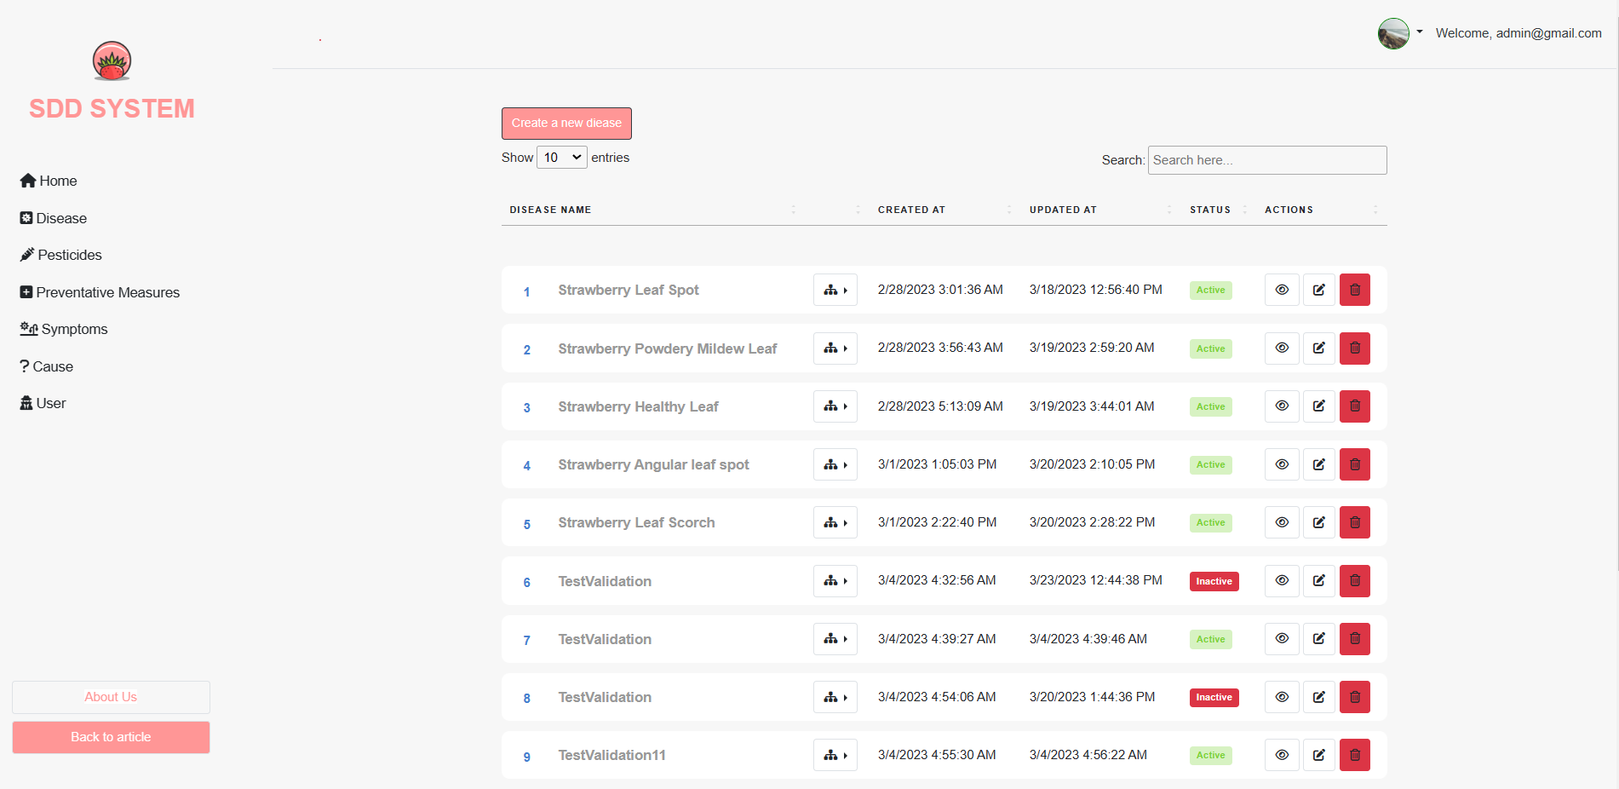

Figure Delete button on disease page

-A popup will be shown, from which you can confirm before deleting. Click on [Confirm] button to delete the account, [Close] button to close the popup and cancel the delete.

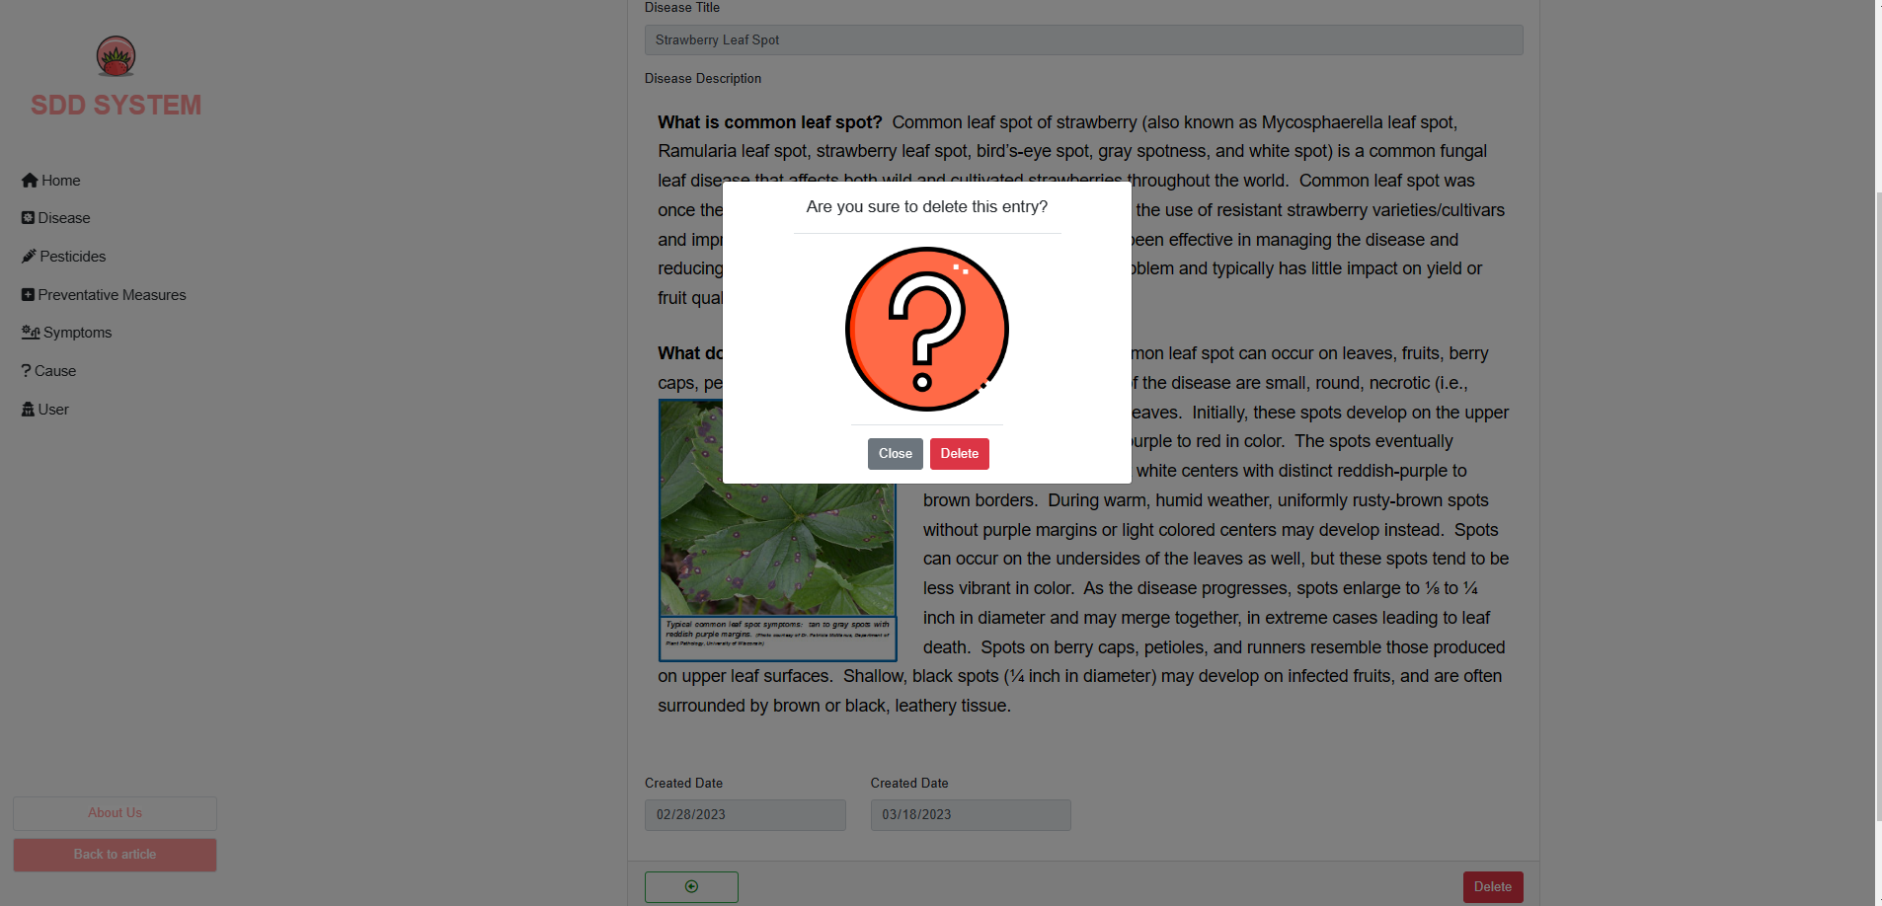

Figure Delete disease confirm

**1.4 Update Disease**

-Click on the [Update Disease] icon on the right side of the list.

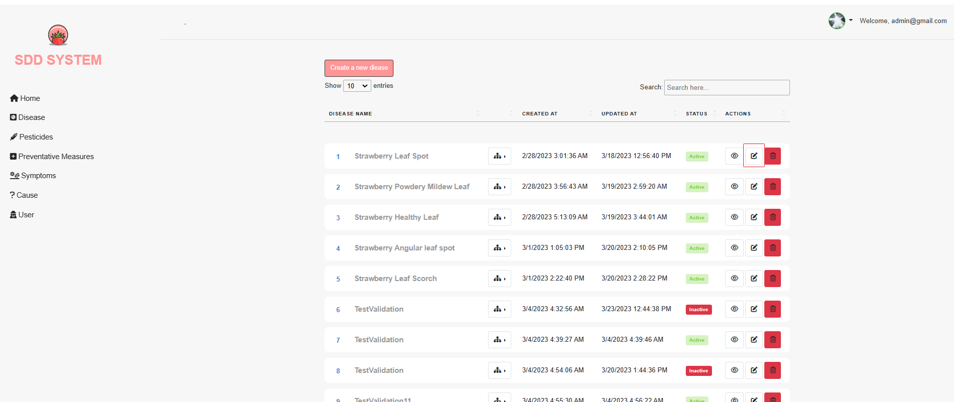

Figure Update disease icon

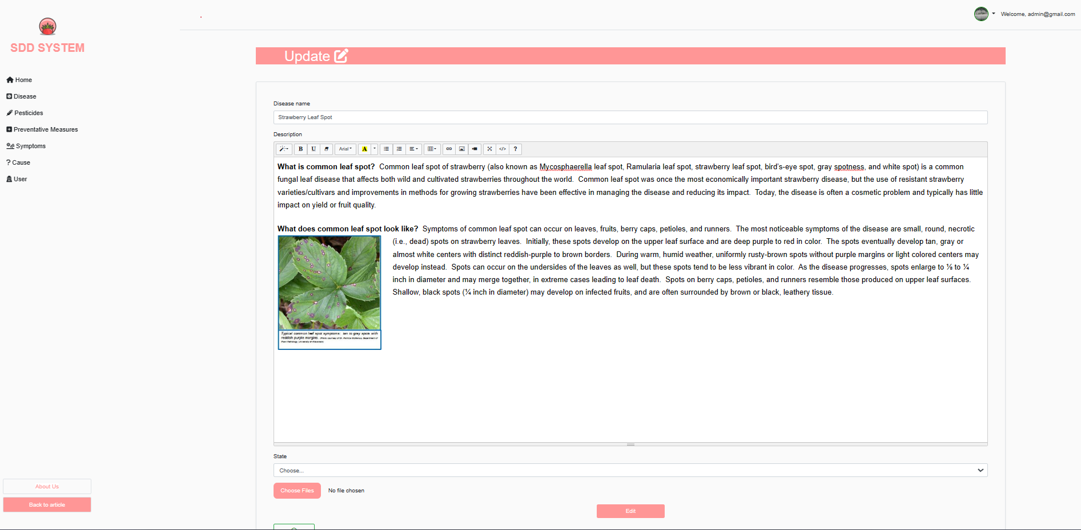

Figure Update disease page

-Edit all the information and click the [Edit] button to update disease information.

1. **Manage Pesticide**

-Click on the [ Pesticide] button on the left vertical navigation bar.

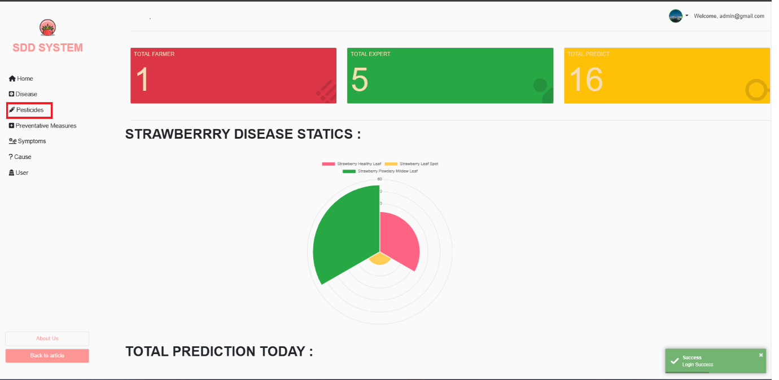

Figure Admin Homepage

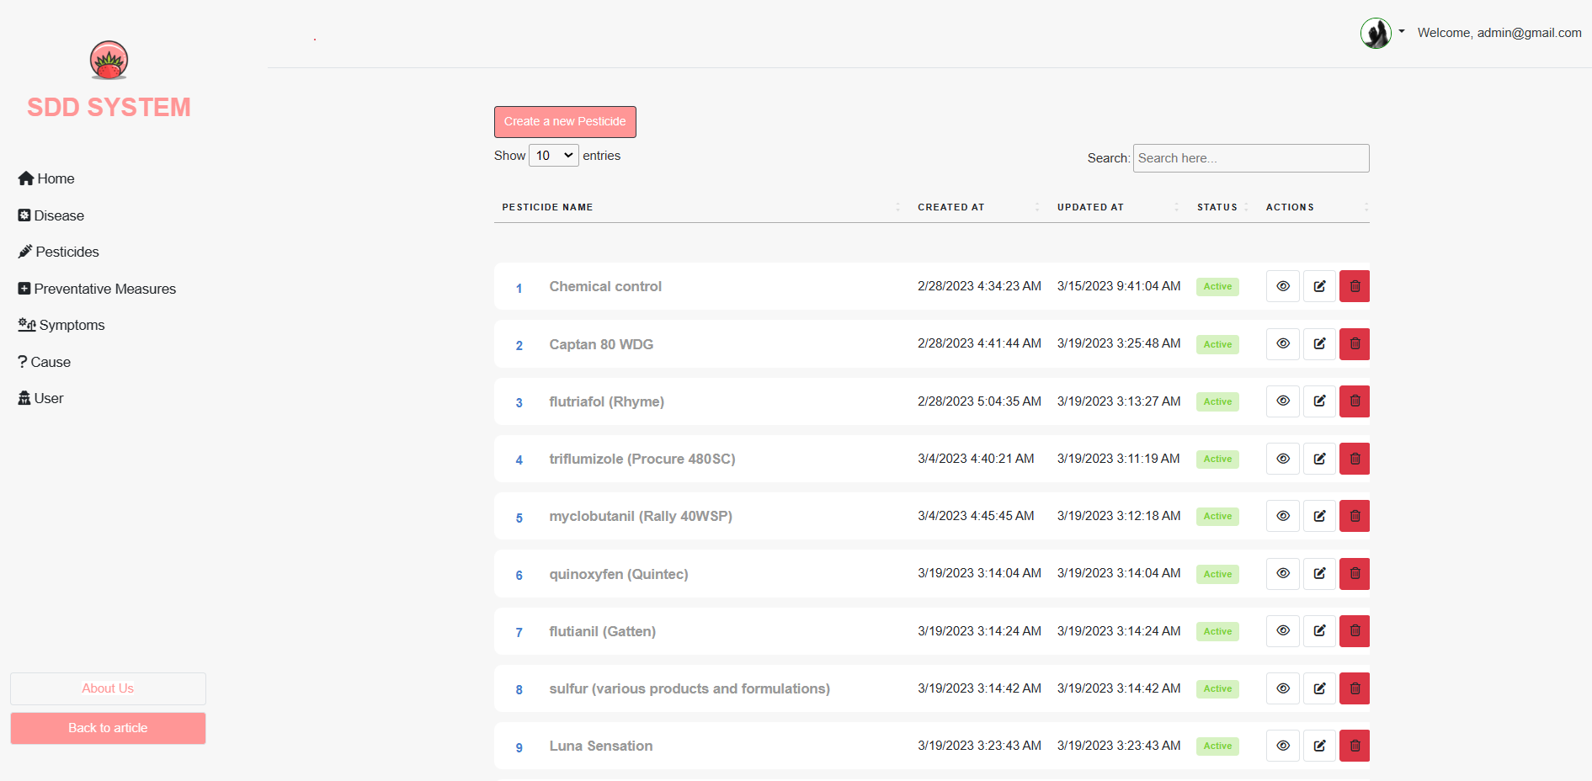

Figure Pesticide Page List

**2.1 Create Pesticide**

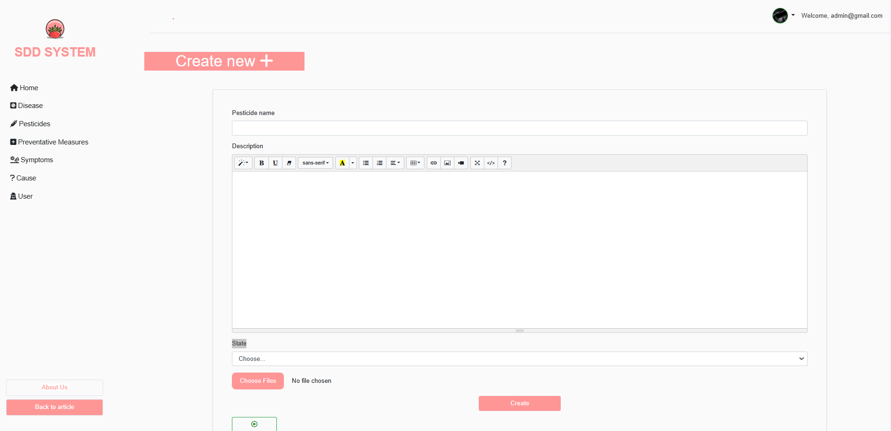

Figure Create Pesticide page

**2.2 Delete Pesticide**

**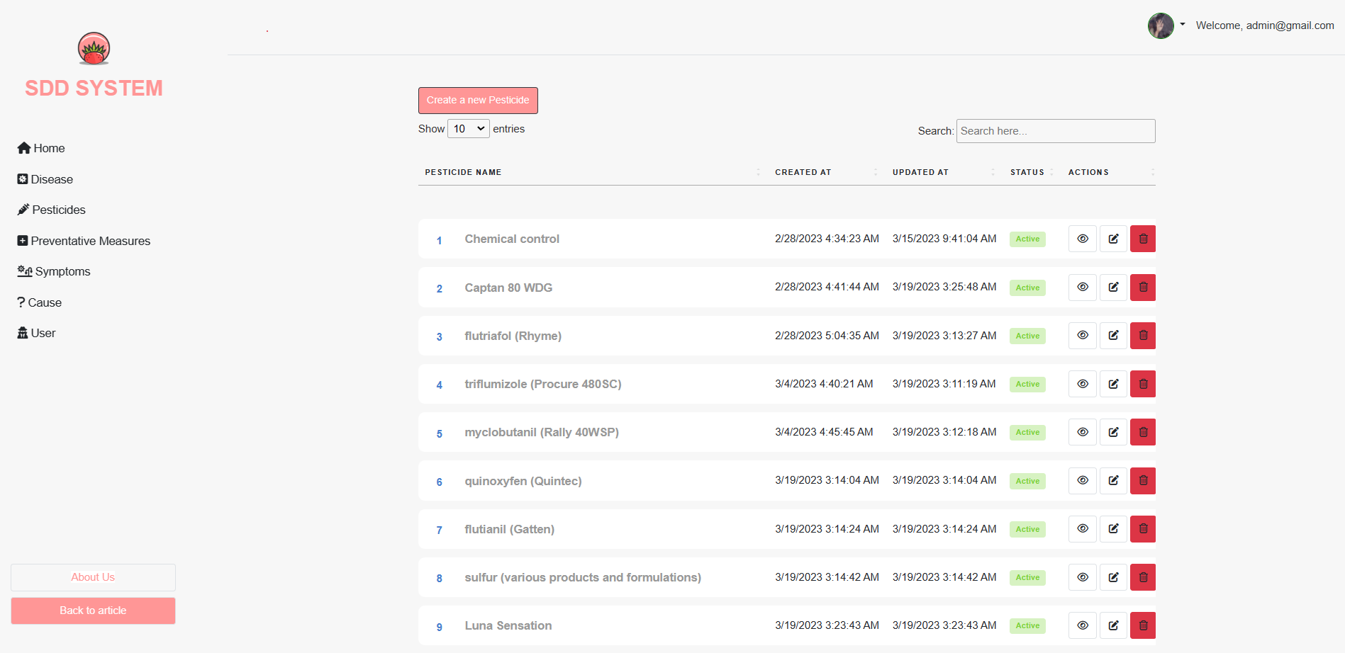**

Figure Pesticide Page List

**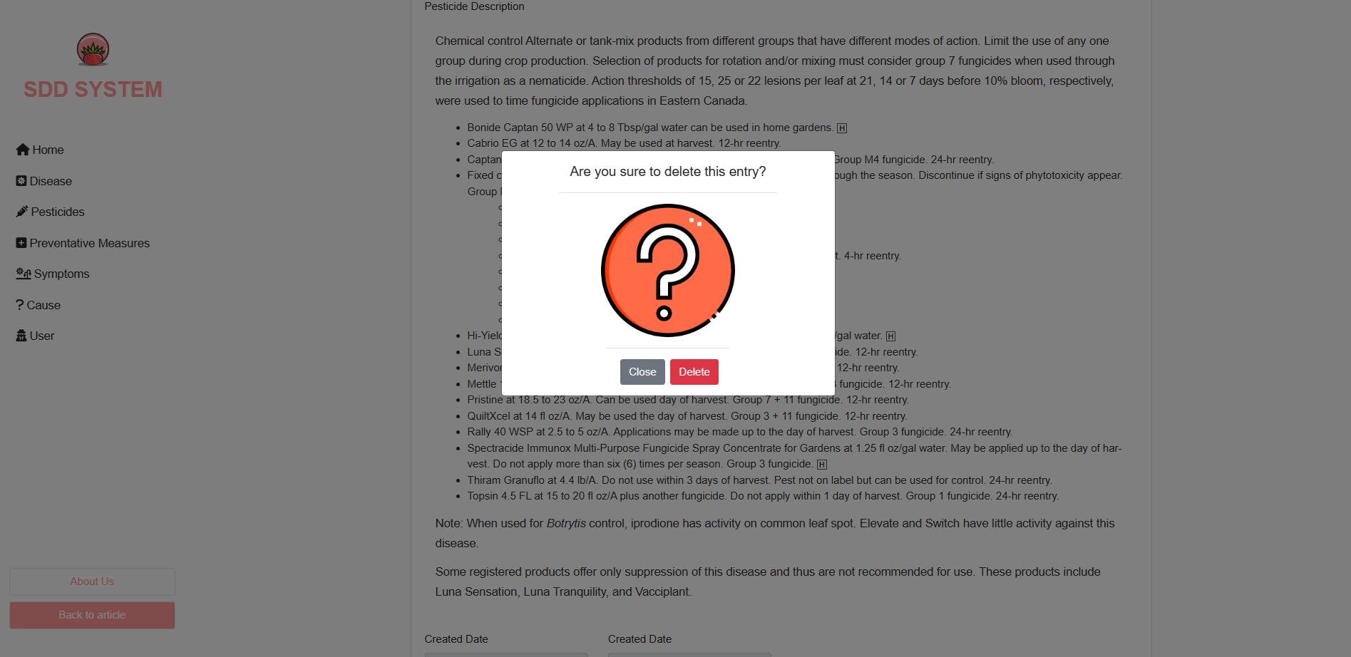**

Figure 34 Delete Pesticide Confirmation Pop up

**2.4 Update Pesticide**

**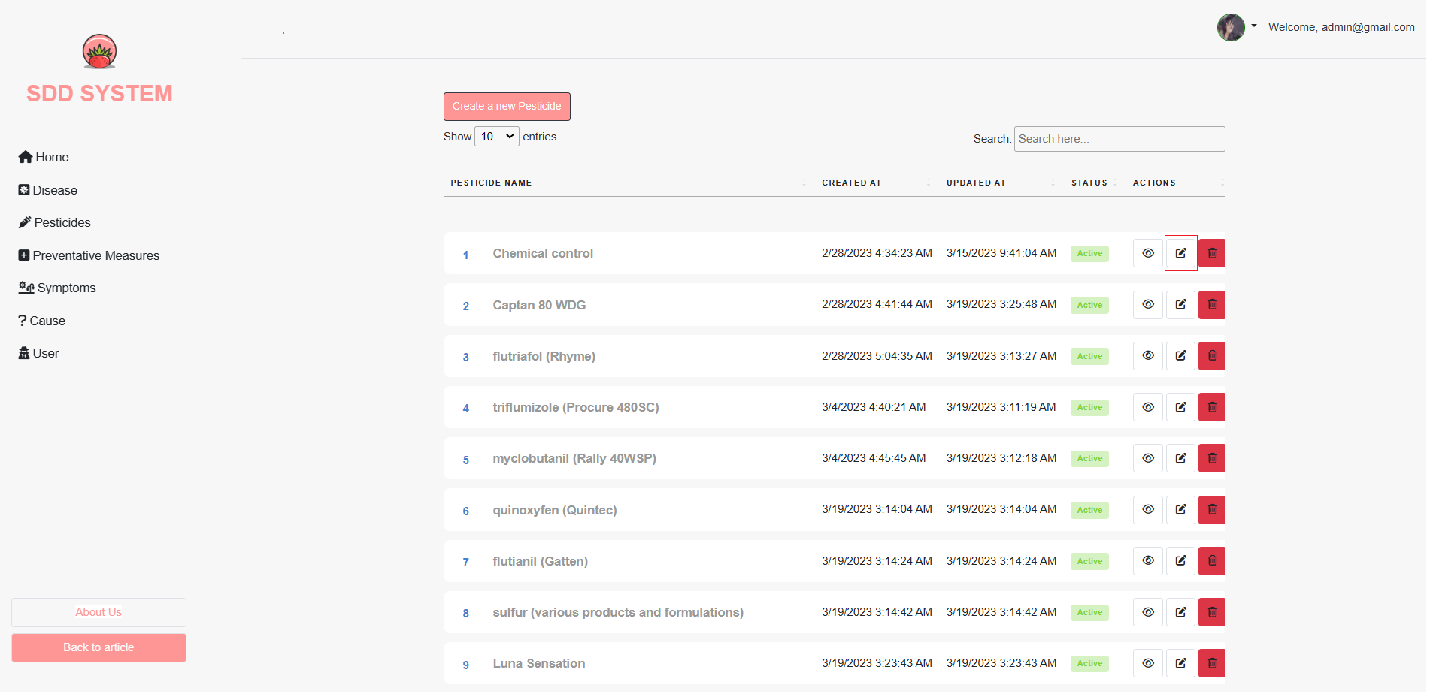**

**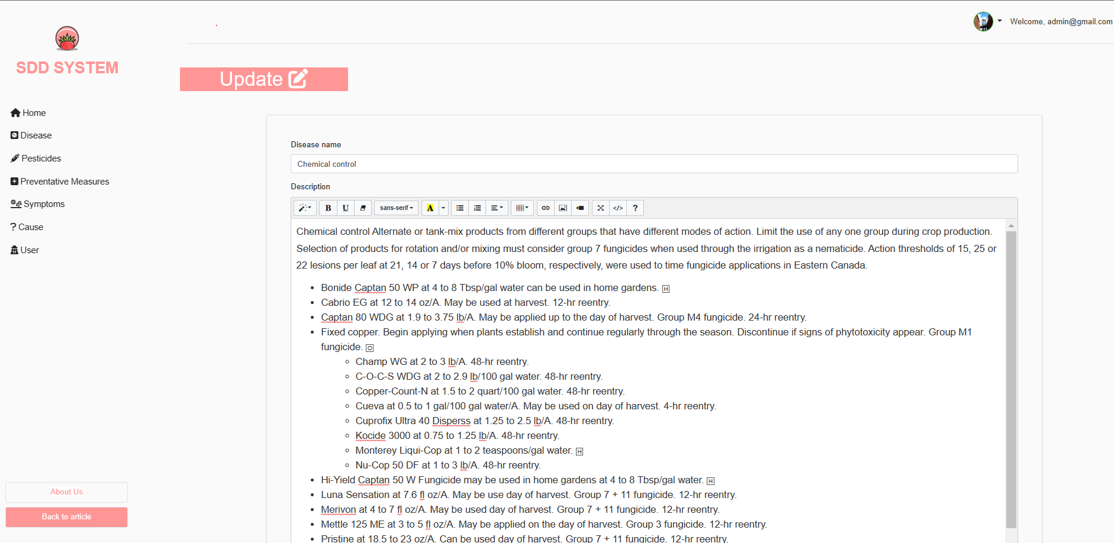**

1. **Manage Preventative Measures**

**3.1 View Preventative Measure**

-Click on the [Create Account] button on the left vertical navigation bar.

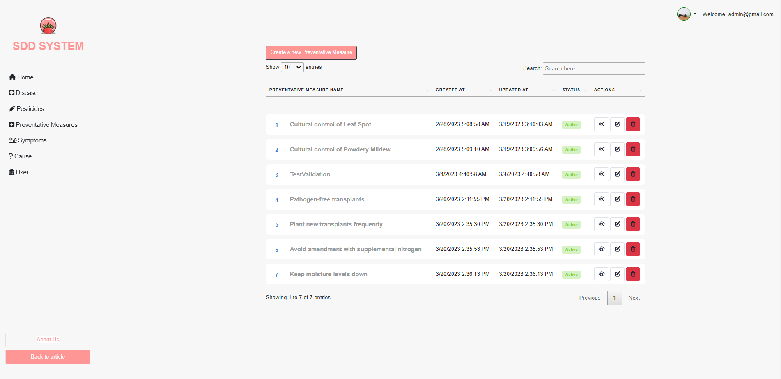

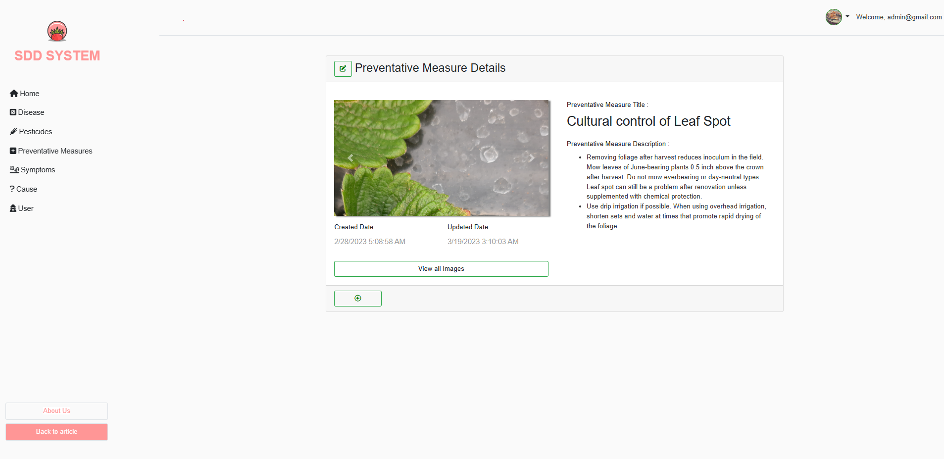

**3.2 Add Preventative Measure**



**3.3 Delete Preventative Measure**

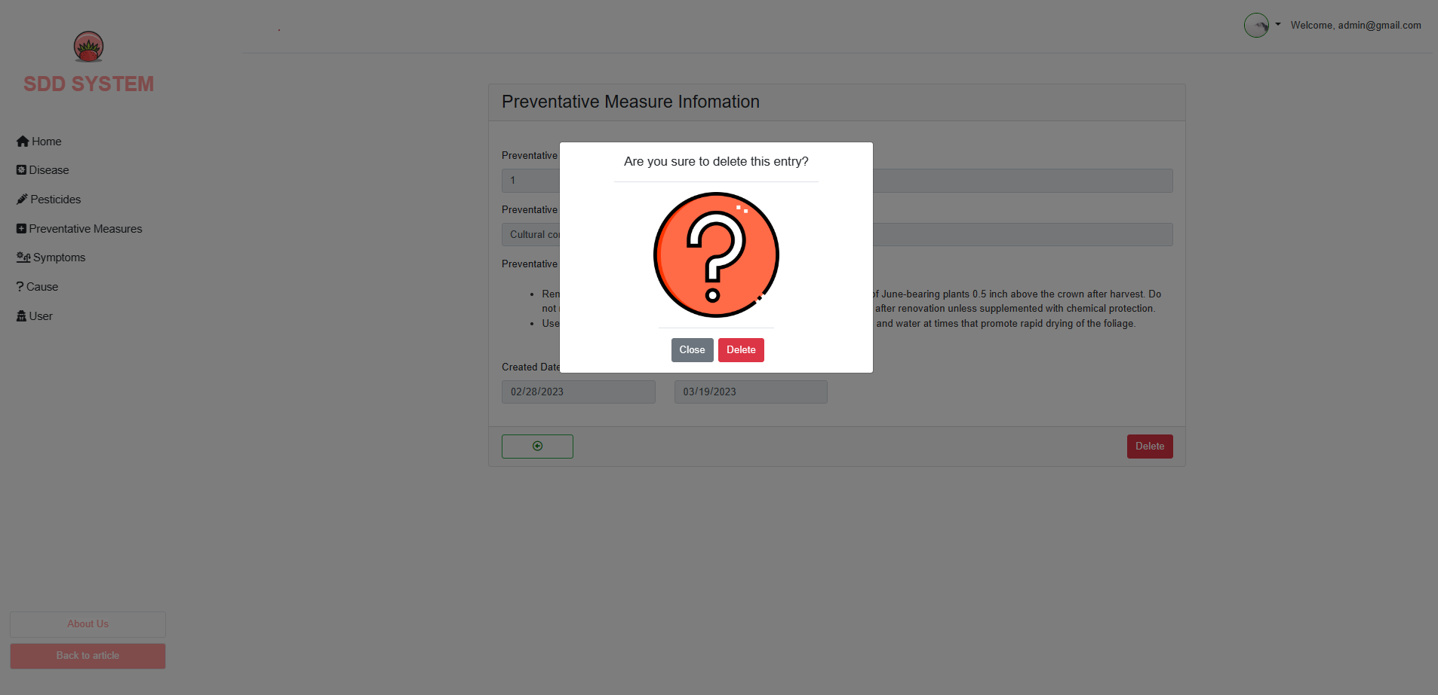

Figure Create account by excel

-Click on the [Download template] button to download the excel template.

**3.4 Update Preventative Measure**

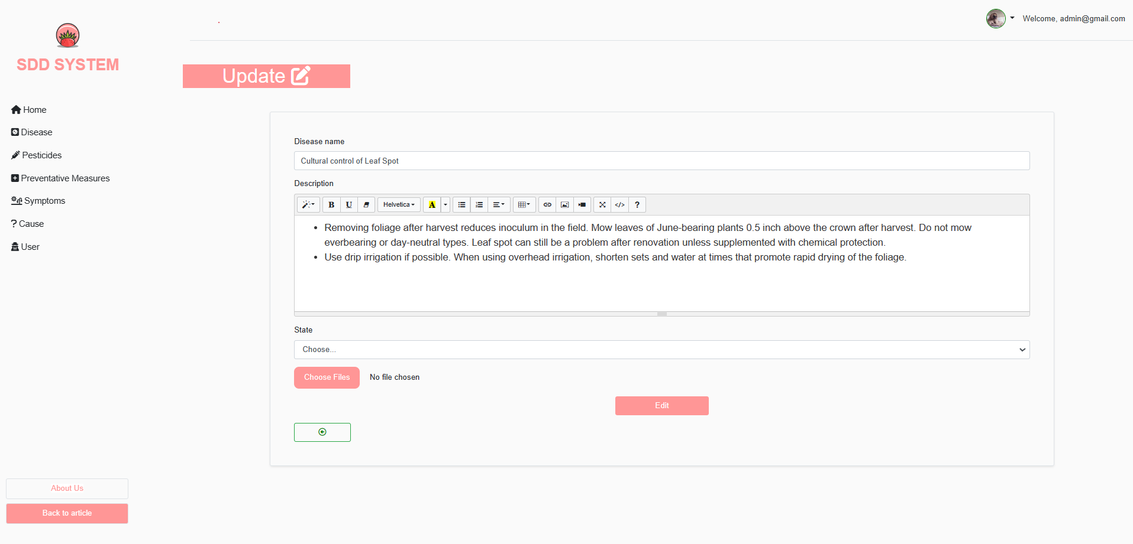

Figure Download button on create account page

-Fill in all the information in excel template and click on the [Edit] button.

**5. Manage Symptom**

**5.1 View Symptom**

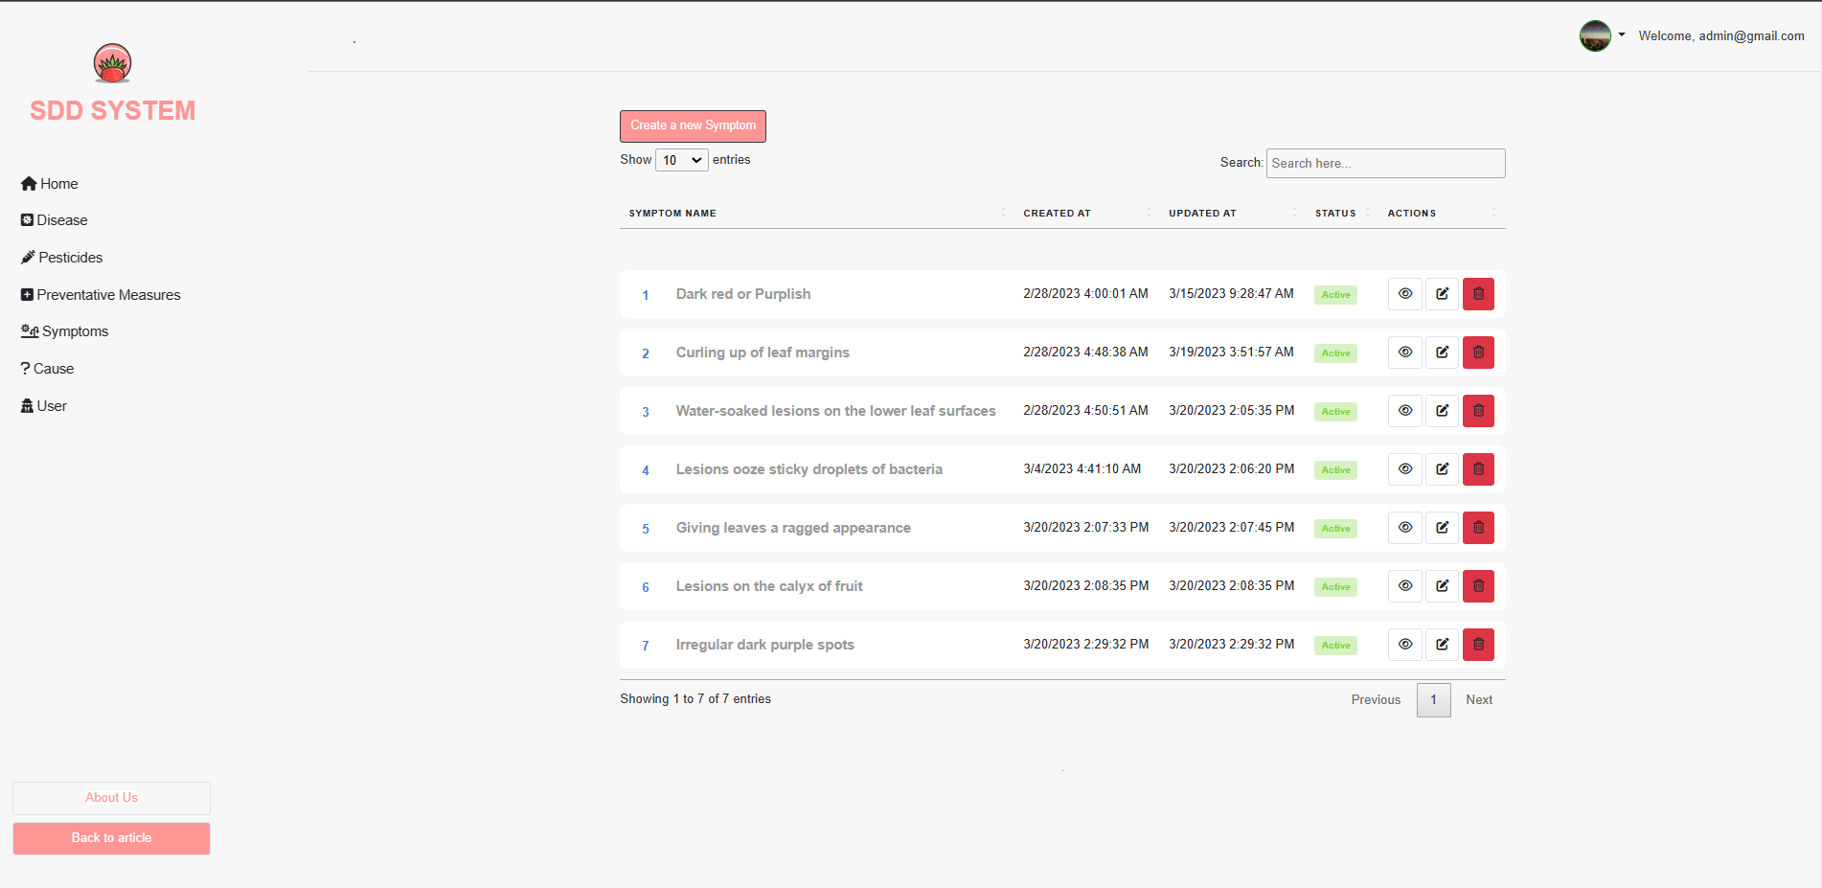

Figure Excel upload button on create account page

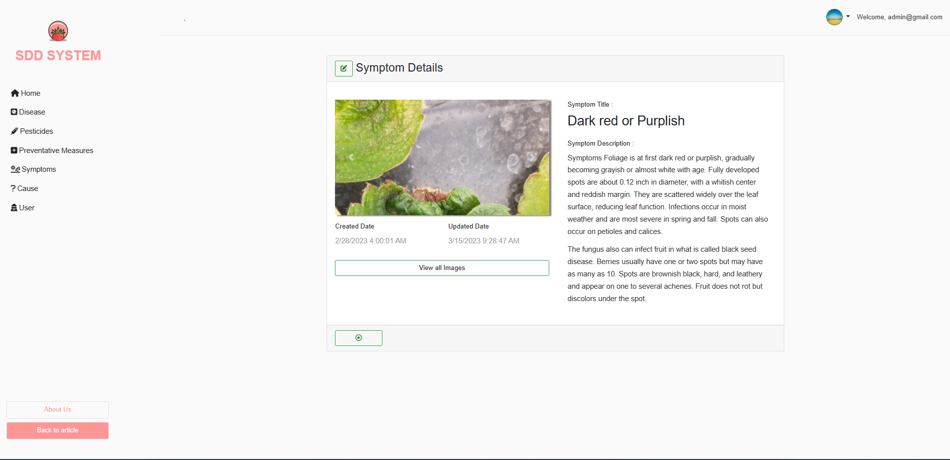

Figure Upload file

**5.2 Add Symptom**



**5.3 Delete Symptom**

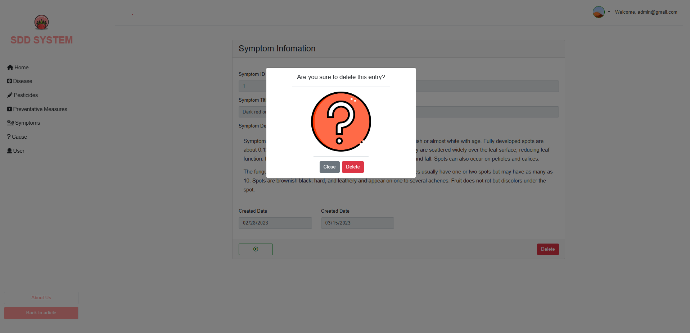

**5.4 Update Symptom**

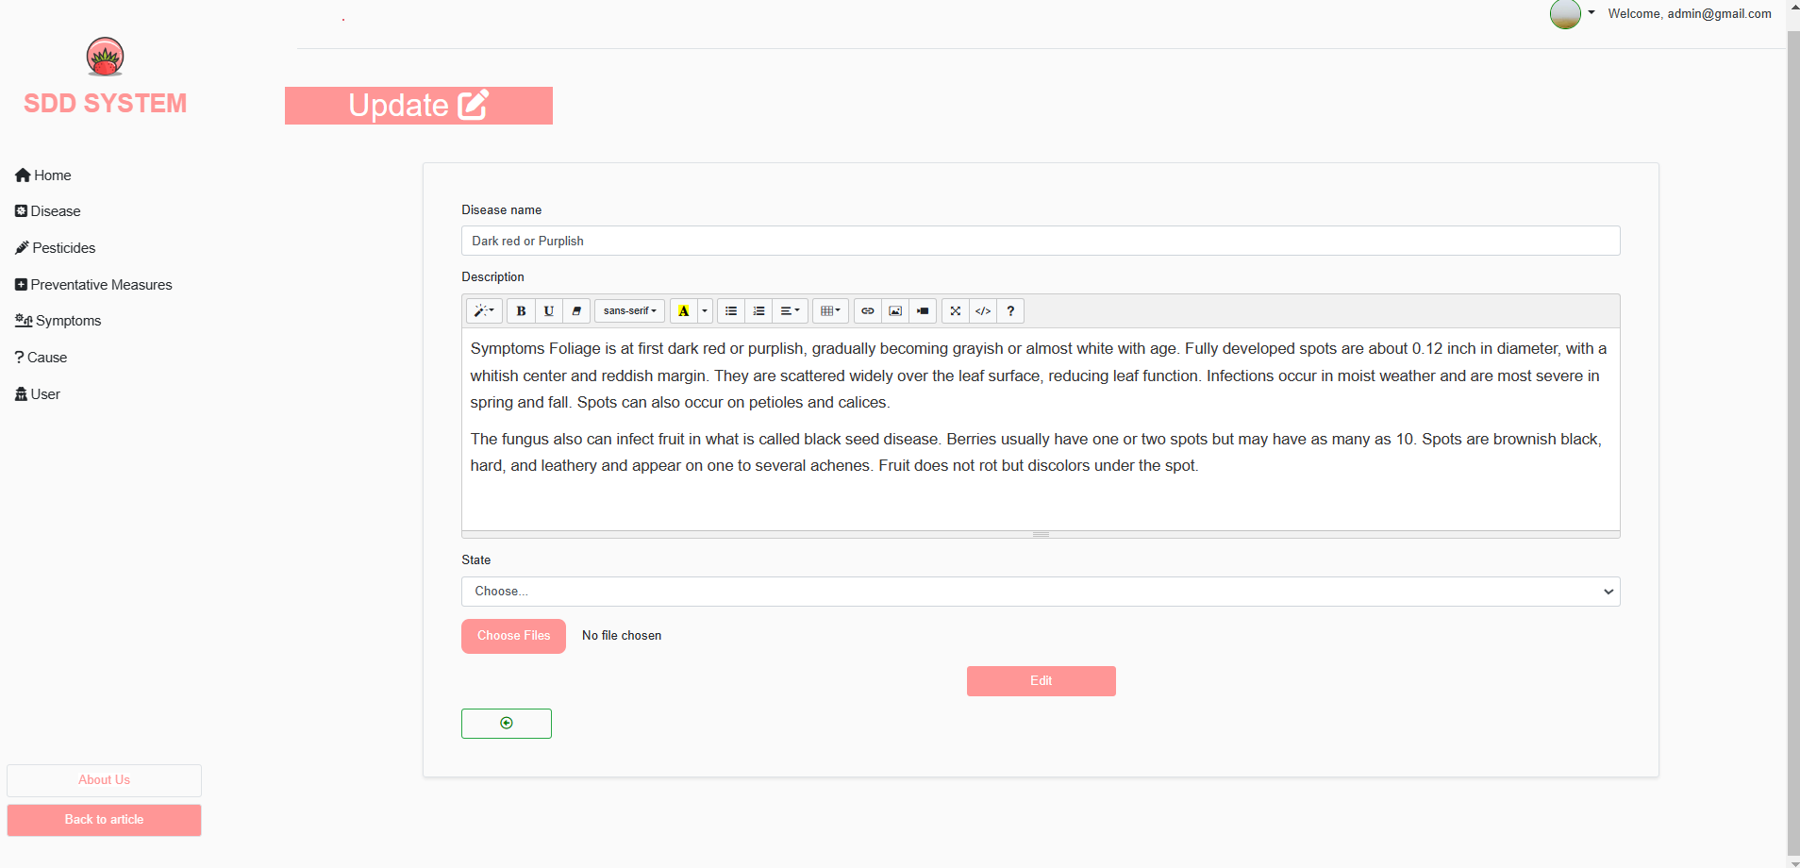

**6. Manage Cause**

**6.1 View Cause**

**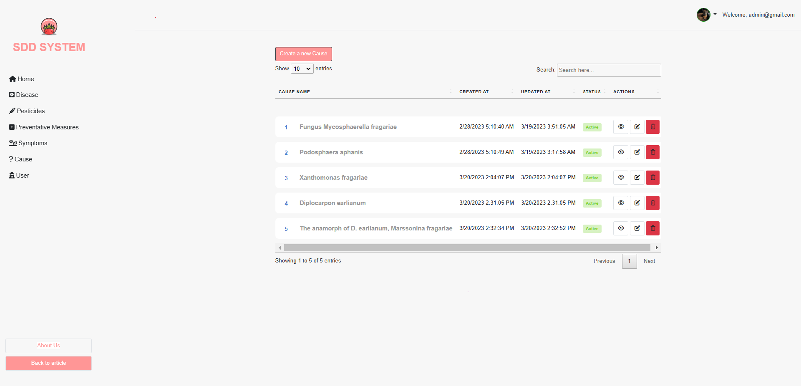**

**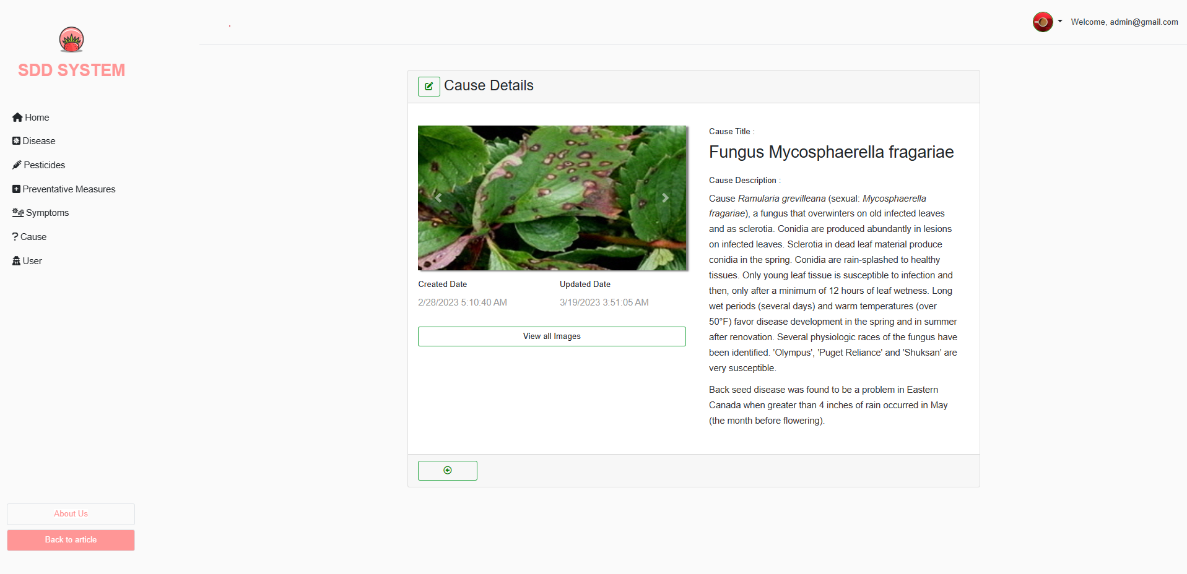**

**6.2 Add Cause**

**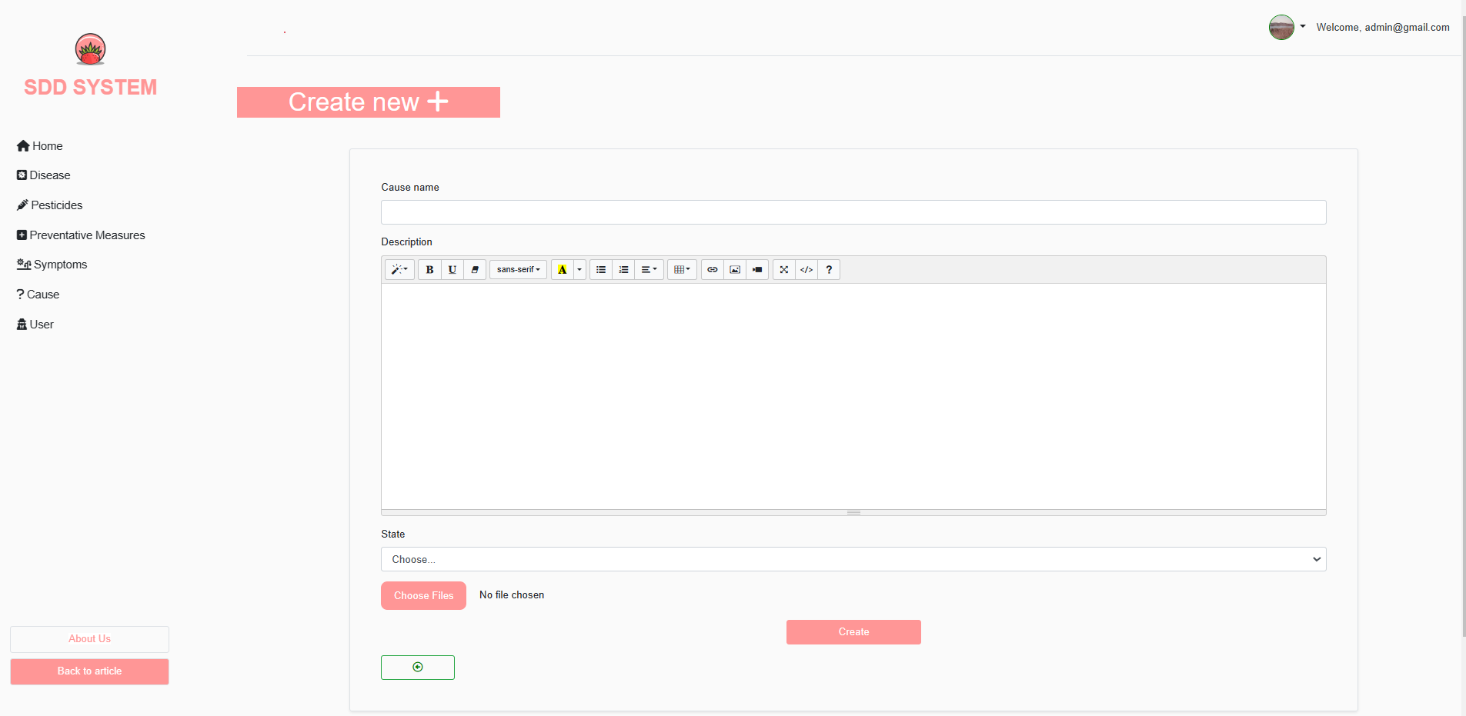**

**6.3 Delete Cause**

**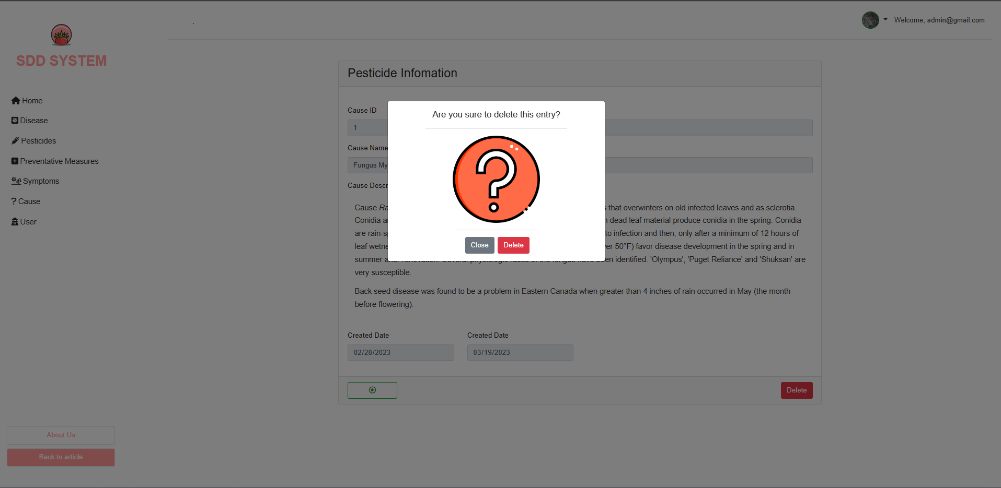**

**6.4 Update Cause**

**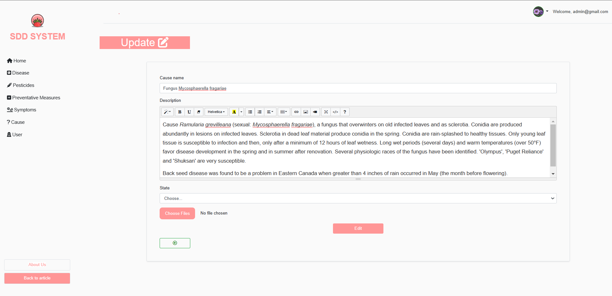**

**7. Manage Account**

**7.1 View Account List**

**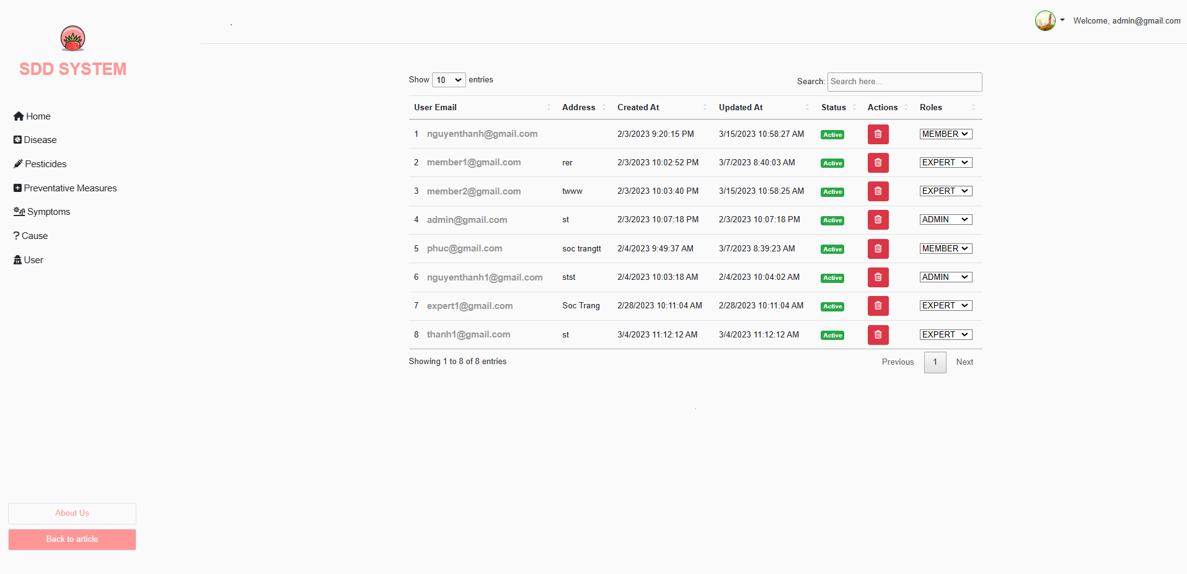**

**7.2 Change account role**

**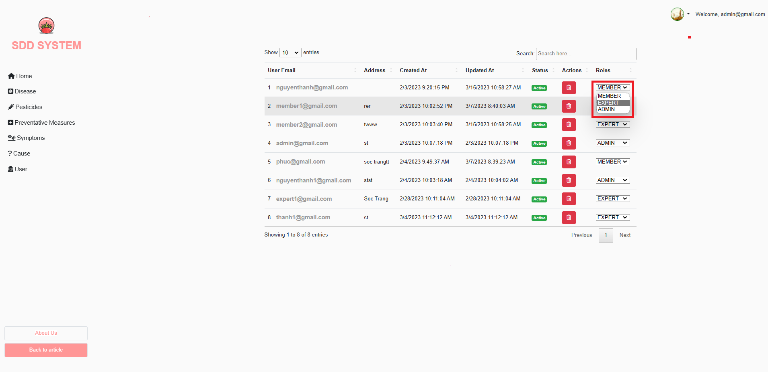**

**7.3 Deactivate Account**

**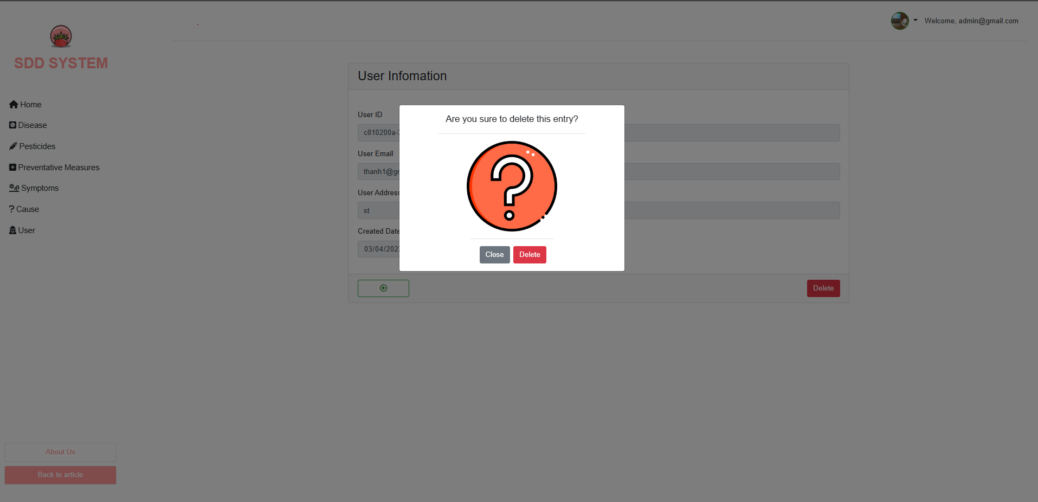**

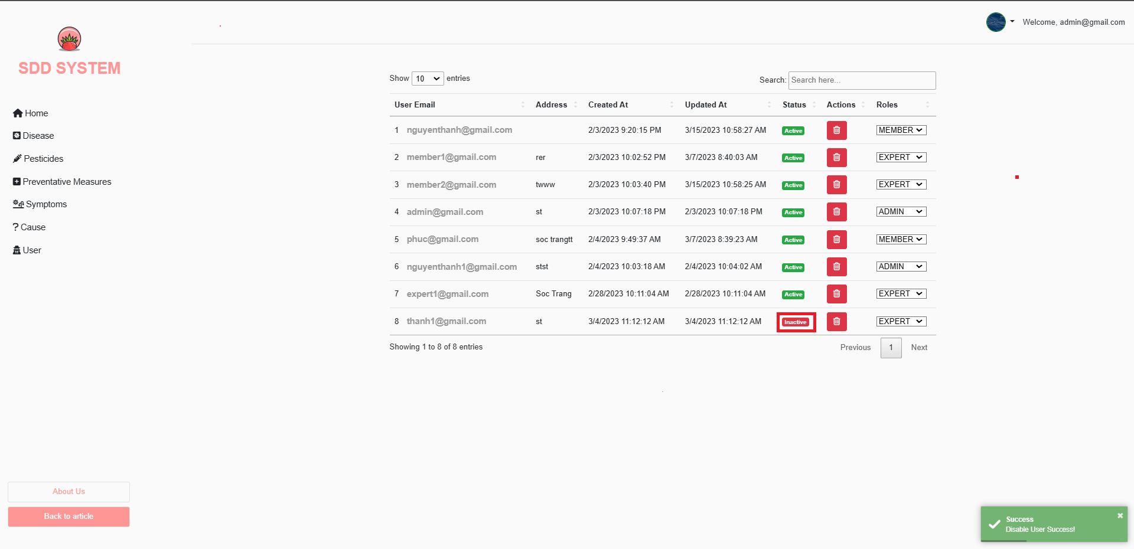

#### d. Role Farmer

1. **Upload Image**

The academic department can perform module related activities from the module list page.

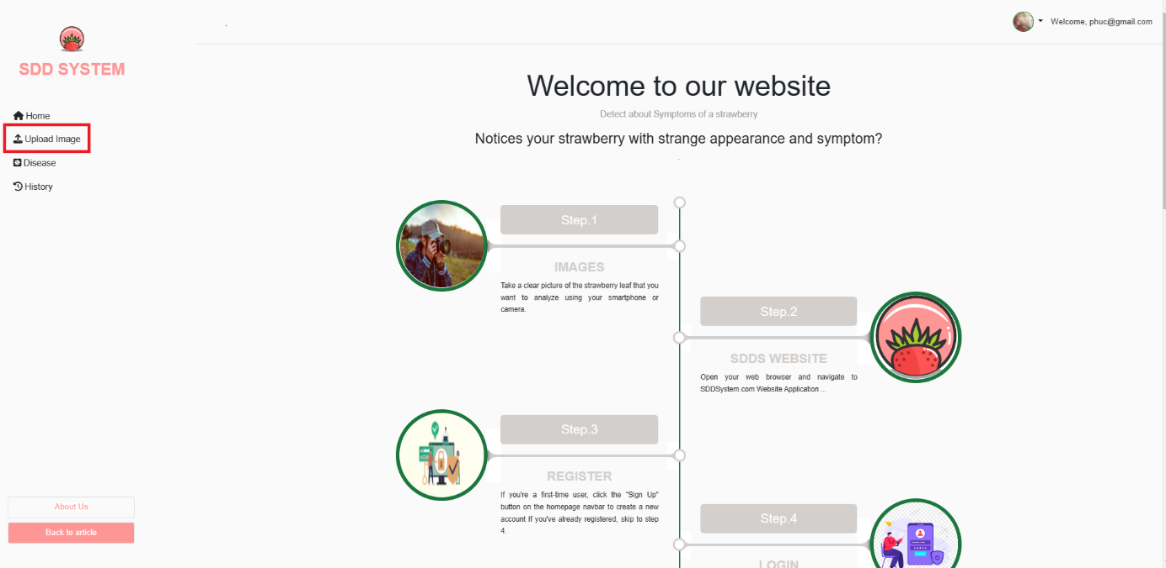

Figure Create module button

They can click on the plus icon to start creating a new module.

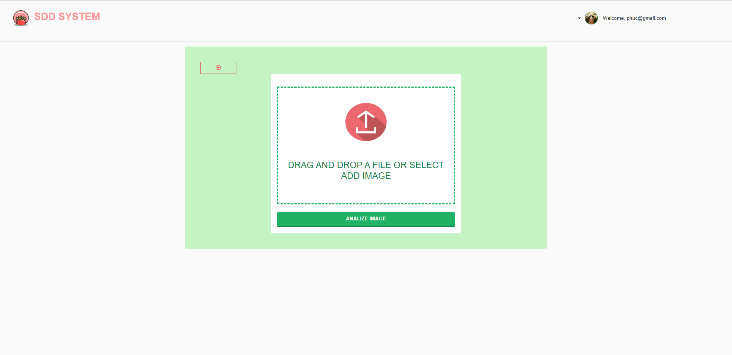

Figure Upload Image form

-A popup will show. Click on the [Choose file] button and choose the Image file(PNG) you have filled in in the previous step, after that click on the [Analyze image] button.

.

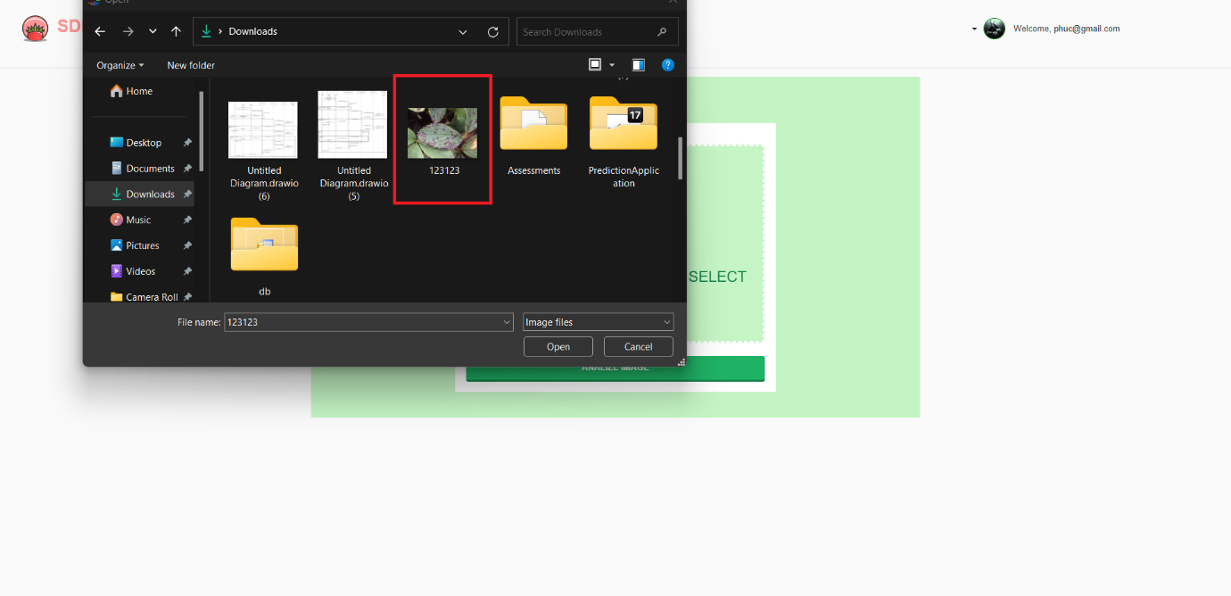

Figure Create module confirm

After clicking confirm, a pop up will appear asking for confirmation. If the user clicks “Yes”, a new module will be created. If the user clicks “Cancel”, they will exit the pop ups.

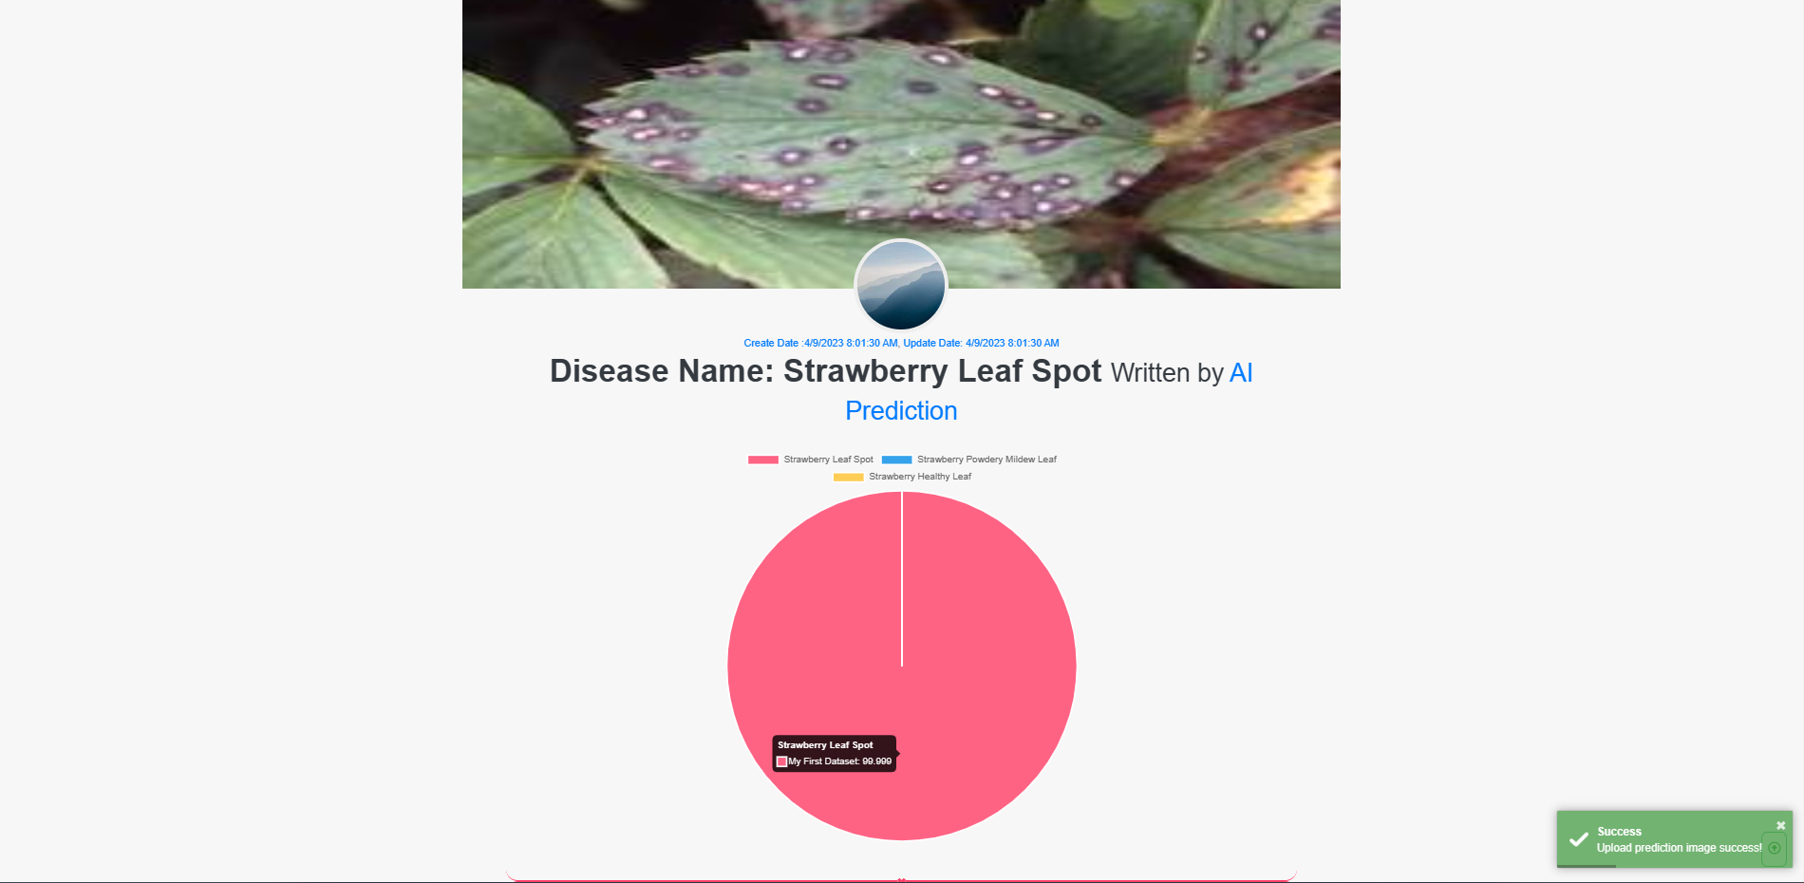

Figure Module list page

The user can start updating a module by click on the edit icon in the actions column for a specific module.

After clicking the edit icon, a popup will appear, allowing the user to enter a new module’s name. The user can then click Confirm to proceed.

After clicking confirm, a popup will appear asking for the user’s confirmation. If the user clicks “Yes”, then the module will be updated. If the user clicks “Cancel” then they will exit the popups.

1. **View Disease Details**

Users can perform create new class from the class list page by clicking on the plus icon at the top-right of the page.

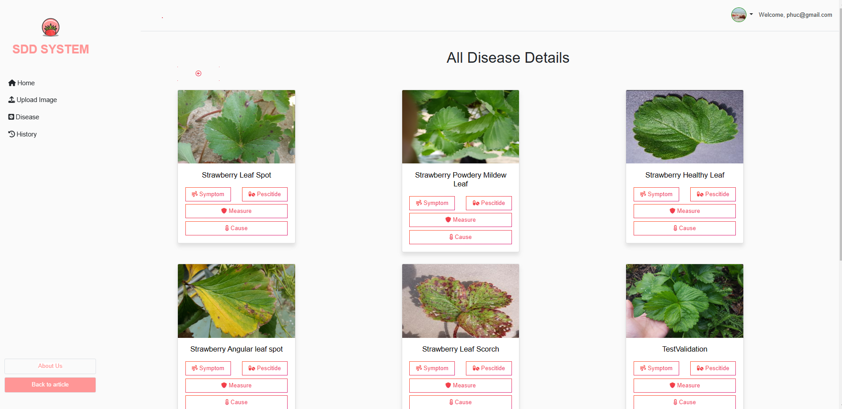

Figure Create class button

The create class form is a multi-level form, user need to fill in all the input fields of all section on the left hand side.

**2.1 View Disease’s pesticide**

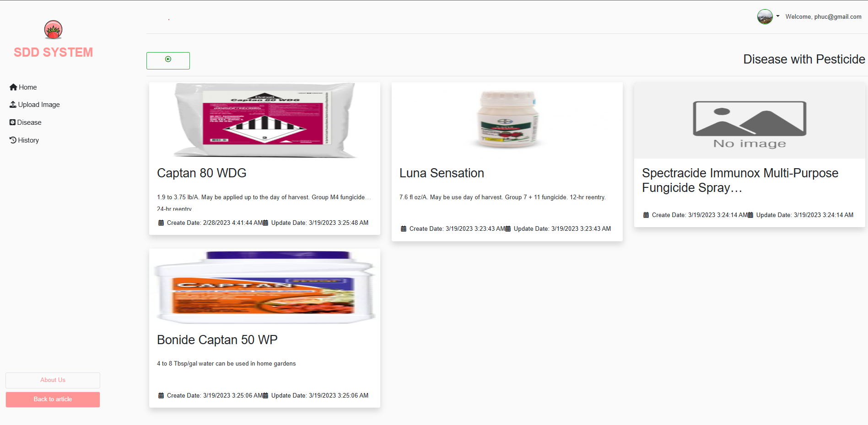

Figure Create class form

Otherwise, by clicking on each class, users are provided a class detail page where all the class information is displayed. User can choose to Update class information or go into detail of each module of the class.

**2.1 View Disease’s symptom**

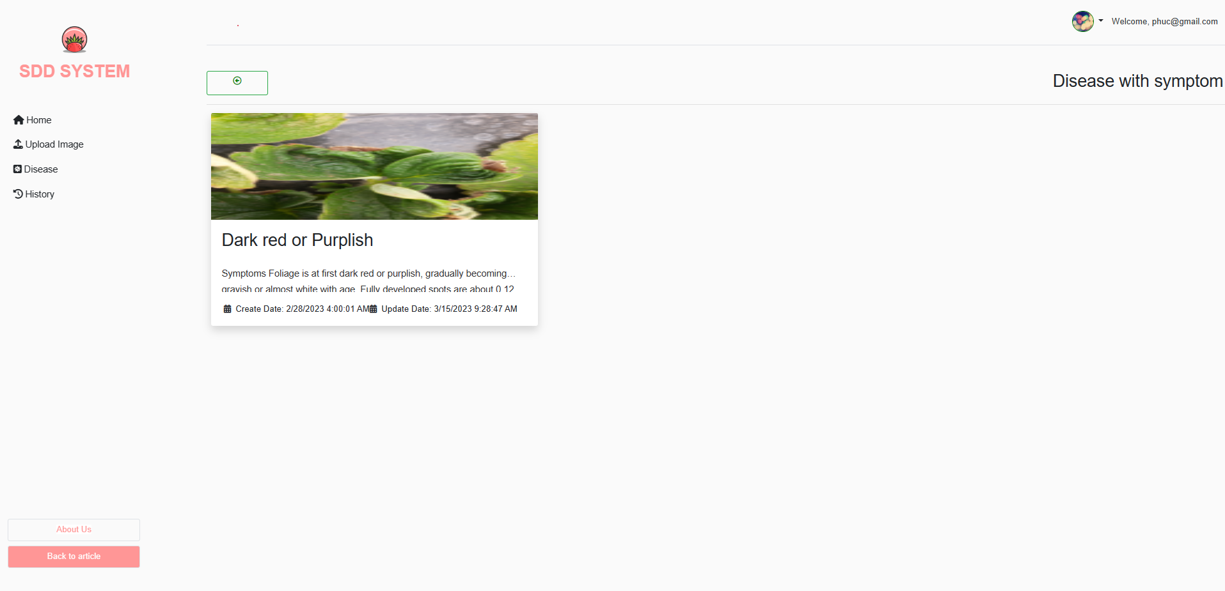

Figure Update class button

To update class information, user just need to edit the text in the input and click “Save Change” to confirm when user is done.

**2.3 View Disease’s preventative measure**

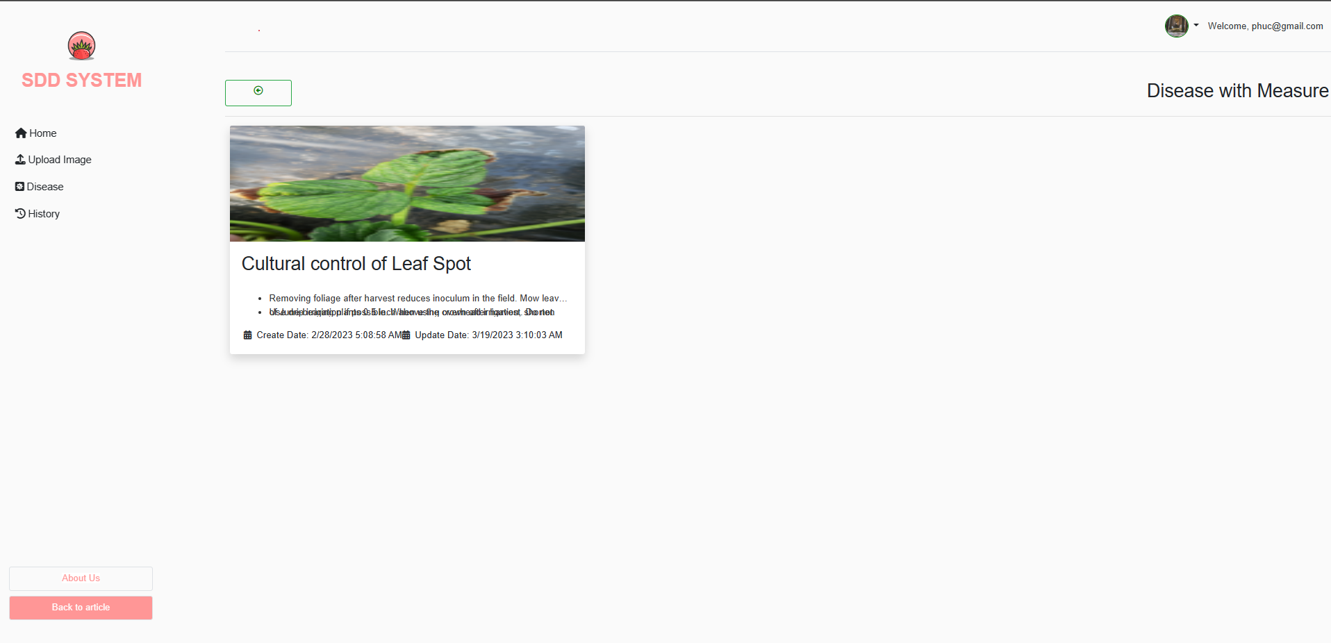

Figure Update class button

**2.4 View Disease’s cause**

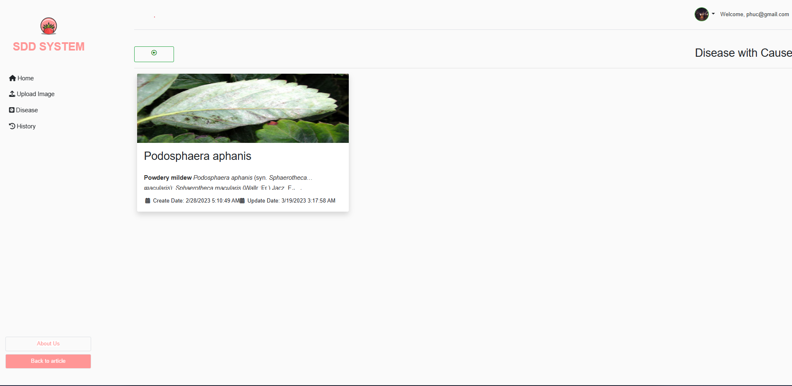

1. **View History/Prediction History**

User can start performing exam related activities from the Exam list page.

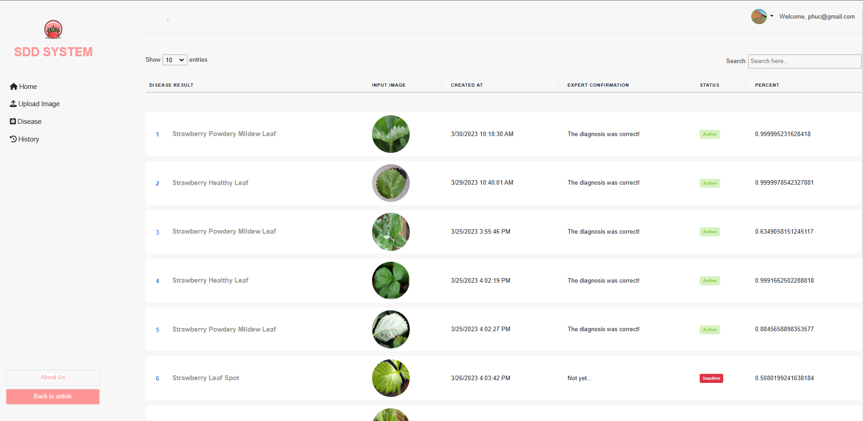

Figure Create Exam button

The user can start creating a new exam by clicking on the plus icon.

1. **Profile**

**4.1 View Profile** **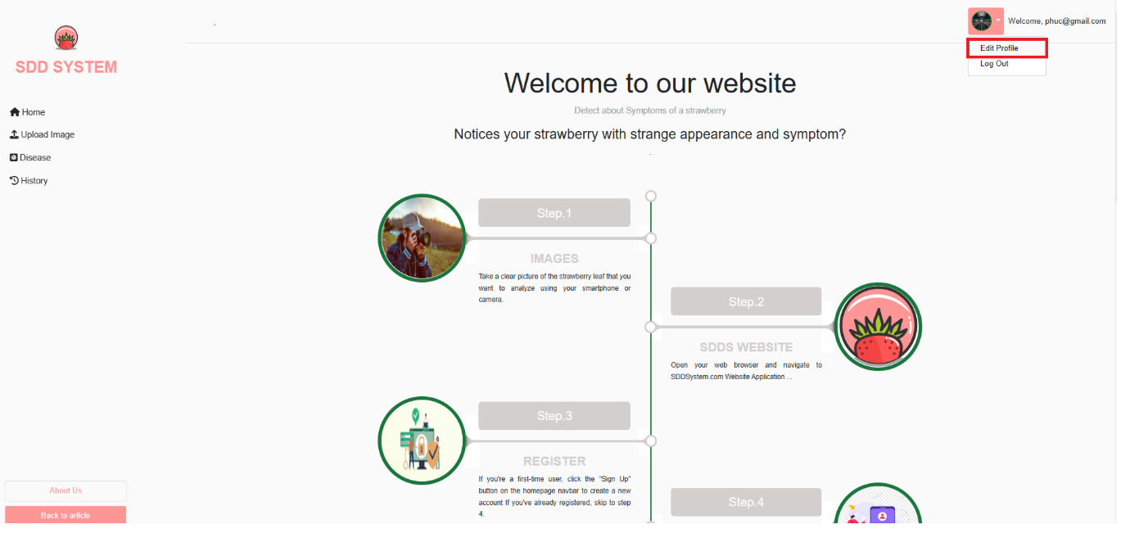**

Figure Create Exam button

After clicking the plus icon, the user will be redirected to the create exam page. Here, the user are prompted to input the required information in 4 steps. Step 1, they are required to fill in the Exam Name, Duration and Date. The fields description, room and password are not required. Only if the user has filled all required fields, will the “Next” button be lit up and the user can click on it to proceed.

After successfully filling all the information, the user can click the submit button to create the exam. The program will show a popup asking for the user’s confirmation. If the user agrees to proceed, the exam will be created and they will be redirected to start creating the problem sets for the exam.

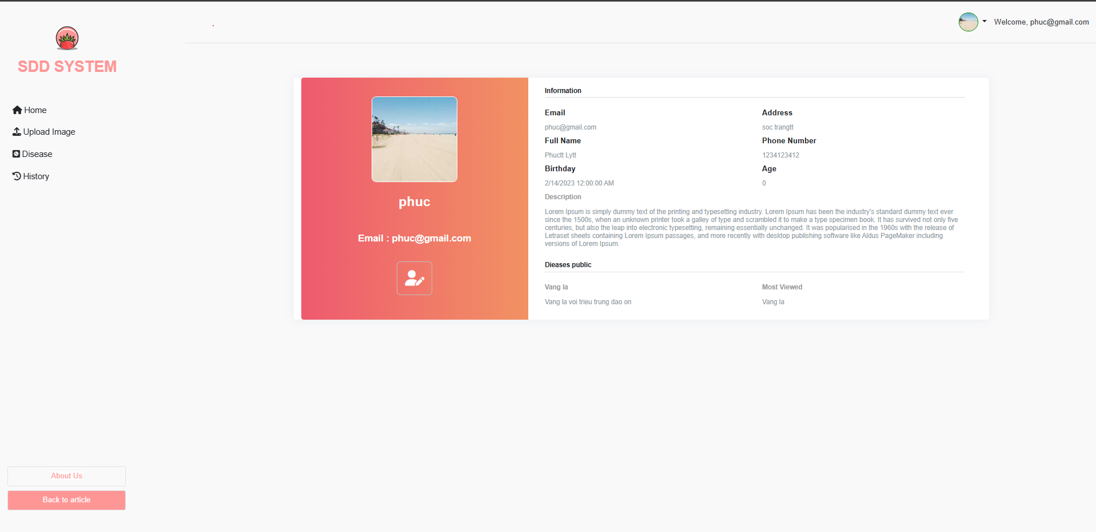

Figure Exam detail page

The user can also access the detail page by clicking on the “Detail” button in the “Action” column for a specific exam. After clicking on the “Detail” button, the user will be redirected to the Detail page. Here the user can view the detail of the exam, and they can also update the exam’s information or cancel the exam.

**4.2 Update Profile**

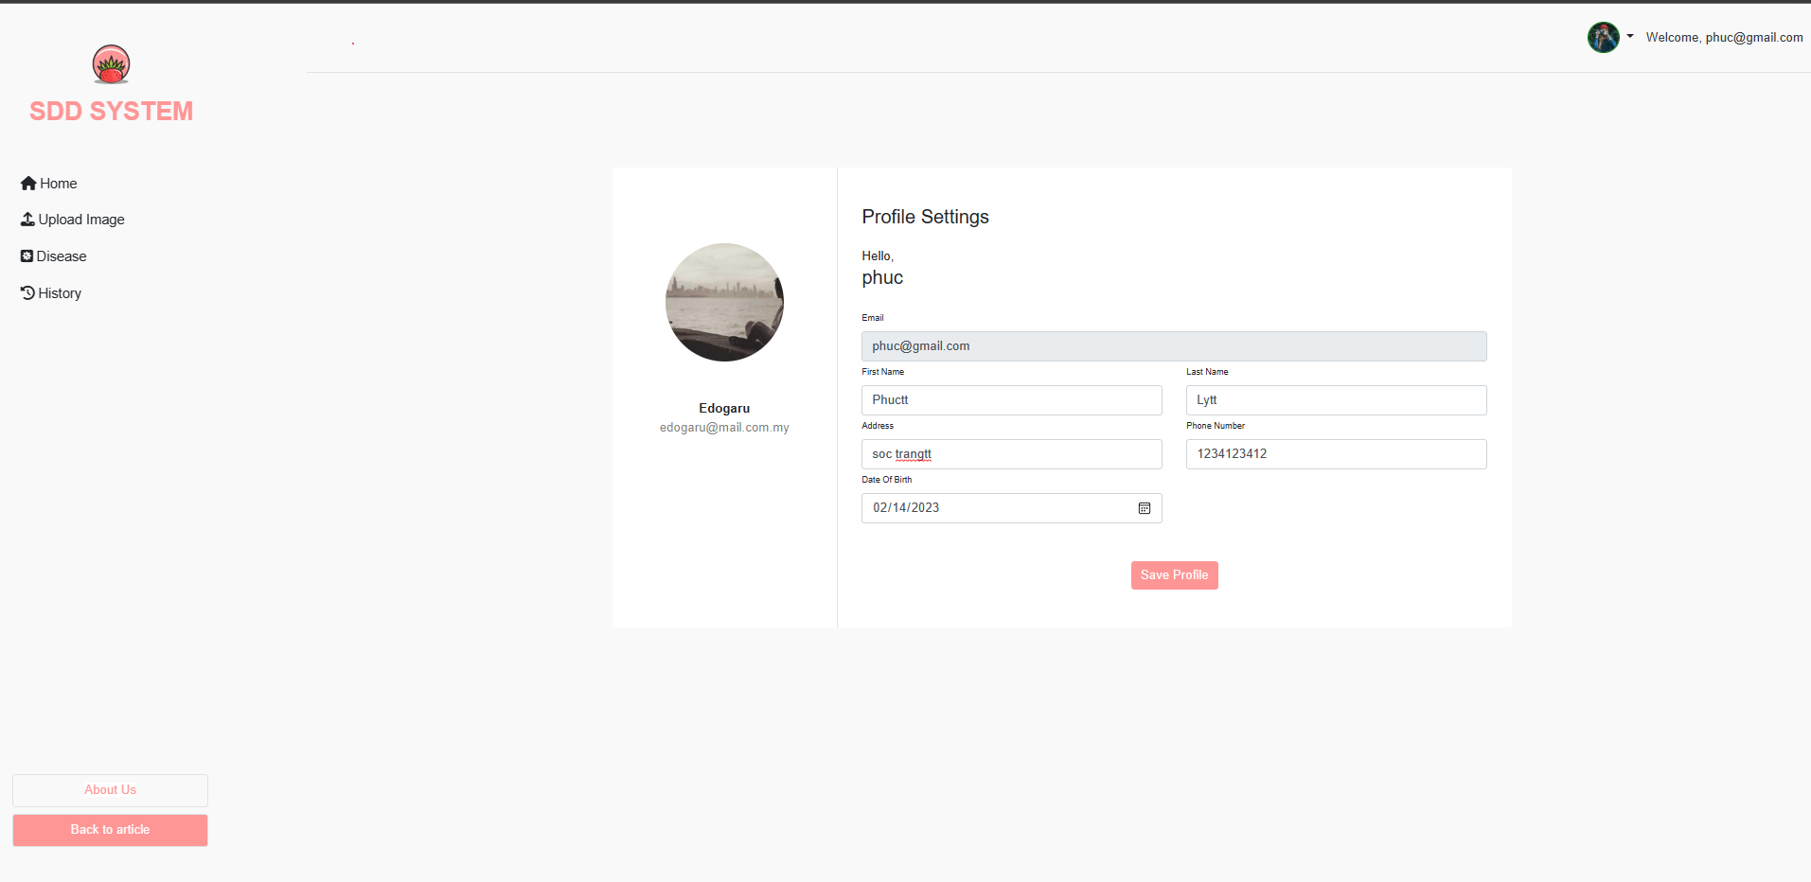

#### e. Role Expert

1. **View Disease Details**

**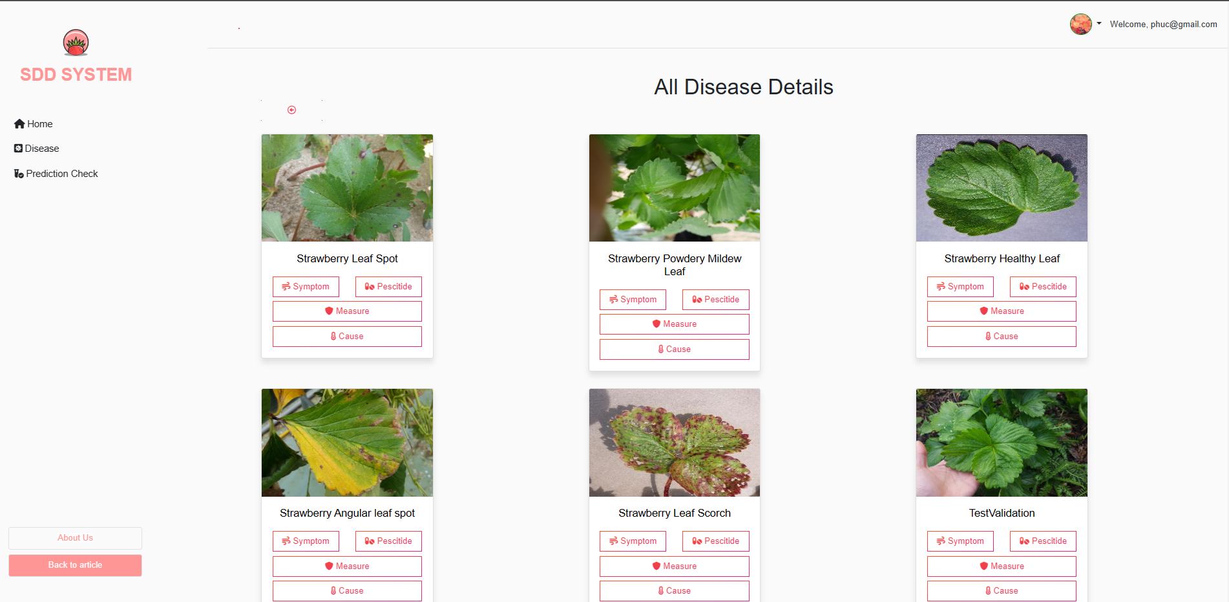**

* 1. **View Disease’s pesticide**

After login in successfully with the teacher’s account, user can click on the “Create Exam” icon on the vertical navigation bar to go to a create exam page (Figure 47).

Here, user is prompted to input the required information in 3 steps:

* Step 1, user is required to fill in the Exam Name, Duration, and Date. The fields description, room, and password are not required. Only if the user has filled all required fields, will the “Next” button be lit up and the user can click on it to proceed (Figure 47).



Figure The create exam page in step 1

­

* 1. **View Disease’s Pesticide**



User can click on the “Module” icon on the vertical navigation bar to go to the module list page, click on the module tab to expand it, and click on the appropriate class under each module tab to go to the exam list (Figure 55, 56).

* 1. **View Disease’s preventative measure**



Figure The exam list page and the “Detail” button

**1.4. View Disease’s symptom**

User can click on the “Detail” button in the exam card to view all details of the exam (Figure 56, 57).



Figure The exam details page with the “Update” and “Cancel” button

**1.5. View Disease’s Cause**

User can click on the “Update” button on the exam details page to go to the update exam page (Figure 57). In the update exam page, user can update all the basic information of the exam (Firgure 58).



Figure The update exam page

1. **View History/Prediction History**

**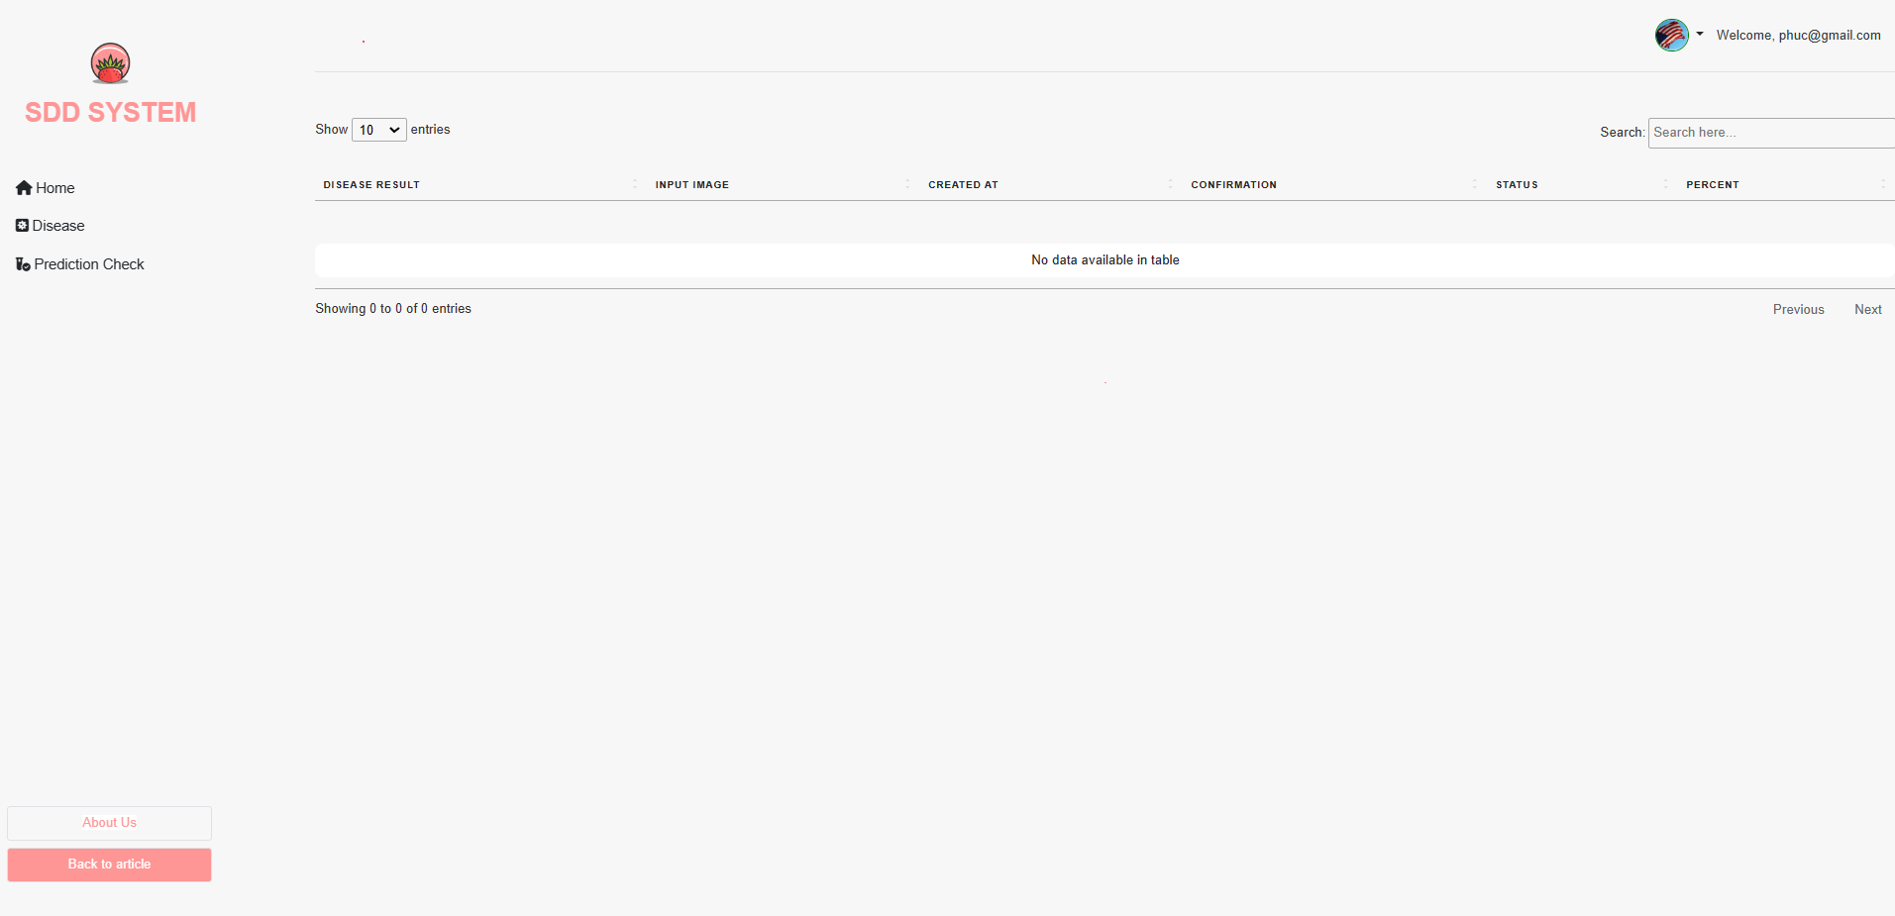**

Figure Click on a class

Before grading written question, teachers need to find exactly the module and class to see the right exam result.

# VII. Appendix

## 1. References

1. [↑](#footnote-ref-1)
2. [↑](#footnote-ref-2)
3. [↑](#footnote-ref-3)
4. [↑](#footnote-ref-4)
5. [↑](#footnote-ref-5)